Advanced Python LAB: FASTAPI
Shriharsh S Kotecha
22MIC0021

Code:

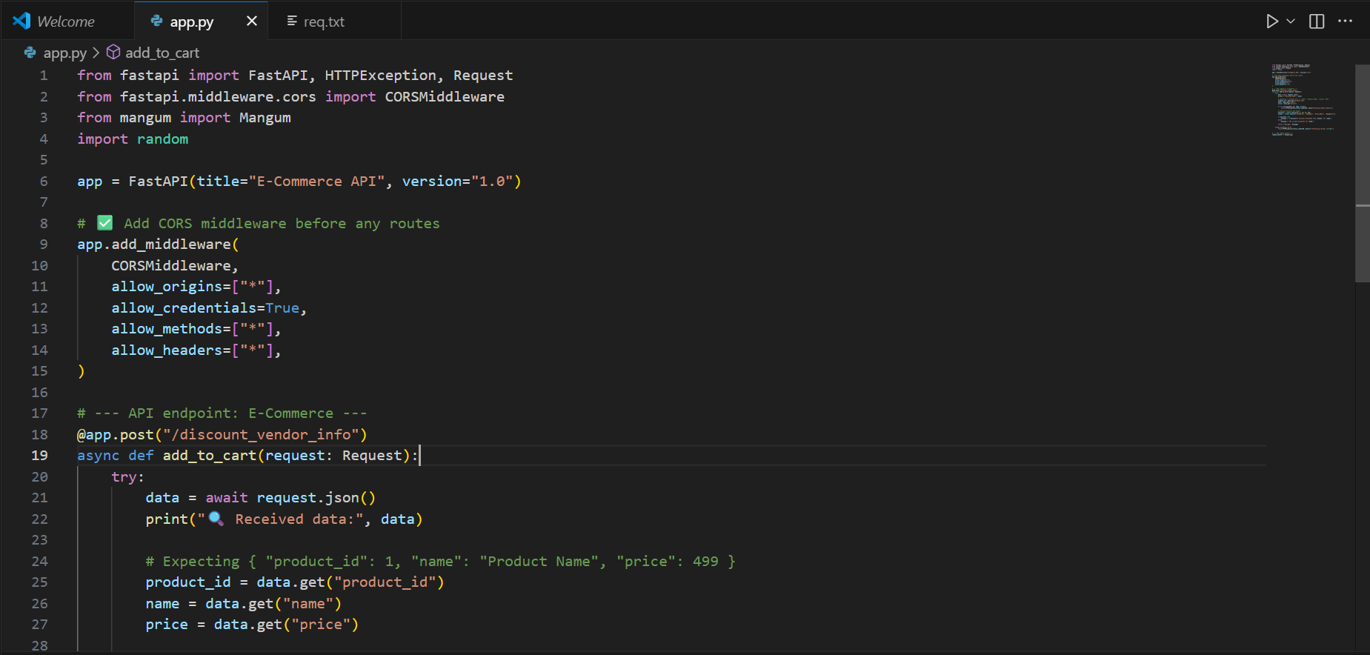
from fastapi import FastAPI, HTTPException, Request
from fastapi.middleware.cors import CORSMiddleware
from mangum import Mangum
import random

app = FastAPI(title="E-Commerce API", version="1.0")

# ✅ Add CORS middleware before any routes
app.add_middleware(
CORSMiddleware,
allow_origins=["*"],
allow_credentials=True,
allow_methods=["*"],
allow_headers=["*"],
)

# --- API endpoint: E-Commerce ---
@app.post("/discount_vendor_info")
async def add_to_cart(request: Request):
try:
data = await request.json()
print("🔍 Received data:", data)

# Expecting { "product_id": 1, "name": "Product Name", "price": 499 }
product_id = data.get("product_id")
name = data.get("name")
price = data.get("price")

if not all([product_id, name, price]):
raise HTTPException(status_code=400, detail="Missing product details")

# Simulate discount and vendor
discount = random.choice([0, 5, 10, 15, 20])
vendor = random.choice(["TechWorld", "ShopEase", "ElectroMart", "MegaDeals"])

if discount > 0:
message = f"{discount}% discount available from {vendor} for {name}."
else:
message = f"No current discounts for {name}."

return {"message": message}

except Exception as e:
raise HTTPException(status_code=500, detail=f"Processing failed: {str(e)}")

# --- AWS Lambda handler ---
lambda_handler = Mangum(app)

Terminal:
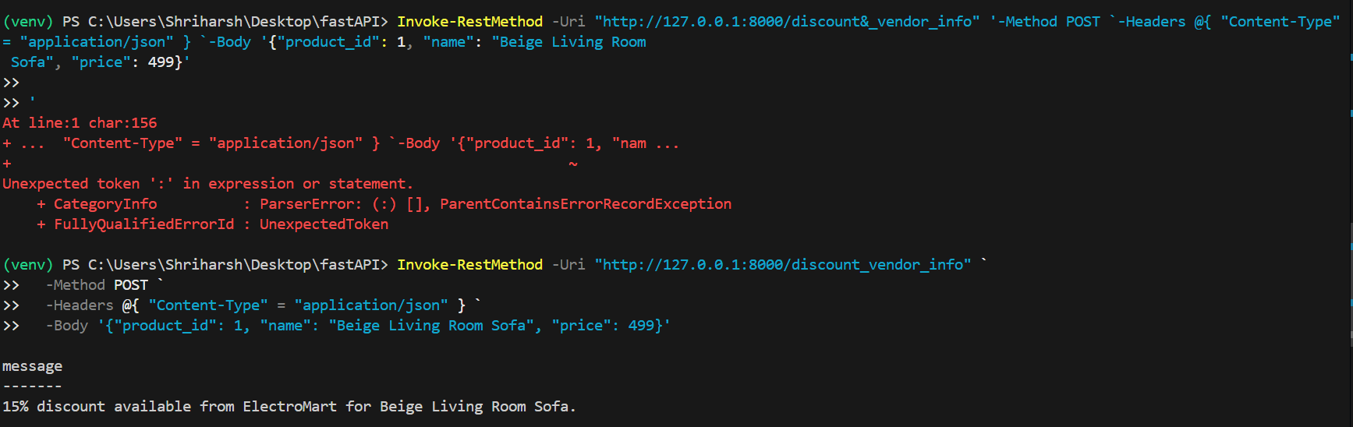

Fixed the error by make sure the backticks ` for line continuation are outside of any quoted strings and splitting the code into different lines.

Docker Image:

Code:
FROM public.ecr.aws/lambda/python:3.11

WORKDIR /var/task

# Install system tools
RUN yum install -y gcc make rust cargo && \
python3.11 -m pip install --upgrade pip setuptools wheel

# Copy requirements and install them directly
COPY req.txt .
RUN python3.11 -m pip install --no-cache-dir -r req.txt

# Copy application code
COPY . .

# Lambda entrypoint
CMD ["app.lambda_handler"]

docker build -t app .
