HELP DOCUMENT

Steps:

1. Create a conda virtual environment using the command “conda create –n name_of_env “
2. Install the packages mentioned below.
3. Copy the source code into a folder
4. Change directory (cd) till the first Resume_Reader_Project folder
5. Run python manage.py runserver
6. The server will be up and running. You should get a page like this.

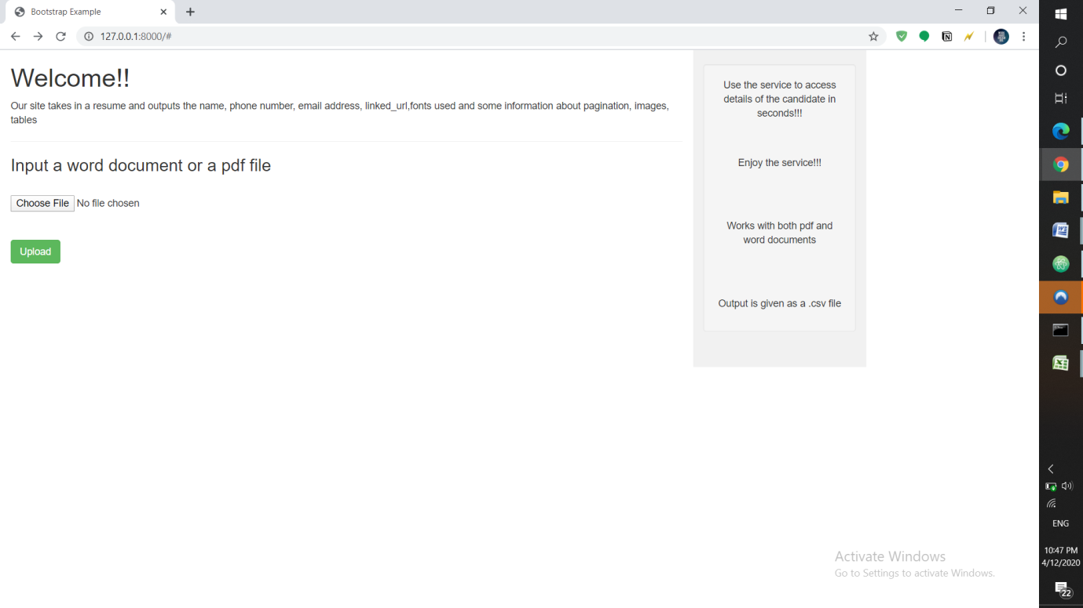

Note: I have not changed the DEBUG=False, because I am not aware of the details of the host that you are using. So, for now,the project will be running in your local server, <http://127.0.0.1:8000/>

Packages Required:

asgiref 3.2.5

atomicwrites 1.3.0

attrs 19.3.0

blis 0.4.1

catalogue 1.0.0

certifi 2020.4.5.1

chardet 3.0.4

colorama 0.4.3

comtypes 1.1.7

cymem 2.0.3

distro 1.5.0

Django 3.0.3

docx2pdf 0.1.5

docx2python 1.22

docx2txt 0.8

en-core-web-sm 2.2.5

idna 2.9

ipaddress 1.0.23

lxml 4.5.0

mail-parser 3.12.0

minecart 0.3.0

more-itertools 8.2.0

murmurhash 1.0.2

numpy 1.18.2

packaging 20.3

pandas 1.0.3

pdfminer3k 1.3.1

pip 20.0.2

plac 1.1.3

pluggy 0.13.1

ply 3.11

preshed 3.0.2

py 1.8.1

pycryptodome 3.9.7

pyparsing 2.4.7

pyPdf 1.13

PyPDF2 1.26.0

pypiwin32 223

pytest 5.4.1

python-dateutil 2.8.1

python-docx 0.8.10

python-magic 0.4.15

pytz 2019.3

pywin32 227

requests 2.23.0

setuptools 46.1.3.post20200330

simplejson 3.17.0

six 1.14.0

sortedcontainers 2.1.0

spacy 2.2.4

sqlparse 0.3.0

srsly 1.0.2

tabula-py 2.1.0

thinc 7.4.0

tika 1.24

tika-app 1.5.0

tqdm 4.45.0

urllib3 1.25.8

wasabi 0.6.0

wcwidth 0.1.9

wheel 0.34.2

wincertstore 0.2