**7. Explore the functionalities of Cloud Watch**

1. Type Cloud watch in the Search bar.
2. Select All alarms under Alarms option
3. Click the Option “Create alarm”

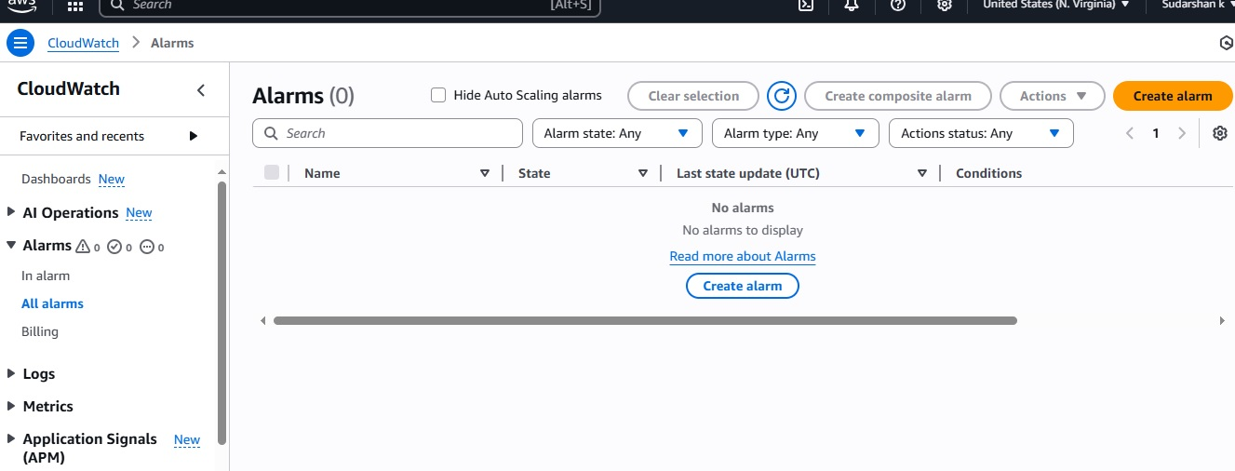

1. Select EC2 option under select metric option

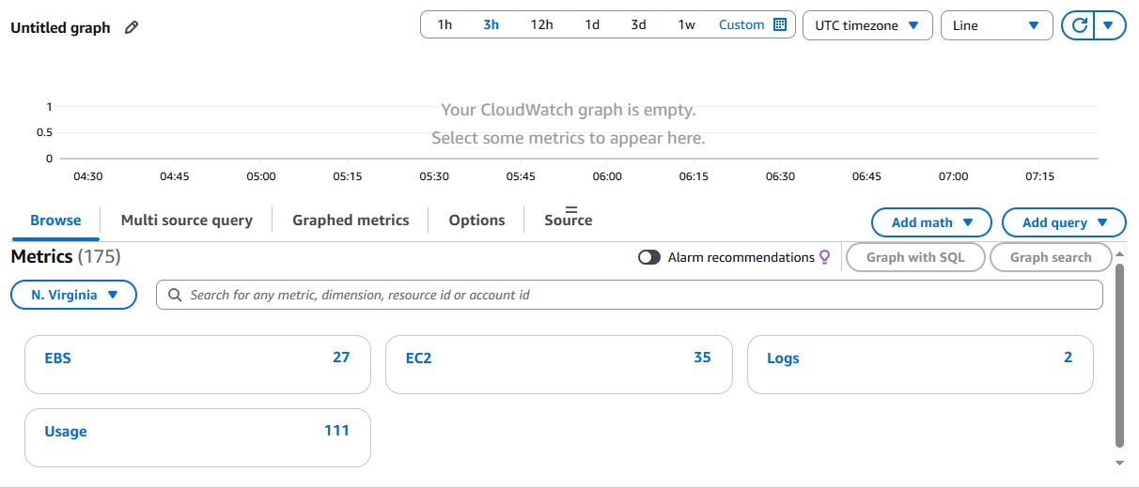

1. Select CPUUtilization under Per-instance Metrics

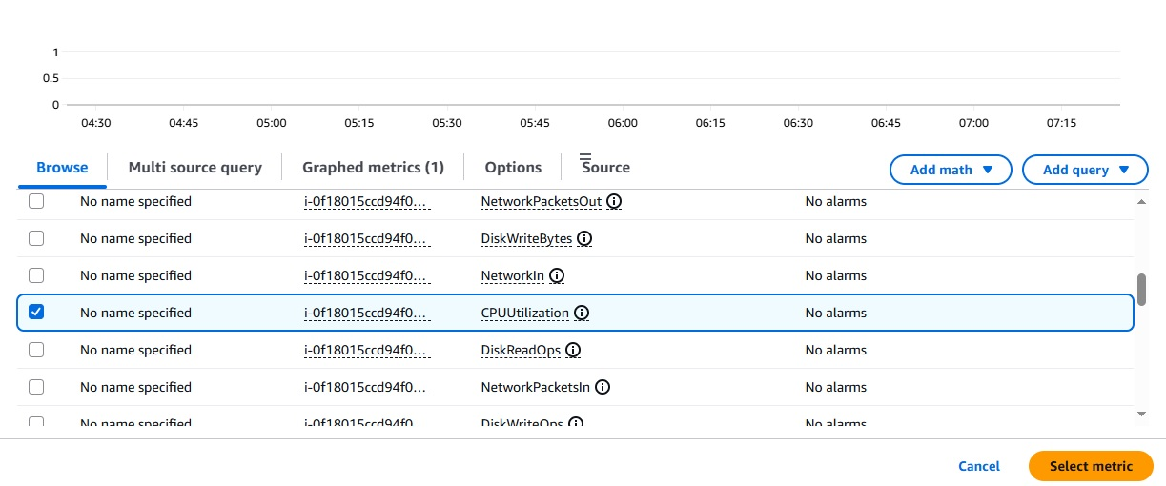

1. In the next step, set the periods and threshold value for CPUutilization

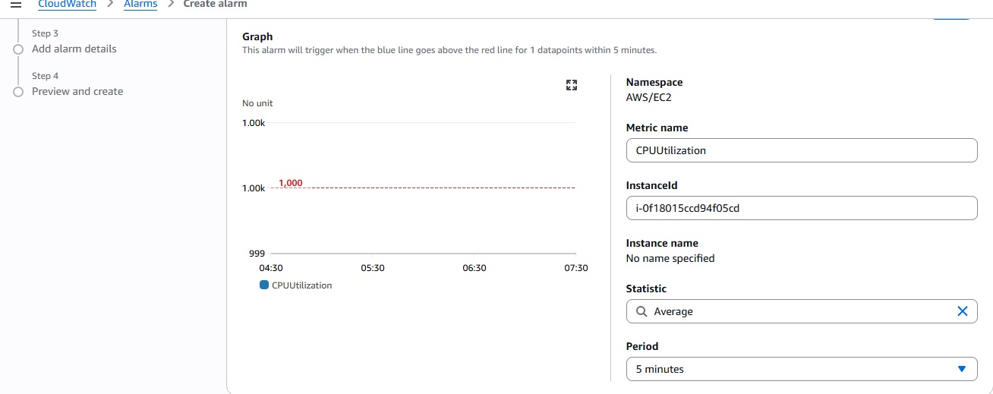

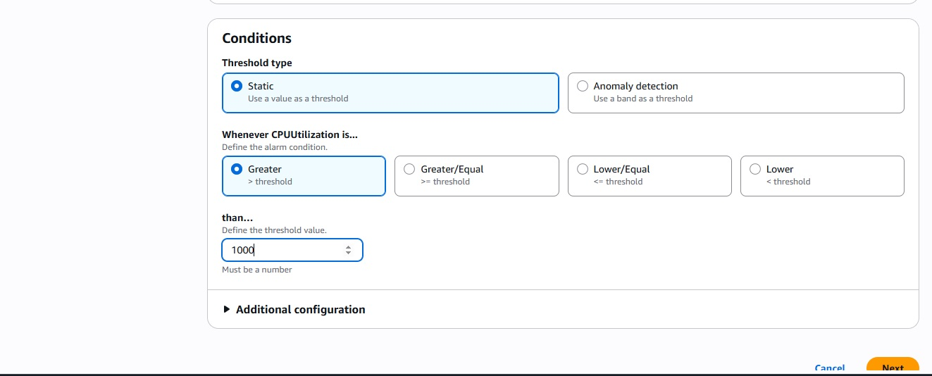

1. Next Create the new topic or select the already existing SNS topic

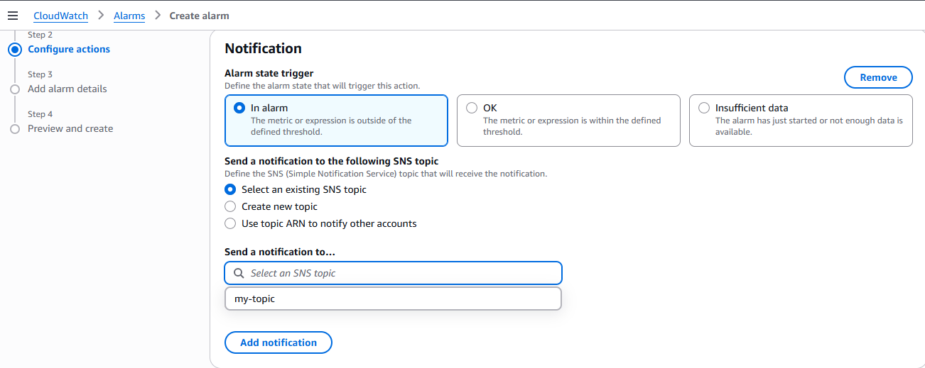

1. Type the alarm name in the next screen

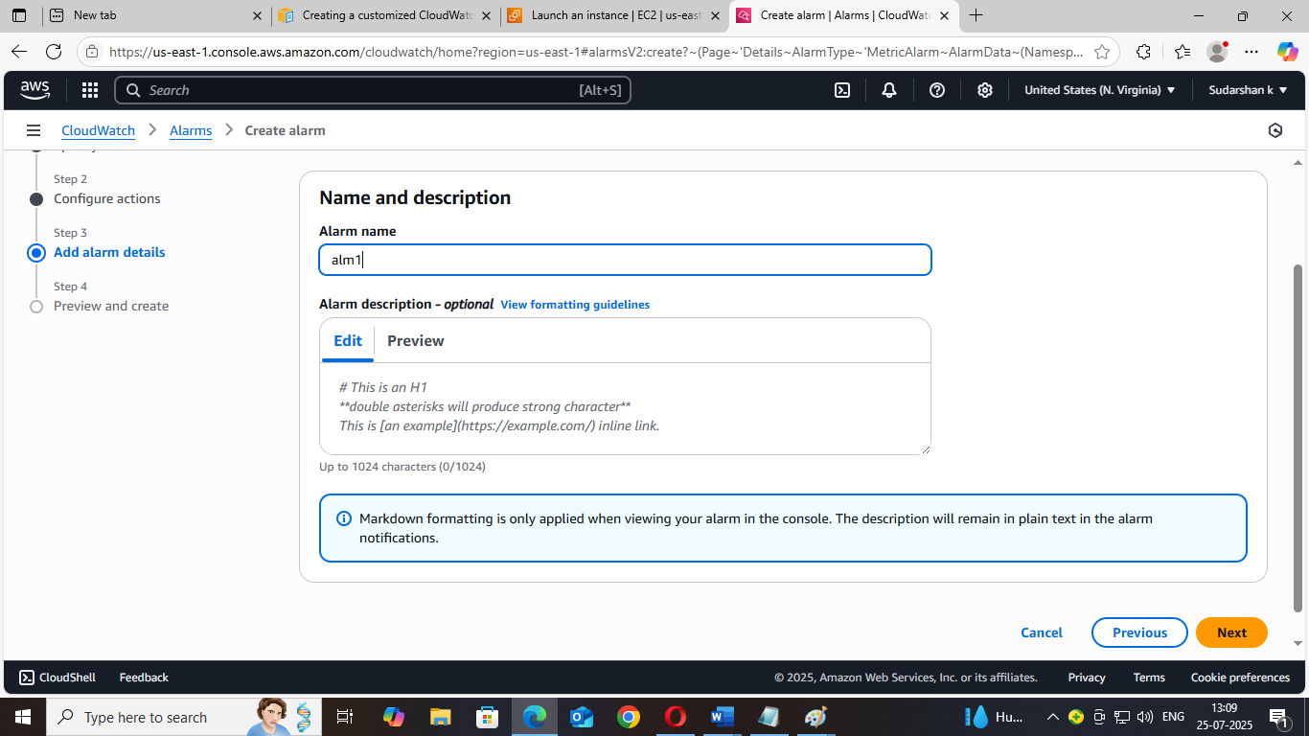

1. Click Next button and select the create alarm button. Then Alarm will be created.

