**6. Create a Virtual Private Cloud (VPC) using AWS**

**AWS VPC Creation - Step by Step**

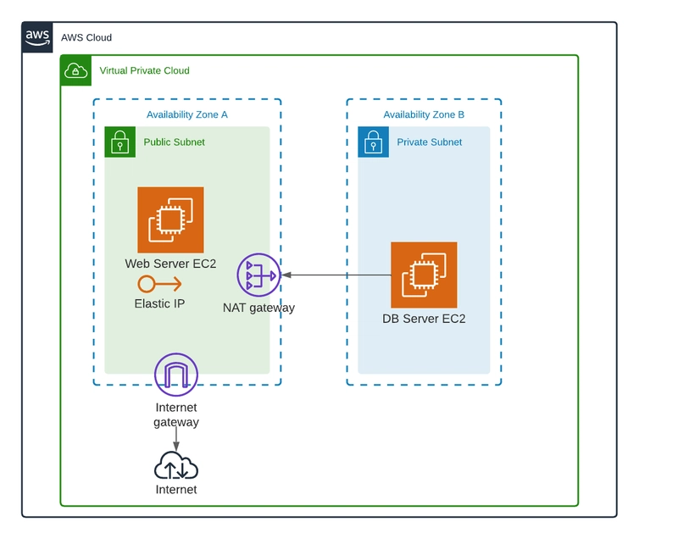

In AWS Management Console search and go VPC services after that click creates vpc button.

Give the name for VPC and add IPv4 CIDR. You can use the 10.0.0.0/16 CIDR range.  
[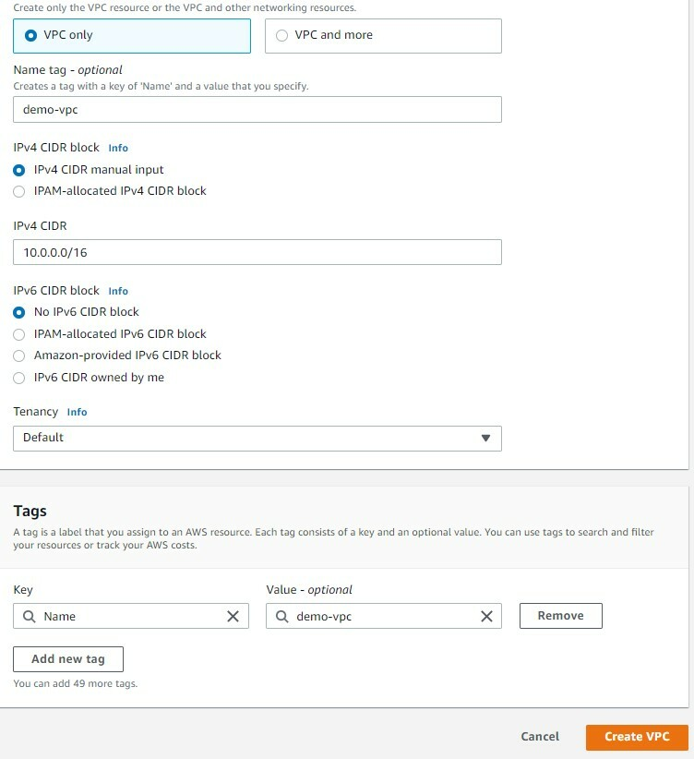](https://media2.dev.to/dynamic/image/width=800%2Cheight=%2Cfit=scale-down%2Cgravity=auto%2Cformat=auto/https%3A%2F%2Fdev-to-uploads.s3.amazonaws.com%2Fuploads%2Farticles%2Ffc6iypvs89705iuov6gu.jpg)

Create Two Subnets. Firstly create a public subnet. You can use the 10.0.1.0/24 CIDR range for the public subnet. Select the availability zone and give the name for the subnet.  
[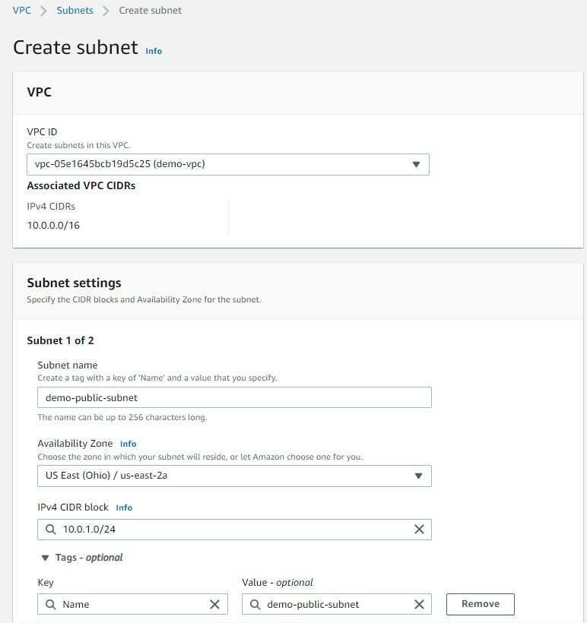](https://media2.dev.to/dynamic/image/width=800%2Cheight=%2Cfit=scale-down%2Cgravity=auto%2Cformat=auto/https%3A%2F%2Fdev-to-uploads.s3.amazonaws.com%2Fuploads%2Farticles%2Fisa5gsphnpfq8sgq1fzs.jpg)

Now the same interface, click add new subnet button for private subnet creation.

Add IPv4 CIDR as 10.0.2.0/24. After that give the subnet name and select the availability zone. finally, click create subnet button.  
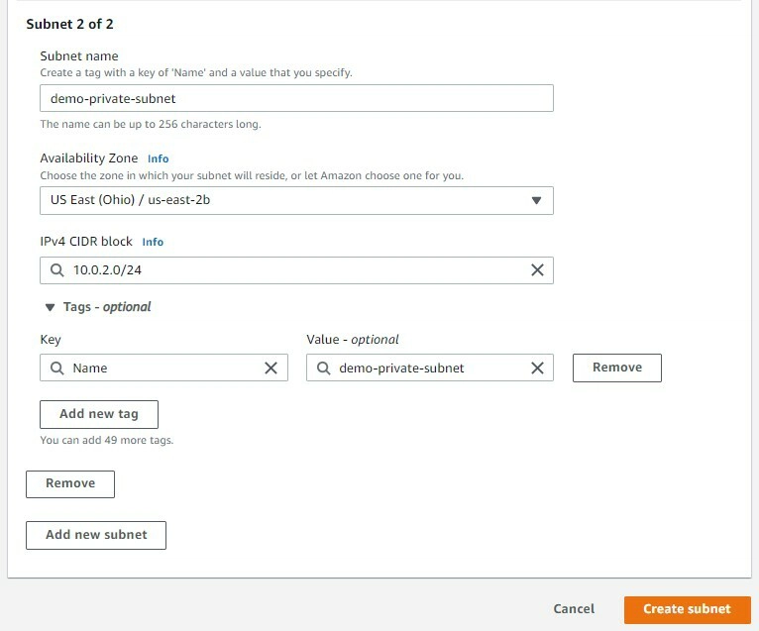

Now create an internet gateway for public subnet internet access. In VPC Console select Internet Gateway and create internet gateway. Give the name of Internet Gateway and hit

the create button

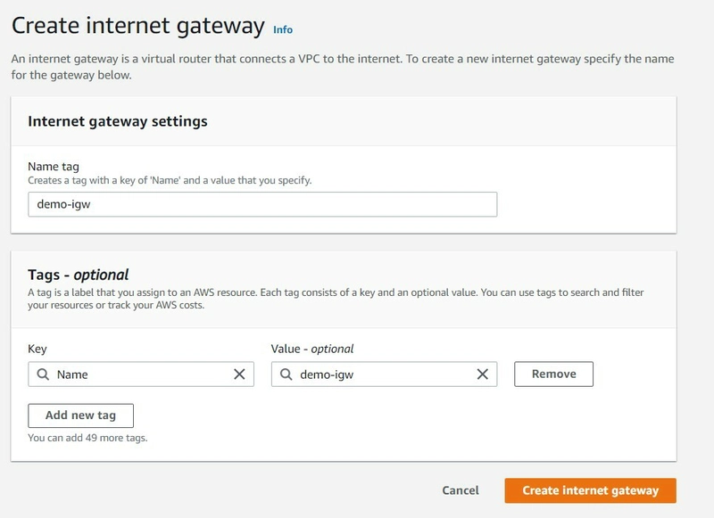

Next, we want to attach this internet gateway for VPC. You can select the internet gateway and click Attach to VPC.  
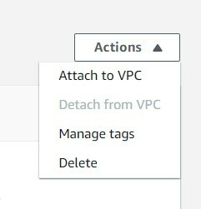

Next, select the previously created VPC and click attach internet gateway button.

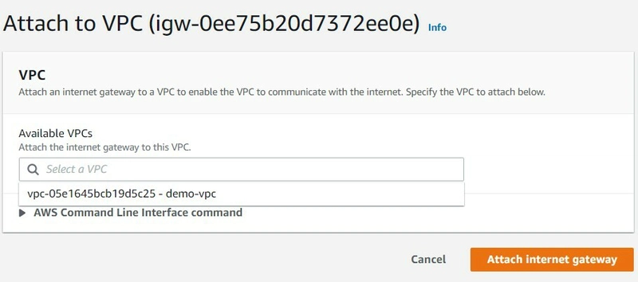

Next, Go to the route table and create a route table for the public subnet. give the name for the route table and select the previously created VPC. The next click creates the route table button.

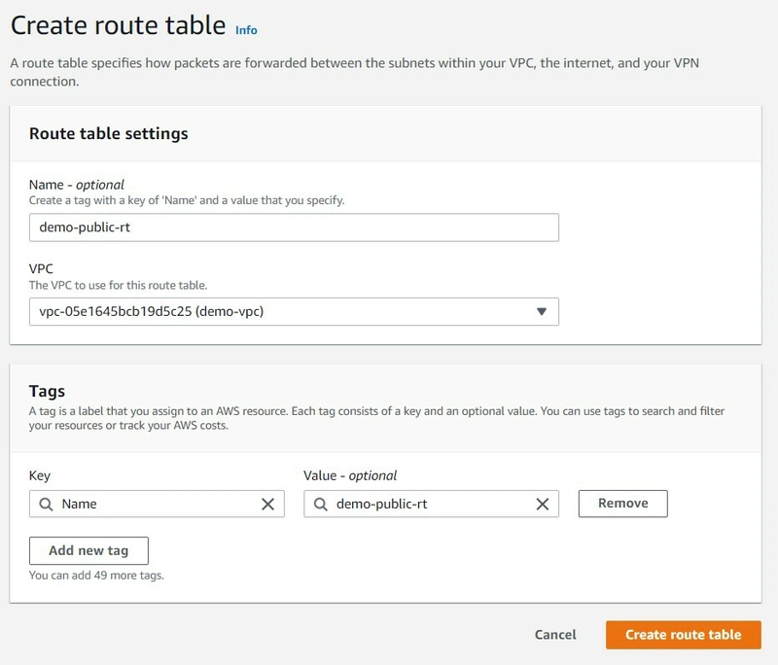

Create two Route tables . Connect one Route table with Public Subnet and another Route table with Public subnet

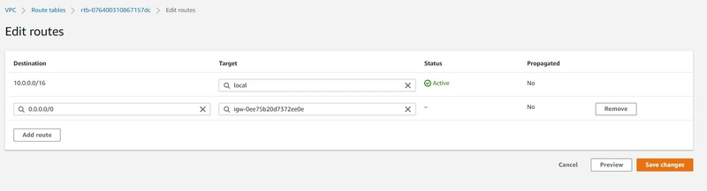

In the public subnet route table click the subnet association section and click edit "Explicit subnet associations" section

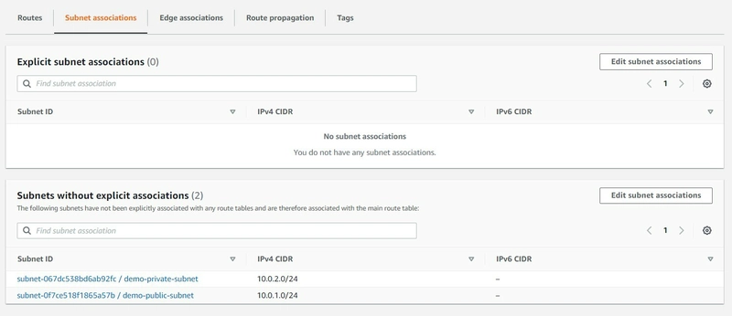

Next, select public subnet and click the save association button

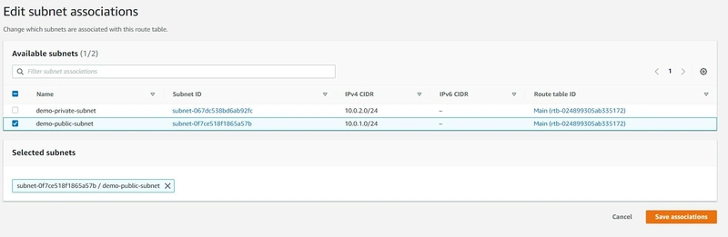

Now we go to public subnet and click subnet settings and enable "Enable auto-assign public IPv4 address" and click save

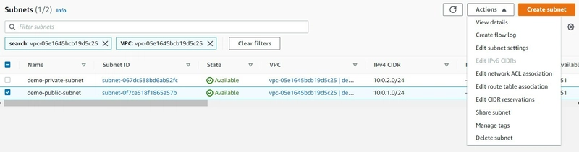

Next, we have to create EC2 instances and edit the Network Settings . Then Launch the EC2 Instance.