**8. Host a basic website using an EC2 Instance.**

1. Create the EC2 Ubuntu Instance and Select the HTTP and HTTPS options under Network settings.

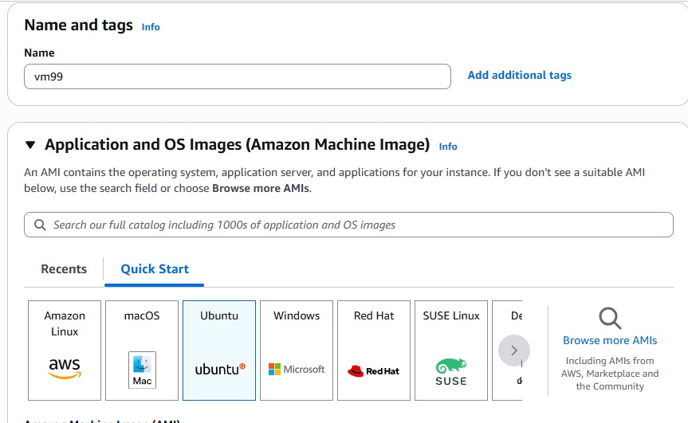

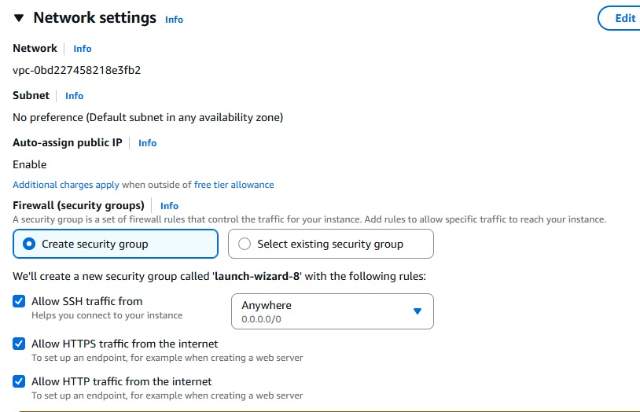

2. Connect the instance to the Ubuntu Prompt.

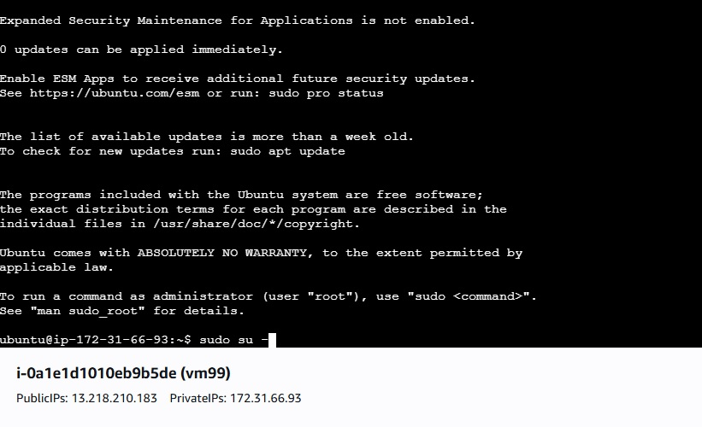

3. Type the following Commands to Launch the website

Type the following commands in Ubuntu prompt

1. sudo su -

2. apt update

3. apt install apache2 -y

4. systemctl start apache2

5. systemctl enable apache2

6. echo "<h1>hello, welcome</h1>" > /var/www/html/index.html

4. Copy the publicIP of the instance in the Ubuntu and paste the public IP in the Web browser