AcadEval+
A Graph-Based Novelty Assessment Platform for Academic / Capstone Engineering Projects

Workflow, Implementation Guide & Publication Roadmap
Prepared to explain the problem, the graph-based novelty solution, module-by-module implementation steps, and the path to publishing this work as a research paper — for presentation to the faculty guide.

Repository | github.com/ShriShivani/acadeval
Core research module | Graph-Based Novelty Assessment using a Project Knowledge Graph
Stack | React + TypeScript + Vite (frontend) • FastAPI + Python (backend) • Neo4j (graph engine)
Target outputs | 1) Deployed web platform 2) Peer-reviewed research paper

Built on the AcadEval_Corpus (running) and the dataset roadmap already drafted by the project team.

Contents

- Executive Summary
- The Problem — Why AcadEval+ Needs to Exist
- Why This Is Genuinely Research-Oriented (In Simple Words)
- What We Are Building — Objectives & Scope
- Core Research Contribution: Graph-Based Novelty Assessment
- System Workflow — End-to-End Pipeline
- Module-by-Module Explanation & Implementation Steps
- Dataset Design — The Updated AcadEval+ Data Roadmap
- Existing Tools (Free, Paid & Enterprise/Patent-Grade)
- How AcadEval+ Is Different — The Research Gap
- Research Contribution — Path to a Publishable Paper
- Technology Stack Summary
- Publication Plan — Target Venues & Paper Types
- Project Roadmap & Milestones
- How to Pitch This to Your Guide

1 Executive Summary

AcadEval+ is a proposal to build and validate a Graph-Based Novelty Assessment Platform that helps guides and evaluation panels judge how new a student project idea actually is. Instead of comparing documents or code (what plagiarism tools already do), AcadEval+ represents every project as a small knowledge graph — its domain, algorithms, technologies, datasets, and application — and measures novelty from the structure of that graph: how far it sits from existing project graphs, how rare its individual parts are, and whether it creates a connection between concepts that has never been made before.
This single idea — novelty from graph structure, not from a manually assigned percentage formula — is what turns AcadEval+ from "a useful student tool" into a genuine, defensible research contribution. It is explainable, it is testable against real faculty judgment, and it produces reusable datasets that do not currently exist anywhere in public research.
This document walks through the problem, explains in plain language why the approach is research-grade, breaks the system into modules with concrete step-by-step implementation instructions, updates the dataset roadmap to match the graph-based design, surveys existing tools (including professional, patent-grade AI novelty checkers), and lays out a realistic path to publishing this as a paper.

2 The Problem — Why AcadEval+ Needs to Exist

Every year, engineering colleges run thousands of final-year and mini-projects. Guides and evaluation panels are expected to judge each proposal on novelty — is this idea new, or is it a repackaged version of something already done? In practice, this judgment is made almost entirely from memory and gut feeling, because no structured tool exists that evaluates the novelty of a project idea the way Turnitin evaluates the originality of a written document.
The tools that do exist solve a different problem. Plagiarism checkers (Turnitin, Copyleaks, MOSS, JPlag) compare text or code against a database and return a similarity percentage. Research-trend tools (Semantic Scholar, Connected Papers) show what is trending in the literature, but say nothing about a specific student project. Even the heavy-duty, professional AI novelty checkers used in industry (see Section 9) are built to search patents and legal literature for a granted-patent style prior-art check — not to evaluate a student capstone idea against a college's own project history. There is a real, unfilled gap between document/patent-level prior-art search and idea-level novelty evaluation for academic projects.
One-line problem statement: Engineering colleges lack a structured, explainable, data-driven way to measure how novel a student project idea is relative to prior work — evaluation today is manual, inconsistent, and cannot be justified with evidence when questioned.

3 Why This Is Genuinely Research-Oriented (In Simple Words)

A guide will reasonably ask: "is this really research, or just a coding project with a nice UI?" Here is the honest, simple answer — five reasons this qualifies as research:

It replaces an unjustifiable formula with an explainable method
An earlier version of this idea scored novelty as 40% similarity + 30% features + 20% trend + 10% faculty score. Any reviewer's first question would be: why 40%, why not 35%? There is no way to defend those numbers. The graph-based approach removes this weakness — every signal comes from the structure of the graph itself, not from a number someone picked.

It borrows proven methods from a mature field and applies them somewhere new
Graph distance, node embeddings, rarity scoring, and link prediction are not invented here — they come from network science, a field with decades of peer-reviewed use in social networks, biology, and citation analysis. Applying an established, rigorous method to a brand-new problem (academic project novelty) is exactly what counts as a research contribution — you are not reinventing graph theory, you are the first to point it at this problem.

It can be proven right or wrong
Because faculty give real novelty ratings (AcadEval_FacultyEvaluation), the system's graph-based score can be statistically compared against expert judgment — for example, using a Spearman correlation. If the correlation is strong, that is evidence the method works. If a specific signal (say, Graph Density) is removed and the correlation drops, that is proof that signal matters. This kind of testable, falsifiable claim is what separates research from a demo.

It creates new things the research world does not already have
The taxonomy, feature knowledge base, and — most importantly — the Project Knowledge Graph Bank and the faculty-validated NovelBench dataset do not exist anywhere publicly today. Even before any paper is written about the method, the datasets themselves are a legitimate, citable contribution.

It generalizes beyond one college or one batch of students
Once the taxonomy and feature vocabulary are populated, the same graph engine can, in principle, be reused for any department or institution. Reviewers value methods that are not one-off hacks tied to a single dataset — this one is designed to scale to new domains simply by extending the taxonomy.

4 What We Are Building — Objectives & Scope

AcadEval+ takes a student project proposal (title, abstract, tech stack, features) and returns a structured, explainable novelty report. Concretely, the platform will:
- Classify the project into a domain and sub-domain, so it is only compared against relevant peers.
- Extract structured entities (algorithms, datasets, technologies, application) from free-text descriptions.
- Build a Project Knowledge Graph for the proposal and store it alongside every previous project's graph.
- Compute a Graph-Based Novelty score from five independent, explainable graph signals.
- Pull in a live research-trend signal from Semantic Scholar so novelty judgments account for what is currently rising or declining in the literature.
- Present an explainable report to the guide, and collect a faculty rating that both validates and improves the system over time.

Explicit non-goals (keep the scope defensible)
- Not a replacement for plagiarism detection on written reports — Turnitin/Copyleaks still handle that.
- Not a fully automatic accept/reject system — faculty remain the final decision-makers; the tool produces evidence, not verdicts.
- Not a patent-prior-art search tool — it evaluates academic project ideas against a college project history, not granted patents or global IP literature.

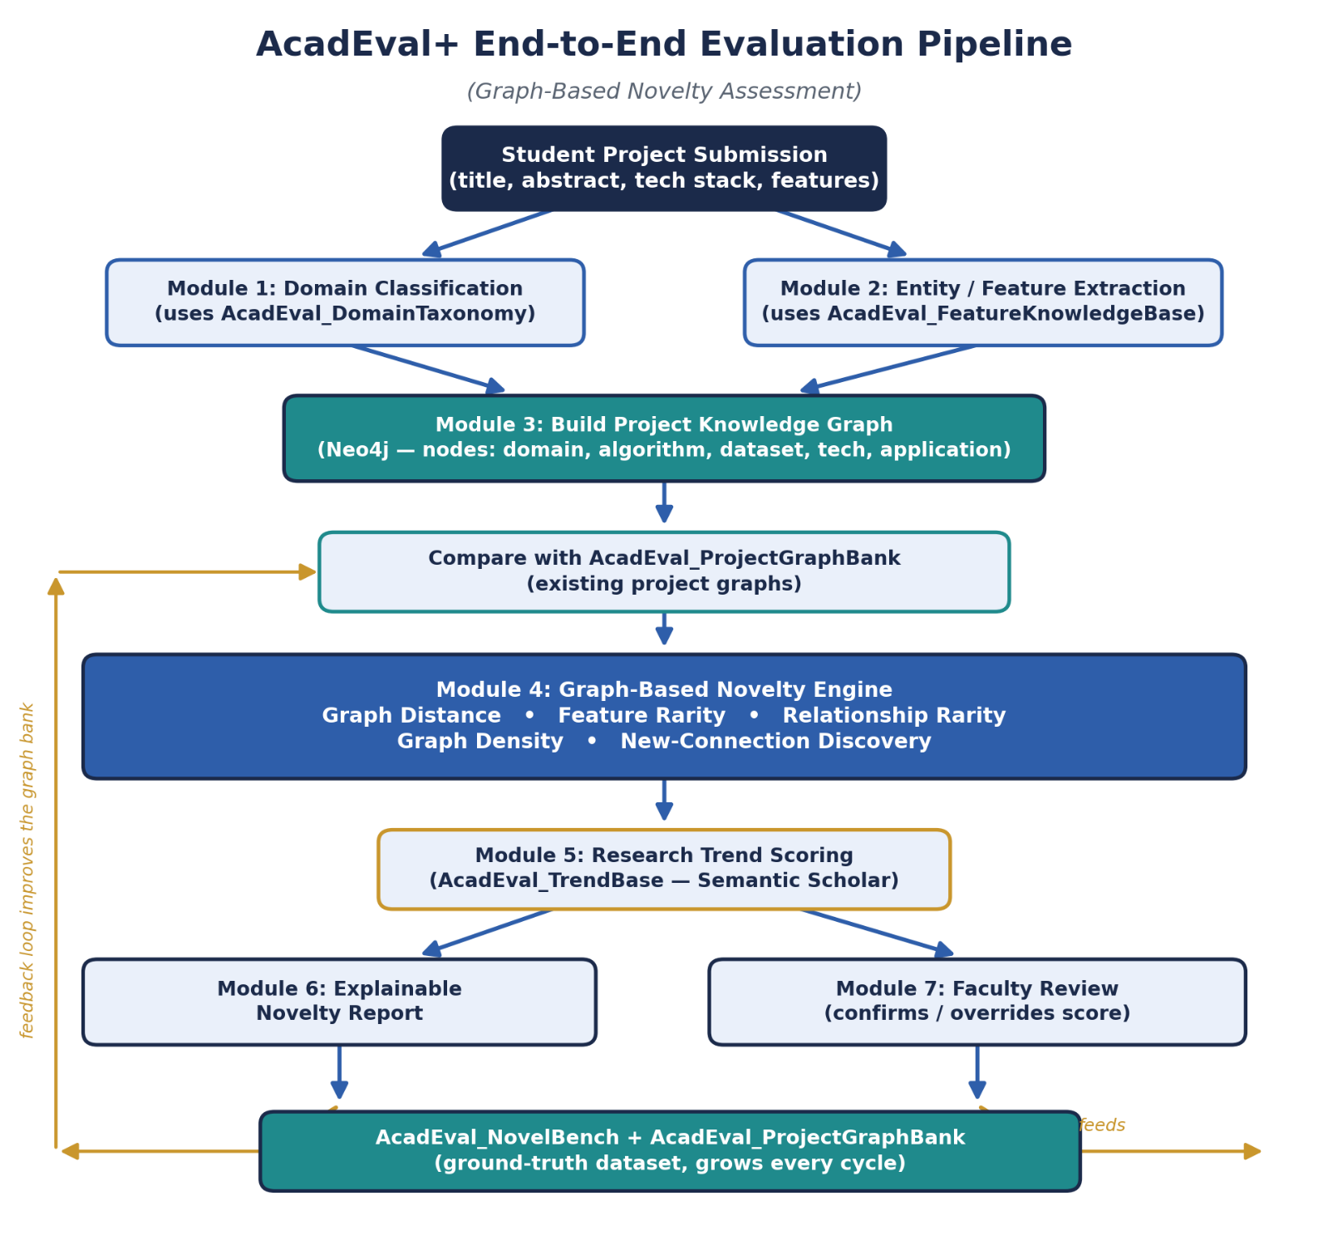

5 Core Research Contribution: Graph-Based Novelty Assessment

Why Not Manual Weighted Scoring
The obvious, simple way to compute novelty is a weighted formula, for example:
Novelty = 40% Similarity + 30% Features + 20% Trend + 10% Faculty Score
The problem is that there is no scientific justification for these particular numbers — why 40%, why not 35%, and do the same weights even make sense across every department? A reviewer will ask exactly this question, and "it seemed reasonable" is not a defensible answer. AcadEval+ avoids this entirely by deriving novelty from graph structure instead of hand-picked percentages.

What Is a Project Knowledge Graph
Instead of storing a proposal as a paragraph of text, AcadEval+ converts it into a small graph. Take the example: "AI-Based Smart Attendance using Face Recognition and Edge Computing." Rather than storing this as a title string, the system extracts and connects its parts — domain, sub-domain, algorithm, technology, application, dataset, and evaluation metric — as shown below.

Figure 1. A project becomes structured knowledge — a small graph — instead of a plain-text description.

How Graphs Reveal Similarity That Text Hides
This structural view is what makes the method powerful. Two proposals with very different wording can turn out to have nearly identical graphs, and two proposals with similar-sounding titles can turn out to connect to completely different concepts. For example, "Deep Learning Attendance System" and "Vision-based Student Presence Monitoring" read as different phrases, but both graphs resolve to the same chain: Attendance → Computer Vision → Face Recognition. Comparing the graphs catches this real similarity that a plain text or keyword comparison would miss.

Exactly How the Graph Is Built — Node Types, Edge Types & Schema
This is the concrete data model behind Section 5.2 — the actual node labels, relationship types, and properties stored in Neo4j. Every project, without exception, is ingested through this same schema.

Node types

Node Label | Represents | Key Properties
Project | One student proposal / submission | id, title, abstract, submitted_at, embedding (vector)
Domain | A top-level field, e.g. “Artificial Intelligence” | name, acm_code
Subdomain | A field within a domain, e.g. “Computer Vision” | name, parent_domain
Algorithm | A named method or model, e.g. “FaceNet”, “CNN” | name, category, first_seen_year
Technology | A platform/tool, e.g. “Edge Computing”, “Firebase” | name, category
Dataset | A named data source, e.g. “LFW”, “PlantVillage” | name, source_url, size
Application | The real-world use case, e.g. “Attendance” | name, sector
Metric | The evaluation measure, e.g. “Accuracy”, “F1-score” | name

Relationship (edge) types

Relationship | From → To | Meaning / Properties
HAS_DOMAIN | Project → Domain | assigned by Module 1
HAS_SUBDOMAI N | Project → Subdomain | assigned by Module 1
SUBDOMAIN_OF | Subdomain → Domain | static taxonomy structure, loaded once from AcadEval_DomainTaxonomy
USES_ALGORITH M | Project → Algorithm | properties: confidence (0-1), extracted_from (title/abstract)
USES_TECHNOLO GY | Project → Technology | properties: confidence
USES_DATASET | Project → Dataset | -
TARGETS_APPLIC ATION | Project → Application | -
EVALUATED_BY | Project → Metric | properties: reported_value (if known)
SIMILAR_TO | Project → Project | derived/cached edge: properties distance, computed_at — written by the novelty engine, not by ingestion
Note the last row: SIMILAR_TO is not created at ingestion time. It is a derived edge written later, once the Graph-Based Novelty Engine (Section 5.6) computes graph distances — this keeps the raw ingested facts (what a project actually uses) cleanly separate from computed results (how similar it turned out to be).

The ingestion script — how a submission actually becomes graph nodes and edges
When Module 2 (entity extraction) finishes, it hands off a structured JSON object per project. That JSON is what actually drives graph construction:
{
"project_id": "P-2041",
"title": "AI-Based Smart Attendance using Face Recognition and Edge Computing", "domain": "Artificial Intelligence",
"subdomain": "Computer Vision",
"algorithms": [{"name": "FaceNet", "confidence": 0.94}], "technologies": [{"name": "Edge Computing", "confidence": 0.88}], "datasets": [{"name": "LFW"}],
"application": "Attendance", "metrics": [{"name": "Accuracy"}]
}
This JSON is passed straight into a parameterised Cypher ingestion query, run once per project through the Neo4j Python driver:
MERGE (p:Project {id: $project_id})
SET p.title = $title, p.abstract = $abstract, p.submitted_at = datetime()

MERGE (d:Domain {name: $domain}) MERGE (p)-[:HAS_DOMAIN]->(d)

MERGE (sd:Subdomain {name: $subdomain}) MERGE (sd)-[:SUBDOMAIN_OF]->(d)
MERGE (p)-[:HAS_SUBDOMAIN]->(sd)

WITH p
UNWIND $algorithms AS algo
MERGE (a:Algorithm {name: algo.name})
ON CREATE SET a.category = algo.category, a.first_seen_year = date().year MERGE (p)-[:USES_ALGORITHM {confidence: algo.confidence}]->(a)

WITH p
UNWIND $technologies AS tech
MERGE (t:Technology {name: tech.name})
MERGE (p)-[:USES_TECHNOLOGY {confidence: tech.confidence}]->(t)

WITH p
UNWIND $datasets AS ds
MERGE (d2:Dataset {name: ds.name}) MERGE (p)-[:USES_DATASET]->(d2)

MERGE (app:Application {name: $application}) MERGE (p)-[:TARGETS_APPLICATION]->(app)
The MERGE keyword is the important detail: if 50 earlier projects already used “CNN”, this query reuses the same Algorithm node instead of creating 50 duplicates. That shared-node structure is exactly what lets the rarity and density signals below be computed by simply counting how many Project nodes connect to a given entity node.

Worked example — same query, two different projects
Running this ingestion query for Project A (“CNN → Plant Disease → Leaf Dataset”) and Project B (“CNN → Plant Disease → PlantVillage”) produces two separate Project nodes that both MERGE onto the same Algorithm(“CNN”) node and the same Application(“Plant Disease”) node, but connect to two different Dataset nodes. Project C (“Vision Transformer → Plant Disease → PlantVillage”) MERGEs onto the same Application and Dataset nodes as Project B, but creates a brand-new Algorithm(“Vision Transformer”) node. This is precisely the structure the novelty engine below reads to tell Project C apart from A and B.

The Five Components of the Graph-Based Novelty Engine — What They Measure
Novelty is evaluated from five independent, explainable graph characteristics, not a single blended score:

Component 1 — Graph Distance
How far is this project's graph from the graphs of existing projects? A near-identical graph means low novelty; a graph with new relationships pulls it further from the crowd, meaning higher novelty.

Component 2 — Feature Rarity
Some parts are common (a plain CNN), some are less common (a Vision Transformer), and some combinations are rare (Vision Transformer + Edge AI + Attendance together). Rare individual features raise the novelty score.

Component 3 — Relationship Rarity
It's not just which features appear, but which pairs of features appear together. If 100 existing projects connect CNN → Plant Disease but only one connects Transformer → Plant Disease, that specific relationship is rare — and rare relationships raise novelty.

Component 4 — Graph Density
A crowded neighborhood (500 nearby "Plant Disease" projects) signals low novelty for anything landing in it. A sparse neighborhood (only 2 projects near "Quantum Computing + Agriculture") signals higher novelty for anything landing there.

Component 5 — New-Connection Discovery
Sometimes a proposal creates a link between two concepts that have simply never been connected before in the graph — for example, connecting Edge AI to Healthcare and Transformer to Agriculture is known, but no existing project connects Transformer + Healthcare Edge AI. When the graph discovers a brand-new path like this, it is one of the strongest signals of genuine novelty.
Section 7.4 gives the exact Cypher / Neo4j Graph Data Science (GDS) calls and formulas used to compute each of these five signals in code.

Open Research Questions to Resolve Before Implementation
Before writing production code, three questions need a deliberate, documented answer — and answering them well is itself part of the research contribution:
  - How should the Project Knowledge Graph ontology be designed? — the node/edge schema in Section 5.4 is a first draft; it should be reviewed against a larger sample of real proposals before being locked in.
  - Which graph algorithms best estimate novelty? — candidates include graph edit distance, node embedding similarity (Node2Vec / FastRP), clustering coefficient / community detection, centrality measures, and link prediction (Adamic-Adar, common neighbors) — see Section 7.4 for the specific choice made for each signal.
  - How will the novelty score be validated against expert opinion? — for example, Spearman/Pearson rank correlation against faculty ratings, or building a small labeled benchmark (NovelBench) specifically for this purpose.
Getting this module right — with a well-defined graph model, justified algorithm choices, and a solid evaluation strategy
— is the heart of the project. Once it is solid, the surrounding modules (trend scoring, reporting, the web platform) become comparatively straightforward to build around it.

6 System Workflow — End-to-End Pipeline

The diagram below shows the full journey of a submitted project, from raw text to a faculty-validated, explainable novelty report, and shows where each dataset and module plugs in.

Figure 2. End-to-end AcadEval+ pipeline: from submission to graph construction, novelty scoring, and the faculty feedback loop.

In short: a submission is classified into a domain, its entities are extracted, a Project Knowledge Graph is built and compared against every existing graph in AcadEval_ProjectGraphBank, five graph signals plus a research-trend signal are combined into an explainable novelty report, and faculty review closes the loop by feeding validated scores back into the graph bank and NovelBench — improving the system with every evaluation cycle.

7 Module-by-Module Explanation & Real Implementation Plans

This section gives a concrete, buildable implementation plan for every module — not just what each one does, but the actual schema, code, prompts, and formulas needed to build it, using the existing React + FastAPI repository as the base.

Module 1 — Domain & Sub-domain Classification
What it is: assigns every project to a domain and sub-domain (e.g. Artificial Intelligence → Computer Vision), using AcadEval_DomainTaxonomy.
Why it matters: without domain scoping, the system would compare an ECG project against a blockchain project — a meaningless comparison. Domain scoping keeps every novelty judgment relevant.

Data model
AcadEval_DomainTaxonomy is stored as a plain JSON/YAML tree first, then loaded into Neo4j as Domain/Subdomain nodes (Section 5.4). Each leaf entry looks like:
{
"domain": "Artificial Intelligence", "acm_code": "I.2",
"subdomains": [
{ "name": "Computer Vision", "keywords": ["image", "face", "detection", "CNN"] },
{ "name": "NLP", "keywords": ["text", "language", "transformer", "BERT"] }
]
}

Classification pipeline — step by step
- Build the taxonomy file (~100-300 leaf entries) from ACM Computing Classification, IEEE taxonomies, GitHub Topics, and manual curation.
- Load it into Neo4j once, at setup time, using a small loader script that creates Domain/Subdomain nodes and SUBDOMAIN_OF edges.
- For every incoming project, embed the abstract using a Sentence-Transformers model (e.g. all-MiniLM-L6-v2), and pre-compute an embedding for every taxonomy node's name + keyword list.
- Score every taxonomy leaf by cosine similarity to the project embedding and keep the top match; this is a nearest-neighbour lookup, not a trained classifier, so it works even with very few labeled examples.
- If the top-2 scores are within 0.05 of each other (an ambiguous case), send both candidates to an LLM tie-breaker prompt (below) instead of guessing.
- Store the winning Domain/Subdomain as a HAS_DOMAIN / HAS_SUBDOMAIN edge on the Project node (Section 5.4).
- Validate on ~50 faculty-reviewed projects — track top-1 accuracy — before trusting the classifier downstream.

Reference implementation — embedding-based classifier
from sentence_transformers import SentenceTransformer, util

model = SentenceTransformer("all-MiniLM-L6-v2")
taxonomy_embeddings = model.encode(taxonomy_leaf_texts) # pre-computed once, cached

def classify_domain(abstract: str): query_emb = model.encode(abstract)
scores = util.cos_sim(query_emb, taxonomy_embeddings)[0] top2 = scores.topk(2)
if (top2.values[0] - top2.values[1]) < 0.05:
return llm_tiebreak(abstract, candidates=top2.indices) return taxonomy_leaves[top2.indices[0]]

LLM tie-breaker prompt (used only for ambiguous cases)
SYSTEM: You are classifying a student project abstract into exactly one taxonomy leaf. Choose the single best match from the candidates given. Return only the taxonomy leaf name, nothing else.

USER: Abstract: "{abstract}"
Candidates: ["Computer Vision", "Robotics"]

Module 2 — Entity / Feature Extraction
What it is: pulls structured entities — algorithms, datasets, technologies, application, metrics — out of free-text proposals, using AcadEval_FeatureKnowledgeBase as the vocabulary.
Why it matters: this is what turns unstructured text into the building blocks the graph is made of (Section 5.4). Without it, there is nothing to build a graph from.

Data model
AcadEval_FeatureKnowledgeBase (~300-500 curated entries) is a simple table:

Field | Example | Purpose
name | "FaceNet" | canonical entity name, matched against text
category | "Algorithm" | maps to a graph node label
aliases | ["Face-Net", "face net"] | spelling/casing variants for matching
first_seen_year | 2015 | used later for trend context

Extraction pipeline — step by step
- Auto-generate a spaCy EntityRuler pattern file directly from the FeatureKnowledgeBase name/alias columns — one pattern entry per known entity, tagged with its category.
- Run the abstract through spaCy: the base model handles generic NER (organizations, misc terms), the EntityRuler catches every known FeatureKnowledgeBase term.
- Collect spans spaCy did not match to any known entity — these are candidate new features.
- Send those unmatched spans to an LLM verification prompt (below), asking it to either map the phrase to the closest existing entry or confirm it as a genuinely new feature.
- Route confirmed new-feature candidates to a manual review queue; once approved, add them to FeatureKnowledgeBase so future extractions catch them automatically.
- Emit the final structured JSON (shown in Section 5.4) that feeds directly into the graph ingestion script.

EntityRuler pattern example
import spacy
nlp = spacy.load("en_core_web_sm")
ruler = nlp.add_pipe("entity_ruler", before="ner")

patterns = [
{"label": "ALGORITHM", "pattern": "FaceNet"},
{"label": "ALGORITHM", "pattern": [{"LOWER": "face"}, {"LOWER": "net"}]},
{"label": "TECHNOLOGY", "pattern": "Edge Computing"},
{"label": "DATASET", "pattern": "LFW"},
]
ruler.add_patterns(patterns) # patterns generated automatically from FeatureKnowledgeBase

LLM verification prompt (for spans the ruler could not match)
SYSTEM: You map free-text phrases from student project abstracts to a known feature vocabulary. If the phrase clearly matches an existing entry, return its exact name. If it does not match anything in the list, return NEW_FEATURE and a short category guess.

USER: Phrase: "liveness detection"
Known entries near this category: ["Face Recognition", "Anti-Spoofing"]

Module 3 — Project Knowledge Graph Construction (operational plan)
What it is: the running service that takes Module 2's structured JSON and permanently writes it into Neo4j as the schema defined in Section 5.4.
Why it matters: this is the service boundary between “we extracted some data” and “this project is now part of the searchable graph bank.” The exact node/edge schema and the full Cypher ingestion script are given in Section 5.4 — this subsection covers what it takes to run that reliably in production.

Implementation steps
- Apply schema constraints once at setup, so MERGE calls stay fast and duplicate-free as the graph grows (example below).
CREATE CONSTRAINT project_id IF NOT EXISTS FOR (p:Project) REQUIRE p.id IS UNIQUE;
CREATE CONSTRAINT algo_name IF NOT EXISTS FOR (a:Algorithm) REQUIRE a.name IS UNIQUE; CREATE CONSTRAINT tech_name IF NOT EXISTS FOR (t:Technology) REQUIRE t.name IS UNIQUE; CREATE CONSTRAINT dataset_name IF NOT EXISTS FOR (d:Dataset) REQUIRE d.name IS UNIQUE; CREATE CONSTRAINT app_name IF NOT EXISTS FOR (a:Application) REQUIRE a.name IS UNIQUE;
- Wrap the Section 5.4 ingestion Cypher in a single FastAPI endpoint (POST /build-graph) that runs inside one Neo4j transaction per project, so a partially-extracted project never leaves a half-written graph.
- Backfill the existing AcadEval_Corpus through the same endpoint once, in a batch script, so historical projects and new submissions end up in exactly the same graph shape.
- Log every ingestion (project_id, node/edge counts written) so a broken extraction can be traced back to a specific submission.
- Visually spot-check new projects in Neo4j Browser (MATCH (p:Project {id: $id})-[r]-(n) RETURN p, r, n) during early testing.

Module 4 — Graph-Based Novelty Engine (the core research module)
What it is: computes the actual novelty score from the graph, combining the five signals introduced in Section 5.5, using Neo4j's Graph Data Science (GDS) library.
Why it matters: this replaces the old arbitrary weighted formula. Each signal below is independently computable and independently testable — exactly what a reviewer wants to see.

Step 0 — project a GDS graph once per scoring run
CALL gds.graph.project( 'acadEvalGraph',
['Project','Domain','Subdomain','Algorithm','Technology','Dataset','Application','Metric'],

['HAS_DOMAIN','HAS_SUBDOMAIN','USES_ALGORITHM','USES_TECHNOLOGY','USES_DATASET','TARGETS_APPLI CATION','EVALUATED_BY']
)

Signal 1 — Graph Distance (node embeddings)
Generate a structural embedding for every Project node with FastRP, then compare the new project's vector to every existing one:
CALL gds.fastRP.mutate('acadEvalGraph', { embeddingDimension: 128,
randomSeed: 42, mutateProperty: 'embedding'
})

# in Python, after streaming embeddings out via gds.graph.nodeProperty.stream: from sklearn.metrics.pairwise import cosine_similarity
sims = cosine_similarity([new_project_vec], existing_project_vecs)[0] graph_distance = 1 - sims.max() # nearest existing project defines the distance

Signal 2 — Feature Rarity
For every entity node the new project connects to, rarity is the inverse of how many other projects already connect to it:
MATCH (e)<-[:USES_ALGORITHM|USES_TECHNOLOGY|USES_DATASET]-(proj:Project)
WHERE elementId(e) = $entity_id RETURN count(DISTINCT proj) AS degree
rarity(entity) = 1 / (degree + 1); feature_rarity_score(project) = average of rarity(entity) across all its entity nodes.

Signal 3 — Relationship Rarity
Same idea, one level up — how many projects share this exact entity pair:
MATCH (p:Project)-[:USES_ALGORITHM]->(a:Algorithm {name:$algo}), (p)-[:TARGETS_APPLICATION]->(app:Application {name:$app})
RETURN count(DISTINCT p) AS pair_count
relationship_rarity(pair) = 1 / (pair_count + 1); averaged across every (algorithm, application), (technology, application), etc. pair the new project has.

Signal 4 — Graph Density

Use GDS local clustering coefficient around the project's domain neighbourhood: a crowded, tightly-interconnected neighbourhood scores high (low novelty); a sparse one scores low (high novelty).
CALL gds.localClusteringCoefficient.stream('acadEvalGraph') YIELD nodeId, localClusteringCoefficient
RETURN gds.util.asNode(nodeId).name AS node, localClusteringCoefficient ORDER BY localClusteringCoefficient DESC

Signal 5 — New-Connection Discovery (link prediction)
Check whether the specific entity pair this project introduces has ever co-occurred anywhere in the graph, using a common-neighbours / Adamic-Adar score between the two entity nodes:
MATCH (a:Algorithm {name:$algo}), (b:Application {name:$app}) RETURN gds.alpha.linkprediction.adamicAdar(a, b) AS aa_score
An aa_score of 0 (no common neighbours anywhere in the graph) combined with pair_count = 0 from Signal 3 is the strongest possible signal that this exact combination has never been proposed before.

Combining the five signals
This is intentionally not a fixed percentage formula (see Section 5.1). Two honest, defensible options, worth reporting and comparing in the paper:
- Documented composite index (v1): an unweighted or simply-justified combination (e.g. average of the five normalized signals), used until enough faculty-labeled data exists.
- Learned model (v2): once AcadEval_FacultyEvaluation has enough rows, train a small regression model (Ridge regression or a shallow gradient-boosted tree — chosen deliberately because the dataset will be small) with the five signals as input features and the faculty score as the target; report its coefficients as the paper's evidence for which signals matter most.

Module 5 — Research Trend Scoring
What it is: adds a real-world signal — is this topic currently rising or declining in the research literature — using AcadEval_TrendBase.
Why it matters: a rare-but-declining topic is different from a rare-and-emerging one; the trend signal makes the novelty judgment richer and more current.

Implementation steps
- Call the Semantic Scholar Graph API for each taxonomy leaf topic and/or extracted algorithm/technology name.
- Store yearly paper counts and citation counts in AcadEval_TrendBase (topic, year, paper_count, citation_count).
- Compute a trend score as the year-over-year growth rate of paper count over the last 3-5 years.
- Attach the trend score as a property on the matching Domain/Technology node so the novelty report (Module 6) can display it as context.

Semantic Scholar API call
GET https://api.semanticscholar.org/graph/v1/paper/search? query=vision+transformer+agriculture&fields=year,citationCount&limit=100

# aggregate the JSON response by year, then:
trend_score = (papers_last_year - papers_3_years_ago) / max(papers_3_years_ago, 1)

Module 6 — Explainable Novelty Report
What it is: turns the five graph signals plus the trend score into a plain-language report a guide can actually read and question.
Why it matters: explainability is both a research requirement (reviewers will ask "why did it get this score?") and a practical one — faculty will not trust a black-box number.

Report JSON schema
{
"project_id": "P-2041", "novelty_band": "High", "signals": {
"graph_distance": 0.81,
"feature_rarity": 0.64,
"relationship_rarity": 0.90,
"graph_density": 0.22, "new_connection": true
},
"explanation": [
"No existing project connects Vision Transformer to Attendance.",
"Only 2 projects share this Application in the last 3 years (sparse neighbourhood)."
],
"similar_projects": ["P-1187", "P-0933", "P-1502"],
"trend": { "topic": "Vision Transformer", "trend_score": 1.8 }
}

Implementation steps
- Generate this JSON server-side, right after Module 4 and Module 5 both return their results for a project.
- Convert each signal into one plain-language explanation line using a small template per signal (not free-form LLM text, so explanations stay consistent and auditable).
- Render the JSON in the web dashboard: an overall band, a breakdown chart of the five signals, and a side-by-side list of the most similar existing projects.

Module 7 — Faculty Review & Feedback Loop
What it is: lets faculty confirm or override the system's score.
Why it matters: this produces AcadEval_FacultyEvaluation, the ground truth that validates — or disproves — the whole method. Without it, there is no evidence to publish.

Database schema (PostgreSQL)
CREATE TABLE faculty_evaluation ( id SERIAL PRIMARY KEY,
project_id VARCHAR REFERENCES projects(id), faculty_id VARCHAR NOT NULL,
system_score NUMERIC,

faculty_score NUMERIC NOT NULL, comment TEXT,
reviewed_at TIMESTAMP DEFAULT now()
);

Implementation steps
- Build a review screen showing the Module 6 report, with a numeric novelty rating field (1-10) plus an optional comment for faculty.
- On submit, insert a row into faculty_evaluation via POST /faculty-review.
- Run a scheduled job that recomputes the correlation between system_score and faculty_score as the table grows — this becomes a core evaluation result for the paper (example below).
from scipy.stats import spearmanr
corr, p_value = spearmanr(df['system_score'], df['faculty_score']) print(f"Spearman correlation: {corr:.2f} (p={p_value:.3f})")
- Feed confirmed/overridden scores back to enrich AcadEval_NovelBench, the final research dataset.

Module 8 — Web Platform
What it is: the deployed, demoable product — the practical, gradeable deliverable that sits on top of the research engine.
Why it matters: a working prototype is what makes the project concrete for a guide and usable in a real pilot.

API surface

Endpoint | Method | Does
/submit | POST | accepts a new proposal (title, abstract, tech stack)
/classify | POST | runs Module 1, returns domain/subdomain
/extract-entities | POST | runs Module 2, returns structured JSON (Section 5.4)
/build-graph | POST | runs Module 3, writes nodes/edges into Neo4j
/novelty-score | GET | runs Module 4, returns the five signals
/trend-score | GET | runs Module 5, returns trend data
/report | GET | runs Module 6, returns the explainable JSON report
/faculty-review | POST | runs Module 7, stores the faculty rating

Implementation steps
- Frontend: React + TypeScript (existing skeleton) — a submission form, a results dashboard rendering the Section 7.6 report, and a faculty review screen.
- Backend: FastAPI implementing the endpoints above, each one a thin wrapper around the corresponding module.
- Storage: PostgreSQL for tabular datasets (Corpus, Taxonomy, FeatureKB, FacultyEvaluation, NovelBench); Neo4j for ProjectGraphBank and all graph operations.
- Deployment: Dockerize both services; host the frontend on Vercel/Netlify and the backend + Neo4j on Render/Railway or a college server.

8 Dataset Design — The Updated AcadEval+ Data Roadmap

Moving to a graph-based design changes the dataset roadmap. AcadEval_SimBench and AcadEval_FeatureSet from the earlier plan are no longer needed as separate manually-labeled datasets — pairwise similarity now comes directly out of the Graph-Based Novelty Engine (Section 7.4), and feature sets are captured automatically as part of every project's graph. The updated roadmap has seven datasets:
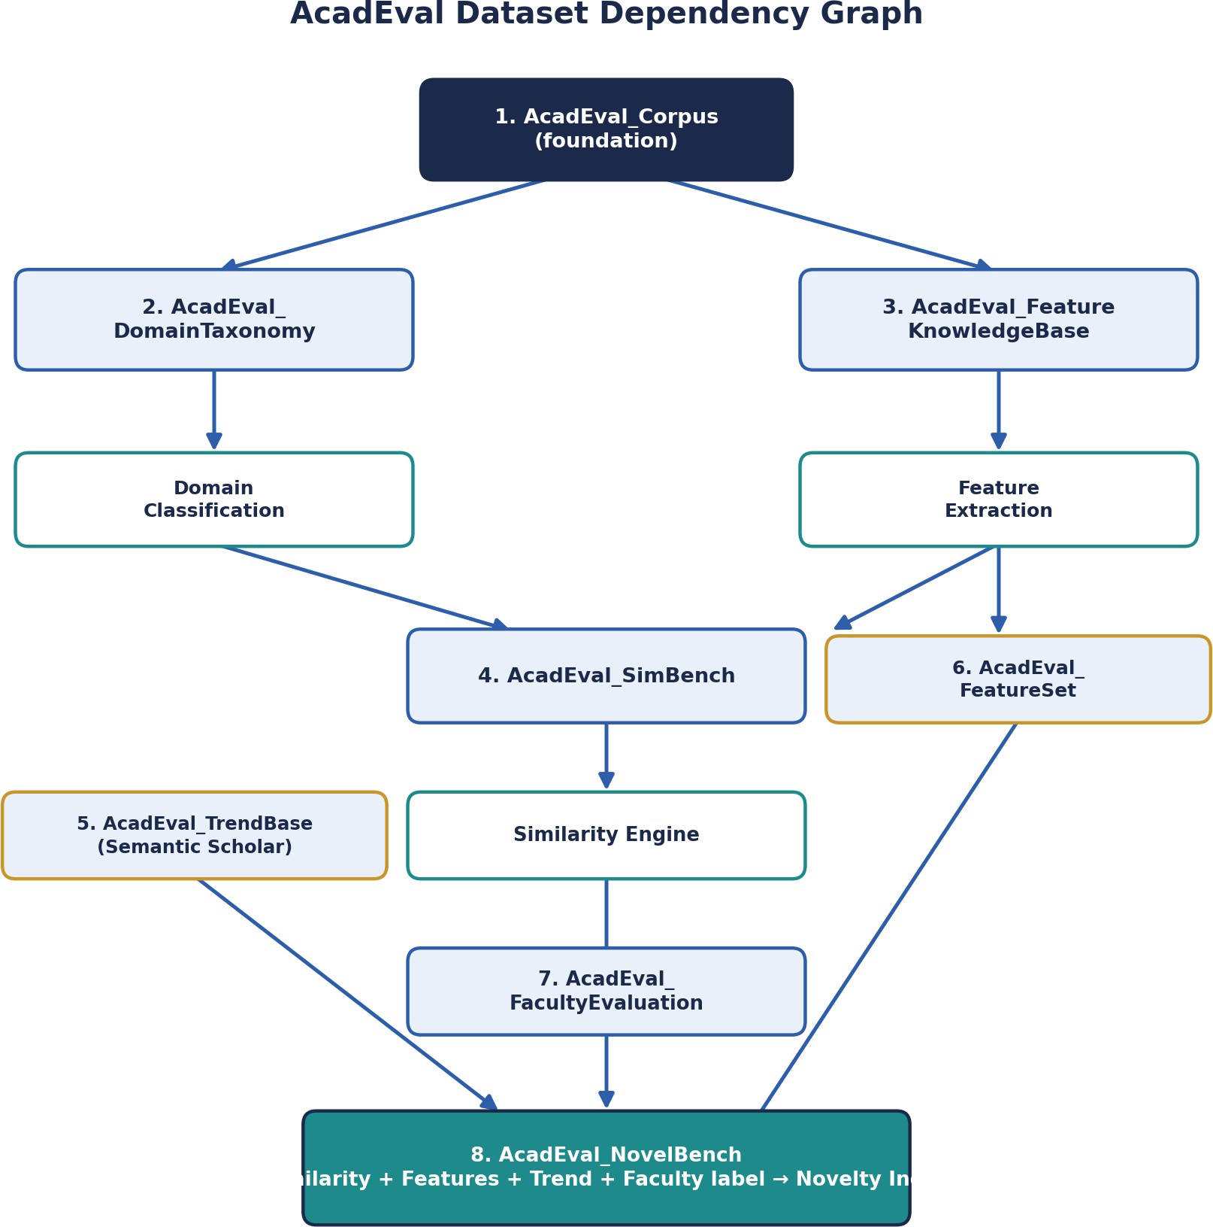

# | Dataset | Purpose | Depends On | Status
1 | AcadEval_Corpus | Master repository of raw project proposals — foundation for everything else. | None | Running
2 | AcadEval_DomainTaxonomy | Structured domain/sub-domain tree used by Module 1 for classification. | Corpus | Planned
3 | AcadEval_FeatureKnowledgeBase | Catalog of ~300-500 features with category, difficulty, rarity stats — powers Module 2. | Corpus | Planned
4 | AcadEval_ProjectGraphBank | The Project Knowledge Graph for every project (Neo4j) — the core structural dataset that everything else compares against. | Corpus + Taxonomy + Feature KB | Planned
5 | AcadEval_TrendBase | Topic / year / paper count / citation count from Semantic Scholar — feeds Module 5. | Semantic Scholar API | Planned
6 | AcadEval_FacultyEvaluation | Faculty-given novelty ratings — the ground truth used to validate the Graph-Based Novelty Engine. | Faculty input | Planned
7 | AcadEval_NovelBench | Fusion of graph signals + trend score + faculty label — the final research/validation dataset. | All previous datasets | Planned

Figure 3. Updated dataset dependency graph — AcadEval_ProjectGraphBank is now the central structural dataset that both the novelty engine and the feedback loop revolve around.

Why SimBench and FeatureSet were dropped: SimBench existed to have faculty manually label pairs of projects as "similar" or "different" so a similarity engine could be calibrated. In the graph-based design, similarity is instead computed directly from graph distance (Section 7.4), and FacultyEvaluation still provides the validation signal — so a separate pairwise-labeling dataset is no longer necessary. FeatureSet was an auto-extracted per-project feature list; this is now inherent in every project's graph inside ProjectGraphBank, so keeping it as a separate dataset would just duplicate data.

9 Existing Tools in This Space (Free, Paid & Enterprise/Patent-Grade)

A fair pitch to a guide is not "nothing like this exists" — it is "here is exactly what exists, and here is precisely what none of it does." The table below includes everyday plagiarism/trend tools and the professional, enterprise-grade AI novelty-checking tools used in the patent world, since those are the closest thing to "AI + novelty" that currently exists commercially.

Category | Tool | Pricing | What it actually checks
Text plagiarism | Turnitin / iThenticate | Paid (institutional license) | Text similarity vs. a proprietary database of papers, web pages, and student submissions.
Text plagiarism | Copyleaks | Freemium | Text similarity plus basic AI-generated-text detection.
Text plagiarism | Quetext / DupliChecker | Free (limited) | Web-search-based text matching with shallow database coverage.
Source code plagiarism | MOSS (Stanford) / JPlag | Free / open-source | Structural similarity between source-code submissions within a batch.
Source code plagiarism | Codequiry | Paid | Code and web similarity checks for programming assignments.
Research trend / literature | Semantic Scholar | Free (API) | Paper search, citation graphs, topic metadata — no project-level scoring.
Research trend / literature | Connected Papers / ResearchRabbit | Freemium | Visualizes related papers; built for literature review, not project evaluation.
Patent novelty (enterprise) | IPRally AI Agent | Paid / enterprise (free trial available) | An agentic AI tool for patent professionals and R&D teams: it reads an invention disclosure, identifies key claim features, searches over 120 million patents using a graph-based AI trained on patent-examiner citations, and produces a structured novelty/prior-art report mapping results to each claim.
Patent novelty (enterprise) | XLSCOUT Novelty Checker LLM | Paid / enterprise | An LLM- and generative-AI-based tool that searches patent and non-patent literature to produce a ranked list of prior-art references and an automated novelty report, aimed at inventors, R&D teams, and patent attorneys assessing patentability before filing.
Project ideation | GitHub Topics / Explore, IEEE/ACM digital libraries | Free | Manual browsing for inspiration; no similarity score or novelty metric is returned.
The pattern across every row: the academic tools compare finished text or code, the literature tools surface trends but not project-specific scores, and the professional tools — IPRally and XLSCOUT — are genuinely powerful AI novelty checkers, but they are purpose-built to search patents and non-patent legal/scientific literature for prior art relevant to a filed or about-to-be-filed invention. They are priced and designed for patent attorneys and enterprise R&D teams, not for a college guide evaluating a student's capstone idea against that college's own project history, and none of them build an explainable, domain-scoped knowledge graph calibrated against faculty judgment. That combination is the gap AcadEval+ targets.

10 How AcadEval+ Is Different — The Research Gap

Dimension | Existing tools (academic + enterprise) | AcadEval+
Unit of comparison | Whole document, source file, or patent claim set | Idea-level: a structured knowledge graph of domain, algorithms, tech, and application
Novelty method | Text/claim similarity search against a literature or patent database | Five explainable graph signals — distance, feature rarity, relationship rarity, density, new-connection discovery
Ground truth | None for academic tools; legal precedent for patent tools | Faculty-labeled AcadEval_FacultyEvaluation, used to calibrate and statistically validate the score
Domain scope | Not academic-project-specific; patent tools search global IP literature | Domain-scoped comparison via a structured taxonomy built for academic project categories
Feedback loop | Static — no learning from evaluator decisions | Faculty decisions feed back into ProjectGraphBank and NovelBench, improving the system over time
Target user & price point | Publishers/instructors (academic tools) or patent attorneys/enterprise R&D (IPRally, XLSCOUT) | Project guides and panels evaluating student capstone ideas, designed for a college budget
This is the one table to lead with if time with your guide is short: existing tools answer "has this text, code, or invention already been disclosed somewhere?"; AcadEval+ answers "is this specific student idea structurally new relative to our own project history, and how confident should we be in that judgment?"

11 Research Contribution — Path to a Publishable Paper

AcadEval+ has three independent, legitimate angles for publication, and they can be pursued in sequence rather than all at once.

Dataset contribution
The seven datasets, once built and cleaned, are themselves a citable contribution — particularly AcadEval_ProjectGraphBank and AcadEval_NovelBench, since no public dataset currently represents academic projects as knowledge graphs with faculty-validated novelty labels. This fits data-focused venues (Data in Brief, Scientific Data, or a dataset track at an education-technology conference).

Methodology contribution
The Graph-Based Novelty Engine itself — five explainable, graph-theoretically grounded signals combined into a novelty judgment, with the combination method itself treated as an open research question rather than an arbitrary formula
— is the strongest, most "paper-shaped" contribution: a proposed method, an ablation study (showing which signals matter most), and a validation against faculty scores.

Empirical / evaluation contribution
Correlating the graph-based novelty score against real faculty ratings (AcadEval_FacultyEvaluation) produces a quantitative result — e.g. a Pearson/Spearman correlation coefficient or inter-rater agreement between the system and faculty. This is what gives the paper statistical weight.

Suggested paper structure
- Title (working): "AcadEval+: A Graph-Based Novelty Assessment Framework for Academic Capstone Project Proposals"
- Introduction: the gap between document/patent-level prior-art tools and idea-level novelty evaluation for student projects (Sections 2, 9 &amp; 10, condensed).
- Related Work: the tools table in Section 9, framed as a literature and tool survey, including the enterprise patent-novelty tools.
- Dataset: description of the seven datasets, collection methodology, size, and validation (Section 8).
- Method: domain classification, entity extraction, graph construction, and the five-signal Graph-Based Novelty Engine (Section 7).
- Evaluation: correlation with faculty scores, an ablation study removing each signal in turn, and example case studies of correctly and incorrectly scored projects.
- Discussion &amp; Limitations: domain-coverage limits, the cold-start problem for brand-new domains, dependence on faculty-labeling quality.
- Conclusion &amp; Future Work: extending to other departments/institutions, plans for the deployed web platform.

12 Technology Stack Summary

A single reference table pulling together the technology choices made across Section 7:

Layer | Component | Technology
Frontend | Submission form + dashboard + faculty review screen | React + TypeScript + Vite (existing repo skeleton)
Backend API | Module endpoints | FastAPI (Python)
Tabular storage | Corpus, Taxonomy, Feature KB, FacultyEvaluation, NovelBench | PostgreSQL
Graph storage | ProjectGraphBank, taxonomy graph, novelty computations | Neo4j + Neo4j Graph Data Science (GDS) library
Entity extraction | Module 2 | spaCy (EntityRuler) + LLM verification pass
Domain classification | Module 1 | Sentence-Transformers embeddings + LLM tie-breaker
Graph algorithms | Module 4 | Node2Vec / FastRP embeddings, clustering coefficient, Adamic-Adar link prediction
External data | Module 5 | Semantic Scholar API
Deployment | Hosting | Docker; frontend on Vercel/Netlify, backend + Neo4j on Render/Railway or a college server

13 Publication Plan — Target Venues & Paper Types

Realistic targets, ordered roughly from fastest turnaround to most prestigious. Planning a conference paper first (faster review cycle, useful on a student timeline) and a journal submission once results and the dataset are more mature is a sensible sequence.

Venue Type | Examples | Why it fits
Student / regional conference | IEEE regional student conferences, college-hosted symposiums | Fast turnaround; a good first step to get reviewer feedback before a bigger submission.
Educational data mining  / Ed-tech | EDM conference, L@S (Learning at Scale), IEEE ICALT | Directly relevant audience studying academic evaluation and learning tools.
Applied AI / systems journal | IEEE Access, Springer journals in educational technology / applied computing | Open to systems + dataset + evaluation papers, moderate review timelines.
Graph / network science venue | Workshops on graph-based ML, applied network science tracks | Directly relevant to the core methodological contribution in Section 5.
Dataset-focused venue | Data in Brief, Scientific Data | Accepts dataset-only papers — a lower-effort separate publication from the seven AcadEval+ datasets.

14 Project Roadmap & Milestones

Phase | Milestone | Deliverable
Phase 1 (done) | AcadEval_Corpus built and running | Master dataset; repo skeleton (frontend + backend) working
Phase 2 | Build DomainTaxonomy & FeatureKnowledgeBase | ~100-300 domain entries; ~300-500 curated features
Phase 3 | Answer the three open research questions (Section 5.5) | Documented graph ontology, chosen algorithms, evaluation plan
Phase 4 | Build ProjectGraphBank + Graph-Based Novelty Engine v1 | Neo4j graph for every corpus project; first working novelty scores
Phase 5 | Build TrendBase and integrate trend scoring | Semantic Scholar pipeline feeding into the novelty report
Phase 6 | Collect FacultyEvaluation ground truth | Faculty ratings on a pilot batch of real project proposals
Phase 7 | Assemble NovelBench; run correlation & ablation studies | Validated novelty engine with statistical evidence
Phase 8 | Website launch (pilot) + manuscript & submission | Deployed dashboard for one department/batch; paper drafted per Section 11.4 and submitted to a venue from Section 13

15 How to Pitch This to Your Guide

A short, structured way to open the conversation, using exactly the material in this document:
- Open with the gap, not the tech: "Guides currently judge project novelty manually because no tool checks idea-level novelty for academic projects — the closest thing that exists (IPRally, XLSCOUT) is built for patent attorneys, not for us."
- Show the tools table (Section 9) so it is clear the homework has been done, including the professional, patent-grade tools.
- Show the difference table (Section 10) as the one-slide summary of the whole pitch.
- Lead with why it's research, not a website (Section 3): the graph-based method replaces an indefensible manual formula with an explainable, testable, network-science-grounded approach.
- Lead with the dataset, not the demo: the roadmap is already partly built (Corpus is running) — this de-risks the project because there is already something concrete on the table.
- Name the two deliverables explicitly: a working website (practical, gradeable, demoable) and a paper (what makes it worth the guide's time and name).
- Ask for what is needed: access to faculty for FacultyEvaluation labeling, a small pilot batch of real project proposals to test on, and sign-off on a target venue from Section 13.
The single sentence to lead with: "We already have a running corpus and a working app skeleton — what's missing from the research world isn't another plagiarism checker, it's an explainable, graph-based way to judge idea-level novelty for academic projects, and that is exactly what the Graph-Based Novelty Engine and the remaining datasets are for."

