**Assignment 2 – Mathematical Modelling**

Sanjayitha Raja

PES1201700560

EEE – 7B

Circuit chosen: Buck Converter connected to a DC Motor

Buck Converter Operation:

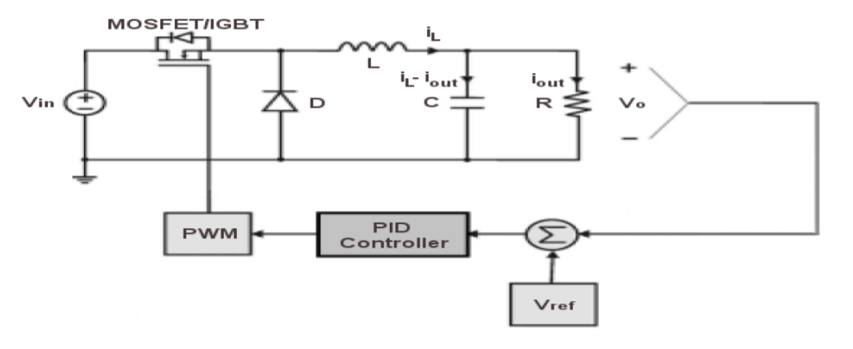

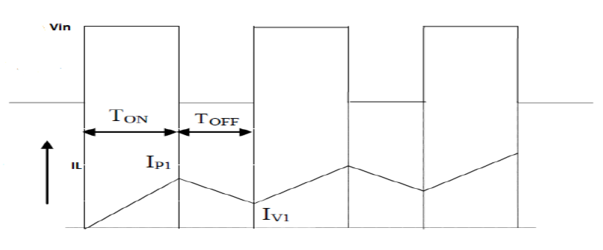

Equations primarily used:

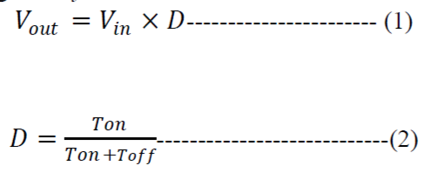

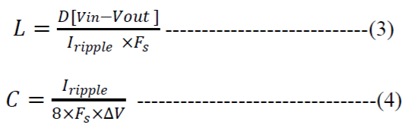

Where Vin = Input Voltage of the Buck Converter,

Vout = Output voltage,

D = Duty Cycle,

Fs = Switching Frequency

Continuous and Discontinuous Modes of Conduction:

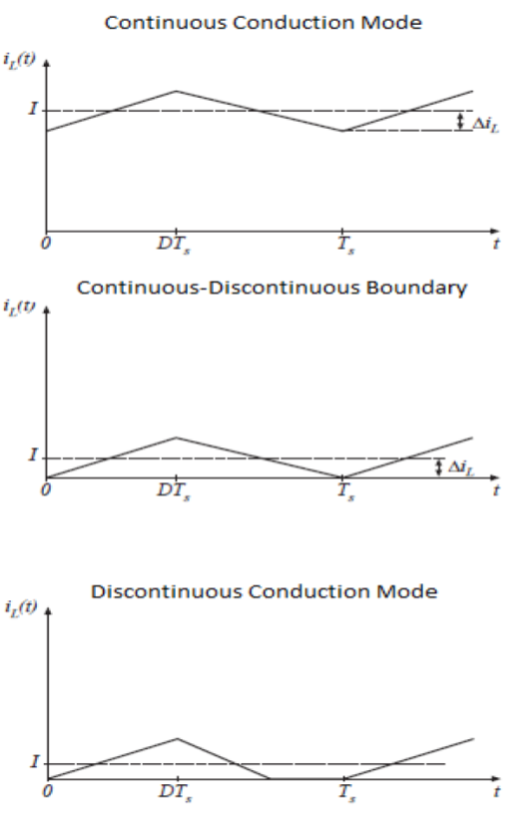

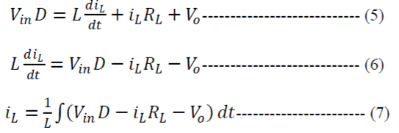

Where Vin= Input Voltage of the Buck Converter.

D=1 when Duty Cycle is ON and D=0 when Duty Cycle is OFF.

iL=Inductor Current

RL=Effective Series Resistance of Inductance

Vo=Output Voltage of the Buck Converter

L=Inductance Value in Henry

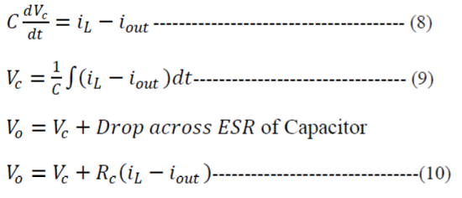

Where iout=Load Current,

C=Capacitance in Farad,

Vc=Voltage across Capacitor,

RC=Effective Series resistance of the Capacitor

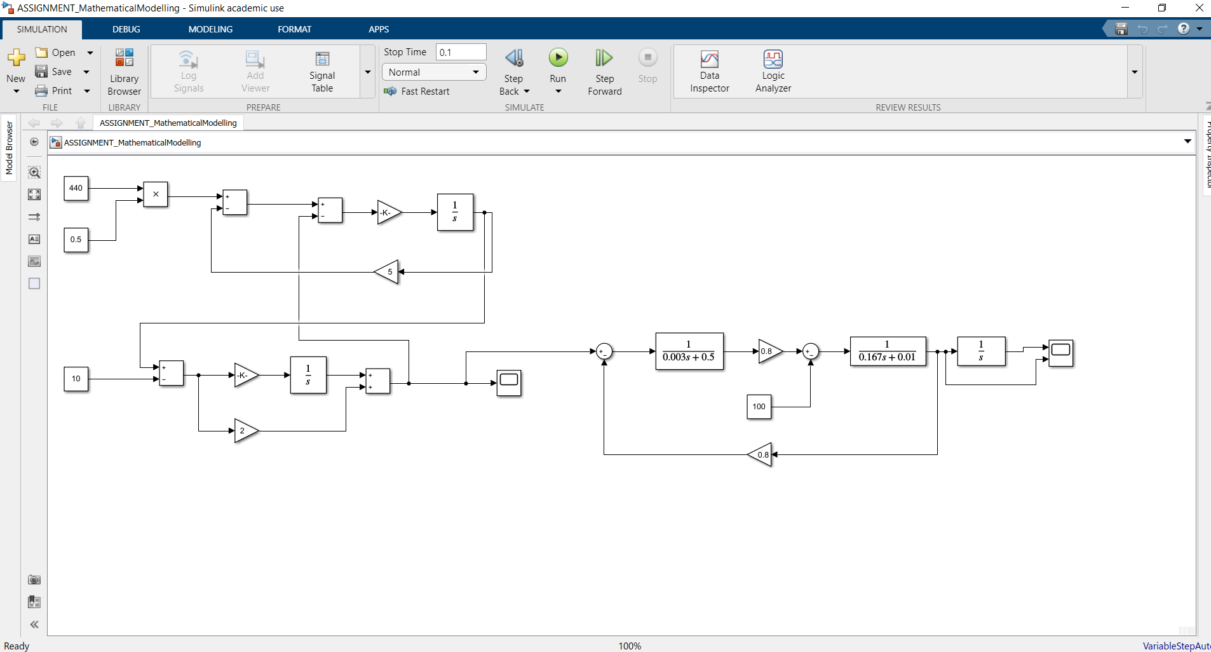Simulink Model:

DC Motor part

Buck Converter part

Buck Converter:

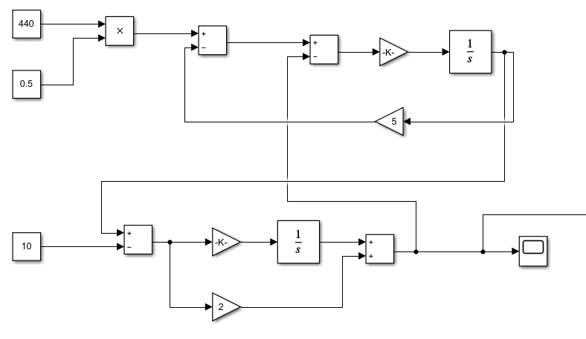

Voltage Output in Scope:

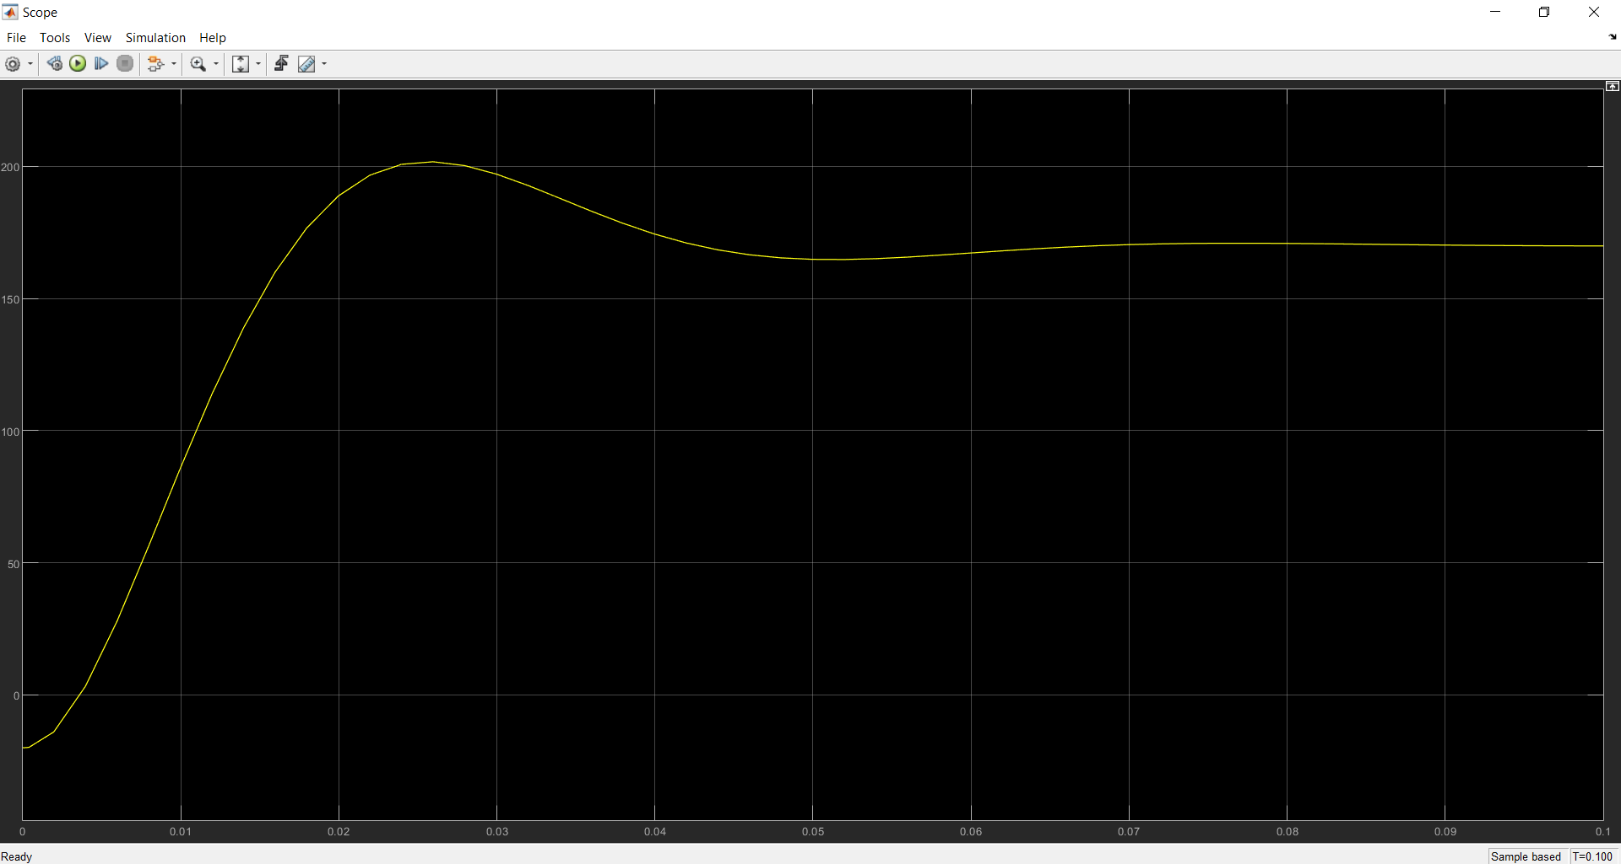

Speed and Distance Output in Scope:

