Game Design Document

Fill up the following document

1. Write the title of your project.

Run to the end!

1. What is the goal of the game?

Save your self from the temple monster and run till he dosen’t leave you.

1. Write a brief story of your game.

One day their was a devil who tried to take the diamond from the

temple monsters house and when he got cought he started running

and the monster wasn’t leaving him and running behind him.

1. Which are the playing characters of this game?

* Playing characters are the ones who respond to the user based on the input from the user.
* Cars, monkeys, dinos, wizards, etc., are the playing characters in the game.

|  |  |  |
| --- | --- | --- |
| Number | Character Name | What can this character do? |
| 1 | devil | Its controled by us |
| 2 |  |  |
| 3 |  |  |
| 4 |  |  |
| 5 |  |  |
| 6 |  |  |
| 7 |  |  |
| 8 |  |  |

1. Which are the Non-Playing Characters of this game?

* Non-Playing characters are the ones that don't have an action or behavior when the user interacts with the game.
* Hurdles, stones, bananas, coins, etc., are non-playing characters in the game.

|  |  |  |
| --- | --- | --- |
| Number | Character Name | What can this character do? |
| 1 | stones | If touched then you would fall. |
| 2 | Lava pool | If you sank then you will lose your whole life. |
| 3 |  |  |
| 4 |  |  |
| 5 |  |  |
| 6 |  |  |
| 7 |  |  |
| 8 |  |  |

Draw your imagination of this game. What does this game look like?

* Draw the game either on your computer or on paper.
* Add images of the game scenes to show each of the playing and non-playing characters at least once.

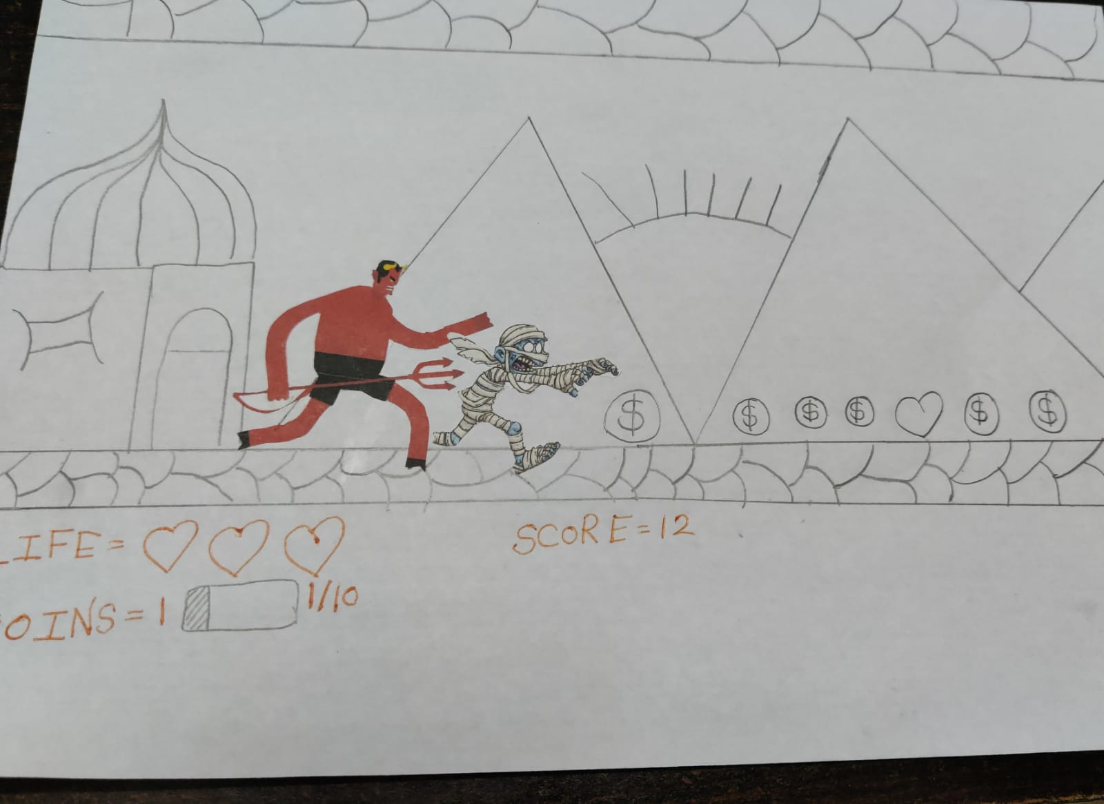

How do you plan to make your game engaging?

I have made it a infinite way so that player will engaged for the end and I have added so good obstacles like stones and lava pool and so a NPC a monster chasing the user. I have even added some rewards to the game like coins which when counter every time to 10 will give a special random ability for a perticular time and health points also a reward as if a player lacks a amount of live points then the player can refill it with some health points.