1. Creating and Renaming Files/Directories
Create a directory named test_dir using mkdir.
Inside test_dir, create an empty file called example.txt.
Rename example.txt to renamed_example.txt using mv

Ans: Please see the screenshot beow.
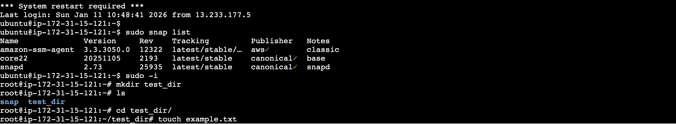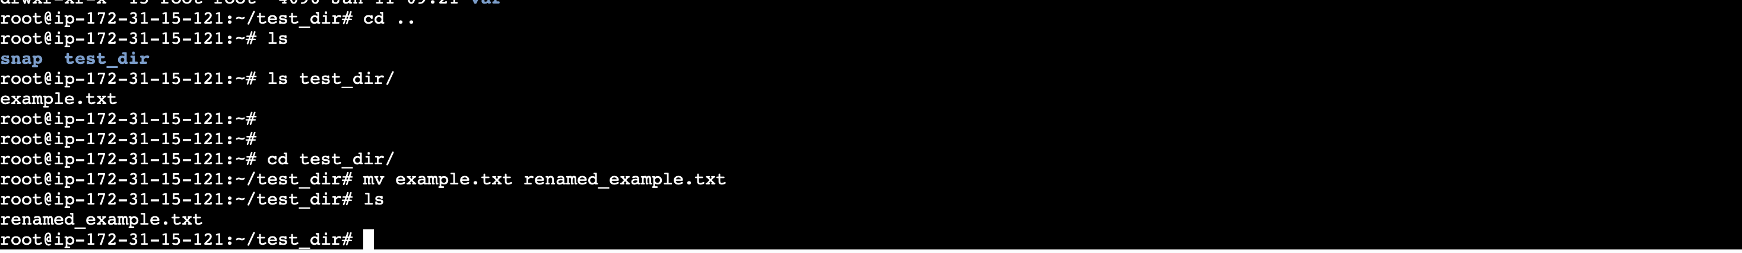

2. Viewing File Contents
Use cat to display the contents of /etc/passwd.
Display only the first 5 lines of /etc/passwd using head.
Display only the last 5 lines of /etc/passwd using tail.
Ans: here is the output below
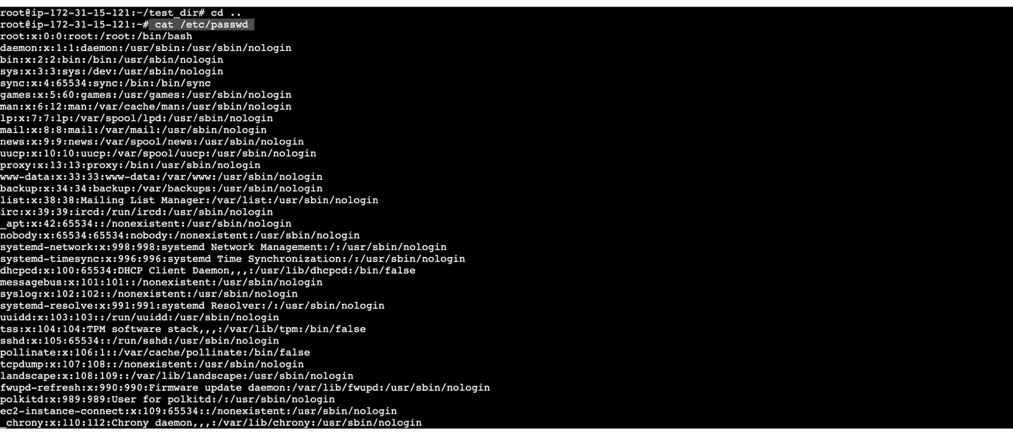
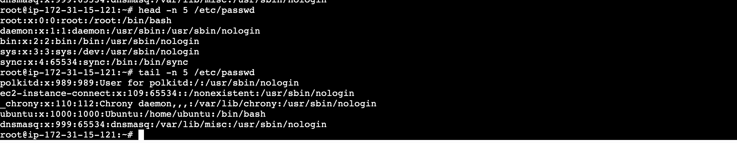

3.Searching for Patterns
Use grep to find all lines containing the word "root" in /etc/passwd.
Ans: here is the output below.
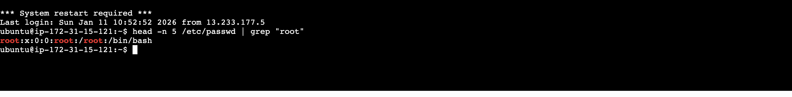

4. Zipping and Unzipping
Compress the test_dir directory into a file named test_dir.zip using zip.
Unzip test_dir.zip into a new directory named unzipped_dir.

Ans : Here is the output below.
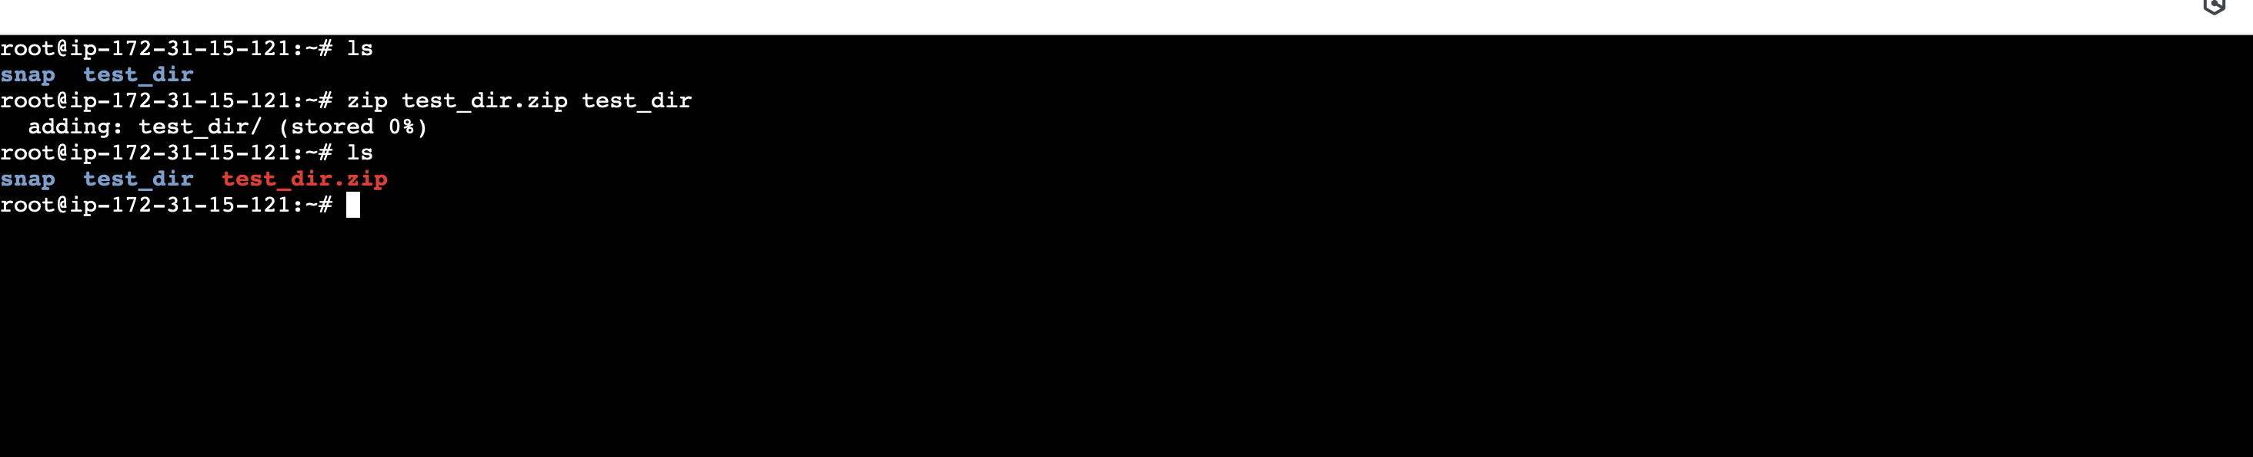
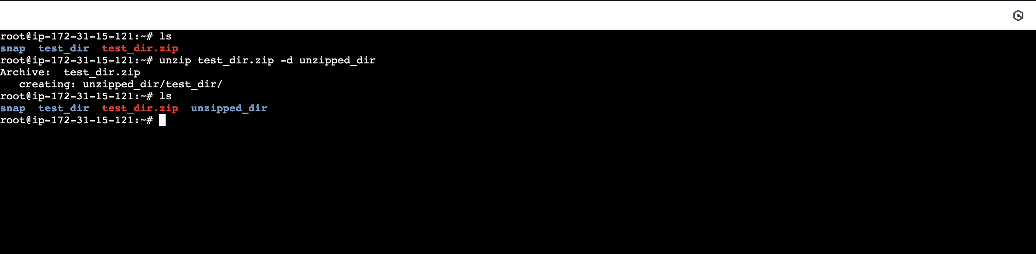
5. Downloading Files
Use wget to download a file from a URL (e.g., https://example.com/sample.txt).

Ans: Please see the output in the screenshot given below.
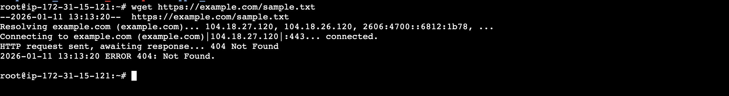
6. Changing Permissions
Create a file named secure.txt and change its permissions to read-only for everyone using chmod.

Ans: To create read only permission for everyone, please see the command in given screenshot.
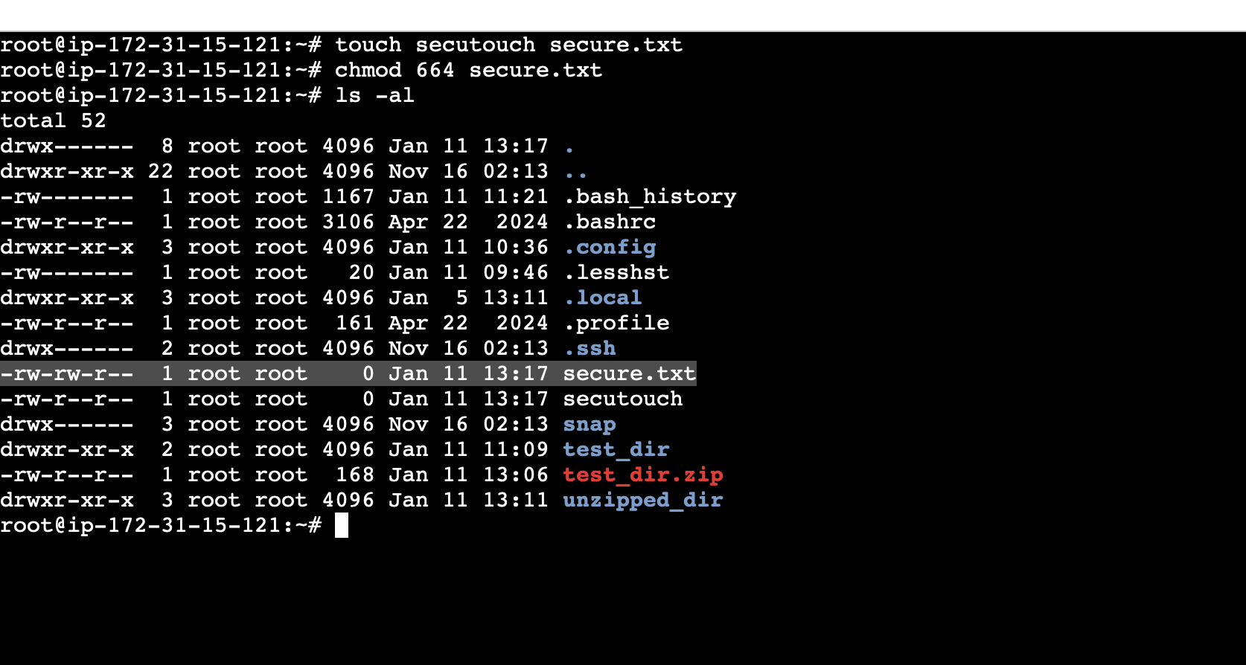

7. Working with Environment Variables
Use export to set a new environment variable called MY_VAR with the value "Hello, Linux!".
Ans: here is the output below
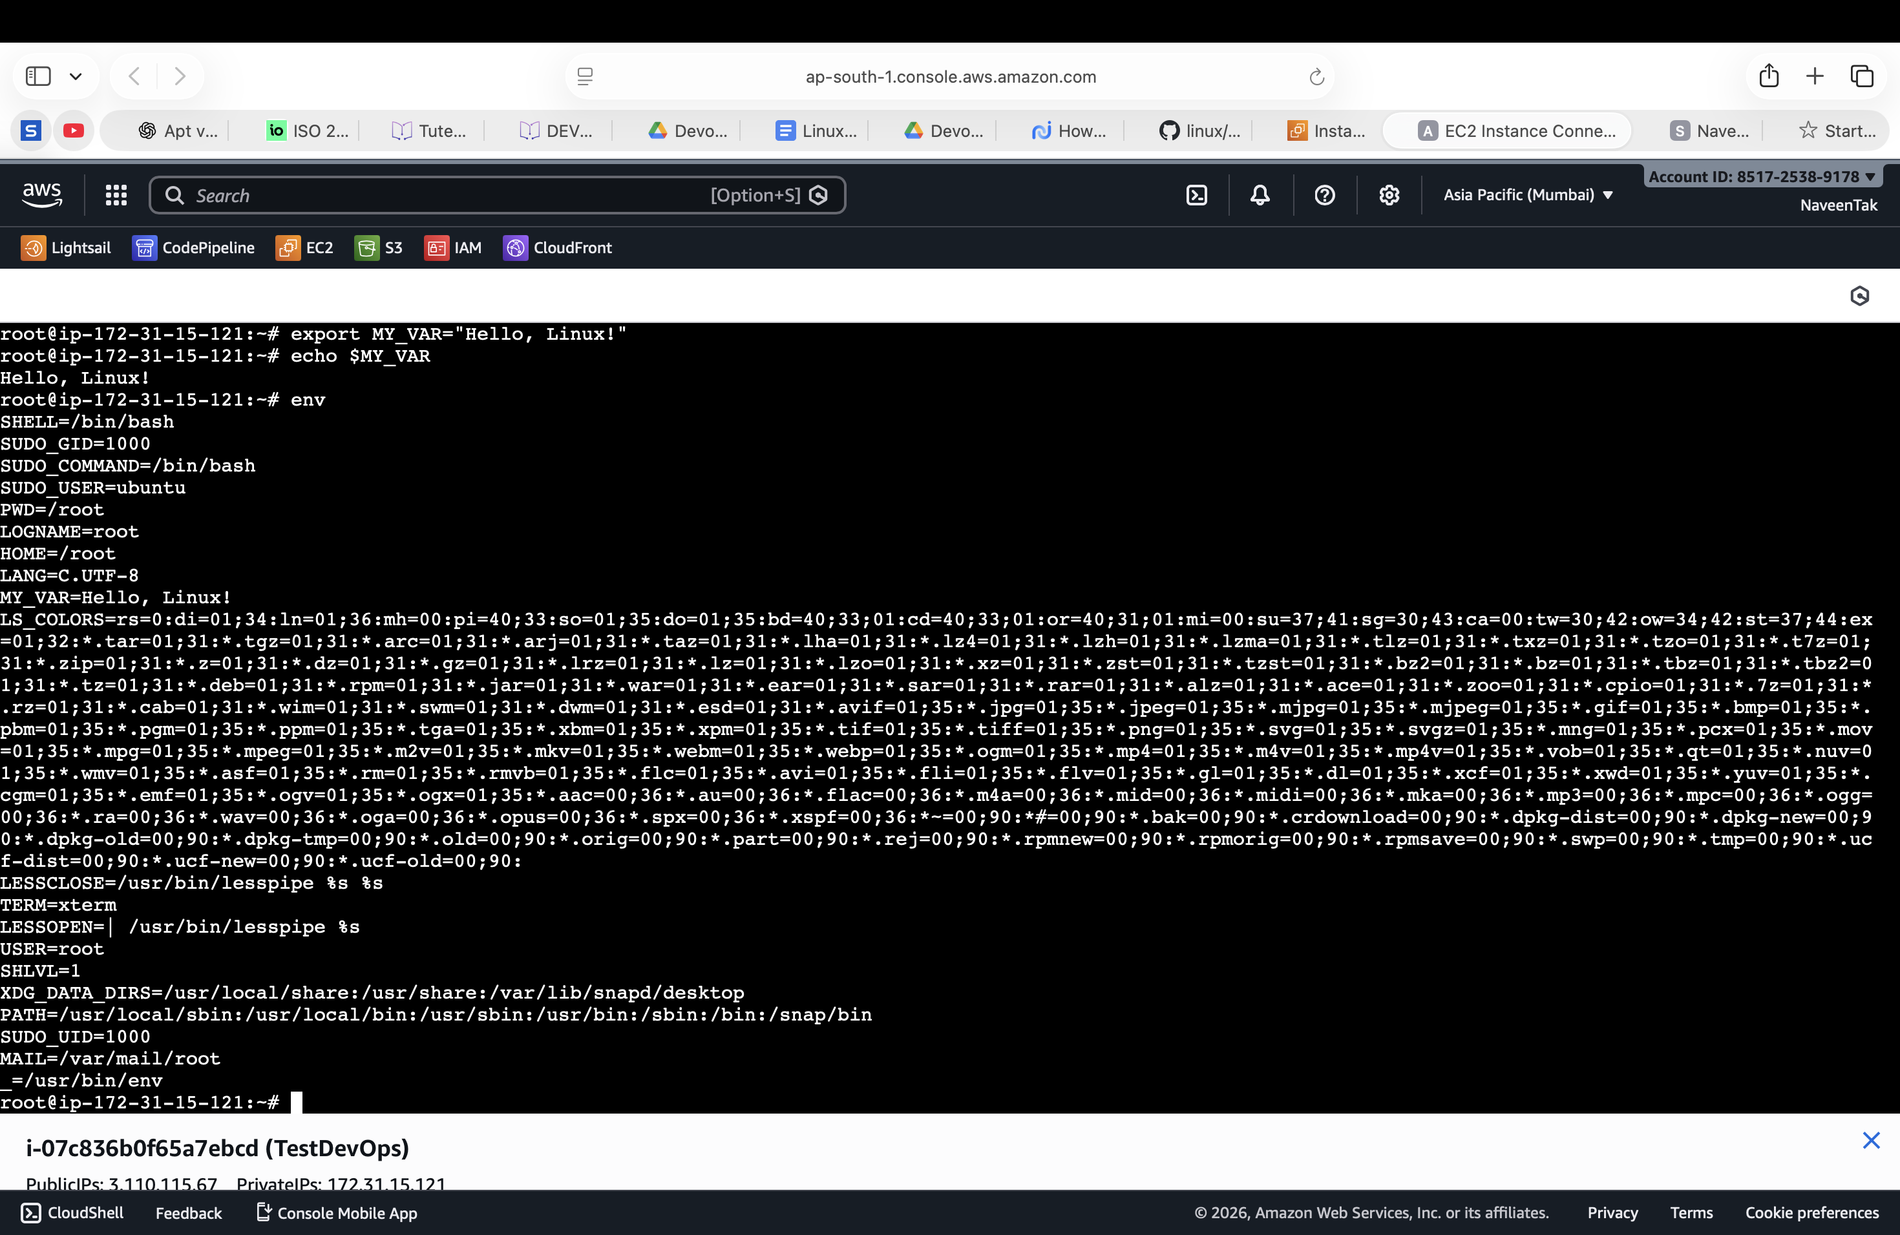

Submission Guidelines -: Attach Screenshots or command along with explanation and submit in doc(google doc or microsoft doc) format also attach github repo link

