**Architecture Design**

**NBA Teams & Player Performance Analysis**

|  |  |
| --- | --- |
| **Written By** | **Shridatta Patil** |
| **Document Version** | **0.1** |
| **Last Revised Date** |  |

**DOCUMENT CONTROL**

**Change Record:**

|  |  |  |  |
| --- | --- | --- | --- |
| **VERSION** | **DATE** | **AUTHOR** | **COMMENTS** |
| 0.1 | **15 Aug 2024** | **Shridatta Patil** |  |
| 0.2 |  |  |  |

**Reviews:**

|  |  |  |  |
| --- | --- | --- | --- |
| **VERSION** | **DATE** | **REVIEWER** | **COMMENTS** |
|  |  |  |  |

**Approval Status:**

|  |  |  |  |  |
| --- | --- | --- | --- | --- |
| **VERSION** | **REVIEW**  **DATE** | **REVIEWED BY** | **APPROVED**  **BY** | **COMMENTS** |
|  |  |  |  |  |

**Contents**

**1. Introduction............................................................................................................. 04**

**1.1 What is Architecture Design Document? .......................................................... 04**

**1.2 Scope .................................................................................................................. 04**

**2. Architecture .............................................................................................................05**

**2.1 Gateway………………………......................................................................................06**

**2.2 Power BI Desktop.................................................................................................06**

**2.3 Power BI Service...............................................................................................….06**

**2.4 Data Server ..........................................................................................................06**

**2.5 Power BI Communication Flow ...........................................................................07**

**3. Deployment ..............................................................................................................07**

**3.1 Deployment Options in Power BI.........................................................................07**

**3.2 Front-end Cluster Architecture ...........................................................................08**

**3.3 Back-end Cluster Architecture .............................................................................08**

**4. Reference...................................................................................................................09**

**1. Introduction**

**1.1 What is Architecture design document?**

Any software needs the architectural design to represents the design of software. IEEE defines architectural design as “the process of defining a collection of hardware and software components and their interfaces to establish the framework for the development of a computer system.” The software that is built for computer-based systems can exhibit one of these many architectures.

Each style will describe a system category that consists of:

• A set of components (e.g.: a database, computational modules) that will perform a function required by the system.

• The set of connectors will help in coordination, communication, and cooperation between the components.

• Conditions that how components can be integrated to form the system.

• Semantic models that help the designer to understand the overall properties of the

System.

**1.2 Scope**

Architecture Design Document (ADD) is an architecture design process that follows a step-by-step refinement process. The process can be used for designing data structures, required software architecture, source code and ultimately, performance algorithms. Overall, the design principles may be defined during requirement analysis and then refined during architectural design work.

**2. Architecture**

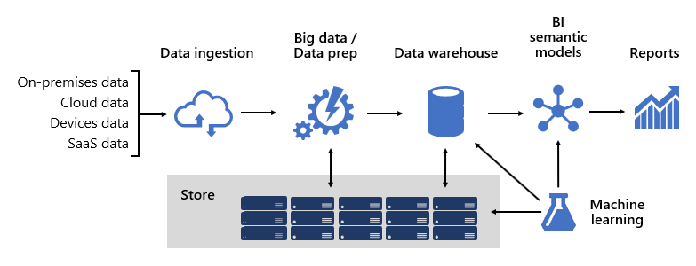

Architecture [1]

**Power BI Service Architecture**

Power BI has a highly scalable, n-tier client-server architecture that serves mobile clients, web clients and desktop-installed software. Power BI Service architecture supports fast and flexible deployments.

**The following diagram shows Power BI Service architecture:**

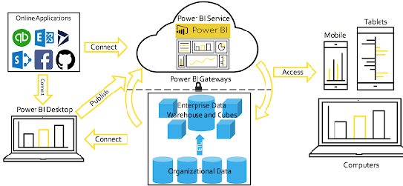

**2.1 Gateway**

It acts as an Entry gate to the Power BI Service and also balances the load to the Server if multiple Processes are configured.

**2.2 Power BI desktop**

Power BI Desktop uses x-Velocity technology and loads data into memory. It uses a local instance of SQL Server Analysis Services (SSAS). Direct Query/Live Connection is a direct connection to data source. Data will NOT be stored in Power BI model. Power BI will be a visualization layer, then query the data from data source every time. Power BI will only store metadata of tables but not the data. For Import mode, data is scratched from data source, being stored on Power BI side.

**2.3 Power BI Service**

The Power BI service is built on Azure. Power BI uses Azure Active Directory (AAD) to store and manage user identities, and manages the storage of data and metadata using Azure BLOB and Azure SQL Database, respectively.

**2.4 Data Server**

Azure Server Manages connections to Power BI Service and data sources. It also maintains metadata from Power BI Desktop, such as calculations, definitions, and groups.

**2.5 Power BI Flow Diagram**

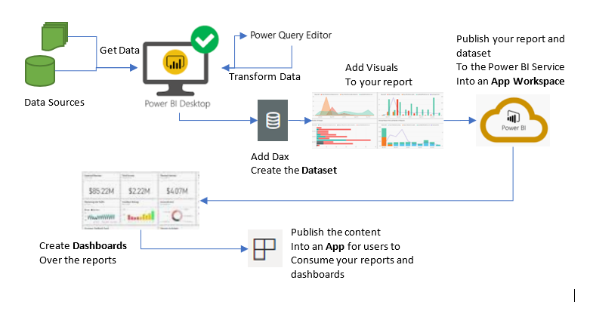

**3. Deployment Description**

**3.1 Deployment options in Power BI**

Power BI platform offers deployment on Power BI service. Power BI Report Server is an on-premises report server with a web portal in which you display and manage reports and KPIs. Along with it come the tools to create Power BI reports, paginated reports, mobile reports, and KPIs. Your users can access those reports in different ways: viewing them in a web browser or mobile device, or as an email in their in-box.

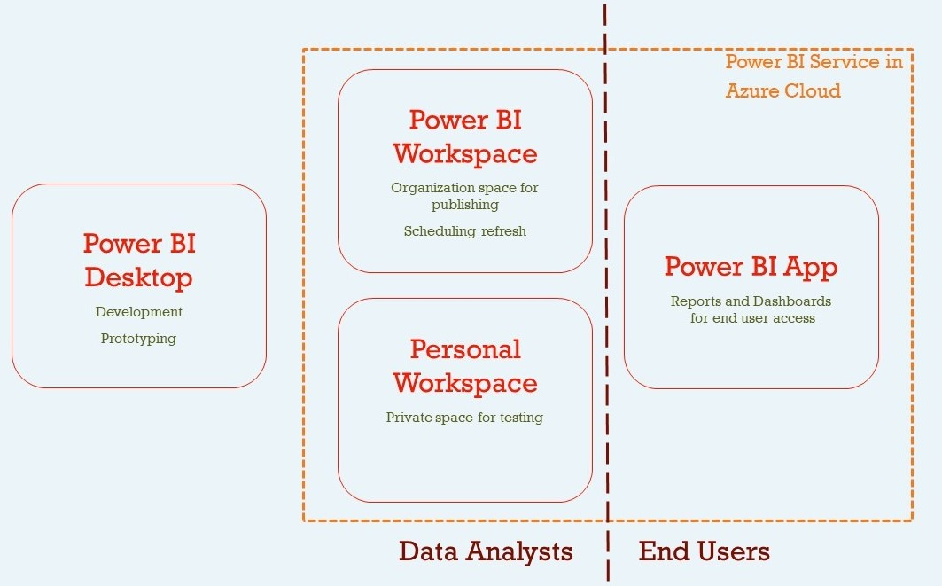

**3.2 Front-end Cluster Architecture**

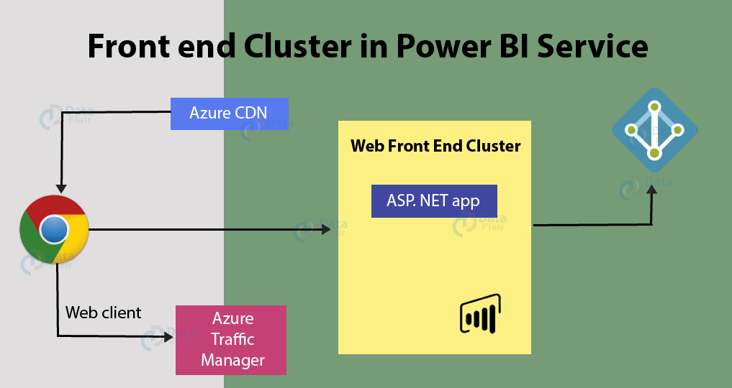

This architecture is a front-end cluster in Power BI Service.

**3.3 Back-end Cluster Architecture**

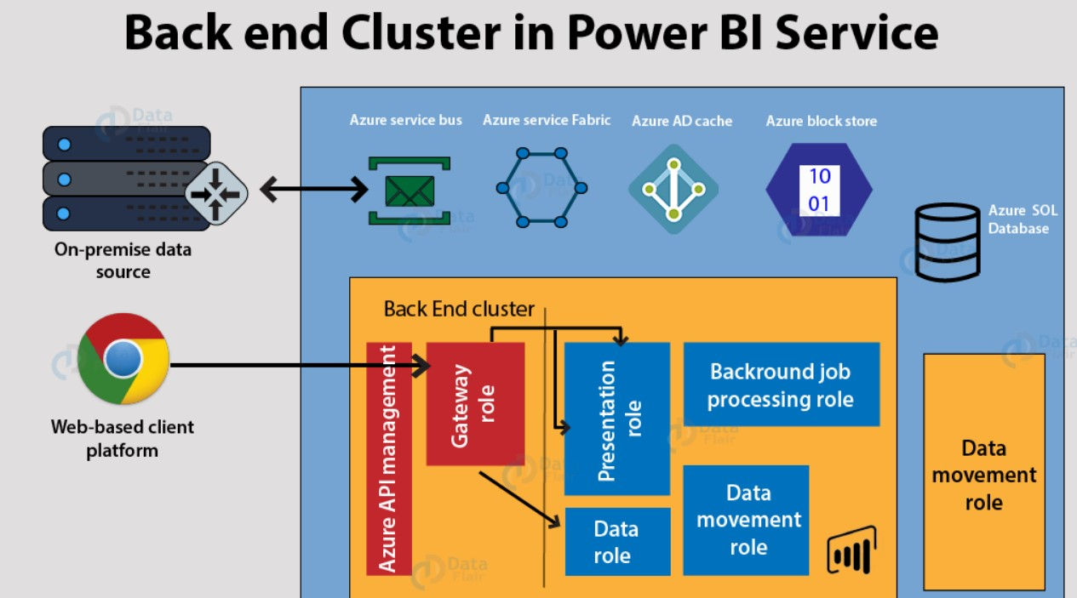

This architecture is a back-end cluster in Power BI Service.

The front end also called the web front-end cluster acts as an intermediary between clients and the back end. The front-end services are used for establishing an initial connection and authenticating clients using Azure Active Directory. The Azure Active Directory stores user identities. Along with this, Azure Traffic Manager is used to direct user requests to the nearest data centre after authentication. Once a client/user is authenticated, the **Azure Content Delivery Network (CDN)** distributes static Power BI content/files to users.

The Power BI services at the back end take care of visualizations, datasets, storage, reports, data connections, data refreshing, and other interactions with Power BI. At the back-end, a web client has only two direct points of interaction, **Azure API Management**, and **Gateway Role**. These two components are responsible for load balancing, authentication, authorization, routing, etc.

**4.Reference**

**Website URL:** <https://data-flair.training/blogs/power-bi-architecture/>