**Low Level Design (LLD)**

**NBA Teams & Player Performance Analysis**

|  |  |
| --- | --- |
| **Written By** | **Shridatta Patil** |
| **Document Version** | **1.0** |
| **Last Revised Date** |  |

**DOCUMENT CONTROL**

**Change Record:**

|  |  |  |  |
| --- | --- | --- | --- |
| **VERSION** | **DATE** | **AUTHOR** | **COMMENTS** |
| 0.1 | **15 AUG 2024** | **Shridatta** |  |
|  |  |  |  |

**Reviews:**

|  |  |  |  |
| --- | --- | --- | --- |
| **VERSION** | **DATE** | **REVIEWER** | **COMMENTS** |
|  |  |  |  |

**Approval Status:**

|  |  |  |  |  |
| --- | --- | --- | --- | --- |
| **VERSION** | **REVIEW**  **DATE** | **REVIEWED BY** | **APPROVED**  **BY** | **COMMENTS** |
|  |  |  |  |  |

**Contents**

**1. Introduction........................................................................................................................ 04**

**1.1 What is Low-Level Design Document? ....................................................................... 04**

**1.2 Scope ............................................................................................................................ 04**

**2. Functional Architecture...................................................................................................... 04**

**3. Architecture Description ................................................................................................... 06**

**3.1 Data Description .......................................................................................................... 06**

**3.2 Data Transformation .................................................................................................... 07**

**3.3 Power BI Configuration ............................................................................................... 07**

**3.4 Deployment .................................................................................................................. 08**

**4. Reference ........................................................................................................................... 08**

**1 Introduction**

**1.1 Why this Low-Level Design Document?**

The goal of the LDD or Low-level design document (LLDD) is to give the internal logic design of the actual program code for the NBA data and dashboard. LDD describes the class diagrams with the methods and relations between classes and programs specs. It describes the modules so that the programmer can directly code the program from the document.

**1.2 Scope**

**Low-level design (LLD) is a component-level design process that follows a step-by-step refinement process. The process can be used for designing data structures, required software architecture, source code and ultimately, performance algorithms. Overall, the data organization may be defined during requirement analysis and then refined during data design work.**

**2 Functional Architecture**

Data Sources Data Analytics Business Analytics BI

Combing Reports and Creating Dashboards

Optimization Tools

Combine Data Analytics with KPI’s

All Season Teams & Player data

Visualization Tools

Statistics

Data Cleaning

Step 1: Gather Data Step 2: Adv Search Step 3: Adv Tools Step 4: BA

**\* BI-Business Intelligence * BA-Business Analytics**

**Power BI Service Architecture**

Power BI has a highly scalable, n-tier client-server architecture that serves mobile clients, web clients and desktop-installed software. Power BI Service architecture supports fast and flexible deployments.

The following diagram shows Power BI Service architecture:

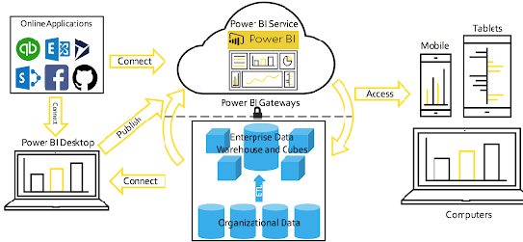

**2.1 Gateway**

It acts as an Entry gate to the Power BI Service and also balances the load to the Server if multiple Processes are configured.

**2.2 Power BI desktop**

Power BI Desktop uses x-Velocity technology and loads data into memory. It uses a local instance of SQL Server Analysis Services (SSAS). Direct Query/Live Connection is a direct connection to data source. Data will NOT be stored in Power BI model. Power BI will be a visualization layer, then query the data from data source every time. Power BI will only store metadata of tables but not the data. For Import mode, data is scratched from data source, being stored on Power BI side.

**2.3 Power BI Service**

The Power BI service is built on Azure. Power BI uses Azure Active Directory (AAD) to store and manage user identities, and manages the storage of data and metadata using Azure BLOB and Azure SQL Database, respectively.

**2.4 Data Server**

Azure Server Manages connections to Power BI Service and data sources. It also maintains metadata from Power BI Desktop, such as calculations, definitions, and groups.

**3. Architecture Description**

**3.1. Data Description**

The Dataset contains the data of all NBA seasons details like teams, players and games played in each season and all drafts details for different year.

**DRAFT**

The draft data for different years and how many rounds happened in that year and players picked from that draft.

**PLAYERS DETAILS**

The data contains the player details like age, height, weight, their country, the college they studied from and the draft year from they picked, games played by that player .

**POINTS**

In this data the points scored by each player each season and per match. Assisted to score a point, rebound points, the player usage percentage in the match.

**NET RATING**

Net rating of the each player and each teams in that season.

**TEAMS**

The teams data shows that player representing that teams, the teams scoring accuracy, net rating and overall performance of the teams.

**3.2. Data Transformation**

In the Transformation Process, we will convert our original datasets with other necessary attributes format. Originally datasets are in the form of wide dataset we converted into long datatype which will be useful for analysis Removing of NaN values and duplicate values.

**3.3. Power BI Configuration**

**Step 1: Configuring Data Source**

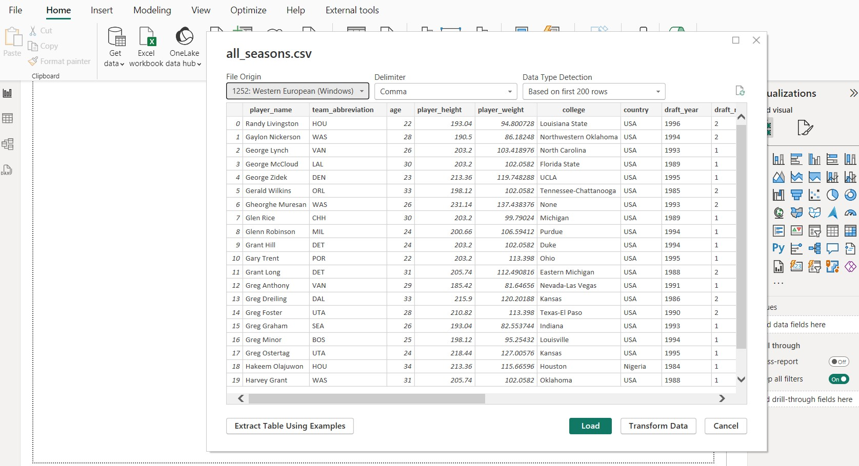

**Step 2: Transforming the data**

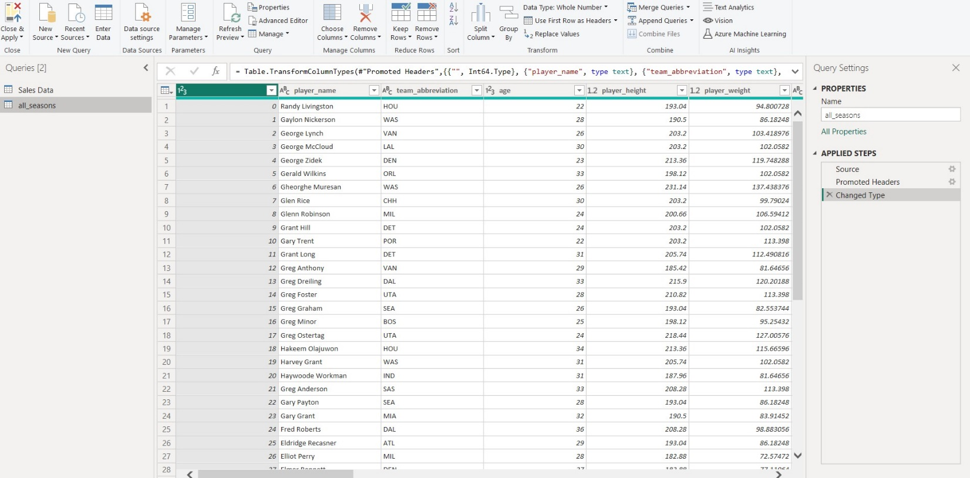

**3.4 Deployment**

Once you’ve completed your dashboard, follow these steps: -

Log In Power BI account and publish the Power BI desktop dashboard in the workspace created in the Power BI service.

**4.Reference**

**Website URL:** <https://data-flair.training/blogs/power-bi-architecture/>