**PROJECT REPORT**

**PROJECT NAME**: - TELECOM BILLING MANAGEMENT SYSTEM.

**DEVELOPMENT**: - C Language.

**PROJECT BY**: - Shridhar M Gurav.

TELECOM BILLING SYSTEM

## TABLE OF CONTENTS

|  |  |  |
| --- | --- | --- |
| **S No.** | **Content** | **Page No.** |
| **1.** | Introduction | **3** |
| **2.** | Objective | **4** |
| **3.** | Requirements | **5** |
| **4.** | Flow chart | **6** |
|  |  |  |
| **5.** | Input and output Display | **7** |
| **6.** | Future scope | **10** |
| **7.** | Reference | **11** |

TELECOM BILLING SYSTEM

# INTRODUCTION

The Telecom Billing Management System Project in C is a consoled based application created using c programming language. This system is a simple mini project and compiled in Code::Blocks IDE using GCC compiler. Telecom Billing System is a small project, you may perform and handle billing processes in the same way as telecom businesses do. You can add records with names, phone numbers, and payment amounts here. Existing records can be viewed, modified, searched, and deleted.

You can also make a payment using your phone number rather than your name. All data that is added or updated is saved in a file. This project will teach you how to use file handling to add, list, modify, search, and delete records.

**Features:**

* **Add New Records** – For the add new billing records, the user can add new billing records details.
* **List of Records**– For the list of billing records, the user can view all the new billing records added.
* **Payment**– For the payment, the user can pay their telecom billing in this system.
* **Search records**– For the search billing records, the user can search through there phone number.
* **Delete Employee** – For the delete billing records, the user can delete their own billing records information.
* **Edit Records**– For the edit records, the user can edit billing records information.
* **Exit** – For the exit, the user can also exit in the system.

TELECOM BILLING SYSTEM

**OBJECTIVE**

The Telecom Billing Management System Project in C is a consoled based application created using c programming language. This system is a simple mini project and compiled in Code::Blocks IDE using GCC compiler. You can add records with names, phone numbers, and payment amounts here. Existing records can be viewed, modified, searched, and deleted. All data that is added or updated is saved in a file. You can also make a payment using your phone number rather than your name.

Telecom Billing System application is so simple to use. In order to use the application, click on the enter and the you will get 7 option to choose,

* A: Adding new record.
* L: List of the Records.
* M: Modifying Records.
* P: For Payments.
* S: Searching Record.
* D: Deleting Records.
* E: Exit.

As per your need enter any one of the given option and follow the instructions provided by the application itself.

TELECOM BILLING SYSTEM

**REQUIREMENTS**

**Software Requirement**

* Operating System: Windows 10.
* Application Software: Visual Studio
* Language : C-Programming

#### Hardware Requirements Specification

#### Processor: Intel core i5

#### Hard Disk: 250GB

#### Ram: 2GB

TELECOM BILLING SYSTEM

**FLOW CHART**

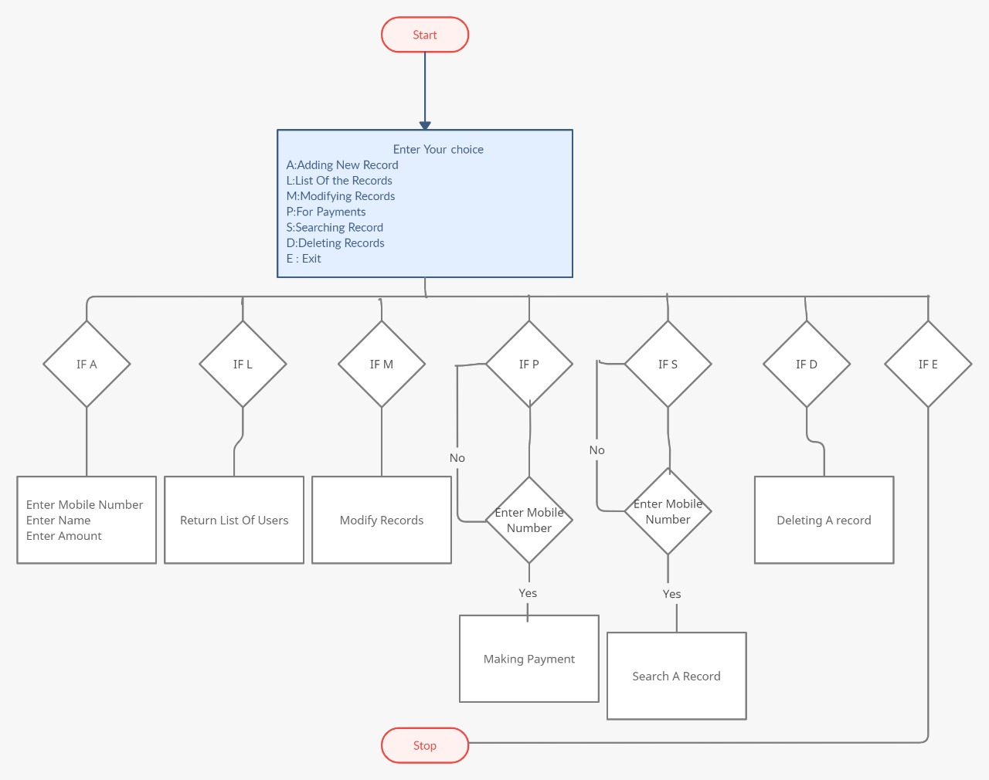

TELECOM BILLING SYSTEM

**INPUT AND OUTPUT DISPLAY**

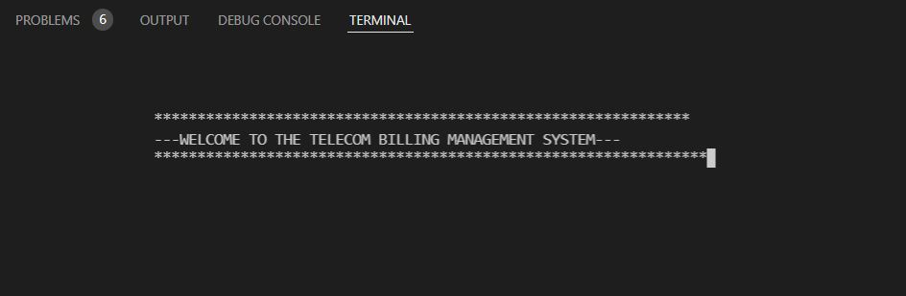

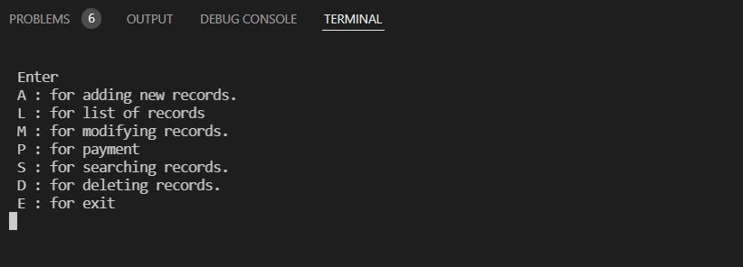

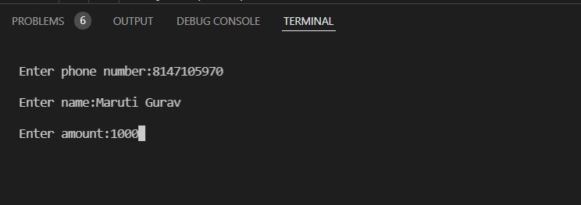

TELECOM BILLING SYSTEM

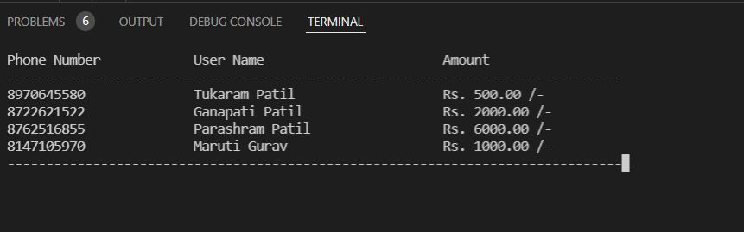

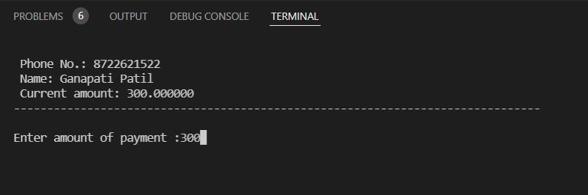



TELECOM BILLING SYSTEM

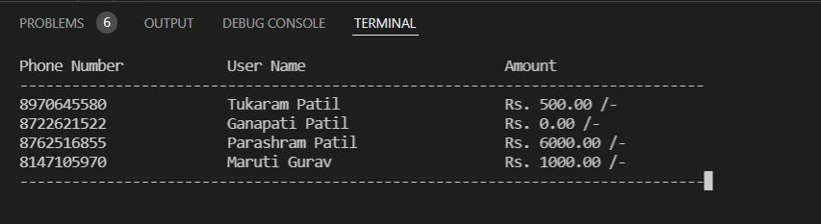

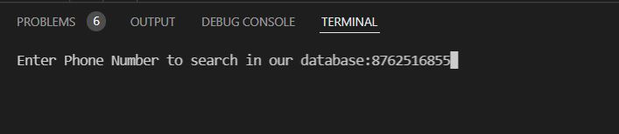

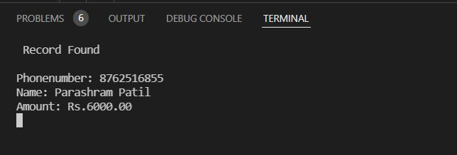

TELECOM BILLING SYSTEM

**Future Scope of Project**

This Project can be modified with better graphics and we can add some extra features according user requirements. The scope of billing software solution services ranges from simple invoice production to comprehensive business management.

We can add features like:-

* Application can send notification to customer about information like current balance, amount to be paid etc.

TELECOM BILLING SYSTEM

**Reference**

* <https://www.codewithc.com>.
* [www.youtube.com](http://www.youtube.com).