# 📌 Title: VAS Using Satellite Data

# 1. Oil Spill Detection

## ✅ Description

Oil spill detection is the process of identifying and distinguishing real oil spills from similar-looking phenomena in ocean surfaces using satellite data. The primary data source for this task is satellite data, which can capture images regardless of weather or lighting conditions — making it ideal for marine monitoring.

## 🧠 Technique: CNN-Based Image Classification

- A Convolutional Neural Network (CNN) is trained using raw images containing both real oil spills and look-alike phenomena.  
- Feature Extraction: The CNN learns spatial features such as shape, texture, and intensity from raw data.  
- Classification: Based on learned features, the CNN distinguishes:  
 • True Oil Spills – Smooth dark patches due to surface damping of capillary waves.

## 🎨 Output Visualization

- The output is typically presented as a color-coded segmentation map, where:  
 • Cyan indicates genuine oil spills

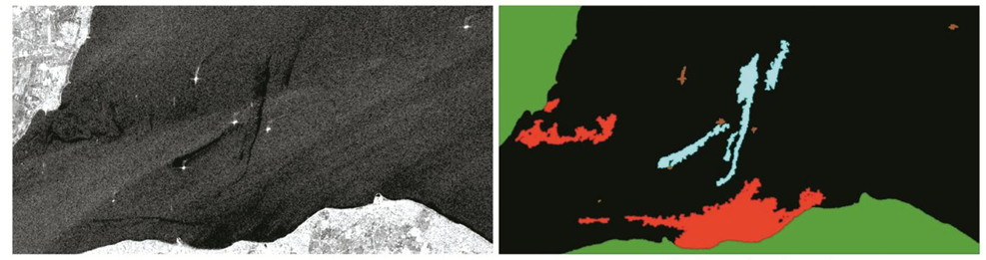

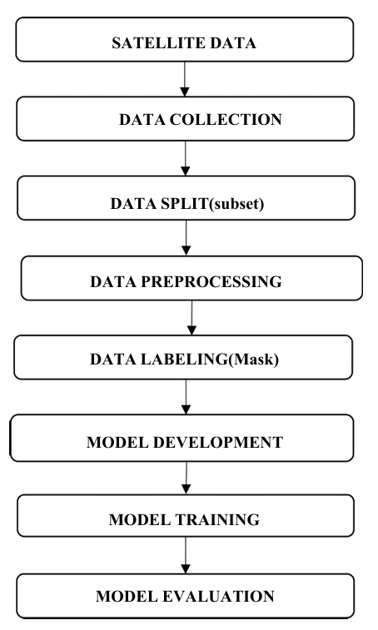

# 2. Detection of Agricultural Land Using Satellite Images

## ✅ Description

Objective:

* To compare the effectiveness of Convolutional Neural Networks (CNN) and Autoencoders (AE) in detecting agricultural land from satellite images.

Importance:

* Accurate detection of agricultural land is crucial for managing natural resources, estimating crop yields, and disaster preparedness.

Data Source:

* Satellite images collected from the Sentinel-2 satellite.

Evaluation Metrics:

* Performance assessed using accuracy, precision, recall, and F1-score.

# 🧠 Technique:

1. Convolutional Neural Networks (CNN):

* Structure: Composed of convolutional and pooling layers to learn complex features.
* Functionality: Excellent for image classification tasks including land cover detection.
* Key Features:
* - Uses ReLU activation for faster learning.
* - Applies dropout to avoid overfitting.
* Architecture Used: VGG16 with pre-trained weights on ImageNet.

1. Autoencoders (AE):

* Structure: Includes an encoder to compress and a decoder to reconstruct input.
* Functionality: Useful for unsupervised learning by learning compact representations.
* Key Features:
* - Identifies essential features by reducing dimensions.
* - Reconstructs original input from learned features.
* Architecture Used: Convolutional autoencoder with encoder-decoder layers.