***A Mini Hardware Project Report***

**ON**

**WALCHAND INSTITUTE OF TECHNOLOGY**

**SOLAPUR**



**“ SMART BIDIRECTIONAL VISITER COUNTER ”**

**Submitted by**

**1 – Shridhar Kumthekar**

**2 – Aishwarya Phatate**

**3 – Prajwal Apchundekar**

**Roll No – 16**

**Roll No – 22**

**Roll No – 01**

**Electronics Engineering Department**

**Walchand Institute of Technology**

**2022-2023**

**Walchand Institute of Technology**

**Ashok Chowk, Solapur**

**Department of**

**Electronics Engineering**



CERTIFICATE

**Certified that the mini-project work entitled “*SMART BIDIRECTIONAL VISITER COUNTER*” is a bona fide work carried out by**

**Roll No – 16**

**Roll No – 22**

**Roll No – 01**

**1 – Shridhar Kumthekar**

**2 – Aishwarya Phatate**

**3 – Prajwal Apchundekar**

**The report has been approved as it satisfies the academic requirements in respect of mini-hardware-project work prescribed for the course**

………………………

**Mr. S. C. Kalshetti**

Mini-Project Coordinator

# **INDEX**

|  |  |  |
| --- | --- | --- |
| SR.NO | Contents | Page No |
| 1 | Abstract |  |
| 2 | Introduction |  |
| 3 | Flow Chart |  |
| 4 | Working of Components |  |
| 5 | Software used in project  Arduino IDE for code |  |
| 6 | Working of System |  |
| 7 | Applications |  |
| 8 | Advantages &  Disadvantages |  |
| 9 | Conclusion |  |
| 10 | Reference |  |

**ABSTRACT**

This project describes smart bidirectional visitor counter with the use of Arduino. The Smart Bidirectional Visitor Counter is an innovative project that aims to accurately count and track the number of people entering and exiting a particular area or building. It utilizes sensors and to detect the presence of individuals and records their movements in real-time.

The project incorporates intelligent features such as bidirectional counting, data storage, and data analysis for better insights. The smart visitor counter assists in effective crowd management by providing real-time information about the number of visitors present in a particular area. This information can help authorities take necessary actions to ensure safety and security.

Overall, the Smart Bidirectional Visitor Counter offers an automated, accurate, and intelligent solution for visitor counting and tracking. It provides valuable insights for various industries and facilitates better management of public spaces, businesses, and events.

# **INTRODUCTION**

Sometimes while exiting the room, we usually forget to turn off the appliances inside the room. This increases the power wastage; our project will be able to solve this mere yet important problem.

Whenever an individual will enter the room, the appliances inside the room will automatically turn “ON”, and the count of the individuals will be maintained on the LCD screen, it will change according to the readings taken by two of the HC-SR04 sensors attached at the entrance. One sensor is attached to take the readings of entrance and another is for the exit. In similar fashion whenever the members will leave the room, the count on the LCD screen will decrease, as soon as the count on the LCD count comes to ‘0’, the appliances inside the room will turn “OFF” smartly, saving a lot of electricity.

By implementing these measures, a smart bidirectional visitor counter can contribute to reducing power wastage by optimizing the operation of lighting, it allows for targeted and efficient use of resources based on real-time, leading to energy savings and cost reduction

**WORKING**

Sensor Placement: Position sensors strategically at the entry and exit points of the monitored area. Common sensor options include infrared sensors, ultrasonic sensors, or other proximity sensors. Ensure that the sensors cover the necessary range and are properly aligned.

Sensor Detection: The sensors continuously monitor the presence or absence of visitors. When a person passes through the sensors' detection range, it triggers a signal indicating the entry or exit of a visitor.

Signal Processing: The signals from the sensors are received and processed by the microcontroller (such as an Arduino) connected to the sensors. The microcontroller interprets the signals and determines whether it represents an entry or exit event.

Visitor Count Update: Based on the signals received, the microcontroller updates the visitor count accordingly. If an entry event is detected, the count is incremented, and if an exit event is detected, the count is decremented. This ensures accurate bidirectional counting of visitors.

Display Update: The visitor count is displayed on a suitable display device, such as an LCD screen, LED display, or through a web interface. This allows real-time visibility of the visitor count to users or staff.

Data Storage and Analysis (Optional): Optionally, the visitor count data can be stored in a storage medium, such as an SD card or a cloud database. This data can be later analysed to gain insights into visitor patterns, peak hours, or other relevant metrics.

Continuous Monitoring: The system continues to monitor the sensors and update the visitor count in real-time. It provides an accurate and ongoing count of visitors entering and exiting the monitored area.

**FLOWCHART**

**START**

Initializing

Appliances is ON

Update the visitor counter

Set up sensors

Read sensor input and chatter relay

No

Appliances OFF

If Person count > 0

Yes

Display the count of visitor

Repeat Step 3 and 4

**END**

**COMPONENTS**

* **Arduino UNO:**

The Arduino Uno is a popular microcontroller board that is widely used in various electronic projects, including robotics, home automation, IoT (Internet of Things), and prototyping. The Arduino Uno is based on the ATmega328P microcontroller from Microchip. It operates at a clock speed of 16 MHz and has 32KB of flash memory, 2KB of SRAM, and 1KB of EEPROM. The Arduino Uno can be powered through a USB connection, a 9V battery, or an external power supply. It has a built-in voltage regulator that allows it to operate within a range of 7V to 12 V.

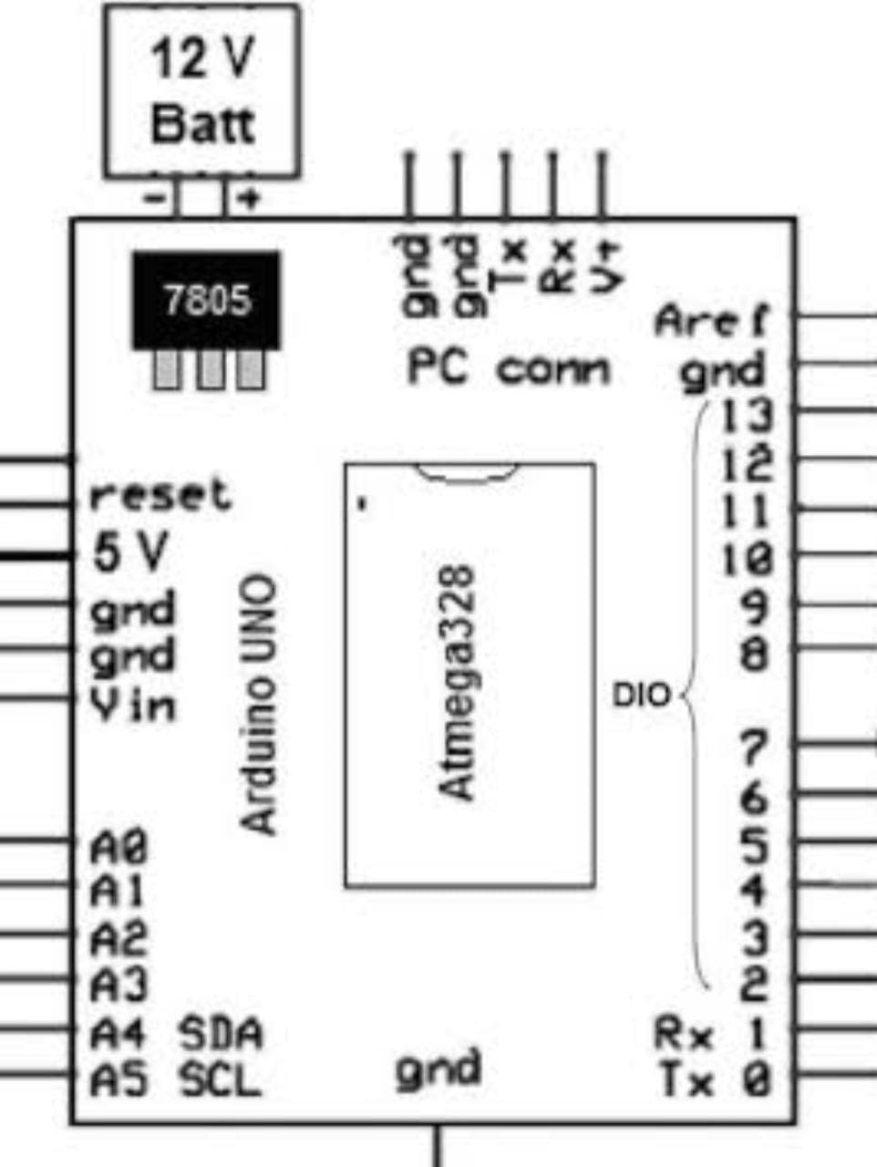

* **Ultrasonic Sensor :**

An ultrasonic sensor is a device that uses sound waves with frequencies above the range of human hearing to detect and measure distances to objects. It works based on the principle of echolocation, like how bats navigate and locate objects in their environment. Ultrasonic sensors offer advantages such as non-contact measurement, high accuracy, and versatility in various environments.

They are commonly used in a wide range of applications that require distance measurement, object detection, proximity sensing, and flow measurement. The reliability and ease of integration of ultrasonic sensors make them a popular choice for many electronic projects.

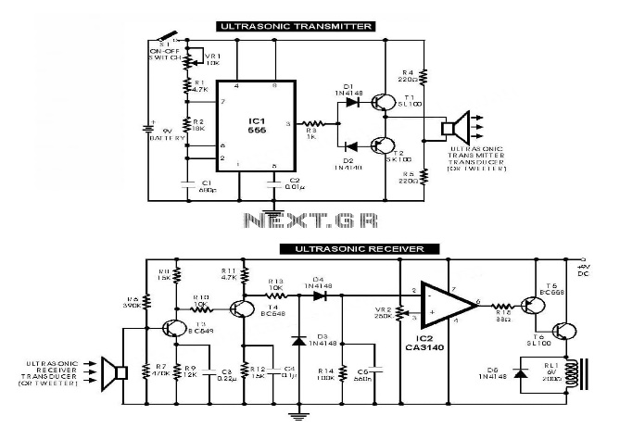

* **Single channel Relay:**

A single-channel relay is an electronic switch that can be controlled by a low-power electrical signal, such as the output from an Arduino microcontroller. By using an **Arduino Uno** and a single-channel relay module, you can control high-voltage or high-power devices, such as lights, motors, and appliances, from your computer or mobile device.

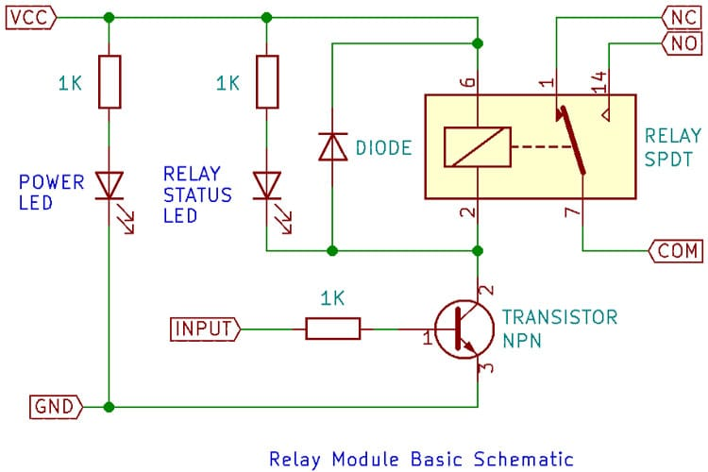

* **LCD Display :**

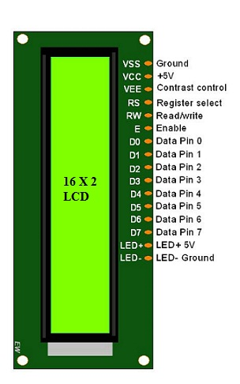LCD (Liquid Crystal Display) is a type of flat panel display which uses liquid crystals in its primary form of operation. The principle behind the LCDs is that for switching pixels on and off to reveal a specific colour

**SOFTWARE USED IN PROJECT**

**Arduino IDE**

The Arduino IDE is an open-source software, which is used to write and upload code to the Arduino boards. The IDE application is suitable for different operating systems such as **Windows, Mac OS X, and Linux**. It supports the programming languages C and C++. Here, IDE stands for**Integrated Development Environment.**

### **Easy EDA**

It is a software used to design and implement PCB circuit , it also helps build the circuit diagram and convert it into a PCB. Easy EDA is a web-based EDA tool suite that enables hardware engineers to design, simulate, share - publicly and privately - and discuss schematics, simulations, and printed circuit boards.

**CIRCUIT DIAGRAM**

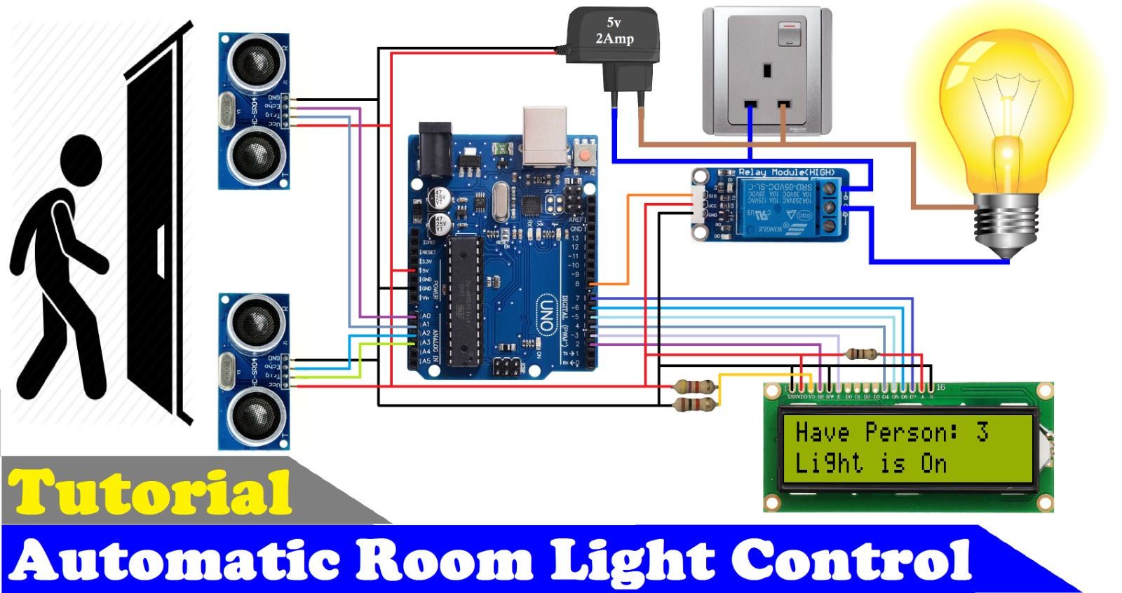

*Fig - the connections to the components*

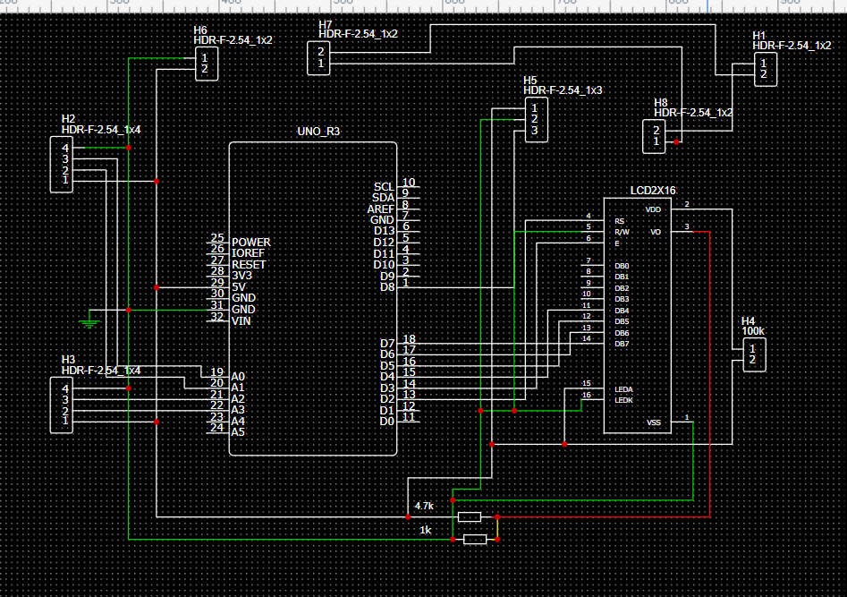

*Fig - showing the circuit diagram in EasyEDA platform.*

**PCB DESIGNINIG AND MAKING**

Over the process while designing and implementing the PCB we faced many challenges which include such as failure of designs and also failed attempt to implement the procedure of making PCB but after 4 failed attempts, we made a successful and a working PCB.

* **Steps of making a PCB:**

1. Designing and maintaining the features:

While designing we needed to carefully draw the circuit diagram on the software. and run and compile the design for several times until the design was error free.

1. Printing the PCB design:

After the finalized design reviews were taken by the mentors and then printing of PCB for its inner layer was done.

1. Drilling and soldering:

The PCB was carefully drilled for the components to be fitted on the board, after sufficient drilling the connectors were soldered making our PCB in such a way that the components can be used again for different purposes.

1. Connections:

After Soldering the continuity of the PCB was checked to

assure the correct ground and seeing that all the soldering is done carefully. we then carefully connected the components.

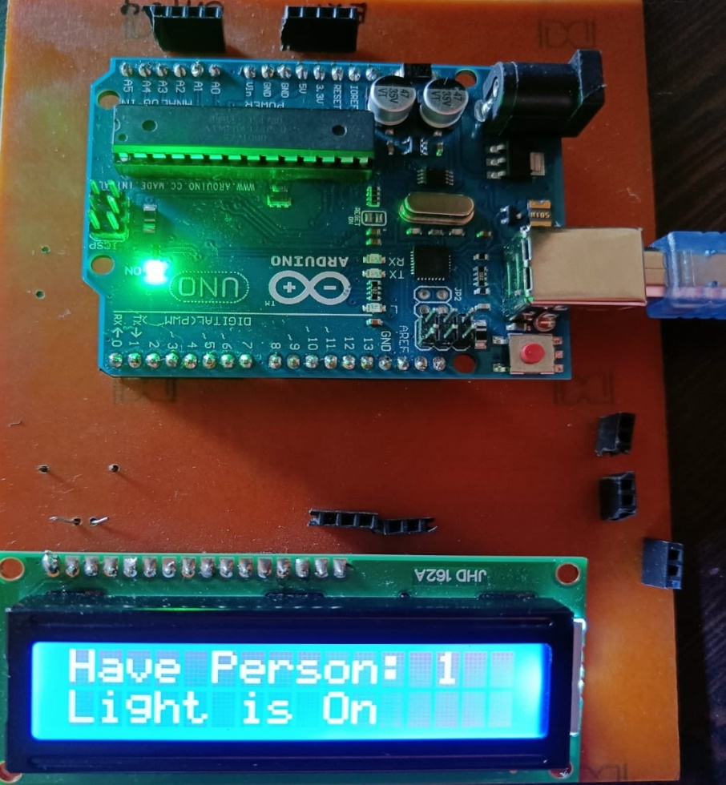

**APPLICATIONS**

The world is moving faster towards automation. People have less time to handle any work so automation is simple way to handle any device or machine will work to our desire. This paper aim is to develop and design a home automation using Arduino with Bluetooth module.

Home automation system gives a simple and reliable technology with Android application. Home appliances like fan, Bulb, AC, automatic door lock is controlled by home automation system using Arduino Uno with Bluetooth module. The paper mainly focuses on the monitor and control of smart home by android phone and provide a security based smart home, when the people does not present at home. This paper motive is controlled home appliances in smart home with user friendly, design at low cost, simple installation.

A “*smart bidirectional visitor counter using Arduino”* can find applications in various sectors where footfall tracking and analysis are valuable. Some sectors where this system can be utilized include:

1. Libraries:

Libraries can benefit from a visitor counter to understand the usage patterns of different sections, such as reference areas, study rooms, or children's sections. It can assist in resource management and improving services.

1. Events and Conferences:

Event organizers can use visitor counters to monitor attendance and assess the success of different sessions or exhibits. The data can guide future event planning and help allocate resources effectively.

1. Public Spaces:

Parks, recreational areas, and tourist attractions can utilize visitor counters to manage crowd flow, enhance safety measures, and allocate resources such as restroom facilities, seating areas, and food stalls accordingly

1. Hospitality:

Hotels and resorts can deploy visitor counters to monitor guest flow, assess peak check-in and check-out times, and optimize staff allocation for a smooth guest experience.

**ADVANTAGES**

**The advantages of using a smart bidirectional visitor counter based on Arduino**:

1. Real-time Data:

The visitor counter can provide real-time data on the number of visitors present at any given time. This information can be used to make timely decisions, such as managing crowd control or allocating resources.

1. Cost-effective Solution:

Arduino-based systems are cost-effective compared to complex and specialized visitor counting systems. Arduino boards and components are affordable and readily available, making it a cost-effective solution for various sectors.

1. Customizability:

Arduino allows for flexibility and customization. The visitor counter can be tailored to specific requirements, such as incorporating additional sensors or integrating with other systems for data analysis or notification purposes.

1. Easy Installation and Maintenance:

Arduino-based systems are relatively easy to install and maintain. The hardware components are simple to connect, and the Arduino platform offers a user-friendly programming environment, making it accessible even for those with limited technical expertise

1. Security and Safety Management:

By monitoring visitor flow, the system can aid in security and safety management. It allows for better control of crowd movements, helps identify potential bottlenecks or overcrowding, and assists in emergency response planning.

1. Data Analysis and Insights:

The collected visitor data can be stored and analyzed for valuable insights. It can help identify visitor patterns, peak hours, and trends, enabling data-driven decision-making for resource allocation, marketing strategies, and operational improvements.

**DISADVANTAGES**

**While a smart bidirectional visitor counter using Arduino offers several advantages, there are a few potential disadvantages to consider:**

1. Limited Range:

Arduino-based systems typically have a limited range of connectivity. This means that the counter's sensors may only be effective within a certain proximity. For large or sprawling areas, additional measures, such as multiple counters or signal repeaters, may be required.

1. Power Supply:

Arduino systems require a stable power supply to function. In the event of a power outage or disruption, the counter may cease to operate, resulting in a loss of data during that time. Implementing backup power solutions or redundant power sources may be necessary to address this concern.

1. Complexity of Implementation:

While Arduino offers a user-friendly programming environment, setting up and configuring the system may still require some technical knowledge. The initial installation and programming process could be challenging for individuals without prior experience or expertise in electronics and programming.

1. Lack of Integration with Existing Systems:

Integrating the visitor counter with existing systems, such as security systems or data management platforms, may require additional effort and customization. Compatibility issues or the need for custom software development may arise, which could add complexity to the implementation process.

1. Reliability and Maintenance:

Arduino-based systems, like any electronic device, may be subject to occasional malfunctions or component failures. Regular maintenance and monitoring are necessary to ensure that the system continues to function reliably over time.

1. Dependency on Arduino Ecosystem:

Reliance on the Arduino ecosystem means being tied to its hardware and software platforms. This dependency may limit access to certain advanced features or technologies that may be available on other more specialized or proprietary systems.

**CONCLUSION**

***Smart bidirectional visitor counter using Arduino*** is a versatile and cost-effective solution for tracking and analysing footfall in various sectors. It offers accurate counting, real-time data, and valuable insights for decision-making and resource allocation.

The project has several uses including ease of installation and maintenance, customization options, scalability, and improved efficiency and customer experience.

Overall, the smart bidirectional visitor counter using Arduino provides a valuable solution for monitoring and managing visitor flow in sectors such as retail, museums, libraries, events, transportation hubs, and healthcare facilities.

By leveraging the benefits and addressing the limitations, organizations can optimize operations, enhance customer experiences, and make data-driven decisions for improved efficiency and resource allocation.

**REFERENCE**

1. <https://youtu.be/_RpSaj9j-GY>
2. Circuit: [https://techatronic.com/smart-blind-stick-using-arduino-](https://techatronic.com/smart-blind-stick-using-arduino-and-ultrasonic-sensor/) [and-ultrasonic-sensor/](https://techatronic.com/smart-blind-stick-using-arduino-and-ultrasonic-sensor/)
3. [https://www.researchgate.net/figure/Figure-2-Block-Diagram-of-](https://www.researchgate.net/figure/Figure-2-Block-Diagram-of-the-Smart-Stick_fig1_339911393) [the-Smart-Stick_fig1_339911393](https://www.researchgate.net/figure/Figure-2-Block-Diagram-of-the-Smart-Stick_fig1_339911393)
4. Arduino Programming Book.