

**Ministry/Organization Name/Student Innovation**: Ministry of Jal Shakti

**PS Code:** SIH1293

**Problem Statement Title:**

Automatic regulation of valves for release of water based upon soil moisture availability in the root zone of the crop, using artificial intelligence, in a piped and micro irrigation network of irrigation system.

**Team Name:** Circuit Aura

**Team Leader Name:** Shridhar Kumthekar

**Institute Code (AISHE):** C-15788

**Institute Name:** Walchand Institute of Technology, Solapur

**Theme Name:** Agriculture, FoodTech & Rural Development

|  |  |  |
| --- | --- | --- |
| **Team Members** | **Branch-Stream** | **Year** |
| Shridhar Kumthekar | Btech-ECE | IV |
| Aishwarya Phatate | Btech-ECE | IV |
| Rucha Rashinkar | Btech-ECE | IV |
| Pravin Gundla | Btech-ECE | II |
| Uday Ige | Btech-ECE | II |
| Anurag Mangaonkar | Btech-ECE | II |

**Team Mentor:** Ravikant Khamitkar

**Category:** Academic

**Expertise:** ML

**Domain Experience:** 8 years

## INDEX

|  |  |  |
| --- | --- | --- |
| Sr. No | Content | Page No. |
|  | Abstract | 4 |
|  | Problem Statement | 4 |
|  | Objective | 5 |
|  | Methodology | 6 |
|  | Dependencies/Show Stopper | 7 |
|  | Tools and Technologies | 7 |
|  | Reference | 7 |

**1. Abstract: -**

* In India, there are large number of solutions available with shed net farming, but there are mere solutions when we talk about open land farming.
* To address this problem, there is a compelling need for an innovative solution that leverages artificial intelligence (AI) to enable the automatic regulation of valves for water release in piped and micro irrigation networks
* The main aim of this project is on crop production at low water usage, in order to concentrate on the water available to plants at the appropriate time
* This idea does not only emphasize on easy methods but also looks upon the resource conservation, sustainability and efficient outcomes.
* Traditional irrigation methods often lead to water wastage and suboptimal yields.
* At its core, this project addresses the challenge of water management in agriculture.

## 2. Problem Statement: -

Automatic regulation of valves for release of water based upon soil moisture availability in the root zone of the crop, through AI in a piped and micro irrigation network of irrigation system.

## 3. Objective: -

## Design and develop Sensor Nodes for obtaining real time soil moisture data of the farm land.

## Automatic regulation of solenoid valves according to the decision taken by the edge device.

## Establishing reliable communication between edge device and sensor nodes.

## Send the data acquired by sensor node to edge device with data storage compatibilities for computing and decision making.

## Deploy the AI driven decision-making algorithm into the edge device.

## 4. Methodology: -

## Use Case Diagram:

## 

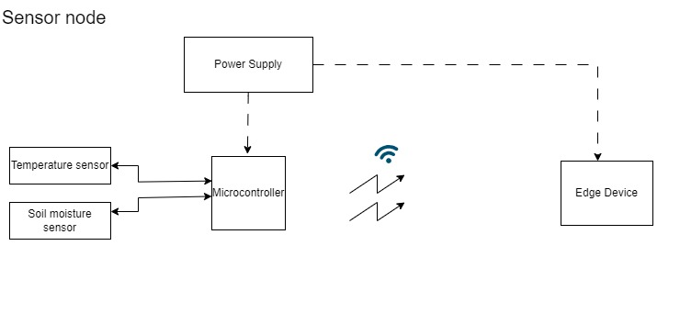

Solenoid Valve

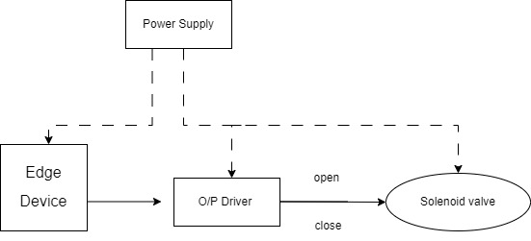

**5.Dependencies/Show Stopper**

* Establishing communication between sensor node and edge device.
* Self- Sustainable power supply for sensor nodes.
* Decision making through Edge Computing.

**6. Tools & Technologies: -**

## 

## Hardware Tools: -

* Microcontroller board
* Soil moisture sensor
* Device drivers
* Communication Module
* Power supply

Software Tools: -

* Embedded Programming
* IDE (Integrated Development Environment)
* Communication module software

**7. References: -**

* **International Journal of Engineering**- Automated Irrigation System using WSN and GPRS Module
* **Choudhary, Himanshu, and A. K. Misra**- International Conference on Communication Systems and Network Technologies. IEEE, 2013
* **Google Scholar-** Google Scholar is a platform to search for academic papers and research articles related to tech in irrigation, AI in agriculture, and related topics.