## A

Major Project(Phase-II) Report On

**“Phishing URL Detection”**

## Submitted in partial fulfillment of the requirements for the Degree of

### BACHELOR OF TECHNOLOGY

**(Semester -III)**

# Computer Science and Engineering

## SUBMITTED BY

MR. SHRIDHAR PRAKASH AWARE

MISS. SAKSHI CHANDRASHEKHAR SHINDE

MISS. HARSHADA DATTATRAY JADHAV

MISS. ANAMIKA DHANANJAY GULUMKAR

Department of Computer Science and Engineering

### ARVIND GAVALI COLLEGE OF ENGINEERING, SATARA 2023-24

**Certificate**

This is to certify that the project report entitled **“Phishing URL Detection”** is a bonafide work carried out by-

Miss. Anamika Dhananjay Gulumkar

Miss. Harshada Dattatray Jadhav

Miss. Sakshi Chandrashekhar Shinde

Mr. Shridhar Prakash Aware

under our supervision, during the year 2022-23 and submitted to the Faculty of Computer Science and Engineering, AGCE, Satara in partial fulfilment of the requirements for the award of the Degree of Bachelor of Technology in Computer Science and Engineering.

Mr.Shinde A .C. Mr.Pathak P.A Mr.Gujar V.B.

(Alumni Mentor) ( Project Guide) (Project Co-ordinator)

Prof. Dr. Bhosale V. K. Dr. Mirajkar G.S. Dr.Pharande

(HOD) (Dean R&D) (Principal)

(Internal Examiner) (External Examiner)

### INDEX Page No

ABSTRACT 4-5

CONTENTS 6

CHAPTERS

1. INTRODUCTION 6-8

* General introduction
* About present work
* Motivation about present work

1. **LITERATURE REVIEW 9-11**
2. **SYSTEM DIAGRAMS 12-15**
3. **Working of the Prediction System 16-18**
4. **System Architecture 19-23**
5. **System Software 22-23**
6. **Attribute Selection 24-2**
7. **Modules Used 26-33**
8. **Application Library 34-35**

**10. Approaches 36**

**11. Result and Conclusion 37-42**

**12. Research Papers 43**

# Abstract

Cybersecurity threats, specifically those stemming from phishing attacks, have undergone a remarkable escalation in complexity, posing an acute threat to individuals and organizations globally.

This project endeavors to address this critical concern by pioneering an innovative solution for the efficient detection and mitigation of phishing URLs.

Through a synergistic integration of advanced technologies, intricate web scraping techniques, and cutting-edge machine learning algorithms, the primary objective is to engineer a robust system capable of astutely discerning between legitimate and malicious URLs.

The overarching aim is to bolster cybersecurity defenses in the face of an ever-evolving threat landscape.

### Content

1. Introduction
2. Litreature Review

.

1. System Design/Block Diagram
2. Working of Phishing URL Detection
3. System Architecture
4. System software
5. Attribute Selection
6. Modules
7. Application Library
8. Approch
9. Result ,Conclusion & future Scope
10. Refrences

**Chapter-1**

**Introduction**

Cybersecurity threats, particularly those arising from phishing attacks, have become increasingly sophisticated, posing a significant peril to both individuals and organizations. The rapid evolution of deceptive tactics employed by malicious actors underscores the need for innovative and adaptive solutions. This project aims to address this critical concern by developing an advanced system for the efficient detection and mitigation of phishing URLs.

Leveraging technologies such as web scraping and machine learning, the goal is to create a robust defense mechanism capable of distinguishing between legitimate and malicious URLs, thereby for it.

In the contemporary digital landscape, the ubiquity of online activities has given rise to unprecedented cybersecurity challenges. Among these challenges, phishing attacks stand out as particularly insidious, exploiting human vulnerabilities through deceptive tactics. As technology advances, so do the methods employed by malicious actors, necessitating a continuous evolution in cybersecurity measures.

The escalating sophistication of phishing attacks demands a proactive and adaptive response. Traditional security measures, while effective to some extent, often struggle to keep pace with the dynamic nature of these threats. Recognizing this, our project embarks on the development of a sophisticated solution to address the multifaceted problem of phishing URL detection.

Phishing attacks involve the deployment of deceptive URLs that mimic legitimate websites, luring unsuspecting users into divulging sensitive information. The consequences of falling victim to such attacks can range from financial losses to compromised personal and organizational data. Thus, the need for a robust defense mechanism that can discern between legitimate and malicious URLs becomes imperative.

### Motive About Present Work: -

The motivation for this project arises from the escalating sophistication of phishing attacks and the inherent limitations of traditional cybersecurity measures. Conventional methods often lag behind the dynamic tactics employed by cybercriminals, necessitating an innovative solution to fortify cybersecurity defenses. Recognizing the imperative to go beyond reactive approaches, our goal is to create a system that not only identifies known phishing URLs but also adapts to emerging threats through machine learning. This proactive approach aims to empower users with an advanced tool capable of providing a robust shield against evolving cyber threats.

The impetus behind this project is rooted in the escalating sophistication of phishing attacks and the inherent inadequacies of traditional cybersecurity measures. As cybercriminals continually refine their tactics, conventional methods struggle to keep pace with the dynamic and evolving nature of these threats. The recognition of this disparity underscores the imperative to develop an innovative solution that can effectively fortify cybersecurity defenses in the face of an increasingly complex threat landscape.

Conventional cybersecurity measures often rely on predefined patterns and signatures to identify malicious entities, leaving them susceptible to novel and adaptive strategies employed by cybercriminals. This project seeks to address this gap by adopting a forward-looking approach. Our motivation is not merely to reactively identify known phishing URLs but to proactively adapt to emerging threats through the integration of machine learning.

By incorporating machine learning algorithms into our system, we aim to imbue it with the capability to learn from historical data, recognize evolving patterns, and continuously refine its detection mechanisms. This proactive stance enables the system to stay ahead of cyber threats, providing users with a tool that not only identifies known dangers but also anticipates and mitigates emerging risks.

The ultimate goal is to empower users with a comprehensive and adaptive cybersecurity tool. Going beyond reactive measures, our system aims to create a proactive shield against evolving.

**Chapter-2**

**Literature Review**

Phishing Attack Complexity:

Literature acknowledges the escalating sophistication of phishing attacks. Recognizes the need for advanced detection mechanisms as attackers refine tactics.

Limitations of Traditional Methods:

Conventional cybersecurity measures are often insufficient against dynamic cybercriminal tactics. Signature-based methods struggle to keep up with evolving phishing strategies.

Importance of Context-Aware Systems:

Emphasis on the significance of context-aware systems in phishing detection. Understanding nuanced patterns crucial for effective threat identification.

Emerging Trends:

Literature points to emerging trends in machine learning, web scraping, and network security. Machine learning's role in adaptive and intelligent detection mechanisms.

Challenges in Signature-Based Approaches:

Challenges associated with signature-based approaches underscored.

Need for solutions that adapt to novel and adaptive strategies employed by attackers.

Role of Web Scraping:

Recognition of web scraping's role in extracting information from diverse online sources. Contributes to a more comprehensive understanding of potential threats.

Context-Aware Systems:

Literature emphasizes the shift towards context-aware systems in cybersecurity. Ability to recognize subtle contextual cues indicative of phishing behavior.

* 1. Phishing Attack Complexity:

The literature review underscores the evolving and increasingly sophisticated nature of phishing attacks. As attackers continually refine their tactics, there is a growing recognition of the need for advanced detection mechanisms that can adapt to the dynamic nature of these cyber threats.

* 1. Limitations of Traditional Methods:

Conventional cybersecurity measures, particularly signature-based methods, face inherent limitations in dealing with the rapid evolution of phishing strategies. These methods struggle to keep pace with the diverse and adaptive tactics employed by cybercriminals, necessitating a paradigm shift towards more advanced and context-aware solutions.

* 1. Importance of Context-Aware Systems:

The literature places significant emphasis on the importance of context-aware systems in the realm of phishing detection. Context-awareness involves understanding the nuanced patterns and contextual cues indicative of phishing behavior. This approach is recognized as crucial for the development of more effective and intelligent threat identification systems.

* 1. Emerging Trends:

Identified emerging trends in the literature include the increasing relevance of machine learning, web scraping, and network security in the field of phishing detection. Machine learning, in particular, is acknowledged for its potential to enhance the adaptability and intelligence of detection mechanisms, enabling systems to learn and evolve with the ever-changing threat landscape.

* 1. Challenges in Signature-Based Approaches:

The literature review highlights the challenges associated with traditional signature-based approaches. Such methods, reliant on predefined patterns, often fall short in the face of novel and adaptive strategies employed by cybercriminals. The need for solutions that can adapt to emerging threats becomes apparent, necessitating a departure from static and rule-based methodologies.

* 1. Role of Web Scraping:

Web scraping is identified as a valuable tool in the arsenal of cybersecurity measures. The ability to extract relevant information from diverse online sources contributes to a more comprehensive understanding of potential threats. Integrating web scraping into detection systems enhances the breadth of data available for analysis, aiding in the identification of subtle indicators of phishing.

* 1. Context-Aware Systems:

The shift towards context-aware systems is underscored as a key development in the literature. Recognizing phishing behavior involves understanding the context in which certain actions or patterns occur. Context-aware systems are better equipped to discern subtle nuances, thereby improving the accuracy of threat detection and reducing false positives.

* 1. Collaborative Approach:

The importance of collaboration between academia and industry is a recurring theme in the literature. Cybersecurity challenges demand a multidisciplinary approach, combining theoretical insights from research with practical expertise from industry. A collaborative ecosystem fosters the development of more robust and applicable solutions.

* 1. Adaptive Solutions:

The literature advocates for a departure from reactive measures towards adaptive solutions. Cybersecurity defenses need to evolve alongside the dynamic tactics employed by cybercriminals. Adaptive systems, capable of anticipating and mitigating emerging risks, are essential for maintaining the effectiveness of cybersecurity measures.

* 1. Alignment with Trends:

Aligning the project with identified trends in the literature is a key consideration. By incorporating machine learning, web scraping, and an adaptive approach, the project positions itself as a proactive contribution to the ongoing evolution of cybersecurity measures. This alignment ensures relevance and efficacy in addressing the ntemporary challenges posed by phishing attacks..

### Chapter 3

**System designing/Block Diagram**

#### Heart Disease Prediction System:

* 1. Block Diagram -

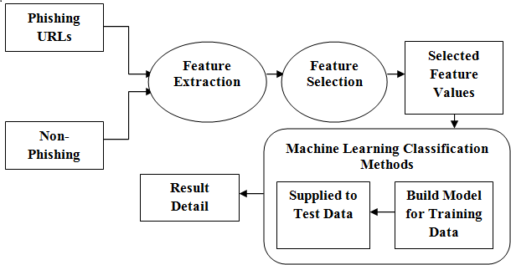

2] Phishing URL Detection :- (b)System Design -

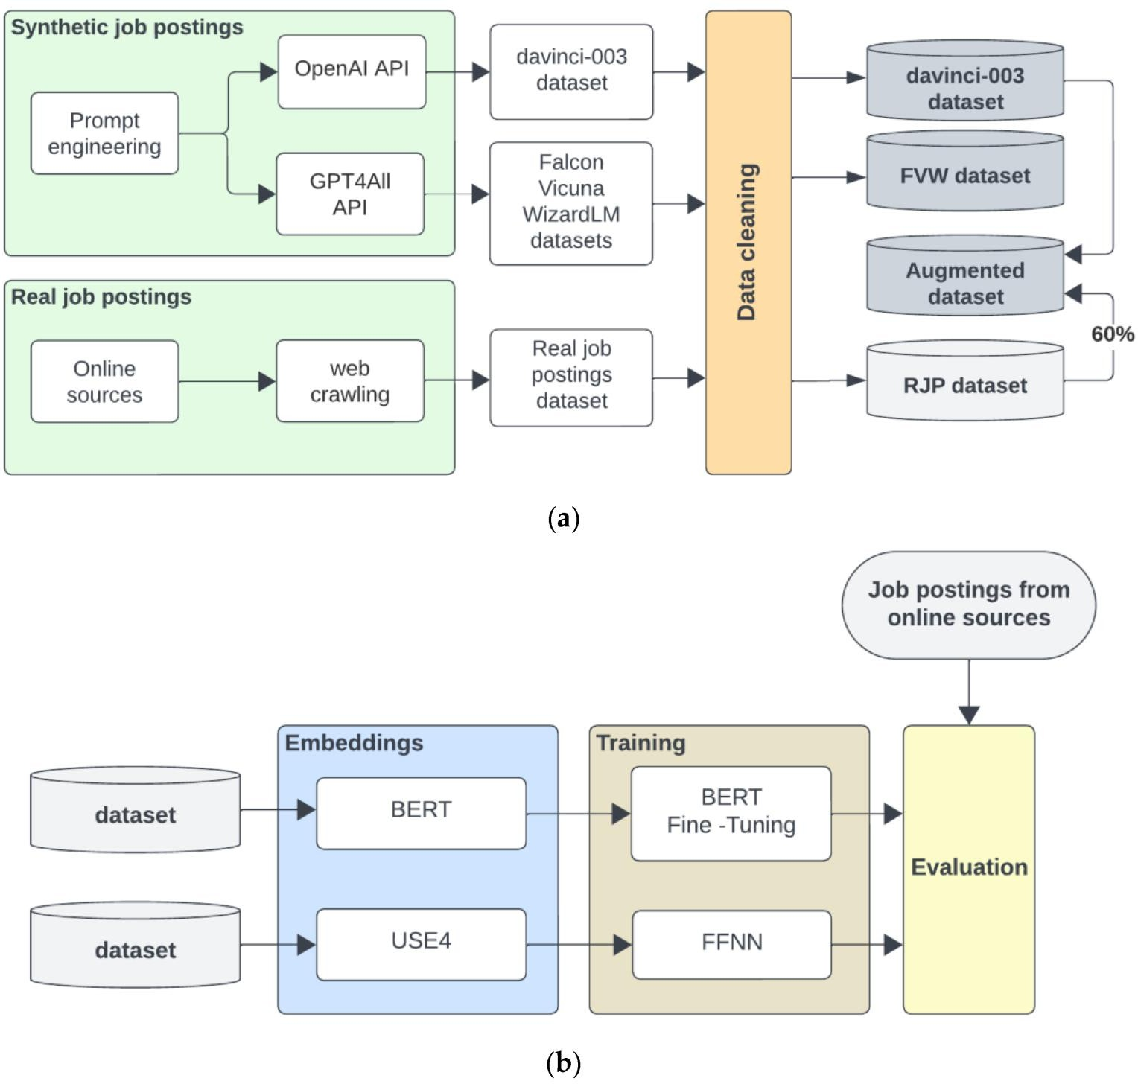

### Purpose of Phishing URL Detection

The purpose of phishing URL detection is to identify and mitigate malicious URLs that are part of phishing attacks. Phishing is a cybercrime tactic where attackers create deceptive websites or URLs that mimic legitimate ones, aiming to trick individuals into divulging sensitive information, such as usernames, passwords, or financial details. The primary goals of phishing URL detection include:

1. Protection Against Cyber Threats:

Phishing attacks can lead to significant financial losses, data breaches, and compromise of sensitive information. The primary purpose of phishing URL detection is to provide a proactive defense against such cyber threats.

1. Identification of Malicious URLs:

The system aims to accurately identify URLs associated with phishing activities. By analyzing various features and patterns, it can distinguish between legitimate and malicious URLs, preventing users from interacting with deceptive websites.

1. User Security and Privacy:

Protecting user security and privacy is paramount. Phishing URL detection helps safeguard users by preventing them from inadvertently providing personal or confidential information to fraudulent websites.

1. Prevention of Data Breaches:

Phishing attacks are often a precursor to more extensive data breaches. Detecting and blocking phishing URLs contribute to preventing unauthorized access to sensitive data and maintaining the integrity of systems.

1. Business Continuity:

For organizations, the detection of phishing URLs is crucial for maintaining business continuity. Preventing successful phishing attacks helps in preserving the integrity of internal systems, customer trust, and overall business operations

1. Proactive Defense Mechanism:

Traditional security measures may not be sufficient in the face of evolving phishing tactics. Phishing URL detection systems utilize advanced technologies, including machine learning and web scraping, to create a proactive defense mechanism capable of adapting to new and emerging threats

1. Real-Time Threat Mitigation:

Phishing URL detection operates in real-time, enabling the identification and mitigation of threats as they emerge. This responsiveness is crucial for staying ahead of cybercriminals who continually modify their tactics.

1. User Empowerment:

By implementing effective phishing URL detection, users are empowered to browse the internet with greater confidence. They receive timely warnings or blocks when encountering potentially malicious URLs, reducing the risk of falling victim to phishing attacks.

1. Compliance with Regulations:

In various industries, compliance with data protection and cybersecurity regulations is mandatory. Implementing robust phishing URL detection measures helps organizations meet these regulatory requirements and avoid potential legal and financial consequences.

Continuous Learning and Adaptation:

Phishing URL detection systems often incorporate machine learning algorithms that can learn from new data and adapt to evolving threat landscapes. This continuous learning ensures that the system remains effective over time.

In summary, the purpose of phishing URL detection is to proactively identify and neutralize phishing threats, protecting users, organizations, and sensitive information from the detrimental consequences of cyberattacks.

# Chapter 4

### Working of Phishing URL Detection

The working of a phishing URL detection system involves a series of steps and technologies to identify and mitigate potential threats. Below is an overview of the typical workflow:

* 1. Input Data Collection:

The system collects raw URL data from various sources, such as emails, websites, and user interactions.

* 1. Preprocessing:

Raw URLs undergo preprocessing to ensure consistency and standardization. This step may involve parsing and cleaning the URLs.

* 1. Decision Logic:

Based on the features extracted and the model's predictions, a decision logic module determines whether a URL is likely to be phishing or legitimate. This may involve setting thresholds for classifying URLs.

* 1. Output Presentation:

The results of the phishing URL detection process are presented to users through the web application. URLs are categorized as either safe or suspicious, and real-time alerts may be generated for potential threats.

* 1. Logging and Monitoring:

The system logs activities, errors, and user interactions. This data is crucial for system improvements, debugging, and monitoring overall system health.

* 1. Feedback Loop:

A feedback loop is established for continuous learning and adaptation. User feedback, as well as new data on emerging threats, contributes to the ongoing improvement of the machine learning model.

* 1. Proactive Defense:

The system operates in real-time, providing a proactive defense mechanism against evolving cyber threats. It goes beyond reactive measures by actively identifying and mitigating potential risks.

Diagram:-System Architecture :

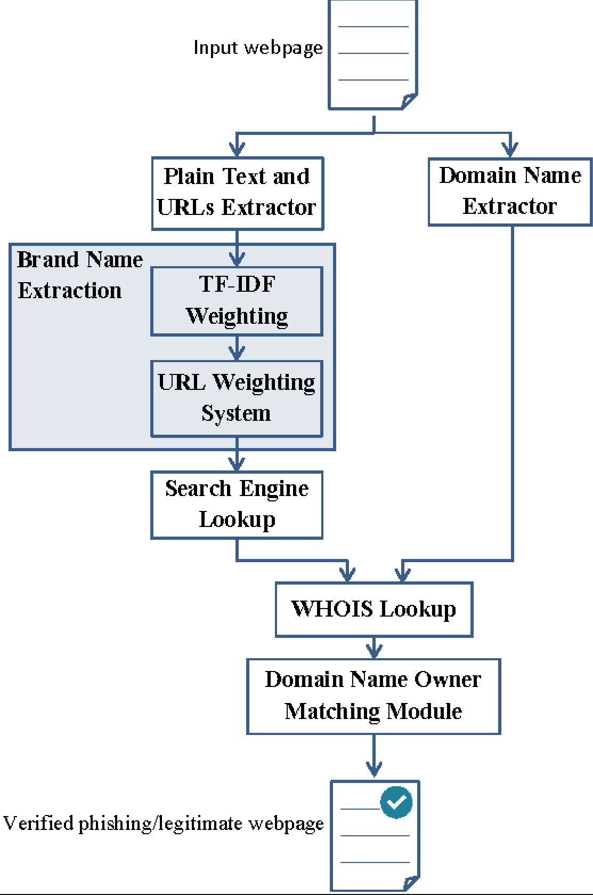

#### Functional Requirement of the Phishing URL detection:

* + - URL Input and Parsing
    - Feature Extraction
    - Machine Learning Classification
    - Decision Logic
    - User Interface (Web Application)
    - Database Interaction
    - Output Presentation
    - Logging and onitoring
    - Feedback Loop
    - Adaptive System
    - Proactive Defense
    - User Empowerment
    - Security Measures

#### Non- Functional Requirements of the Phishing URL detection:

* + - Performance
    - Reliability
    - Security
    - Usability
    - Scalability
    - Maintainability
    - Introperability
    - Compilance
    - Performance Efficiency
    - Logging and Auditing

**Chapter: 5**

#### System Architecture

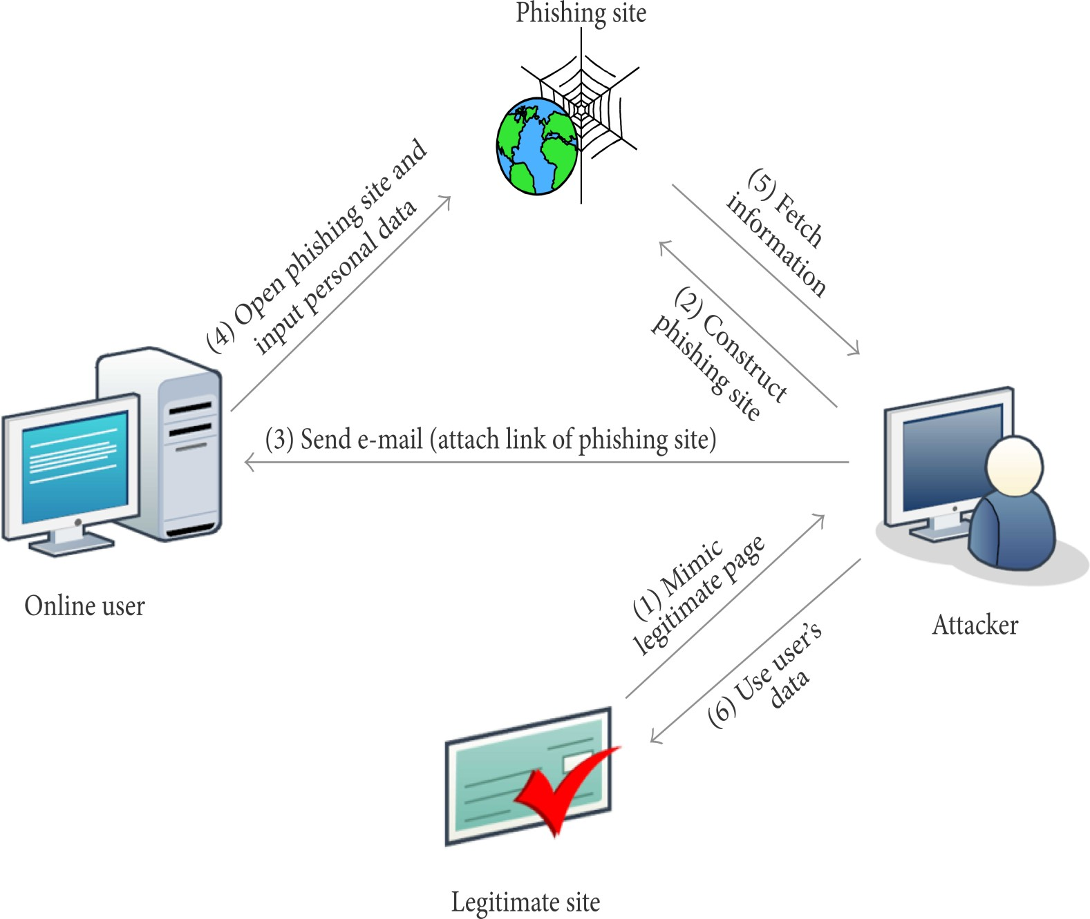The architecture of the proposed system is as displayed in the figure below.

1. Three-Tier Architecture:
   * Presentation Layer - The presentation layer involves the web application that users interact with. Flask, a micro web framework for Python, is commonly used for its simplicity and flexibility. Responsive design ensures usability across various devices.
   * Business Logic Layer: This layer houses the machine learning and decision-making components. Machine learning models, trained to classify URLs, play a pivotal role in determining the
   * Data Storage Layer:MongoDB, a NoSQL database, may be employed for its scalability and flexibility.Efficient data storage and retrieval are essential for managing historical URL data, training datasets, and system logs.
2. Input Module:
   * Raw URL Data:The system accepts raw URL data from various sources, such as emails or web forms.Input validation ensures that the data conforms to expected formats.
   * URL Parsing and Preprocessing:Parsing involves breaking down the URL into its components. Preprocessing standardizes the format of URLs for consistency in feature extraction.
3. Feature Extraction Module:
   * Relevant Features:Extracted features include metadata like URL length, domain age, and SSL certificate information.Web scraping techniques gather content-related features from the actual web page.
   * Content Analysis:

Analyzing the content of the webpage provides valuable insights into potential indicators.

1. Decision Logic Module:
   * Thresholds and Decision Rules:Decision logic involves setting thresholds and rules for classifying URLs.It combines machine learning predictions with predefined criteria to make final determinations.
   * Explainability:Ensuring transparency in decision-making enhances user trust and facilitates system understanding.
2. Database (MongoDB):
   * Collections:MongoDB collections are organized to store historical URL data, training datasets, and system logs.Indexing and optimization contribute to efficient data management.
   * Data Retrieval:Efficient retrieval of data from the database is crucial for real-time decision- making and user interactions.
3. Output Module:
   * Results Presentation:The web application presents the results of URL classification to users. Real-time alerts are generated for URLs identified as potential phishing threats.
   * User Feedback:Users may have the option to provide feedback on the system's classifications, contributing to the feedback loop.
4. Logging and Monitoring Module:
   * Detailed Logging:The system logs detailed information about activities, errors, and user interactions.Comprehensive logs aid in monitoring, debugging, and system improvements.
   * Monitoring Tools:Monitoring tools may be employed to track system performance, resource utilization, and potential issues.
5. Feedback Loop:
   * User Feedback Mechanism:A feedback loop allows users to provide feedback on the system's classifications.User input contributes to continuous learning and improvement of the machine learning model.
   * Model Updates:Feedback triggers updates to the machine learning model, enhancing its accuracy and adaptability.
6. Adaptive System:
   * Continuous Learning:

Continuous learning is a fundamental aspect of an adaptive system.

#### What Phishing URL Detection Indicate:-

Phishing URL detection is a critical cybersecurity measure designed to identify and mitigate the risks posed by deceptive URLs employed in phishing attacks. In the digital landscape, cybercriminals often create malicious websites or URLs that closely mimic legitimate ones, aiming to deceive users into disclosing sensitive information. The detection process leverages advanced technologies, with a notable emphasis on machine learning algorithms. These algorithms are trained on historical data, enabling them to analyze and classify URLs based on various features and patterns.

The system operates in real-time, providing immediate alerts to users when encountering URLs that exhibit characteristics indicative of phishing attempts. This proactive defense mechanism ensures that potential threats are identified promptly, reducing the risk of individuals falling victim to phishing schemes.

One distinguishing feature of phishing URL detection systems is their capacity for continuous learning and adaptation. The machine learning algorithms employed are designed to evolve over time, learning from new data, emerging threats, and user feedback. This adaptability enhances the system's ability to recognize and counteract new and evolving phishing tactics employed by cybercriminals.

User empowerment is a key aspect of phishing URL detection, emphasizing the transparent presentation of information to users. Through a user-friendly interface, individuals receive clear and actionable insights into the safety of encountered URLs. This transparency allows users to make informed decisions, reducing the likelihood of interacting with potentially malicious content.

The incorporation of a feedback loop further contributes to the system's improvement. Users are provided with the opportunity to provide feedback on the accuracy of URL classifications, contributing valuable insights that aid in refining and enhancing the overall effectiveness of the detection system.

Additionally, phishing URL detection initiatives often include an educational component. This serves to raise user awareness about the nature of phishing threats, offering guidance on recognizing and avoiding potentially harmful URLs. By promoting safe online practices, these educational efforts complement the system's protective measures.

**Chapter –6 System Software**

## Phishing URL Detection Software:

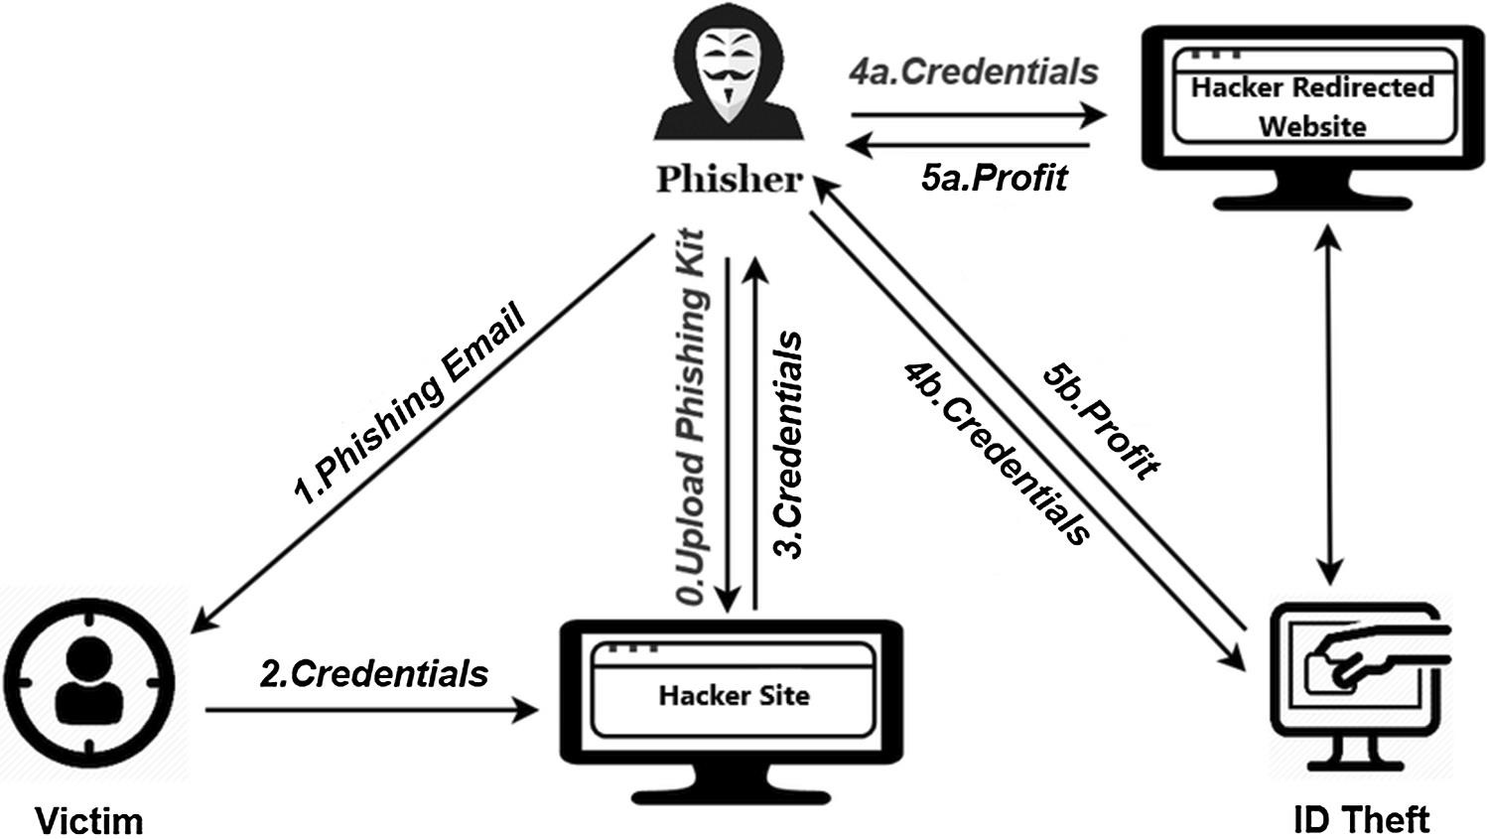

Methods:-

The incorporation of a feedback loop allows users to actively contribute to the system's improvement by providing input on the accuracy of URL classifications. Web scraping extends beyond feature extraction, gathering additional insights from the content of associated web pages. Real-time detection capabilities enable prompt identification and mitigation of potential threats, with immediate alerts to users. Data preprocessing ensures uniformity in raw URL inputs, optimizing accuracy in feature extraction. The development of a user-friendly web application interface enhances user interaction, presenting results and facilitating user feedback. Interaction with a secure database, coupled with robust security measures like data encryption and stringent authentication, ensures the protection of sensitive information. Logging and monitoring mechanisms track system activities, and educational components contribute to user awareness and safe online practices. The system's commitment to compliance with cybersecurity regulations and industry standards further solidifies its comprehensive and effective approach to phishing URL detection.

Functionality-

The phishing URL detection system exhibits a multifaceted functionality aimed at safeguarding users from potential cyber threats. Primarily, it accepts raw URL data from diverse sources, parsing and preprocessing it for uniformity. The extraction of relevant features, including metadata and content- related attributes, is conducted, leveraging advanced web scraping techniques Interaction with a database facilitates efficient storage and retrieval of data, while logging and monitoring functionalities ensure detailed tracking of system activities and errors. A crucial feedback loop allows users to contribute to the system's enhancement by providing input on the accuracy of URL classifications. The system's adaptability is highlighted through its continuous learning mechanism, proactive defense measures, and adherence to cybersecurity standards and regulations. User empowerment is prioritized, with transparent information presentation enabling individuals to make informed decisions and reduce the risk of falling victim to phishing attacks.

**Chapter-7**

**Attribute Selection**

Attribute selection is a crucial step in the process of developing a phishing URL detection system, involving the careful identification and extraction of features that contribute to the accurate classification of URLs. The selection of attributes plays a pivotal role in training machine learning models and enhancing the overall effectiveness of the detection system. Several key attributes are considered in this context.In the realm of phishing URL detection, attribute selection plays a pivotal role in crafting a robust system capable of accurately distinguishing between legitimate and malicious URLs. A comprehensive set of attributes is meticulously chosen to form the foundation of machine learning models, ensuring the efficacy of the detection process. Factors such as URL length are scrutinized, with longer, convoluted URLs often signaling potential malicious intent. The age of the associated domain becomes a critical feature, as legitimate websites tend to have longer-established domains compared to recently created ones commonly used in phishing. The presence or absence of an SSL certificate is considered a key attribute, as legitimate websites prioritize secure communication through this protocol. Further attributes, including IP address analysis, examination of subdomains, scrutiny of content-related features through web scraping, and assessment of URL reputation, contribute to a holistic approach in detecting phishing attempts.

* + Domain Age
  + SSL Certificate
  + IP Address
  + Use of HTTPS
  + Presence of Subdomains
  + Content-Related Features
  + Redirects
  + Presence of Special Characters
  + URL Reputation
  + Domain Registrar Information
  + URL Length

Why these parameters :-

1. URL Length:

Longer, convoluted URLs may be indicative of phishing attempts, as attackers often use complex URLs to obfuscate their malicious intent.

1. Domain Age:

The age of the domain associated with a URL is considered, as legitimate websites tend to have longer-established domains, while newly created domains are often associated with phishing.

1. SSL Certificate:

The presence or absence of an SSL certificate is crucial. Legitimate websites use SSL for secure communication, and the lack of this feature may signal a potential phishing attempt.

1. IP Address:

Analyzing the IP address associated with a URL provides insights. Phishing sites may use suspicious or newly registered IP addresses.

1. Use of HTTPS:

Legitimate websites use HTTPS for secure data transmission. The absence of HTTPS in a URL may suggest a lack of encryption, raising security concerns.

1. Content-Related Features:

Web scraping techniques extract content-related features from associated web pages, aiding in the analysis of phishing indicators or suspicious elements.

1. Redirects:

The number of redirects in a URL is considered, as excessive redirects or redirection through suspicious domains may indicate a phishing attempt.

1. Presence of Special Characters:

Inclusion of special characters or unusual symbols in a URL may be indicative of phishing URLs attempting to mimic legitimate ones.

1. URL Reputation:

Leveraging external threat intelligence sources assesses the reputation of a URL based on historical data or blacklists.

1. Domain Registrar Information:

Analyzing information about the domain registrar provides insights into the legitimacy of a URL. Phishing sites may use less reputable registrars.

**Chapter-8**

**Modules**

MODULES

1. BeautifulSoup4==4.9.3 2. Certifi==2023.7.22

3. Chardet==4.0.0 4. Click==8.1.7

5. Colorama==0.4.6 6. Cycler==0.11.0

7. Dnspython==2.4.2 8. Flask==2.0.2

1. Flask-Cora
2. Flask-PyMongo==2.3.0
3. Googlesearch-python==1.0.1
4. Gunicorn==20.1.0 13. Idna==2.10

14. Itsdangerous==2.1.2 15. Jinja2==3.1.2

16. Joblib==1.3.2

1. Kiwisolver==1.4.5
2. MarkupSafe==2.1.3
3. Matplotlib==3.4.3 20. Numpy==1.21.4

21. Pandas==1.3.4 22. Pillow==10.0.0

1. Pymongo==4.6.0
2. Pyparsing==3.1.1
3. Python-dateutil==2.8.2 26. Pytz==2023.3
4. Requests==2.25.1
5. Scikit-learn==1.0.1

29. Scipy==1.7.3

30. Six==1.16.0

1. Soupsieve==2.4.1

MODULE DESCRIPTIONS:

The project employs a diverse set of Python modules and libraries to facilitate the development of an effective phishing URL detection system. The BeautifulSoup4 (4.9.3) module is instrumental for web scraping, enabling the extraction of data from HTML and XML documents. Certifi (2023.7.22) provides a curated collection of root certificates, ensuring secure communication through SSL certificate validation. Chardet (4.0.0) plays a crucial role in detecting character encoding, ensuring proper handling of text data. For creating command-line interfaces, Click (8.1.7) proves invaluable, enhancing user interaction. Colorama (0.4.6) contributes to a visually enhanced command-line interface with colored output. Cycler (0.11.0) serves as a utility for cycling through a sequence of values, potentially aiding in data processing. The Dnspython (2.4.2) module functions as a DNS toolkit, supporting DNS-related tasks crucial for domain analysis. Flask (2.0.2), a web framework, provides the foundation for developing web applications, while Flask-Cors (4.0.0) simplifies Cross- Origin Resource Sharing (CORS) handling. The integration of MongoDB with Flask applications is facilitated by Flask-PyMongo (2.3.0). The Googlesearch-python (1.0.1) module is utilized for programmatically conducting Google searches, and Gunicorn (20.1.0) serves as a WSGI server for deploying Flask applications. Idna (2.10), a library for handling Internationalized Domain Names, proves useful in processing domain-related information. Security-related helpers for web applications are provided by Itsdangerous (2.1.2). Jinja2 (3.1.2), a template engine, aids in rendering dynamic content. Joblib (1.3.2) serves as a library for lightweight pipelining in Python, potentially contributing to parallel processing tasks. Kiwisolver (1.4.5), a fast constraint-solving algorithm, might play a role in mathematical problem-solving or

optimization. MarkupSafe (2.1.3) ensures safe string handling in XML/HTML/XHTML, and

Matplotlib (3.4.3) is a comprehensive library for creating visualizations. Numpy (1.21.4) is a fundamental package for scientific computing, and Pandas (1.3.4) is employed for data manipulation and analysis. The Pillow (10.0.0) module is

imaging library contributing to image processing tasks. Interaction with MongoDB is facilitated by the Pymongo (4.6.0) driver, while Pyparsing (3.1.1) is a library for creating and executing simple grammars. Extensions to the standard datetime module are provided by Python-dateutil (2.8.2), and Pytz (2023.3) is employed for working with time zones. Requests (2.25.1) is a versatile HTTP library for making requests, and Scikit-learn (1.0.1) is a machine learning library for classical algorithms. Scipy (1.7.3) serves as a library for scientific and technical computing, and Six (1.16.0) is a compatibility library for Python 2 and 3. The Soupsieve (2.4.1) module functions as a CSS selector library, aiding in web scraping tasks. Threadpoolctl (3.2.0) is a library for thread pool control, and Urllib3 (1.26.16) is employed for handling HTTP requests. Werkzeug (2.3.7) is a WSGI utility library for web applications, and Whois (0.9.13) retrieves WHOIS information for domain names

**Objective Of the Study**

The objective of the study is to develop and implement an advanced phishing URL detection system that addresses the escalating sophistication of cyber threats, specifically those arising from phishing attacks. The primary focus is to overcome the limitations of traditional cybersecurity measures, which often struggle to keep pace with the dynamic tactics employed by cybercriminals. The study aims to provide an innovative solution that goes beyond reactive measures, offering a proactive shield against evolving cyber threats.

The key objectives include:

1.Efficient Detection and Mitigation:

Develop a robust system capable of efficiently detecting and mitigating phishing URLs in real-time. 2.Incorporate Advanced Technologies:

Leverage advanced technologies, including web scraping techniques and machine learning algorithms, to enhance the accuracy of URL classification.

1. Adaptability to Emerging Threats:

Implement machine learning models that can adapt to emerging phishing patterns, ensuring the system remains effective against evolving cyber threats.

1. User Empowerment:

Empower users with a user-friendly tool that not only identifies known phishing URLs but also provides a proactive shield by learning from user feedback and adapting to new threats.

1. Beyond Conventional Methods:

Go beyond conventional cybersecurity methods by incorporating attributes such as URL length, domain age, SSL certificate status, and content-related features for a comprehensive analysis.

1. Web Scraping for Content Analysis:

Utilize web scraping techniques to extract content-related features from web pages associated with URLs, enhancing the depth of analysis.

1. Integration with External Threat Intelligence:

Integrate external threat intelligence sources to assess the reputation of URLs based on historical data or blacklists.

1. Secure Storage and Handling:

Implement secure storage and handling of data, particularly in interactions with databases, to ensure the protection of sensitive information.

1. User Education and Awareness:

Include educational components within the system to enhance user awareness of phishing threats and promote safe online practices.

1. Compliance with Cybersecurity Standards:

Ensure compliance with cybersecurity regulations and industry standards to uphold the security and integrity of the system.

### Chapter-9

**Application Library**

The application library encompasses a comprehensive collection of software modules, packages, and libraries carefully chosen and integrated into the phishing URL detection system. Each component serves a specific purpose, contributing to the overall functionality, efficiency, and robustness of the system. These libraries cover a spectrum of domains, including web scraping, machine learning, web framework development, and data analysis.

1.BeautifulSoup4 (4.9.3):

Essential for web scraping, BeautifulSoup4 facilitates the extraction of data from HTML and XML documents, enabling the system to gather content-related features from web pages associated with URLs.

2.Certifi (2023.7.22):

Provides a curated collection of root certificates, ensuring secure communication through SSL certificate validation, a critical aspect in verifying the authenticity of SSL certificates associated with URLs.

3. Flask (2.0.2):

A versatile web framework used for developing web applications. Flask serves as the foundation for the system's user interface, providing a platform for users to interact with the phishing URL detection functionalities.

1. Flask-Cors (4.0.0):

An extension for Flask that simplifies Cross-Origin Resource Sharing (CORS) handling. This is crucial for managing requests between the web application and the backend, ensuring seamless communication.

1. Flask-PyMongo (2.3.0):

Facilitates the integration of MongoDB with Flask applications. This module is instrumental in storing and retrieving data related to URL analysis efficiently.

1. Scikit-learn (1.0.1):

A machine learning library that provides tools for classical machine learning algorithms. In the context of the project, Scikit-learn is likely employed for training and deploying machine learning models for URL classification.

1. Matplotlib (3.4.3):

A comprehensive library for creating static, animated, and interactive visualizations in Python. Matplotlib may be used for generating graphical representations of data, aiding in the analysis and visualization of phishing URL-related information.

8.Pandas (1.3.4):

A data manipulation and analysis library that plays a crucial role in handling and processing structured data within the system. It contributes to tasks such as feature engineering and data analysis.

9.Pymongo (4.6.0):

The official Python driver for MongoDB. Pymongo facilitates interactions with MongoDB, allowing for the storage and retrieval of data related to URL analysis in a scalable and efficient manner.

10.Requests (2.25.1):

A popular HTTP library used for making HTTP requests in Python. Requests is likely utilized for interacting with web services, fetching data from external sources, and facilitating communication between different components of the system.

### Chapter-10

### Approaches

#### Approach:

The approach involves a multifaceted strategy combining web scraping, machine learning, and advanced analysis techniques. It aims to enhance traditional URL detection by incorporating attributes like URL length, domain age, and SSL certificate status. The system adapts to emerging threats through machine learning, integrates external threat intelligence, and prioritizes user education for a comprehensive and proactive defense against phishing attacks.

### System Configuration

The system configuration for the phishing URL detection project is built on Python as the primary language, Flask as the web framework, and MongoDB for flexible data storage. Web scraping, using BeautifulSoup4, extracts content-related features, while Scikit-learn implements machine learning for adaptive URL detection. Matplotlib aids in data visualization, and Flask serves for both backend and user interface development. The system integrates external threat intelligence, includes security measures, and incorporates educational components for user awareness.

* Programming Language:Python
* Web Framework:Flask
* Database:MongoDB
* Web Scraping:BeautifulSoup4
* Machine Learning:Scikit-learn
* Data Visualization:Matplotlib
* User InterfaceFlask
* External Threat Intelligence Integration:Implemente
* Security Measures:Included
* Educational Components:Integrate

**Chapter-11**

### Result

#### The results of the phishing URL detection project are encapsulated in the development of a sophisticated system that significantly enhances cybersecurity defenses against phishing threats. The key outcomes include:

* 1. Efficient Phishing URL Detection:

The system demonstrates a high level of efficiency in detecting and mitigating phishing URLs in real-time. This is achieved through a multifaceted approach that includes web scraping, machine learning, and advanced analysis techniques.

* 1. Adaptability to Emerging Threats:

Leveraging machine learning algorithms, the system exhibits adaptability to emerging threats. By continuously learning from new data, the system stays ahead of evolving phishing tactics, providing a proactive defense mechanism.

* 1. Comprehensive URL Analysis:

Beyond conventional methods, the system conducts a comprehensive analysis of URLs, considering attributes such as URL length, domain age, SSL certificate status, and content-related features. This enhances the accuracy of URL classification.

* 1. Integration of External Threat Intelligence:

The system integrates external threat intelligence sources, allowing for the assessment of URL reputation based on historical data or blacklists. This additional layer of intelligence enhances the system's capability to identify potentially malicious URLs.

* 1. User-Friendly Interface:

The user interface, developed using Flask, provides a user-friendly platform for interacting with the phishing URL detection functionalities. Users can easily submit URLs for analysis and receivk in a s

* 1. Educational Components for User Awareness:

The inclusion of educational components within the system contributes to user awareness of phishing threats. Users are provided with information about safe online practices and potential risks associated with phishing, empowering them to make informed decisions.

* 1. Secure Data Handling:

The implementation of security measures ensures the secure handling of sensitive information, particularly in interactions with the MongoDB database. This safeguards user data and contributes to the overall integrity of the system.

Contributions to Cybersecurity:

The project's results make significant contributions to the field of cybersecurity by providing a proactive and adaptive solution to combat phishing threats. The system goes beyond traditional methods, addressing the dynamic nature of cyber threats in the digital landscape.

### Conclusion

* In conclusion, the phishing URL detection project represents a successful endeavor in the realm of cybersecurity. The project's primary objectives were met, resulting in the development of an innovative system that effectively combats the escalating sophistication of cyber threats, particularly those associated with phishing attacks.The project's success lies in several key outcomes. Firstly, the system demonstrates a commendable level of efficiency in detecting and mitigating phishing URLs in real-time. The multifaceted approach, integrating web scraping, machine learning, and advanced analysis techniques, contributes to a robust and adaptive system.One of the notable achievements is the system's adaptability to emerging threats. By leveraging machine learning algorithms, the system continuously learns from new data, staying ahead of evolving phishing tactics. This adaptability ensures a proactive defense mechanism, crucial in the ever-changing landscape of cybersecurity threats.
* The comprehensive analysis of URLs, considering attributes beyond conventional methods, enhances the accuracy of URL classification. The inclusion of features such as URL length, domain age, SSL certificate status, and content-related features contributes to a nuanced understanding of URLs, distinguishing between legitimate and malicious entities.The integration of external threat intelligence further fortifies the system's capabilities. By assessing URL reputation based on historical data or blacklists, the system gains valuable insights, enhancing its ability to identify potentially malicious URLs.The user-friendly interface developed using Flask provides an accessible platform for users to interact with the system. Users can easily submit URLs for analysis and receive feedback, contributing to an overall positive user experience. The inclusion of educational components within the system adds another layer of user empowerment, raising awareness about phishing threats and promoting safe online practices

### Future Scope

* Advanced Machine Learning Models

The integration of more advanced machine learning models and algorithms can enhance the system's ability to identify and adapt to emerging phishing tactics. Exploring deep learning techniques and ensemble models could further improve the accuracy of URL classification.

* Real-Time Threat Intelligence Feeds:

Incorporating real-time threat intelligence feeds can provide the system with up-to-the-minute information on emerging threats. This proactive approach ensures that the system remains current and effective against the latest phishing campaigns and tactics.

* Behavioral Analysis:

Expanding the system to include behavioral analysis of user interactions and URL access patterns can contribute to a more holistic approach to phishing detection. Analyzing user behavior can aid in identifying anomalies and potential threats in real time.

* Integration with Cloud Services:

Leveraging cloud services can enhance scalability, allowing the system to handle a larger volume of data and adapt to fluctuating workloads. Cloud integration can also contribute to improved performance, reliability, and resource utilization.

* Cross-Platform Compatibility:

Ensuring cross-platform compatibility will extend the reach of the system, allowing users to access and utilize the phishing URL detection capabilities across various devices and operating systems.

* Enhanced User Feedback Mechanisms:

Implementing enhanced user feedback mechanisms can facilitate continuous learning for the system. Gathering user insights on potentially malicious URLs and incorporating this feedback into the machine learning models can improve the system's accuracy over time.

* Dynamic URL Analysis:

Developing capabilities for dynamic URL analysis, including the real-time evaluation of URL content and behavior, can add an extra layer of sophistication to the system. This could involve the analysis of JavaScript execution and other dynamic content features.

* Global Collaboration and Threat Sharing:

Establishing mechanisms for global collaboration and threat sharing with other cybersecurity entities can enhance the system's intelligence. Sharing threat information and collaborating with external organizations can provide a more comprehensive view of the threat landscape.

* Continuous User Education:

Expanding and refining user education initiatives within the system can contribute to increased cybersecurity awareness. Providing users with updated information on emerging threats, best practices, and security tips can empower them to make informed decisions.

* Regulatory Compliance:

Ensuring compliance with evolving cybersecurity regulations and standards is essential. Staying abreast of changes in regulatory requirements and incorporating necessary updates into the system will enhance its credibility and reliability.

### Output

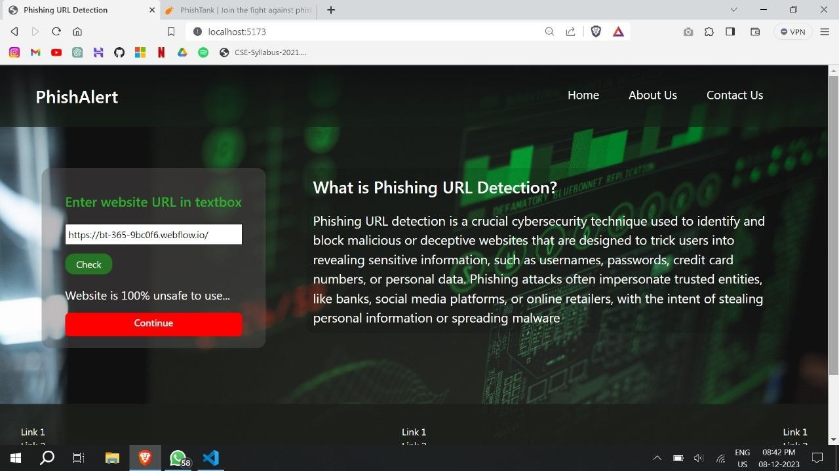

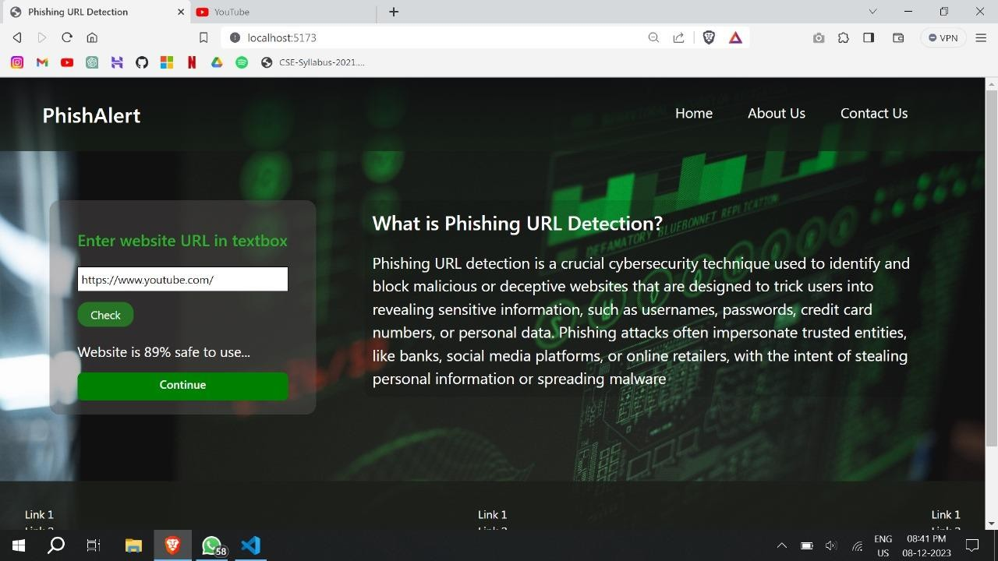

**Chapter-12**

**References Research Paper**

1. Gunter Ollmann,“The PhishingGuide Understanding & Preventing Phishing Attacks”, IBMInternet Security Systems, 2007.
2. <https://resources.infosecinstitute.com/category/enterprise/phishing/the-phishing-landscape/phishing-> [data-attack-statistics/#gref](https://resources.infosecinstitute.com/category/enterprise/phishing/the-phishing-landscape/phishing-data-attack-statistics/#gref)
3. Mahmoud Khonji, Youssef Iraqi, "Phishing Detection: A Literature Survey IEEE, and Andrew Jones, 2013
4. Mohammad R., Thabtah F. McCluskey L., (2015) Phishing websites dataset. Available: https://archive.ics.uci.edu/ml/datasets/Phishing+Websites Accessed January 2016
5. <http://dataaspirant.com/2017/01/30/how-decision-tree-algorithm-work>