**Spring Annotations**

**@Comoponent:**

* Scanning for Component Classes
* Spring will scan your Java classes for special annotations
* Automatically register the beans in the Spring container

**@Autowired:**

* For dependency injection, Spring can use auto wiring
* Spring will look for a class that matches the property
  + matches by type: class or interface
* Spring will inject it automatically ... hence it is autowired

Autowired Injection Types :

1. Constructor
2. Setter
3. Field

**@Qualifier:**

If multiple components are there, @Autowired annotation will be confused with which component/bean select. So we can use @Qualifier to mention bean id.

**@Scope:**

We can specify the scope of a bean.

**@PostConstruct:**

Init method.

**@PreDestroy:**

Destroy method.

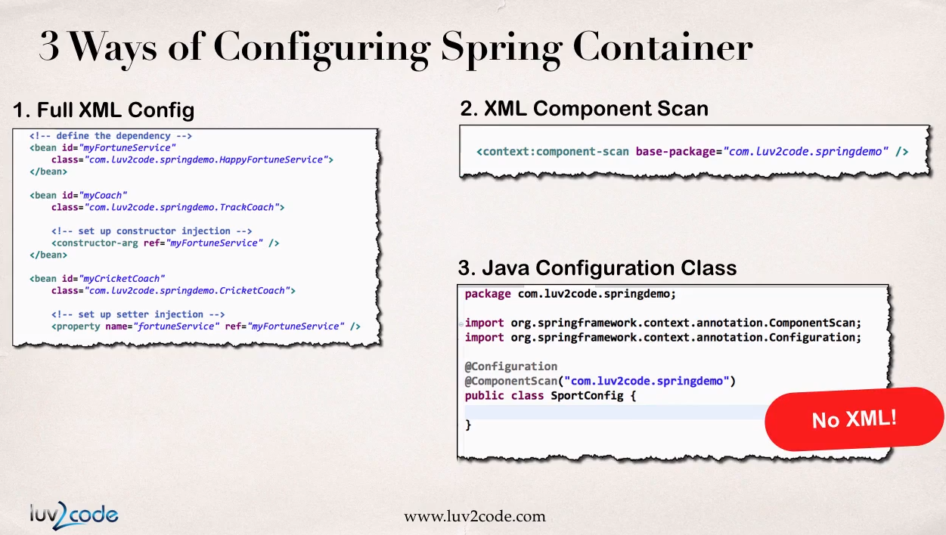

**@Configuration:**

Configuring spring container without using xml file.

**@ComponentScan(***package_name***):**

Package name to scan.

**@Bean:**

Defining bean in configuration class

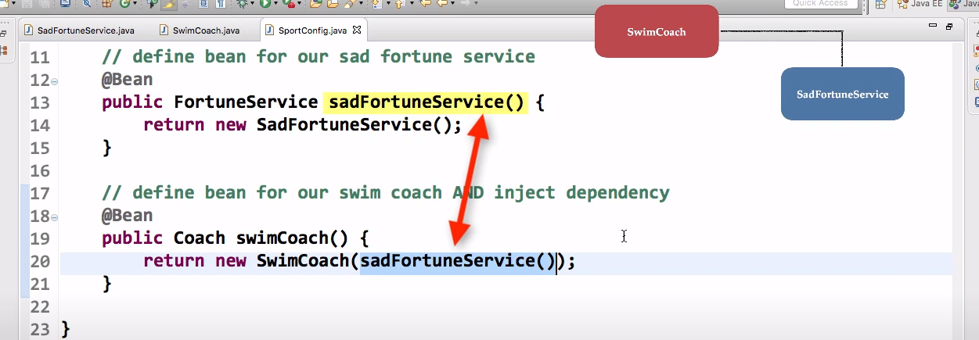

**@PropertySource("classpath:sport.properties"):**

Add property file

**@Value("${foo.email}"):**

Add values from properties file