**Maven**

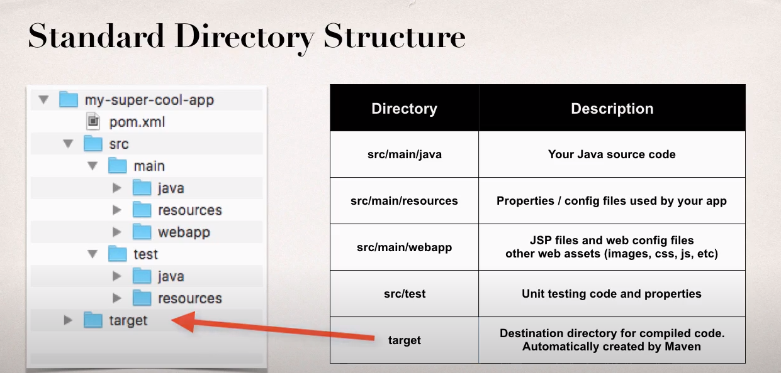

**Advantages of Maven**

* Dependency Management
  + Maven will find JAR files for you
  + No more missing JARS
* Building and Running your Project
  + No more build path /classpath issues
* Standard directory structure

**Project Object Model file: POM file**

* Configuration file for your project
* Basically your "shopping list" for Maven
* Located in the root of your Maven project

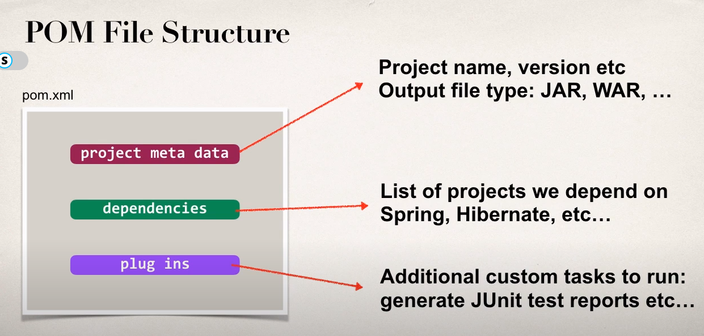

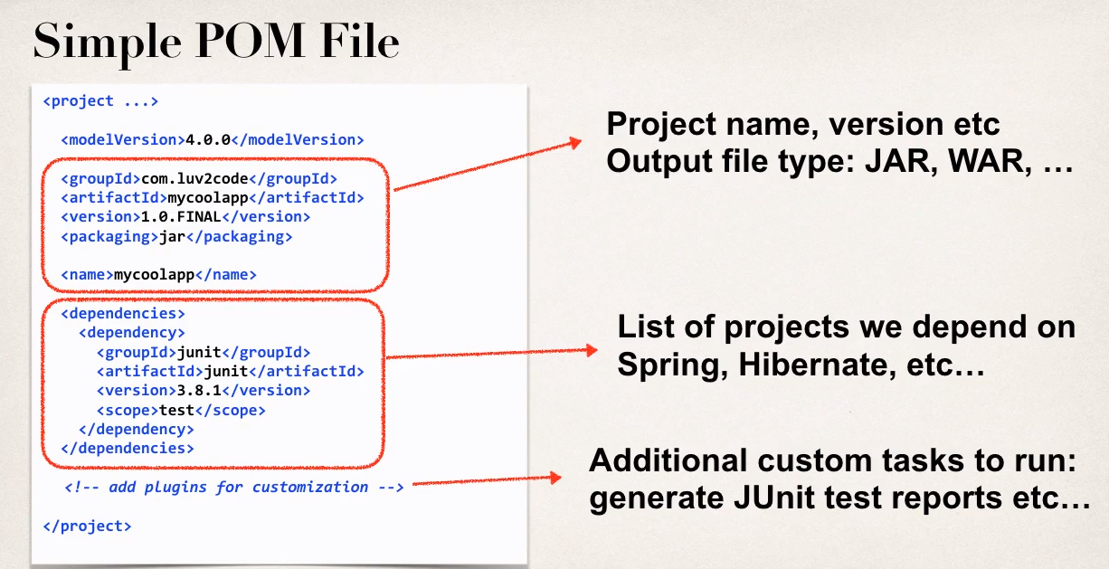

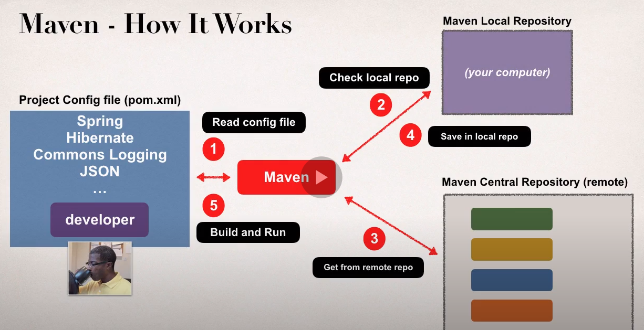

<https://search.maven.org/>

<https://mvnrepository.com/>