Git Kata Practice

git config --global user.name "ShridharDaga"

git config --global user.email “shridhar.daga@zemosolabs.com”

git clone <https link>

1. basic-commits - Very basic creation of commits.
cmd : git commit -m "chikoo added"
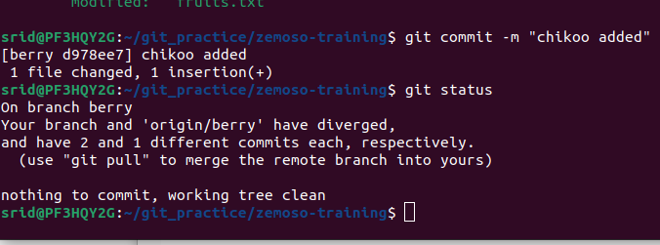
2. basic-staging - Interacting with the stage (index).
cmd : git status, git add . , git add -A, git add <file-name>
As you are working, you may be adding, editing and removing files. But whenever you hit a milestone or finish a part of the work, you should add the files to a Staging Environment.
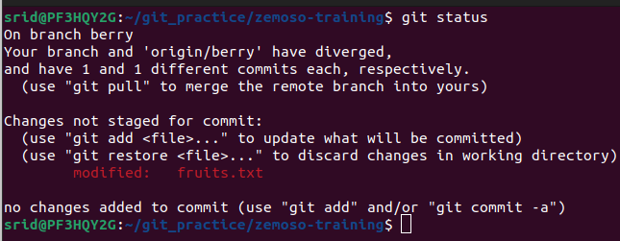
Staged files are files that are ready to be committed to the repository you are working on
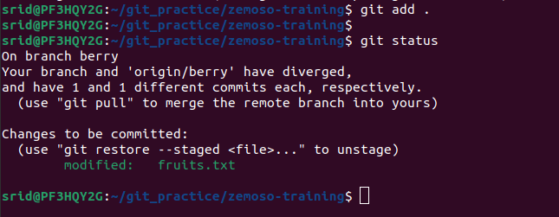
After add cmd

3. basic-branching - The first stride into branching.
Branches allow you to work on different parts of a project without impacting the main branch.
When the work is complete, a branch can be merged with the main project.
You can even switch between branches and work on different projects without them interfering with each other.

cmd : git branch
This cmd gives list of all branches
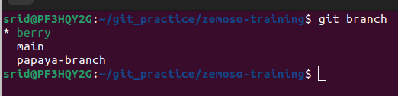

cmd : git checkout main
switching to main branch
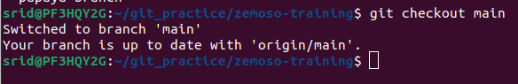
cmd : git branch branch-name
create new branch with name as branch-name
cmd : git branch -d branch-name
deletes the branch
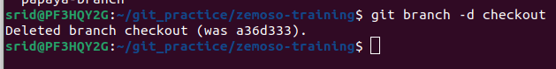
4. Amend - Amending previous commits.
It will change history, commit id.
cmd : git commit –amend
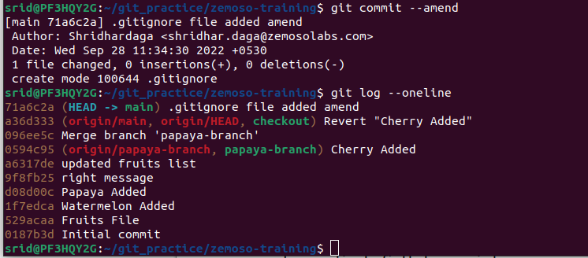
Here new commit message is amended.

5. Ignore - The basics of using the .gitignore file. And using git rm.
When sharing your code with others, there are often files or parts of your project, you do not want to share.

Examples : log files, temporary files, hidden files, personal files, etc.
Git can specify which files or parts of your project should be ignored by Git using a .gitignore file.
Git will not track files and folders specified in .gitignore. However, the .gitignore file itself IS tracked by Git.

Create .gitignore
To create a .gitignore file, go to the root of your local Git, and create it:

Example
touch .gitignore
Now open the file using a text editor.
We are just going to add two simple rules:
Ignore any files with the .log extension
Ignore everything in any directory named temp

Example
# ignore ALL .log files
*.log
# ignore ALL files in ANY directory named temp
temp/
Now all .log files and anything in temp folders will be ignored by Git

6. Git-tag - Tags are convenient for keeping track of commits that bump a version number. In this exercise, you will list, add and delete tags.
Tags are convenient for keeping track of commits that bump a version number. One way of using them is together with branches, where we can tag commits in a branch if they bump the version number, e.g., a branch called version/1.1 can have the tags 1.1.1, 1.1.2 etc. Tags can also be used without branches.

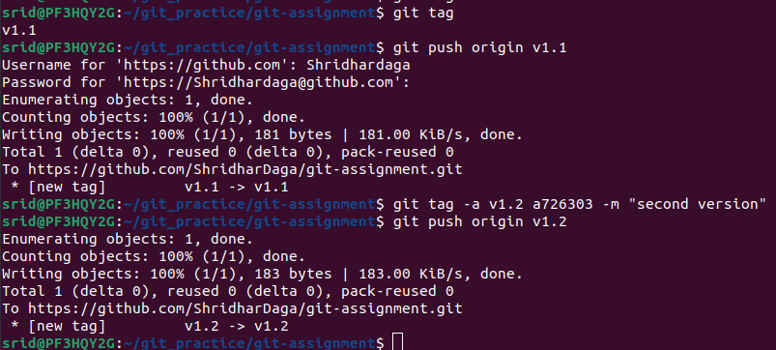

7. Push : Pushing to main branch

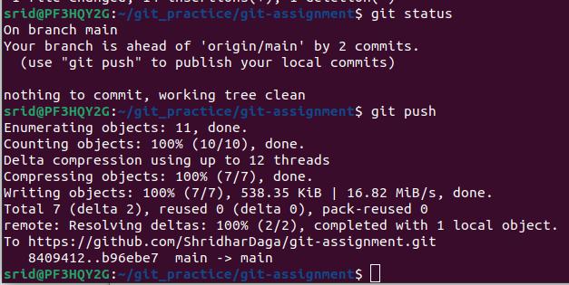
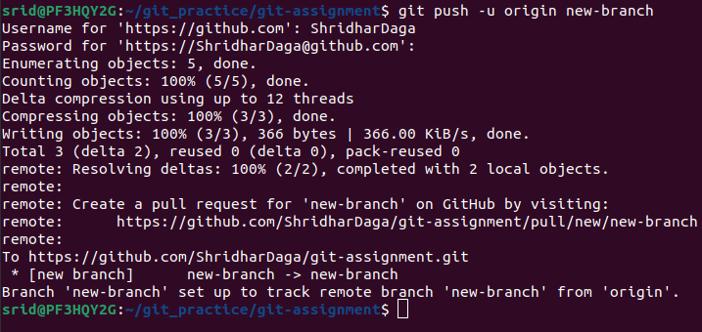
Pushing to new-branch

cmd : git push -u origin newbranch

8. ff-merge - A tour around the most trivial of merges.
Making master branch move to look at latest commit. No changs made on master branch.
Create new branch, add then commit then,
cmd : git switch main // switching to main branch
git merge branch-name // FF merge
9. 3-way-merge - A basic merge, involving multiple diverged branches.
Changes made on both branches. Git uses 3 commits to generate mege commit id.
Git will choose FF or 3-ways-merge automatically.

10. Basic-stashing - The first stride into stashing.
You are working on your project. You've staged some work and have some unstaged work as well. Suddenly, you're made aware that a bug has made it to production. You'll stash your work, fix the bug and get back to your original work.
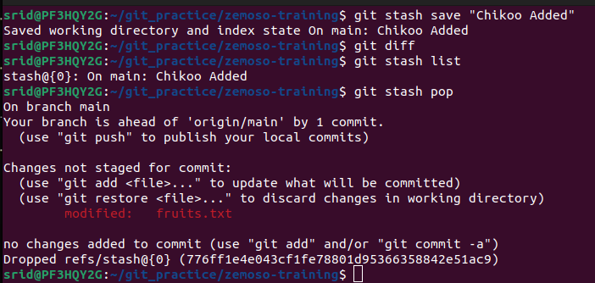

11. reset - Reset is a powerful and slightly dangerous command if you do not know what you are doing. Go through the three modes of resetting here.
- Simple Reset :
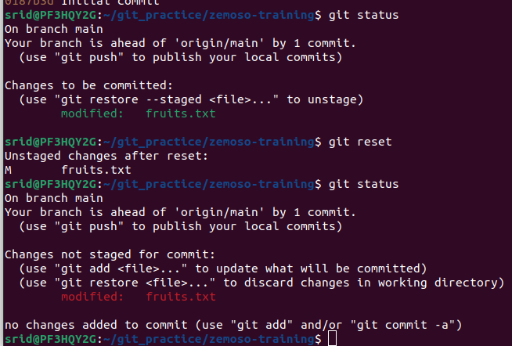
cmd : git reset // unstage the changes

- Soft reset : Keep file in staging area
cmd : git reset –soft <commit id>
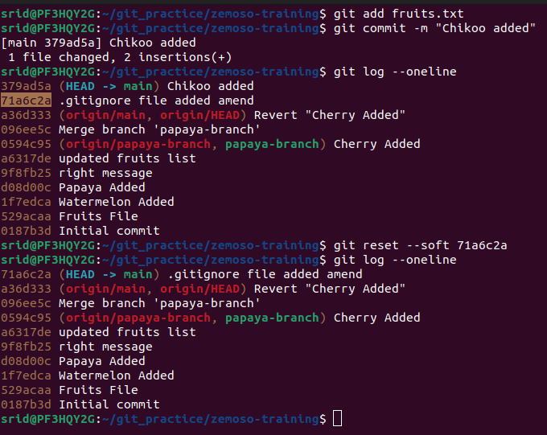
- Mixed Reset (default) : Files will be unstaged.
cmd : git reset <commit id>
- Hard Reset : revert tracked files back to the state they were, but leave untracked files alone.
cmd : git reset –hard <commit id>
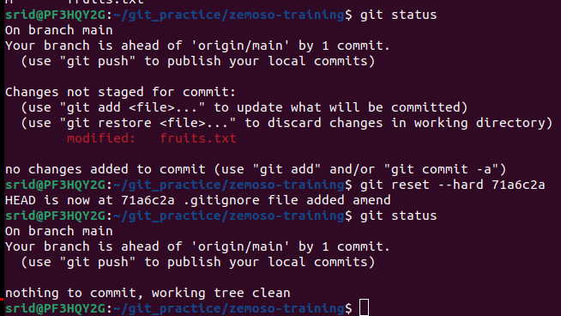
12. basic-cleaning - Cleaning the workspace.
cmd : git clean -df // remove all untracked files
cmd : git clean -n // suggest which file will be renoved

13. Basic-revert - Use revert to revert a change
if we want to revert specific commit
cmd : git revert <commit id>
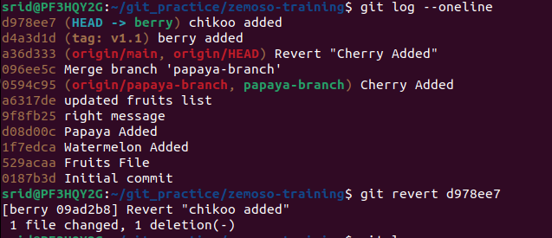
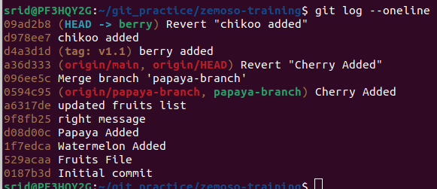

14. rebase-branch - Using rebase as an alternative to merging.
Do not give separate merge commit. (as it gave us in merge)
Moves the entire branch to begin on the top of main branch.
Cmd : git checkout branch-name
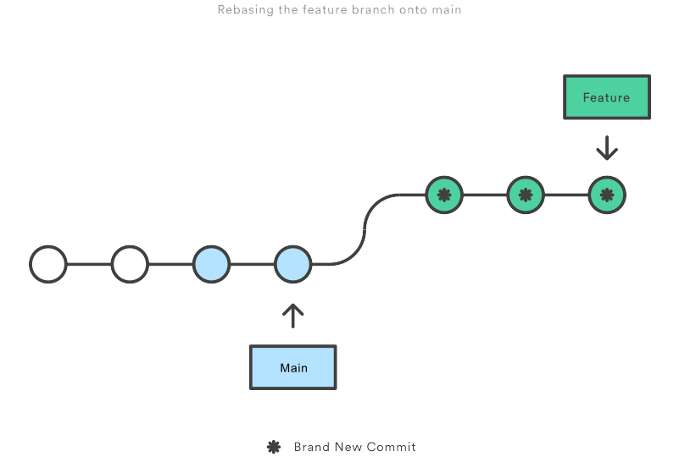
git rebase main

15. advanced-rebase-interactive – We can do
- Change commit msg // reword
- delete commits // drop
- reorder commits // Swap commit lines to change the order.
- combine multiple commits ito one //squash (Squashing)
- spilt an existing commit into multiple new ones //edit
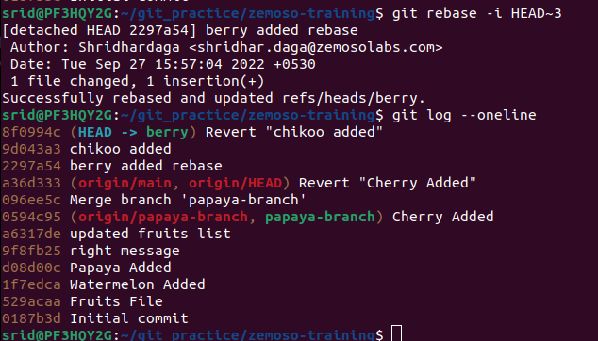
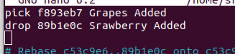
Drop :

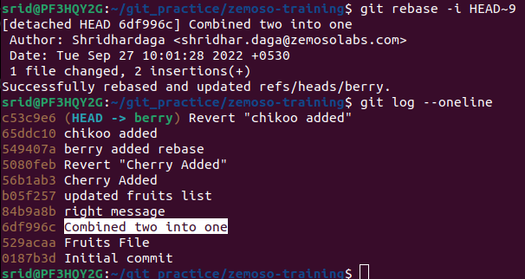
16. squashing – A lot of small commits is good when you are working locally, but for sharing your code, it might be more beneficial to deliver your code changes in large sets. Go here to experiment with that. Write a goodcommit

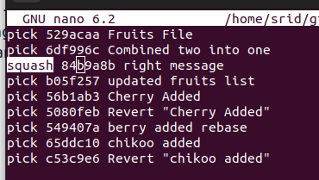

to combine commits for first 3, write squash on 3rd commit id

17. reorder-the-history - Swap two lines to change the order.
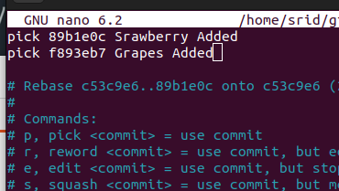

18. merge-conflict - A basic merge between diverging branches with incompatible (but simple) changesets.
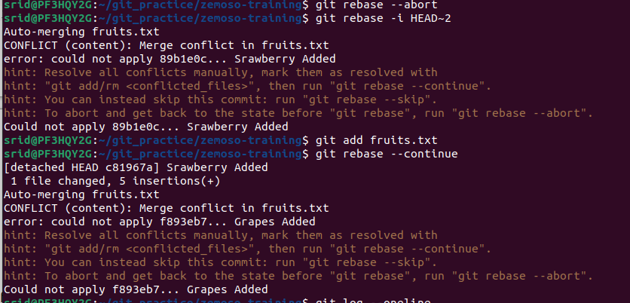
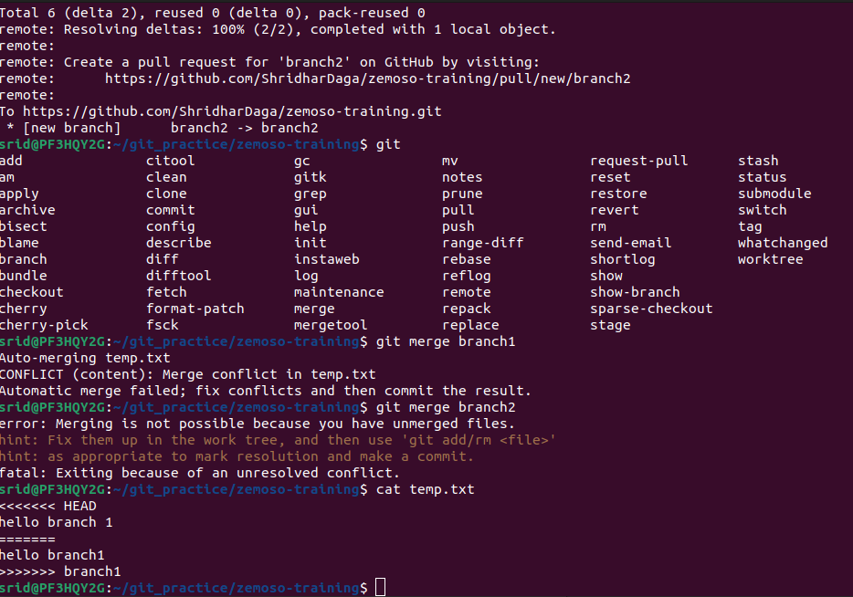
Merge conflict occured due to updating/rebasing dirty file. It can be fixed by rewriting file.

19. merge-mergesort - A merge conflict with actual code.
20. submodules - Submodules are loathed by many. Run through this exercise to see what the ruckus is all about.

