CareerForge Career Preparation Platform - Project Report

Chapter 1: Introduction

1.1 Project Overview
CareerForge is a full-stack, web-based career preparation platform that helps students and early-career professionals prepare for technical interviews and job placements.

1.2 Problem Statement
Job seekers face difficulty transitioning from theoretical knowledge to practical, interview-ready skills; resources are fragmented and lack personalization.

1.3 Objectives
- Centralized platform for learning and interview preparation; - Coding practice with graded assessments; - Resume building and company application tools.

1.4 Scope of the Project
Includes user auth, courses, coding problems, mock interviews, admin console, and resume builder. Excludes scheduling live interviews and payment gateway.

1.5 Methodology
Agile iterative development with sprints, prototyping, feedback cycles, and CI automation.

1.6 Organization of Report
This document covers literature survey, system design, implementation, testing, results, and future scope.

Chapter 2: Literature Survey

2.1 Existing System
Existing platforms provide piecemeal functionality (coding platforms, MOOCs, job portals).

2.2 Limitations
Fragmentation, limited company-focused prep, and poor feedback loops.

2.3 Proposed System
A unified platform integrating learning, practice, assessments, and company application flows.

2.4 Comparative Analysis
CareerForge compares favorably by combining features of many platforms into one.

Chapter 3: System Analysis and Design

3.1 Requirement Analysis
Functional and non-functional requirements focused on auth, problems, judge, and scalability.

3.2 Functional Requirements
User registration, problem attempts, assessments, admin tools, resume builder.

3.3 Non-Functional Requirements
Scalability, performance, security, maintainability, and usability.

3.4 Use Case Diagram
Actors: User, Admin, Recruiter. Use cases: Login, Attempt Problem, Create Assessment, Manage Content.

3.5 Data Flow Diagram
High-level flows: User -> Auth -> APIs; Submission -> Judge -> Results -> Dashboard.

3.6 ER Diagram
Entities: User, Problem, Submission, Assessment, Company, Job. Diagram included as image.

3.7 System Architecture
React frontend, Spring Boot backend, judge workers, MySQL, optional Redis cache.

Chapter 4: Implementation

4.1 Technologies Used
HTML, CSS, JavaScript, React, Monaco, Java Spring Boot, MySQL, Maven, Node.js/npm.

4.2 Module Description
Auth, User/Profile, Course, Problem, Judge, Assessment, Admin Console, Company Module.

4.3 Database Design
Relational design with tables for users, problems, testcases, submissions, assessments, companies.

4.4 Screenshots of Implementation
Screenshots to be included; placeholders present.

4.5 Code Snippets
Reference to key modules and locations in the repo (backend/src, frontend/src).

Chapter 5: Testing

5.1 Test Plan
Unit, integration, frontend unit tests, E2E tests, security testing.

5.2 Test Cases
Sample test cases for signup, login, attempt problem, submit assessment.

5.3 Test Results
Run tests and summarize pass/fail counts (to be populated).

5.4 Bug Fixes and Validation
List and fix issues found during testing; examples included.

Chapter 6: Results and Discussion

6.1 Output Screenshots
Screenshots and sample outputs (placeholders).

6.2 Performance Analysis
Response times and judge scaling notes.

6.3 Discussion of Results
User feedback, pilot metrics, improvement areas.

Chapter 7: Conclusion and Future Enhancement

7.1 Conclusion
CareerForge provides integrated tools for preparation and recruiting; modular architecture supports future enhancements.

7.2 Future Scope
Add ML recommendations, video interviews, payment, gamification, multi-tenant support.

ER Diagram
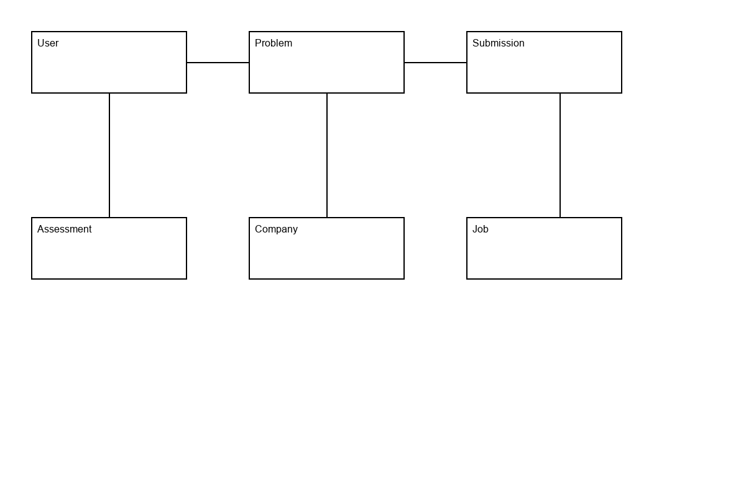

Workflow Diagram
