1.created Vite package : npm create vite@latest
2.giving project name
3. shortcut for basic component structure: rafce
Changed the web site logo:
HTML CODE: <link rel="icon" type="image/svg+xml" href="/favicon.ico" />
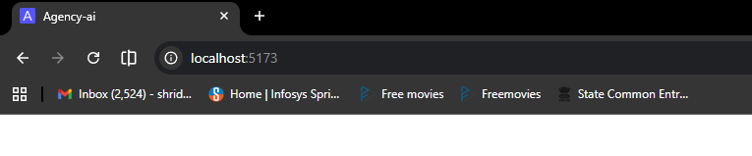
See that A logo we changed it.
4. we installed the tailwindcss : npm install tailwindcss @tailwindcss/vite
5. now adding the google fonts:
Website: https://fonts.google.com/

Started creating the web page
For all the UI I took the help from Figma

