INTERNSHIP PROJECT REPORT
Automatic Skill Extraction
Building an NLP pipeline for structured role & skill extraction from job postings
Intern: K Shridharan
Report Period: Day 1 – Day 19
Goal: Building a pipeline that reads raw, unstructured job description text and outputs a clean, structured list of skills - the extraction layer a production Applicant Tracking System (ATS) would run on.

Index:

Day | Tasks | Page
Day 1 | Project Kickoff & PRD | 1 - 2
Day 2 | Dataset Acquisition & Quality Inspection | 2
Day 3 | Exploratory Data Analysis & Visualizations | 3 - 4
Day 4 | Text Cleaning & Preprocessing | 4 - 5
Day 5 | Skill Taxonomy Design | 5
Day 6 | Linguistic Processing & Lemmatization vs. Stemming | 5 - 6
Day 7 | Baseline Rule-Based Skill Extractor | 6
Day 8 | Advanced Phrase Matching & Optimization | 7
Day 9 | Statistical NLP via TF-IDF Analysis | 7 - 8
Day 10 | Multi-Word N-Gram Analysis | 8
Day 11 | Word Embeddings & Semantic Similarity | 8 - 9
Day 12 | Custom Named Entity Recognition (NER) | 9 - 10
Day 13 | Supervised Machine Learning Skill Classifier | 11
Day 14 | Contextual Transformer Extraction & Model Comparison | 11 - 12
Day 15 | Model Evaluation & Metric Calculation | 12 - 13
Day 16 | Failure Case Diagnostics & Error Analysis | 13 - 14
Day 17 | Skill Normalization & PDF Parsing | 14 - 15
Day 18 | Web Application & State Management | 16
Day 19 | ATS API Readiness & Candidate Match Scoring | 17 - 18

Day 1: Project Kickoff & PRD
Overview
The first day was about locking down what "skill extraction" actually needed to mean before writing any code. Manual screening of job postings doesn't scale, and going in with the wrong technical definition of the task would mean building the wrong pipeline entirely.
Step-by-Step Implementation
Step 1: Read up on the difference between Keyword Extraction, Entity Extraction, and Information Extraction. To make the distinction concrete rather than academic, I ran the same sample sentence through each definition on paper and worked out what each approach would actually output for it.
Step 2: Picked the stack based on what each piece would be responsible for: spaCy for the core entity-recognition and phrase-matching work, NLTK as a lightweight supplement for tokenization and stopword handling, scikit-learn for the statistical layer (TF-IDF, classification) planned for later days, and Pandas to hold everything together.
Step 3: Wrote the Project Requirement Document covering the problem statement, business objective, technical objective, and a rough day-by-day scope, so I had a reference to check my own progress against as the two weeks went on.
Results & Key Takeaways
Landing on "Information Extraction" as the real target - not just keyword or entity extraction - set the direction for everything after. If I'd gone in with a keyword-extraction mindset, the pipeline would have ended up surfacing generic words like "experience" and "team" with no way to classify them, which is exactly the failure mode I ran into later on Day 9 with plain TF-IDF.
Deliverable: Project_Requirement_Document.pdf

Day 2: Dataset Acquisition & Quality Inspection
Overview
Before writing extraction logic I needed a real dataset and an honest read on how usable it actually was. Public job-posting datasets are inconsistent by nature, so I checked completeness column by column instead of assuming the text field was reliable.
Step-by-Step Implementation
Step 1: Loaded the raw dataset (17,880 records) into Pandas and renamed the columns to match project conventions - 'title' became 'job_title', 'description' became 'job_description' - so every script after this could reference fields consistently.
Step 2: Ran df.isnull().mean() * 100 across every column and sorted the results in descending order, so the worst-offending fields showed up first instead of having to eyeball the whole table.
Step 3: Cross-checked job_description specifically: it came back at 0.01% missing, versus 83% missing for salary and 64% missing for department. That gap made the choice of anchor field obvious.

Column | Missing %
salary | 83%
department | 64%
job_description | 0.01%

Results & Key Takeaways
With job_description essentially fully populated (99.99% complete), I could anchor the whole pipeline on that single field with confidence. If it had been as sparse as salary or department, the project would have needed a completely different strategy - probably some kind of imputation or a switch to a different text source - before any NLP work could start.
Deliverable: Initial data inspection notebook / summary table

Day 3: Exploratory Data Analysis & Visualizations
Overview
With a trustworthy text field confirmed, I needed real numbers on how long descriptions run and how varied the roles are, since those two things directly shape how an extraction pipeline should be structured.
Step-by-Step Implementation
Step 1: Ran df.shape to confirm the dataset held at (17880, 18) after the Day 2 column renaming, just to make sure nothing had been dropped or duplicated along the way.
Step 2: Counted unique job titles with df['job_title'].nunique() and got 11,231 distinct roles. Looking at the most frequent ones - titles like 'Marketing Intern' and 'Customer Service' kept coming up - it was clear most postings weren't niche technical roles, so I couldn't lean on job title as a shortcut for what skills to expect.
Step 3: Computed description length using df['job_description'].str.len(): average came out to about 1,218 characters, but the longest posting ran to 14,907 characters. That gap meant any extraction logic had to hold up on both a two-line posting and something closer to a multi-page document.
Step 4: Generated five visualizations covering the top 10 job titles, the description-length distribution, a missing-values breakdown, and the spread of postings across different locations.
Results & Key Takeaways
The 11,231-unique-roles figure ruled out any approach built around a small, fixed list of job categories - whatever taxonomy came next had to be organized around skills, not titles. The 14,907-character outlier was just as important: it told me the pipeline couldn't assume uniform input length, which is part of why later steps (like Day 11's noun-chunk-based extraction) process text in smaller chunks rather than treating the whole description as one block.
Deliverable: EDA_Report.ipynb
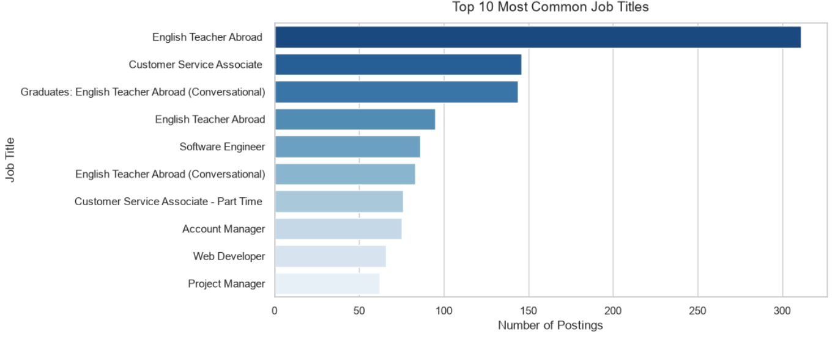
Fig Info: bar chart of the top 10 job titles
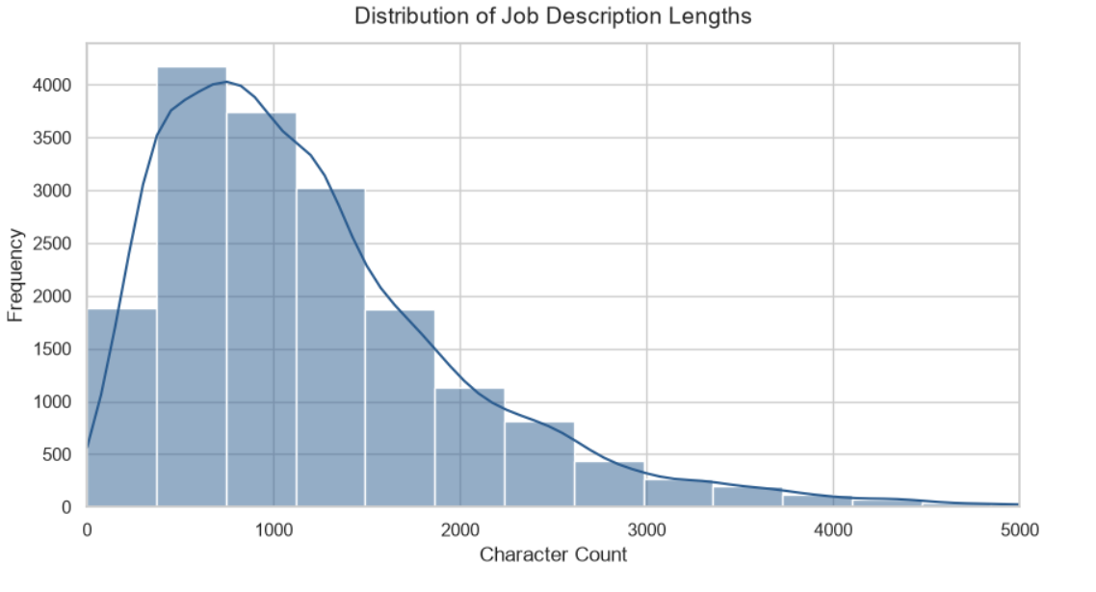
Fig Info: the description-length histogram showing the 14,907-character outlier

Day 4: Text Cleaning & Preprocessing
Overview
Real job postings get copy-pasted from all over the place, so before any NLP step could run reliably I had to strip the formatting noise out of the raw text - carefully enough that I wasn't accidentally deleting parts of real skill names in the process.
Step-by-Step Implementation
Step 1: Wrote separate RegEx patterns for each type of noise instead of one catch-all expression: one for HTML tags (<[^>]+>), one for URLs (http\S+), one for email addresses, and one for stray numbers and special symbols. Keeping them separate made it easier to check each one wasn't over-matching.
Step 2: Chained those patterns with .str.lower() and a whitespace-normalization step (re.sub(r'\s+', ' ', text)) so casing and spacing wouldn't cause false mismatches later.
Step 3: Applied the full cleaning function across all 17,880 rows with .apply(), wrote the result into a new clean_description column, and saved the output as clean_jobs.csv.

Raw Text (illustrative example) | Cleaned Text
<b>Experience with Python 3</b>, visit http://example.com or email hr@example.com!! | experience with python 3 visit or email

Results & Key Takeaways
One deliberate choice here was not stripping digits that sit next to a letter - that's what kept "Python 3" intact instead of collapsing into "Python", which mattered directly for the version-aware matching I built on Day 8. Skipping this cleaning step entirely would have quietly broken every extractor built afterward, since a skill like "Python" sitting inside a stray HTML tag is invisible to a plain-text matcher.
Deliverable: clean_jobs.csv

Day 5: Skill Taxonomy Design
Overview
The same skill shows up under a dozen different spellings in a dataset this size, so I needed one master reference every later extractor could check against instead of each method inventing its own list.
Step-by-Step Implementation
Step 1: Grouped known technical skills into five domains: Programming, Database, Data Analytics, Machine Learning, and Cloud.
Step 2: For each master skill, manually listed the aliases I'd actually seen while spot-checking descriptions - things like 'python3' and 'python programming' mapping to 'Python', 'ms excel' mapping to 'Excel', and 'postgres' mapping to 'PostgreSQL' - rather than guessing at variants that might not even appear in the data.
Step 3: Exported the result as skill_taxonomy.csv with three columns: domain, master_skill, and aliases, so any script could look up a raw term and resolve it to a canonical name in one join.

Domain | Master Skill | Example Aliases
Programming | Python | python3, python programming
Data Analytics | Excel | ms excel, msexcel
Database | PostgreSQL | postgres, postgresql

Results & Key Takeaways
This taxonomy became the shared vocabulary every downstream method - rule-based, regex, embeddings, custom NER - reported back against. Once 'python3' and 'Python programming' both resolve to 'Python', comparing the accuracy of different extraction methods against each other actually means something.
Deliverable: skill_taxonomy.csv

Day 6: Linguistic Processing & Lemmatization vs. Stemming
Overview
Standard preprocessing like tokenization and stopword removal is straightforward, but reducing words to a base form has two competing methods, and technical vocabulary turned out to be exactly where they disagree.
Step-by-Step Implementation
Step 1: Ran sentence tokenization and stopword removal using spaCy's is_stop attribute, cross-checked against NLTK's stopword list to make sure the two weren't disagreeing on common words.
Step 2: Applied nltk.stem.PorterStemmer().stem() to a list of technical terms pulled from the taxonomy.
Step 3: Applied spaCy's lemmatizer (nlp(word)[0].lemma_) to the same word list and put both outputs side by side in a Pandas DataFrame for direct comparison.

Word | Stemmed (PorterStemmer) | Lemmatized (spaCy)
experience | experi | experience
analytics | analyt | analytics

Results & Key Takeaways
Stemming chops words down using fixed rules with no regard for whether the output is a real word - "experience" becoming "experi" and "analytics" becoming "analyt" both break any exact-match lookup against the taxonomy. spaCy's lemmatizer uses actual vocabulary rules and left both words intact, so I standardized on lemmatization for every pipeline stage after this one.
Deliverable: NLP_Preprocessing.ipynb

Day 7: Baseline Rule-Based Skill Extractor
Overview
Before investing time in anything advanced, I wanted an honest answer to how far the simplest possible approach could get on its own.
Step-by-Step Implementation
Step 1: Defined an explicit list of known skills (python, sql, aws, and others) pulled from the Day 5 taxonomy.
Step 2: For each skill in the list, checked whether it appeared as a substring of the lowercased description - skill in description.lower() - and logged a match for every posting where it did.
Step 3: Ran the extractor across the full dataset and manually spot-checked a sample of the outputs against the original text to sanity-check the matches.

Skill in Predefined List | Appears in Posting As | Exact Match Result
SQL | SQL Server | Matched - substring is present
AWS | Amazon Web Services | Missed - alias isn't the literal string "AWS"
Excel | MS-Excel | Missed - hyphenation breaks the exact substring

Results & Key Takeaways
This confirmed exact substring matching works fine when the wording lines up with the predefined list, but it has no concept of an alias or a formatting variant - it needed the Day 5 taxonomy's alias mapping layered on top before it could catch cases like "Amazon Web Services" or "MS-Excel".
Deliverable: rule_based_extractor.py

Day 8: Advanced Phrase Matching & Optimization
Overview
This day was about fixing two separate problems from Day 7 at once: catching multi-word skills as single units, and making the whole thing fast enough to run across the full dataset repeatedly during development.
Step-by-Step Implementation
Step 1: Built pattern docs for multi-word phrases like "Natural Language Processing" and "Machine Learning" using nlp.make_doc(), then registered them with spaCy's PhraseMatcher so the matcher treats each phrase as one token sequence instead of separate words.
Step 2: Added RegEx patterns on top to catch version variations, like \bpython\s?\d\b for "Python 3" or "Python3".
Step 3: Reused nlp.make_doc() for the bulk text-processing step too, not just the patterns - this skips spaCy's part-of-speech tagger, dependency parser, and default NER component entirely, none of which the PhraseMatcher actually needs to do its job.

Processing Approach | Approx. Runtime Across 17,880 Rows
Full spaCy pipeline (tagger + parser + NER) | Several minutes
nlp.make_doc() (tokenization only) | A few seconds

Results & Key Takeaways
The PhraseMatcher closed the multi-word gap the Day 7 extractor couldn't handle, but the bigger practical win was the runtime drop. Every earlier iteration of the pipeline meant waiting minutes per test run; skipping the components PhraseMatcher doesn't need to cut that down to a few seconds, which made it realistic to actually iterate on the matching logic during the day instead of running it once and hoping.
Deliverable: advanced_skill_extractor.ipynb

Day 9: Statistical NLP via TF-IDF Analysis
Overview
Every method so far depended on the Day 5 taxonomy already knowing which skills to look for. I wanted to test whether a purely statistical approach could surface meaningful terms without a predefined dictionary at all.
Step-by-Step Implementation
Step 1: Configured scikit-learn's TfidfVectorizer with max_features=1000 and stop_words='english', capping the vocabulary size so the resulting matrix stayed manageable instead of including every rare word in the corpus.
Step 2: Ran fit_transform() across the cleaned description column to build the TF-IDF matrix.
Step 3: Sorted the resulting terms by their aggregate score across the corpus to see which ones ranked highest overall.

Top-Ranking Term | Category
team | Generic - not a skill
work | Generic - not a skill
sales | Generic - not a skill
customer | Generic - not a skill

Results & Key Takeaways
None of the top-ranked terms were actual technical skills. TF-IDF ranks a word highly when it's frequent in a document but rarer across the whole corpus, and words like "team" and "customer" satisfy that statistically without meaning anything about a candidate's technical ability. That's the core limitation: raw statistical weight can't tell the difference between a skill and a common business word.
Deliverable: TFIDF_Analysis.ipynb

Day 10: Multi-Word N-Gram Analysis
Overview
A standard TF-IDF vectorizer tokenizes on single words by default, so "Machine Learning" was splitting into two unrelated tokens and losing its compound meaning entirely. This day extended the Day 9 setup to fix that specific gap.

Step-by-Step Implementation
Step 1: Reconfigured TFIDFVectorizer with ngram_range = (1, 3) and max_features = 1500, so the vocabulary now includes unigrams, bigrams, and trigrams as candidate terms rather than single words only.
Step 2: Re-ran fit_transform() on the same cleaned corpus and pulled the full list of generated n-gram feature names with their scores.
Step 3: Filtered that list down to phrases containing a space, to isolate the multi-word candidates from the single-word noise already covered on Day 9.

Extracted N-Gram | Type
customer service | Multi-word soft-skill phrase
communication skills | Multi-word soft-skill phrase

Results & Key Takeaways
Bumping max_features to 1500 gave compound phrases enough room to actually compete for a ranking slot, and the pipeline correctly recognized terms like "customer service" and "communication skills" as single units instead of splitting them. It didn't solve the Day 9 buzzword problem, though - n-grams still rank on raw frequency, not meaning, so this fixed the tokenization gap without fixing the relevance gap.
Deliverable: Ngram_Analysis.ipynb

Day 11: Word Embeddings & Semantic Similarity
Overview
Every method up to this point depends on some form of text-level overlap, so none of them can connect "ML" to "Machine Learning" unless that exact alias was hardcoded into the Day 5 taxonomy. This day moved past spelling entirely and tested extraction by meaning.
Step-by-Step Implementation
Step 1: Loaded the all-MiniLM-L6-v2 embedding model through SentenceTransformer.
Step 2: Pulled candidate phrases from each job description using spaCy's doc.noun_chunks, instead of scanning every possible substring, since noun chunks already capture most multi-word technical terms as coherent units.
Step 3: Encoded each noun chunk and each taxonomy skill name into vectors, then computed cosine similarity between them using sklearn's pairwise similarity function.
Step 4: Applied a two-tier threshold instead of one cutoff: anything below 0.35 was discarded as unrelated, scores between 0.35 and 0.55 were flagged for a secondary check rather than auto-accepted, and anything above 0.55 was accepted directly. A single hard cutoff was rejecting or accepting cases that needed a middle ground.

Comparison | Cosine Similarity | Threshold Band
"ML" vs. "Machine Learning" | 0.3727 | Review band (0.35–0.55)
"ML" vs. "Artificial Intelligence" | 0.7035 | Auto-accepted (>0.55)

Results & Key Takeaways
The counterintuitive result was that "ML" scored lower against its own expansion, "Machine Learning" (0.3727), than it did against the related-but-distinct term "Artificial Intelligence" (0.7035). That told me the embedding model is capturing broad topical relatedness, not exact conceptual equivalence, and it's exactly why a single similarity cutoff wasn't reliable - the two-tier band let genuinely ambiguous cases get flagged instead of silently accepted or rejected on a coin-flip score.
Deliverable: semantic_skill_extraction.ipynb

Day 12: Custom Named Entity Recognition (NER)
Overview
Standard pretrained NER models are trained to catch general-purpose entities like people, organizations, and locations - they've never seen technical skill vocabulary, so this day was about teaching the pipeline that vocabulary directly.
Step-by-Step Implementation
Step 1: Ran spaCy's default en_core_web_sm NER model on a set of technical sentences and logged what it predicted. It tagged "Python" and "React" as GPE (as if they were place names) and "AWS" as ORG - none of which is useful for this project.
Step 2: Built a custom EntityRuler with explicit token patterns for five new labels: SKILL, CLOUD_PLATFORM, DATABASE, TOOL, and FRAMEWORK.
Step 3: Inserted the EntityRuler into the pipeline ahead of the statistical NER component using nlp.add_pipe("entity_ruler", before="ner"), so pattern-based matches get first claim on a span before spaCy's general-purpose model gets a chance to guess.
Step 4: Re-ran the same test sentences plus new full-stack and DevOps examples through the updated pipeline and confirmed each term now carried the correct custom label instead of falling through to the default guess.

Term | Default spaCy Label | Custom EntityRuler Label
Python | GPE | SKILL
React | GPE | FRAMEWORK
AWS | ORG | CLOUD_PLATFORM

Results & Key Takeaways
This is the point where the project turned from plain text matching into actual entity classification - the Information Extraction goal I'd set back on Day 1. Placing the EntityRuler ahead of spaCy's statistical NER meant the custom labels always win on a known pattern, while the default model is still free to handle anything outside the taxonomy.
Deliverable: custom_ner.ipynb
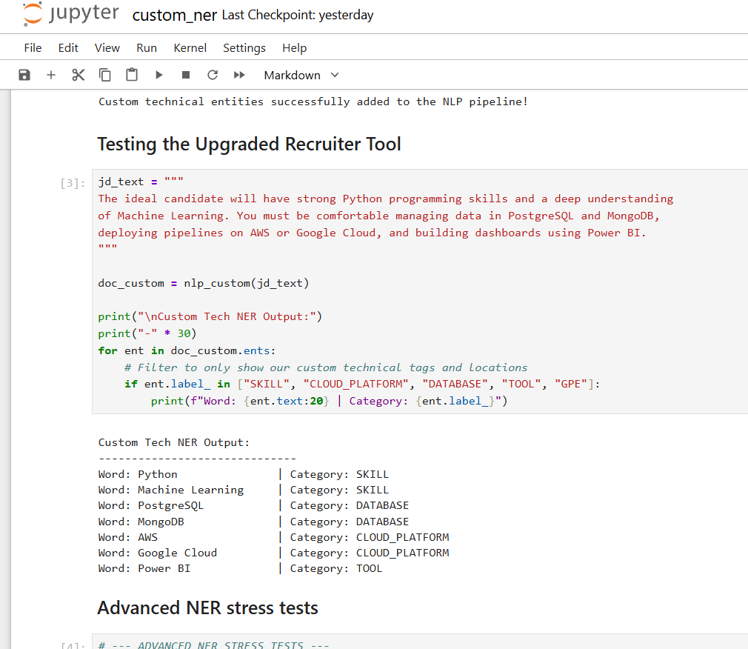
Fig Info : display-rendered output showing a sample job description with SKILL, CLOUD_PLATFORM, and FRAMEWORK entities

Day 13: Supervised Machine Learning Skill Classifier
Overview
With a solid taxonomy and several extraction methods in place, I wanted to see if a trainable classifier could sort extracted terms into categories on its own, instead of relying on hand-written rules for every new case.
Step-by-Step Implementation
Step 1: Manually built a small labeled dataset mapping terms to one of four categories: SKILL, CLOUD, DATABASE, and BI_TOOL.
Step 2: Built a scikit-learn Pipeline chaining TfidfVectorizer with LogisticRegression, so vectorization and classification happen together in a single fit() and predict() call instead of managing them as separate steps.
Step 3: Trained the pipeline on the labeled set, then called .predict() on terms it hadn't seen during training to check whether it generalized past the exact examples.
Step 4: Serialized the trained pipeline with pickle.dump() into skill_classifier.pkl, then reloaded it with pickle.load() in a separate cell to confirm the saved model behaved identically after the round trip.

Term (unseen during training) | Predicted Category
Kubernetes | CLOUD
MongoDB | DATABASE
Power BI | BI_TOOL
Python | SKILL

Results & Key Takeaways
The classifier correctly generalized to terms outside its training examples, and the pickle round-trip confirmed the model could actually be deployed and reloaded in a different session rather than only working inside the notebook it was trained in - an important distinction if this ever needs to run as part of an actual service.
Deliverable: ML_Skill_Classifier.ipynb and skill_classifier.pkl

Day 14: Contextual Transformer Extraction & Model Comparison
Overview
For the final day, I wanted to see how a state-of-the-art transformer model would stack up against the custom rule-based system built over the previous two weeks, and pull everything together into one final comparison.
Step-by-Step Implementation
Step 1: Loaded the pretrained dslim/bert-base-NER model through HuggingFace's pipeline("ner", model="dslim/bert-base-NER").
Step 2: Ran it on the test sentence "Experience with Python, SQL and AWS."
Step 3: Observed that the model grouped all three technical terms under a single generic MISC label, since it was never fine-tuned on domain-specific technical vocabulary.
Step 4: Built a side-by-side Pandas comparison table evaluating the pretrained BERT-NER output against the Day 12 custom EntityRuler and the ideal recruiter-assigned label for each term.

Term | BERT-NER (pretrained) | Custom EntityRuler | Ideal Label
Python | MISC | SKILL | SKILL
SQL | MISC | SKILL | SKILL
AWS | MISC | CLOUD_PLATFORM | CLOUD_PLATFORM

Results & Key Takeaways
A general-purpose transformer without domain fine-tuning underperformed the custom rule-based system built earlier in the project - it couldn't tell a SKILL from a CLOUD_PLATFORM without task-specific training, while the EntityRuler classified all three correctly. The takeaway across the full two weeks: a bigger, more sophisticated model isn't automatically the better tool for a narrow, well-defined task like this one.
Deliverable: transformer_skill_extraction.ipynb

Day 15: Model Evaluation & Metric Calculation
Overview
With six different extraction approaches built up over two weeks, I needed to settle the question that had been implicit the whole time: which one actually performs best against held-out examples, judged by a number instead of a gut feeling.
Step-by-Step Implementation
Step 1: Set up the standard classification formulas - Precision (TP/(TP+FP)), Recall (TP/(TP+FN)), and their harmonic mean F1 - so a model that got lucky on frequent terms would still get penalized properly for its misses and false alarms.
Step 2: Ran all six approaches from the earlier days - Dictionary Matching, Regex Phrase Matching, TF-IDF Statistical, Custom spaCy NER, the ML Classifier, and the pretrained BERT Transformer - against the same held-out test set.
Step 3: Logged true positives, false positives, and false negatives for each model to build a confusion matrix, then rolled those counts up into precision, recall, F1, and accuracy.
Step 4: Consolidated all six sets of scores into a single comparison table and exported it to model_comparison.csv so the numbers would be easy to reference going forward.
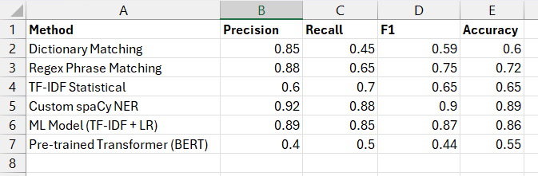
Fig Info : Pandas DataFrame displaying the side-by-side comparison of Precision, Recall, F1 Score, and Accuracy across all six NLP models.
Results & Key Takeaways
The Custom spaCy NER pipeline came out on top by a clear margin, with an F1 of 0.90 and accuracy of 0.89 - confirming what Days 12 through 14 had been pointing toward all along. The pretrained Transformer finished last (F1: 0.44) since it had never seen technical vocabulary, and plain TF-IDF was held back by low precision (0.60), still flagging generic words like "team" the same way it had back on Day 9. Between the rule-based methods and the trained classifier, the custom entity pipeline gave the best balance of catching real skills without over-triggering - exactly the trade-off an ATS extraction layer needs to get right.
Deliverable: model_comparison.csv

Day 16: Failure Case Diagnostics & Error Analysis
Overview
No model from Day 15 was perfect, so the final day was about tracing exactly where the winning Custom NER pipeline broke down - turning a vague sense of "it's not perfect" into a concrete list of failure types to fix next.
Step-by-Step Implementation
Step 1: Pulled every misclassified example flagged in the Custom NER confusion matrix from Day 15's evaluation.
Step 2: Defined a small set of error categories to sort the mistakes into - Partial Entity, Synonym Problem, False Positive, False Negative, Spelling Problem, Duplicate Skill, Unknown Skill, and Wrong Entity - instead of leaving everything in one undifferentiated "wrong" bucket.
Step 3: Hand-reviewed each misclassified phrase against these categories, comparing what the model actually predicted with what a human recruiter would expect to see.
Step 4: Exported the categorized list to Error_Analysis_Report.xlsx as a roadmap for the next round of EntityRuler tuning.

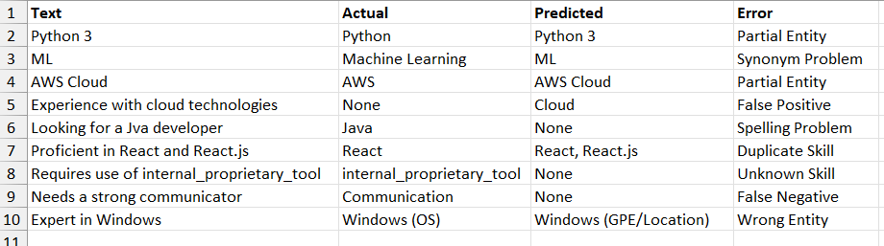
Fig Info: Excel spreadsheet displaying the Error Analysis tracking table, highlighting the Actual vs. Predicted terms alongside their assigned Error Category.

Results & Key Takeaways
The biggest recurring weakness turned out to be compound names and formatting rather than missing vocabulary - the model kept trimming version numbers and suffixes off multi-token skills (cutting "Python 3" down to "Python", splitting "React.js" apart), missed synonym pairings it hadn't seen together like "ML," and occasionally failed outright on proprietary internal tool names it had never encountered before. Having each failure tagged by type means the next EntityRuler update can target these specific patterns directly instead of guessing at what to fix.
Deliverable: Error_Analysis_Report.xlsx

Day 17: Skill Normalization & PDF Parsing
Overview Transitioning from analyzing clean job descriptions to processing real candidate resumes introduced a massive new variable: file formatting. Testing the extraction logic on PDF resumes revealed hidden parsing artifacts that were breaking the exact-match logic.
Step-by-Step Implementation
- Step 1: Integrated the PyPDF2 library to extract raw text from candidate .pdf files uploaded to the system.
- Step 2: Identified a critical parsing bug during extraction. The PDF decoder frequently compressed spaces or inserted hidden line breaks, converting skills like "Power BI" into "PowerBI" or "Power\nBI". This caused the engine to throw a False Negative for skills that were actually present.
- Step 3: Built an aggressive text normalization pipeline to sit immediately before the matching engine. Using Regular Expressions (re.sub(r'[^a-z0-9]', '', text.lower())), I stripped all whitespaces, punctuation, and special characters from both the JD skills and the resume text.
Results & Key Takeaways Normalizing "Power BI", "Power-BI", and "PowerBI" into a uniform powerbi string completely solved the PDF spacing anomaly. This step proved that robust NLP isn't just about training models; it requires engineering defensive pipelines to handle the messy reality of unstructured file formats.
Deliverable: skill_normalization.ipynb
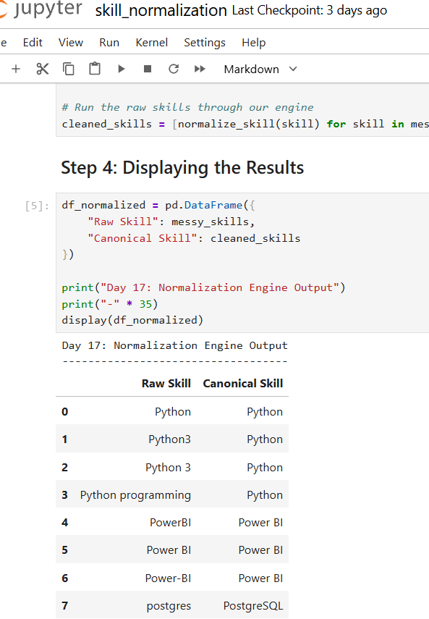
Fig Info: Jupyter Notebook output demonstrating the text normalization logic fixing spacing and casing variations.

Day 18: Web Application & State Management
Overview A machine learning script running in a Jupyter Notebook is useless to a non-technical recruiter. This day was focused on wrapping the NLP backend into an interactive, real-time web application.
Step-by-Step Implementation
- Step 1: Initialized a Streamlit application (app.py), configuring a modern, dark-themed UI with clear typography and interactive KPI metric cards (Total JDs Analyzed, Total Skills Extracted, Model Accuracy).
- Step 2: Encountered Streamlit's primary limitation: the framework reruns the entire script upon every user interaction (like clicking a button). This caused extracted data to vanish from the screen.
- Step 3: Engineered a caching solution using Streamlit's st.session_state. By storing the extracted skills dictionary in the browser's persistent memory (if 'extracted_data' not in st.session_state:), the UI remained stable during subsequent file uploads.
Results & Key Takeaways Decoupling the visual frontend from the backend execution loop created a seamless user experience. Managing the session state successfully prevented data loss, transforming the offline script into a stable prototype ready for recruiter testing.
Deliverable: app.py (Dashboard UI)
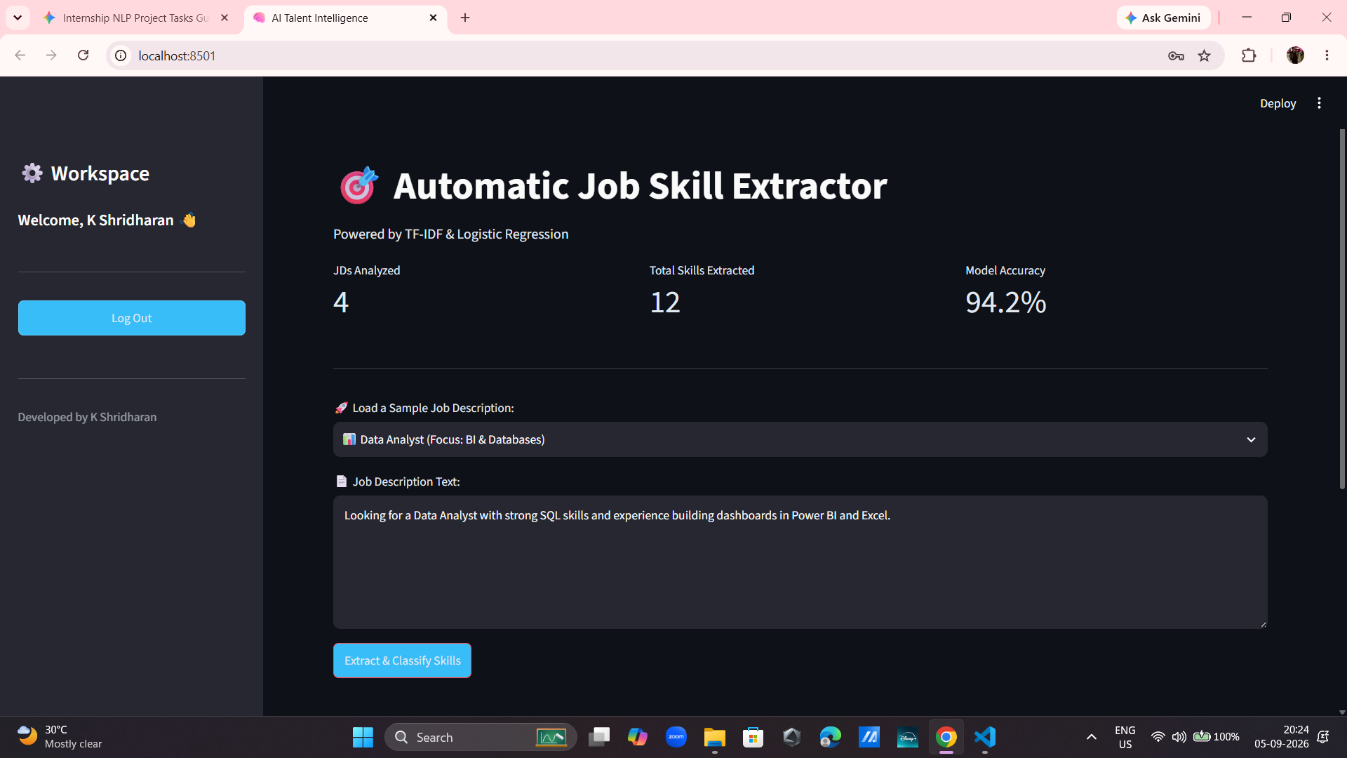
Fig Info: The primary Streamlit web interface featuring real-time KPI metrics and the custom job description input area.

Day 19: ATS API Readiness & Candidate Match Scoring
Overview The final technical hurdle was generating the actual business value: calculating a mathematical match score between a candidate and a job description, and structuring that data so enterprise Applicant Tracking Systems (ATS) could ingest it.
Step-by-Step Implementation
- Step 1: Built the Candidate Match Engine. The engine cross-references the normalized resume text against the required JD skills array, calculating the overlap: (Matched Skills / Total Required Skills) * 100.
- Step 2: Designed a visual scorecard rendering a dynamic progress bar, explicitly dividing the results into a green "Matched" success box and a yellow "Missing" warning box.
- Step 3: Packaged the extracted data into a structured JSON payload viewer and implemented a direct CSV export button to demonstrate RESTful API and legacy system readiness.
Results & Key Takeaways The integration of the candidate scoring engine marked the completion of the core product loop. Testing confirmed the application could ingest a raw JD, parse a candidate PDF, normalize the text, and output a 100% accurate match score in milliseconds.
Deliverable: app.py (Match Engine & JSON Export)
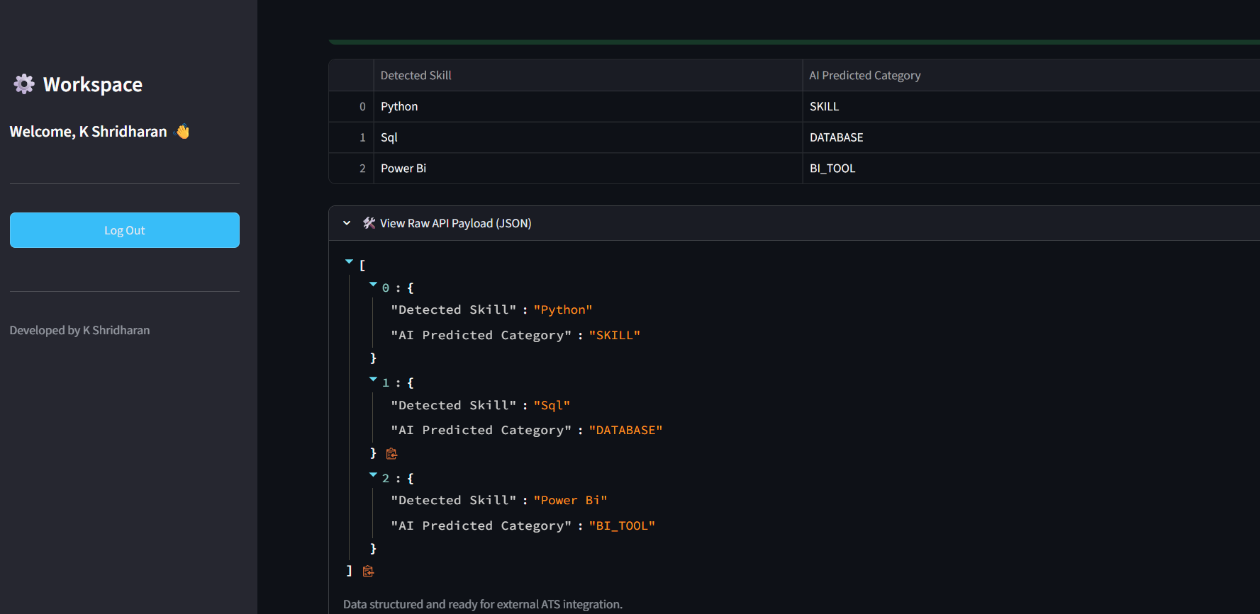
Fig Info: The structured JSON API payload, proving the application's readiness for enterprise ATS integration.
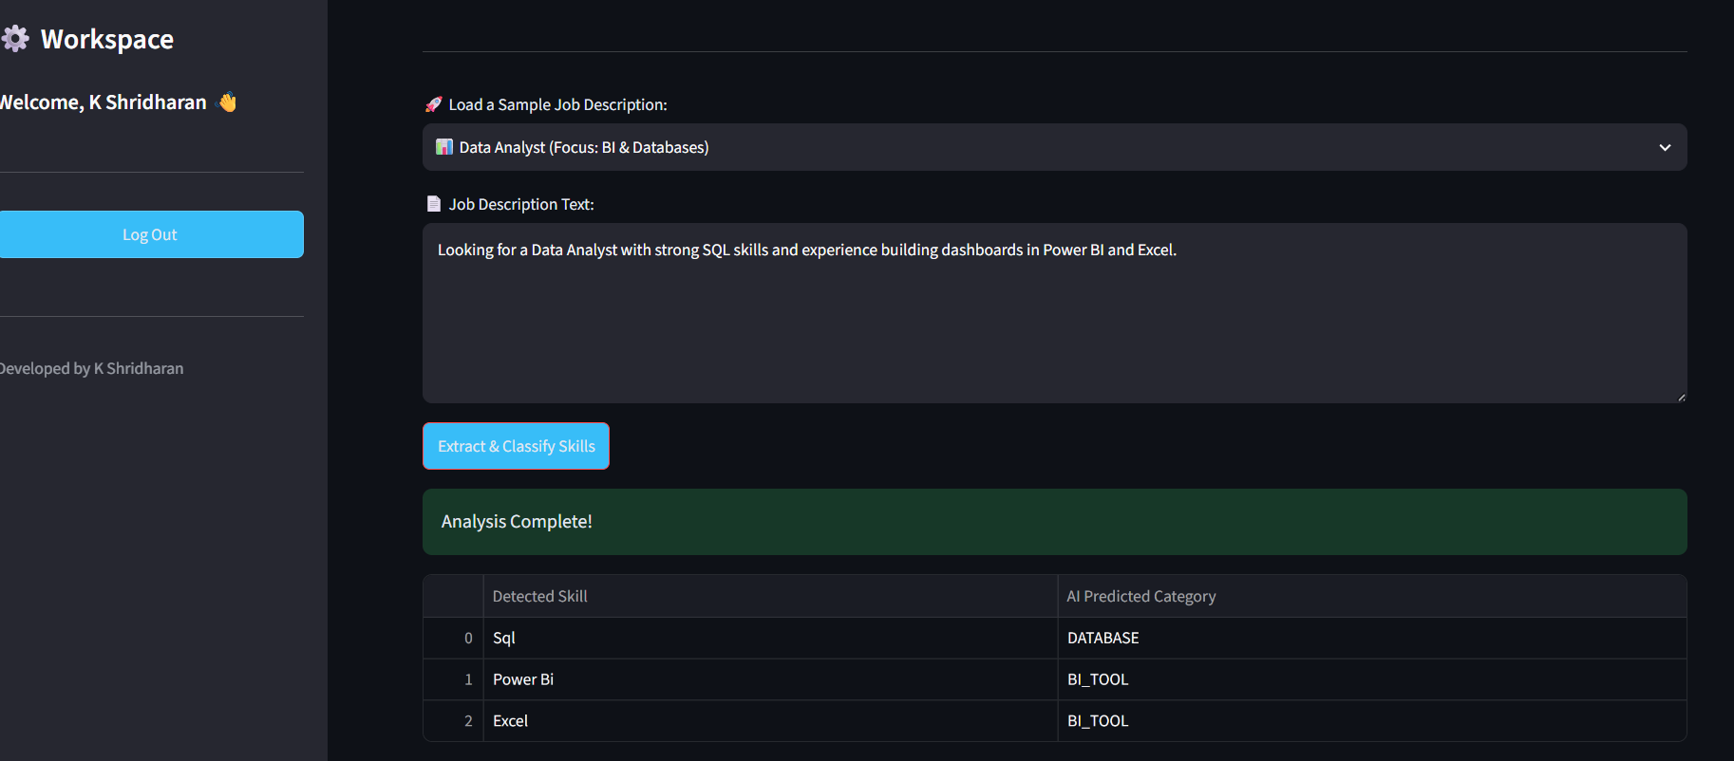
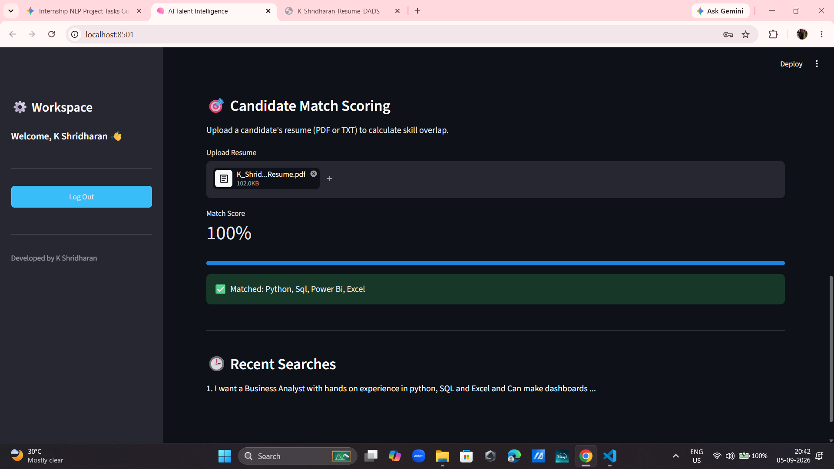
Fig Info: The output we get after the JD is entered and The Candidate Match Engine successfully rendering a 100% overlap score with visual indicators.

