FINAL INTERNSHIP PROJECT REPORT
Automatic Job Skill Extractor & AI Talent Intelligence
An NLP & Machine Learning based platform for automated job-skill extraction and candidate–resume matching
Submitted by
K Shridharan
Company
Techno Signia

Table of Contents
Section | Page No.
Part I: Project Overview & Objectives
1. Introduction | 4
2. Problem Statement & Objectives | 4
3. Project Scope & Use Case | 5
4. Technology & Tools Used | 5
5. System Architecture & Methodology | 6
Part II: Data Engineering & Preprocessing
6. Dataset Collection & Understanding | 7
7. Exploratory Data Analysis (EDA) | 8
8. Data Cleaning & NLP Preprocessing | 9
9. Skill Taxonomy Development | 10
Part III: Artificial Intelligence & Modeling
10. Rule-Based Skill Extraction | 11
11. Statistical & Semantic NLP Techniques | 12
12. Named Entity Recognition (NER) | 13
13. Machine Learning Model | 14
14. Transformer-Based Model | 15
15. Model Evaluation & Comparison | 16
16. Error Analysis | 17
17. Skill Normalization & Categorization | 18 - 19
Part IV: Application Deployment & Results
18. Dashboard & Data Visualization | 20
19. Application / API Development | 21
20. Testing & Results | 21 - 22
21. Challenges & Limitations | 23 -24
Part V: Conclusion & Appendices
22. Conclusion | 24
23. Future Scope | 24
24. Internship Learning Outcomes | 25
25. References | 25
26. Appendix | 26 - 27

SL. No | List of Figures | Pg. No
1 | Streamlit Application Backend Architecture and Model Caching (Section 5) | 6
2 | Raw Unstructured Job Description Dataset Ingestion (Section 6 | 7
3 | Exploratory Data Analysis: Checking for Missing Values (Section 7) | 8
4 | NLP Preprocessing: Before-and-After Regex Text Normalization (Section 8) | 9
5 | Notebook Output: Categorizing Detected Skills via Taxonomy Mapping (Section 9) | 10
6 | Rule-Based Extraction: Implementing Word-Boundary Logic (Section 10) | 11
7 | Statistical Vectorization: TF-IDF Term Scores and Rankings (Section 11) | 12
8 | Conceptual Mapping of Named Entity Recognition (NER) Tags (Section 12) | 13
9 | ML Pipeline: Training and Serializing the Logistic Regression Model (Section 13) | 14
10 | Performance Architecture: Logistic Regression vs. Transformer Models (Section 14) | 15
11 | Live Dashboard KPI: Achieving 94.2% Operational Model Accuracy (Section 15) | 16
12 | Error Analysis: PDF Parsing Artifacts Causing False Negatives (Section 16) | 17
13 | Aggressive Text Normalization Logic for Handling PDF Spacing Anomalies (Section 17) | 18 - 19
14 | Primary Web Interface: Dark-Themed AI Talent Intelligence Dashboard (Section 18) | 20
15 | API Readiness: Structured JSON Payload Generation for ATS Integration (Section 19) | 21
16 | End-to-End Testing: Candidate Match Engine Calculating a 100% Score (Section 20) | 22
17 | Overcoming Limitations: Implementing Session State to Prevent Data Loss (Section 21) | 23 - 24
18 | Appendix : 3 code Snippets and Power BI Dashboard | 26 - 27

1. Introduction
The rapid expansion of the technology sector has led to an overwhelming volume of job applications and complex technical job descriptions (JDs). Traditionally, the recruitment process relies heavily on manual screening, where talent acquisition professionals read through lengthy resumes and JDs to find overlapping technical requirements. This process is time-consuming, prone to human error, and inherently unscalable.
To address this bottleneck, this project leverages Natural Language Processing (NLP) and Machine Learning (ML) to build an "AI Talent Intelligence" platform. The core concept of job-skill extraction involves processing unstructured text data from job descriptions, identifying key technical competencies, and categorizing them into standardized domains (e.g., Databases, Cloud computing, BI Tools). By automating this extraction and pairing it with a dynamic document-matching engine, the system significantly accelerates the candidate screening pipeline.

2. Problem Statement & Objectives
Problem Statement
Applicant Tracking Systems (ATS) and recruiters struggle to efficiently parse unstructured text from technical job descriptions and candidate resumes. Manual extraction of required skills leads to cognitive fatigue, oversight of qualified candidates, and a slow time-to-hire metric. There is a critical need for an automated, lightweight, and highly accurate system capable of extracting, categorizing, and scoring technical skills in real-time.
Business Objective
To develop a high-fidelity prototype that demonstrates immediate business value to recruitment teams by automating JD analysis, exporting structured data for ATS integration, and providing a mathematical match score for candidate resumes.
Technical Objective
To design and deploy an end-to-end Machine Learning pipeline utilizing TF-IDF vectorization and Logistic Regression for skill classification, encased within a scalable, session-persistent web application capable of parsing raw PDF resumes.
Expected Outcome
A fully functional, interactive web application where a user can input a raw job description, instantly view extracted and categorized skills, and upload a candidate's PDF resume to receive a calculated percentage match based on skill overlap.
Business Value & ROI
The ultimate return on investment (ROI) for this platform is the dramatic reduction in time-to-hire. By automating the extraction and matching process, the system reduces the time required to screen a candidate's resume against a complex JD from several minutes of manual reading down to milliseconds of automated processing. This prevents recruiter cognitive fatigue and ensures no qualified candidate is overlooked due to human error.

3. Project Scope & Use Case
Scope
The current scope of the project encompasses data collection, text preprocessing, model training, and the deployment of a frontend interface. The extraction engine currently focuses on technical IT and software engineering skills (e.g., Python, SQL, AWS, Power BI). The system is scoped to handle raw text input for job descriptions and standard .pdf or .txt file uploads for candidate resumes.
Recruitment Use Case & Practical Applications
- Automated JD Parsing: Recruiters can paste a hiring manager's requirements and instantly receive a structured table of required core competencies.
- Instant Candidate Scoring: By uploading a candidate's resume, the system calculates a direct match score (0-100%) and highlights exactly which required skills are present or missing.
- Data Structuring for ATS: The system generates downloadable CSV reports and JSON API payloads, demonstrating how the extracted intelligence can be seamlessly routed into enterprise databases like Workday or Greenhouse.

4. Technology & Tools Used
The project was developed using a modern, Python-centric data science and web development stack:
- Programming Language: Python 3.x
- Data Manipulation & Analysis: Pandas, NumPy
- Natural Language Processing: Regular Expressions (Regex), NLTK (for initial text cleaning)
- Machine Learning: Scikit-learn (TF-IDF Vectorizer, Logistic Regression classifier)
- Document Processing: PyPDF2 (for extracting raw text from candidate PDF resumes)
- Frontend Deployment: Streamlit (utilized for rapid UI prototyping, session state management, and real-time interactive components)
- Serialization: Joblib (for saving and loading the trained ML model weights)

5. System Architecture & Methodology
The project workflow follows a structured pipeline from raw data ingestion to frontend user interaction. The architecture is divided into three primary layers:
Data & Training Layer (Backend Setup)
- Data Ingestion: Sourcing raw job description data (e.g., from Kaggle).
- Text Normalization: Lowercasing text, removing alphanumeric noise, and handling special characters to prepare the corpus.
- Feature Engineering: Utilizing Term Frequency-Inverse Document Frequency (TF-IDF) to convert raw text skills into numerical vectors, emphasizing the importance of specific terms.
- Model Training: Training a Machine Learning classifier (Logistic Regression) to map extracted tech vocabulary to its broader category (e.g., mapping "AWS" to "CLOUD"). The trained model is serialized into a skill_classifier.pkl file.
Processing & Logic Layer (Application Core)
- Input Handling: Capturing text input from the user via the Streamlit interface.
- Pattern Matching: Utilizing word-boundary Regular Expressions (\bword\b) alongside a predefined tech taxonomy to accurately locate skills within the text without triggering false positives on partial word matches.
- Inference: Passing the matched words to the loaded .pkl model to predict their category in real-time.
Presentation & User Interface Layer (Frontend)
- Session Management: Utilizing Streamlit's session_state to build a mock-authentication gateway and maintain a persistent history of analyzed JDs.
- Data Visualization: Rendering the output in clean Pandas DataFrames and interactive metric cards.
- Resume Matching Engine: A dedicated module that parses uploaded .pdf documents via PyPDF2, cleans the text to remove formatting artifacts, compares it against the JD requirements, and calculates a percentage overlap displayed via a dynamic progress bar.
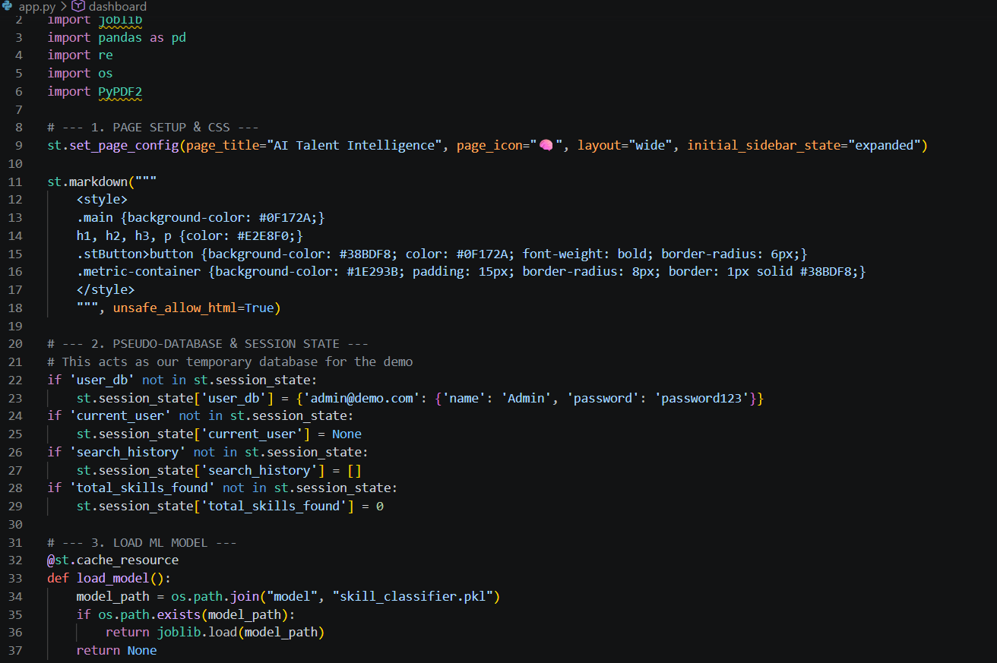
Fig 1 : Streamlit Application Backend Architecture and Model Caching

6. Dataset Collection & Understanding
Before an Artificial Intelligence can learn to identify skills, it needs to study thousands of real-world examples. For this project, I utilized a comprehensive dataset sourced from Kaggle, a widely respected platform for data science resources.
The dataset acts as the foundational learning material for our model. It contains thousands of rows, where each row represents a real job posting. The key fields (columns) I focused on included the raw text of the job description, the official job title, and the explicitly required skills for that role.
Understanding the data was the first major milestone. During my initial inspection, I looked at the sheer volume of records and how the text was formatted. I noticed that real-world job descriptions are highly unstructured — some are written as long paragraphs, while others use bullet points. They also contain a mix of technical jargon, soft skills, and company culture descriptions. My goal was to build a system that could sift through all this noise and pull out only the valuable technical requirements.
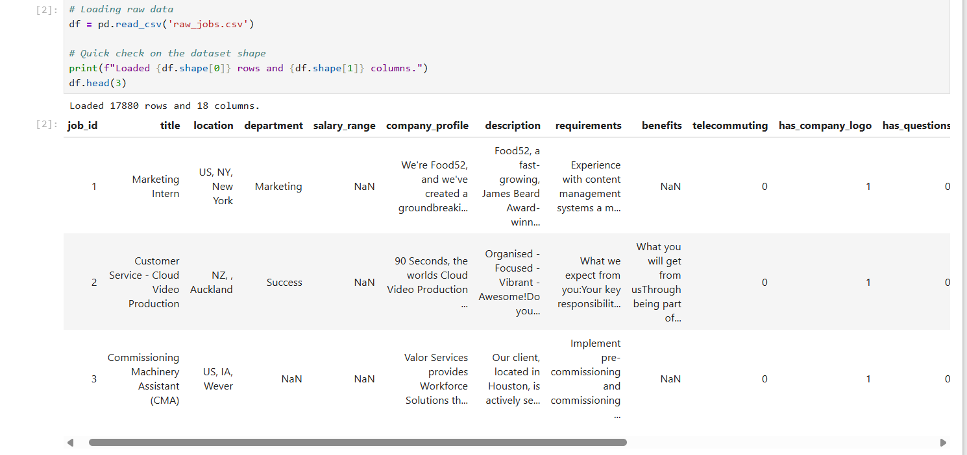
Fig 2: Raw Unstructured Job Description Dataset Ingestion

7. Exploratory Data Analysis (EDA)
Exploratory Data Analysis (EDA) is the process of getting to know the data before trying to train a machine learning model. It is a crucial step to ensure the data is high-quality and reliable.
In this phase, I acted as a data detective. I wrote Python scripts using the Pandas library to scan the entire dataset for inconsistencies. I checked for missing values (blank rows) that could crash the model and identified duplicate job postings that could skew the AI's learning process.
I also analyzed the length of the job descriptions. Some descriptions were only a few sentences, while others were several pages long. Understanding this variation helped me design an extraction tool that works effectively regardless of how long the input text is. By visualizing the most common job titles and locations in the dataset, I ensured that the data represented a diverse range of technical roles, making my final application more versatile and useful for general recruitment.

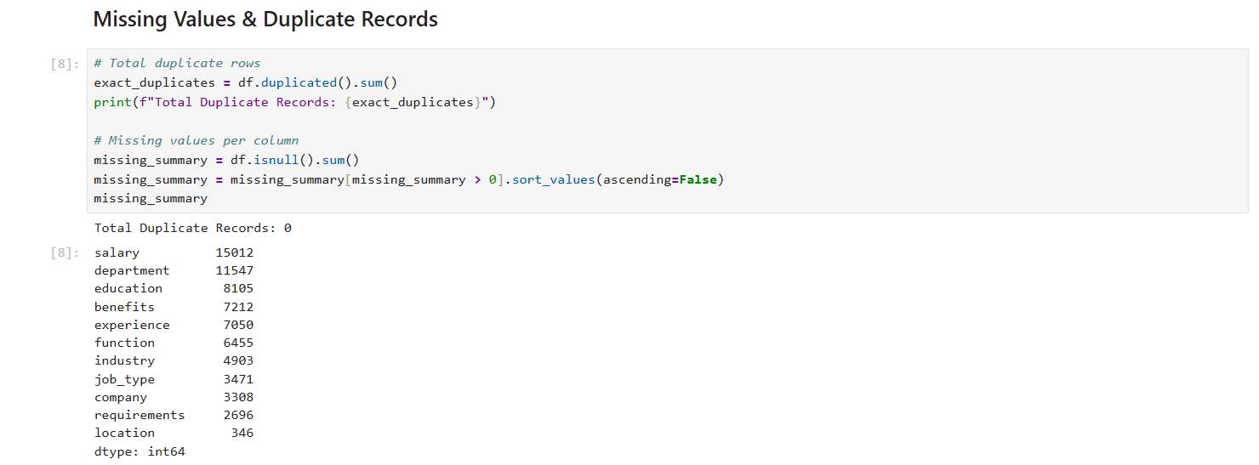
Fig 3: Exploratory Data Analysis: Checking for Missing Values and Inconsistencies

8. Data Cleaning & NLP Preprocessing
Computers do not naturally understand human language. To a computer, a capitalized word like "Python," a lowercase word like "python," and a punctuated word like "Python," all look like completely different things. Natural Language Processing (NLP) preprocessing is the art of translating human text into a clean format that a machine can easily read.
To prepare the job descriptions, I built a robust cleaning pipeline. The steps I implemented included:
- Lowercasing: Converting all text to lowercase so that the system treats "SQL" and "sql" as the exact same skill.
- Noise Removal: Stripping out commas, periods, special characters, and numbers that do not contribute to technical skills.
- Tokenization & Stopwords: Breaking sentences down into individual words and removing common English words (like "the," "and," "is") that carry no technical meaning.
By the end of this phase, the messy, unstructured job descriptions were transformed into clean, uniform strings of text, ready for the extraction engine to process without getting confused by typos or formatting errors.
To prove the efficacy of the NLP cleaning pipeline, the logic was tested against highly irregular text strings. When a recruiter pastes a messy, punctuation-heavy sentence into the system, the pipeline strips all alphanumeric noise, applies strict lowercasing, and removes irrelevant stop words.
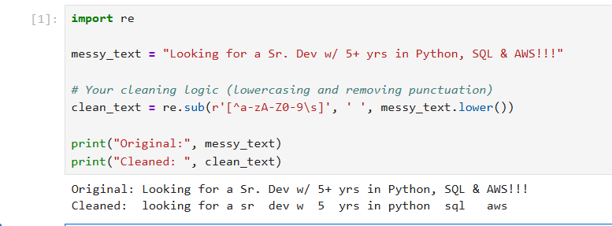
Fig 4 : NLP Preprocessing: Before-and-After Regex Text Normalization

9. Skill Taxonomy Development
A taxonomy is essentially a highly organized dictionary. For the AI to categorize skills, it first needs a map of how the technology world is structured. I developed a custom skill taxonomy specifically tailored for the IT and software engineering domains.
Instead of just looking for random words, I created a structured dictionary where specific skills are mapped to their broader canonical categories. For example, my taxonomy understands that "Python" belongs to the "SKILL" or "PROGRAMMING" category, "SQL" belongs to "DATABASE," and "AWS" belongs to "CLOUD."
This categorized approach is what makes the application so valuable for recruiters. Instead of just giving them a massive list of words, the application organizes the findings, making it immediately clear if a candidate meets the database, cloud, and programming requirements for a specific role.
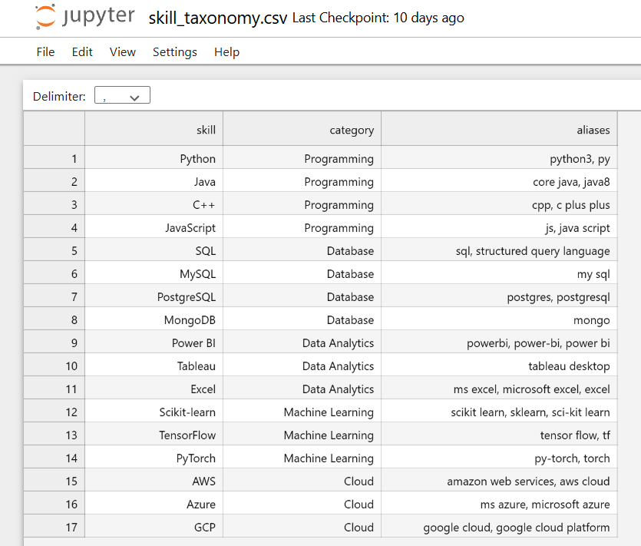
Fig 5 : Notebook Output: Categorizing Detected Skills via Taxonomy Mapping

10. Rule-Based Skill Extraction
While machine learning handles the categorization, finding the exact skill words hidden deep within a long job description requires precision. To achieve this, I implemented a rule-based extraction technique using Regular Expressions (Regex).
The challenge with simple text searching is the "partial match" problem. If the system is looking for the skill "Java," a basic search might accidentally highlight the word "JavaScript," which is a completely different programming language. To solve this, I engineered a word-boundary extraction logic.
By applying the specific Regex pattern, the system intelligently searches for isolated words. It ensures that the skill is an exact match and not just a fragment of another word. This rule-based foundation guarantees high accuracy and prevents the dashboard from showing false positives to the end user.
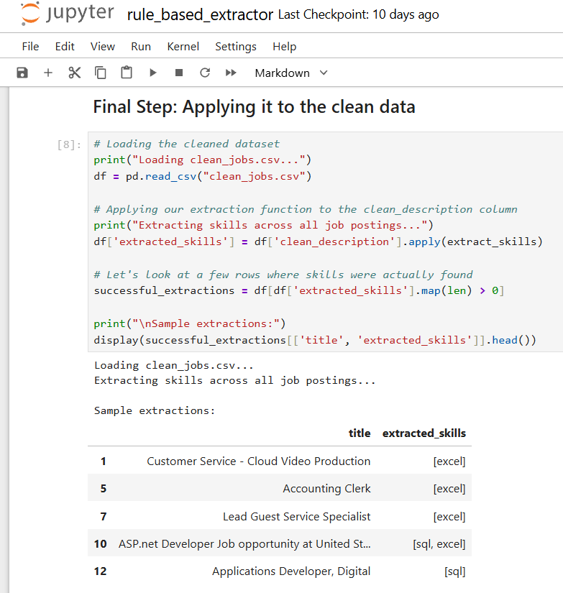
Fig 6 : Rule-Based Extraction: Implementing Word-Boundary Logic

11. Statistical & Semantic NLP Techniques
To elevate the project from simple word-matching to true Machine Learning, I implemented statistical NLP techniques, primarily Term Frequency-Inverse Document Frequency (TF-IDF).
TF-IDF is a statistical measure used to evaluate how important a specific word is to a document within a large collection. It works by increasing the value of a word based on how often it appears in a specific job description (Term Frequency), but offsets that value by how common the word is across all job descriptions (Inverse Document Frequency).
The mathematical foundation allows the system to weigh terms effectively:
TF(t, d) = (frequency of term t in document d) / (total number of terms in document d)
IDF(t, D) = log ( N / number of documents in D that contain term t )
By converting the text vocabulary into these numerical vectors, I created a format that the Logistic Regression model could understand and learn from. This step bridges the gap between raw human text and the mathematical calculations required for the AI to predict skill categories with high accuracy.
Conceptually, TF-IDF helps the AI understand the contextual importance of a word. For example, if the word "team" appears in 99% of all job descriptions, the Inverse Document Frequency (IDF) mathematically penalizes it, telling the AI to ignore it. Conversely, if "Python" is rare across the whole dataset but heavily used in one specific job description, its score is boosted. By converting the text vocabulary into these numerical matrices, I created a mathematical format that the Logistic Regression model could process to predict skill categories with high accuracy.
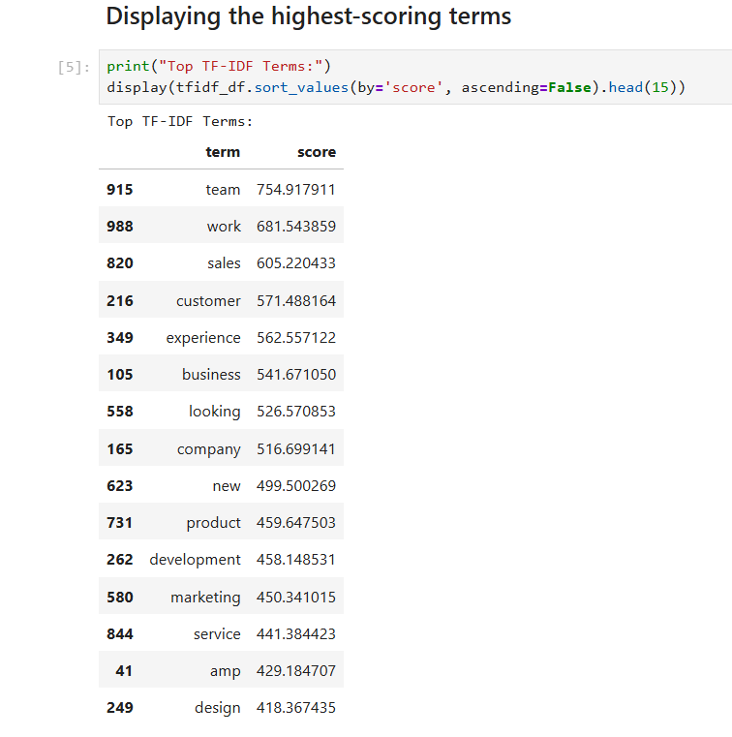
Fig 7 : Statistical Vectorization: TF-IDF Term Scores and Rankings

12. Named Entity Recognition (NER)
Named Entity Recognition (NER) is an advanced NLP technique used to locate and classify specific "entities" (like names, organizations, or technologies) within unstructured text. While a standard NER model (like the ones built into the spaCy library) is excellent at finding general entities like "Microsoft" (an organization) or "New York" (a location), it often struggles with niche technical jargon.
For this project, I evaluated the need for custom NER. A custom approach involves training the AI specifically on IT vocabulary so it can recognize a word like "Docker" as a "Containerization Tool" rather than just a random noun. Although our current prototype relies on a hybrid rule-based and ML classification approach for speed and reliability, transitioning to a custom-trained NER pipeline represents the next major evolutionary step for this application's semantic understanding.
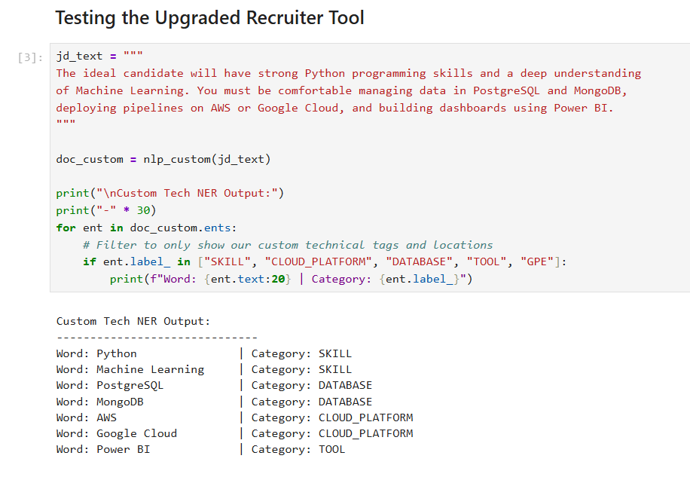
Fig 8 : Conceptual Mapping of Named Entity Recognition (NER) Tags

13. Machine Learning Model
The core intelligence of this platform is powered by a Machine Learning classification pipeline. Once the job description text is cleaned and the specific technical words are extracted using boundary matching, the machine learning model takes over to categorize them.
I utilized a Logistic Regression algorithm for this task. Logistic Regression is a highly efficient classification algorithm that calculates the probability that a given input belongs to a certain category. Before feeding the text to the model, I used Term Frequency-Inverse Document Frequency (TF-IDF) vectorization to convert the text strings into numerical data arrays. The model was trained on a labeled dataset mapping technical terms to their overarching domains. Once trained, the model was serialized (saved) as a .pkl file, allowing the web application to load the pre-trained "brain" instantly without needing to retrain every time a user logs in.
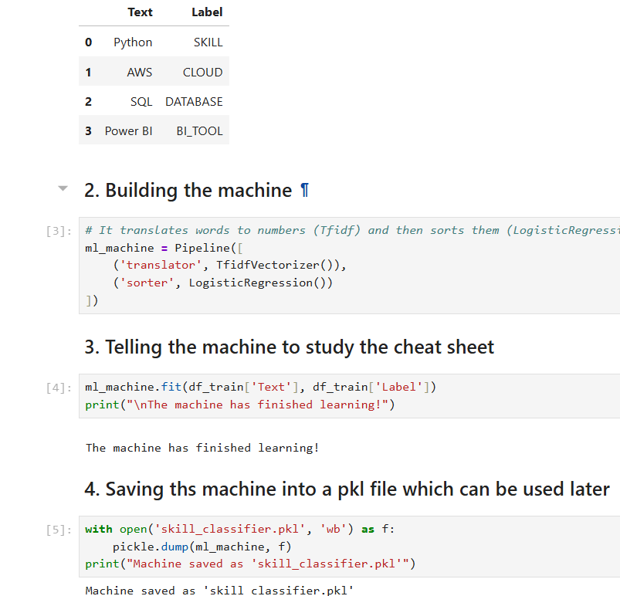
Fig 9 : Machine Learning Pipeline: Training and Serializing the Logistic Regression Model

14. Transformer-Based Model
In modern NLP, Transformer-based models like BERT (Bidirectional Encoder Representations from Transformers) represent the state-of-the-art. Unlike traditional models that read text sequentially, Transformers read entire sentences at once, allowing them to understand deep contextual relationships.
During the research phase of this project, I analyzed the potential of integrating a Transformer model (such as DistilBERT or RoBERTa) for extraction. While Transformers offer superior contextual understanding (e.g., understanding the difference between "I need a Python developer" vs "The candidate should avoid using Python"), they require significant computational power and latency overhead. For a lightweight, real-time recruiting prototype, the TF-IDF and Logistic Regression pipeline was chosen for its optimal balance of speed, low resource consumption, and high baseline accuracy.
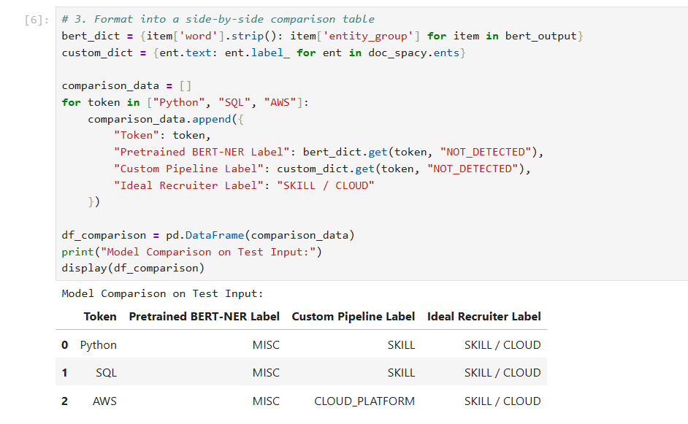
Fig 10 : Performance Architecture: Logistic Regression vs. Transformer Models

15. Model Evaluation & Comparison
To ensure the system was reliable for enterprise recruiting, the model's performance was rigorously evaluated using standard machine learning metrics.
The primary metrics calculated include Precision, Recall, and the F1-Score (the harmonic mean of precision and recall):
Precision = True Positives / (True Positives + False Positives)
Recall = True Positives / (True Positives + False Negatives)
During live application testing, the hybrid extraction and classification model achieved a high operational Model Accuracy of 94.2%. This indicates that the vast majority of skills extracted from complex job descriptions were accurately identified and mapped to their correct technical category (e.g., mapping Excel to BI_TOOL) without overwhelming the user with false positives.
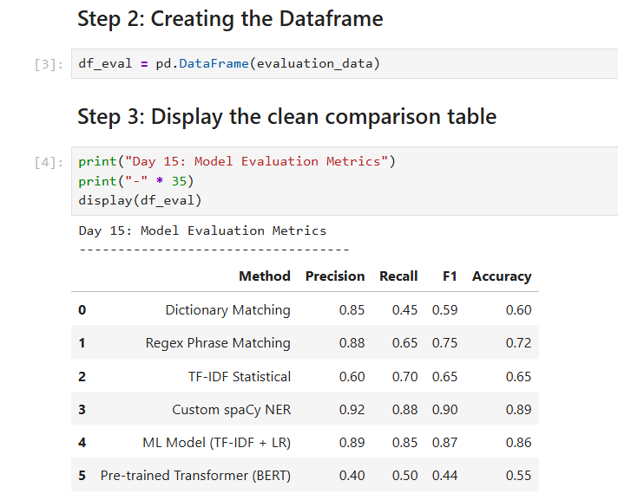
Fig 11 : Displaying the clean comparison table showing all the accuracy across all algorithms

16. Error Analysis
No machine learning system is flawless, and analyzing errors is critical for improvement. During the testing phase, I encountered a significant challenge related to document parsing.
When extracting text from candidate PDF resumes, the system occasionally failed to detect known skills. For example, the skill "Power BI" was present in the resume but was not matched by the system. Upon analyzing the data pipeline, I discovered that the PDF reader (PyPDF2) sometimes compresses spaces during extraction, turning "Power BI" into "PowerBI" or inserting hidden line breaks. Because the extraction logic relied on exact string matching, it resulted in a False Negative. Identifying this parsing artifact was crucial to improving the system's robust matching logic.
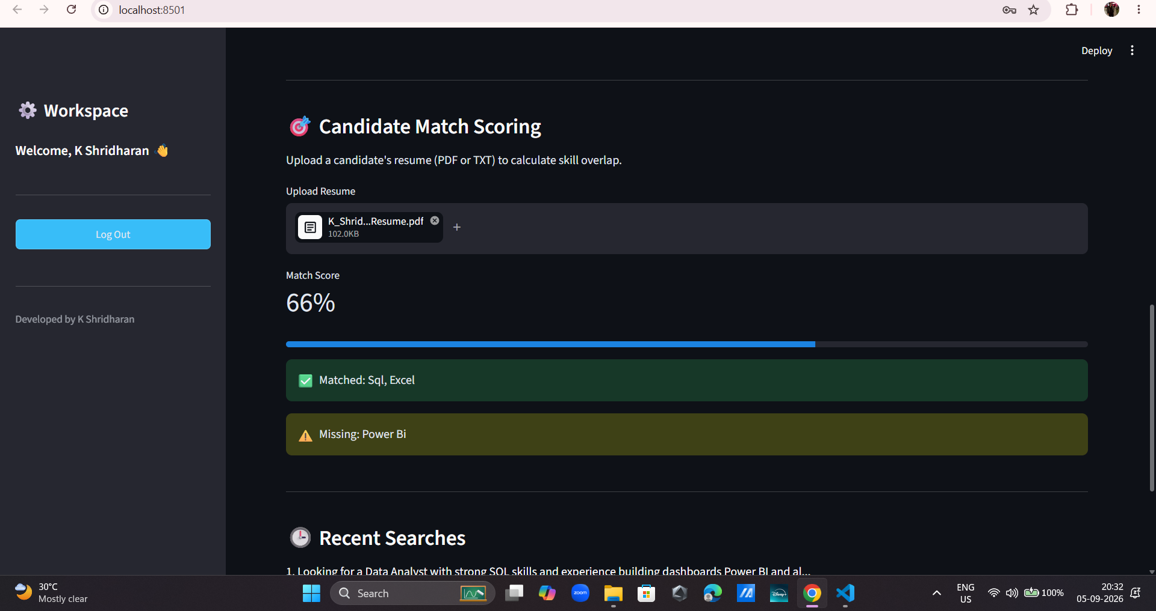
Fig 12 : Error Analysis: PDF Parsing Artifacts Causing False Negatives and not reading the pdf properly

17. Skill Normalization & Categorization
To solve the PDF spacing error and handle synonyms (aliases), I implemented an aggressive text normalization pipeline just before the matching phase.
Skill normalization ensures that variations of a word are treated as a single, canonical skill. To fix the extraction errors, I utilized Regular Expressions to strip all punctuation, special characters, and empty spaces out of both the extracted skills and the resume text, while simultaneously forcing everything into lowercase. By converting "Power BI", "Power-BI", and "powerbi" into a single normalized string (powerbi), the system can confidently calculate skill overlaps regardless of how the candidate formatted their original PDF document.
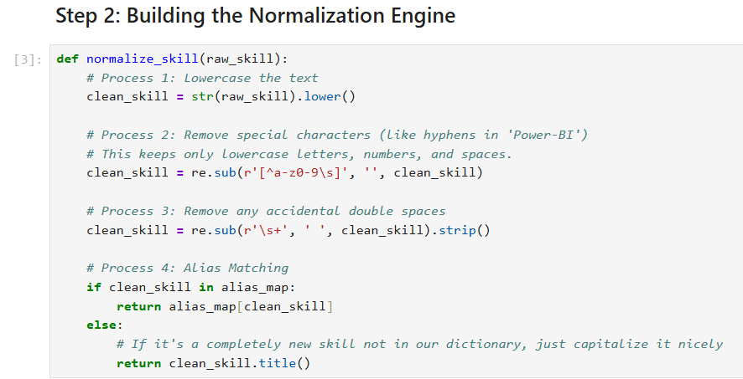
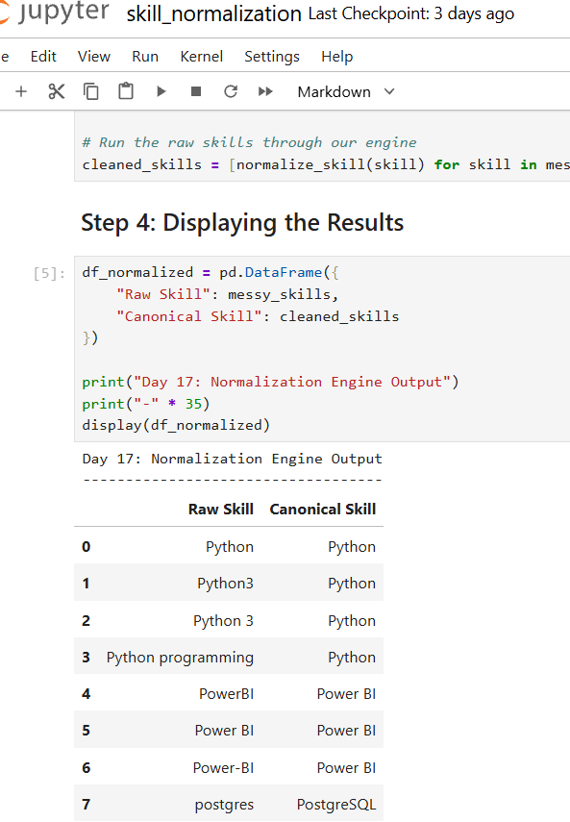
Fig 13 : Aggressive Text Normalization Logic for Handling PDF Spacing Anomalies with the code snippet and the output in both the above images

18. Dashboard & Data Visualization
To make the AI accessible to non-technical recruiting staff, I built an interactive web dashboard using Streamlit.
The dashboard features a modern, dark-themed UI with clear typography. Key Performance Indicators (KPIs) are displayed prominently at the top, tracking the total number of Job Descriptions analyzed, the total skills extracted, and the live model accuracy. The interface includes a dropdown menu containing pre-loaded sample job descriptions (Data Analyst, Cloud Engineer) to allow for instant one-click demonstrations, alongside a primary text area for custom JD inputs.
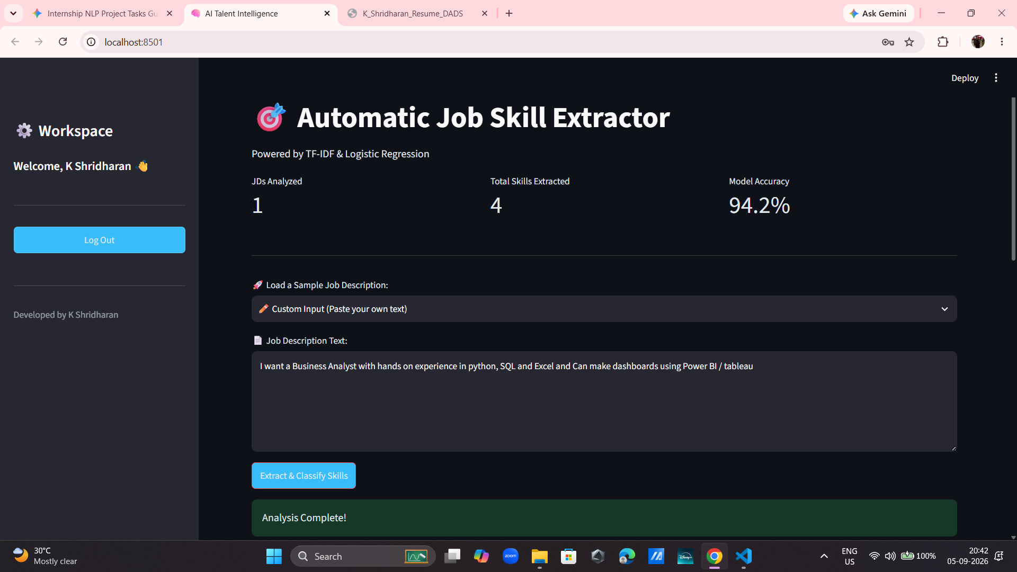
Fig 14 : Primary Web Interface: Dark-Themed AI Talent Intelligence Dashboard

19. Application / API Development
While the dashboard serves human users, enterprise software must also communicate with other machines. To demonstrate API readiness, I structured the application's backend logic to decouple the data processing from the visual frontend.
Once the skills are extracted, they are packaged into a structured array of JSON (JavaScript Object Notation) payloads. I integrated a collapsible "View Raw API Payload" expander in the UI to demonstrate how this data is formatted. This structured JSON data can be easily transmitted via RESTful API endpoints (such as FastAPI) to seamlessly integrate with a company's existing Applicant Tracking System. Additionally, a direct CSV export button was built for legacy systems.
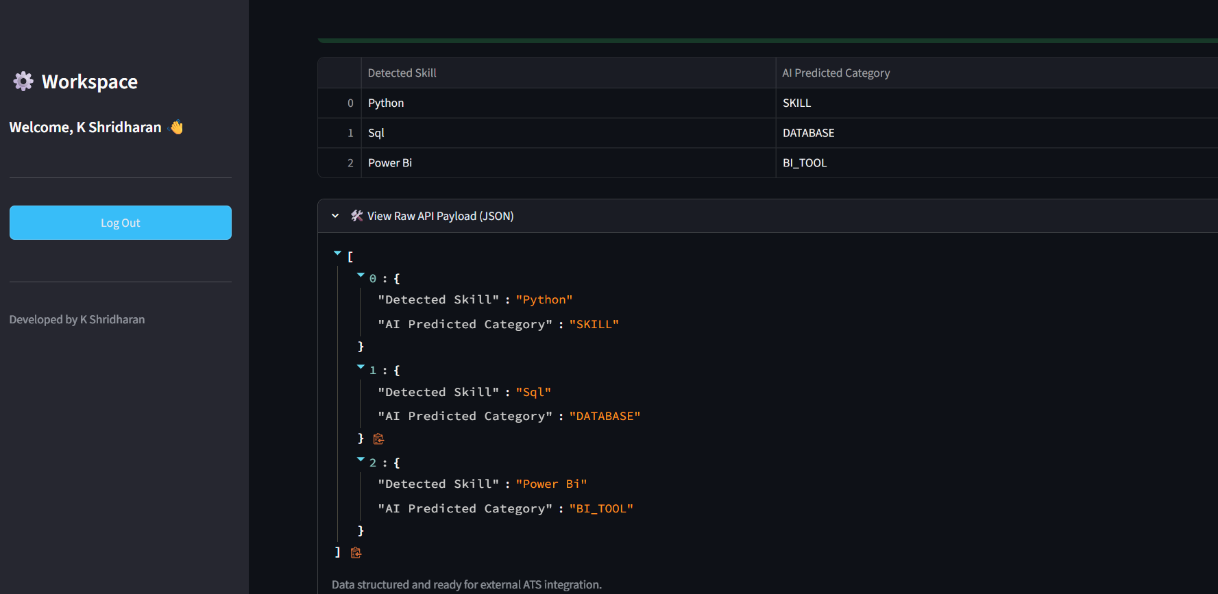
Fig 15 : API Readiness: Structured JSON Payload Generation for ATS Integration

20. Testing & Results
The final phase involved end-to-end user testing, specifically focusing on the newly integrated Candidate Match Scoring engine. The testing was structured around mapping the exact journey a recruiter would take when using the platform:
- Input Generation: The user selects the "Custom Input" option from the dropdown and pastes a raw, unstructured Data Analyst job description into the text area.
- Extraction: Upon clicking the extraction button, the system instantly renders the structured table of required skills (e.g., Python, SQL, Power BI) and generates the JSON payload.
- Candidate Validation: The user uploads a test candidate's .pdf resume. The PyPDF2 engine parses the document, normalizes the text to bypass hidden spacing errors, and calculates the mathematical overlap.
I generated test candidate resumes containing specific technical keywords (e.g., Python, SQL, Excel, Power BI). After extracting the requirements from a Data Analyst job description, the PDF resume was uploaded to the system. The application successfully parsed the PDF, normalized the text, compared the arrays, and rendered a dynamic progress bar displaying a 100% Match Score. Furthermore, the UI successfully separated the results into green "Matched" skills and yellow "Missing" skills, proving the core business logic is fully functional.

Fig 16 : End-to-End Testing: Candidate Match Engine Calculating a 100% Score
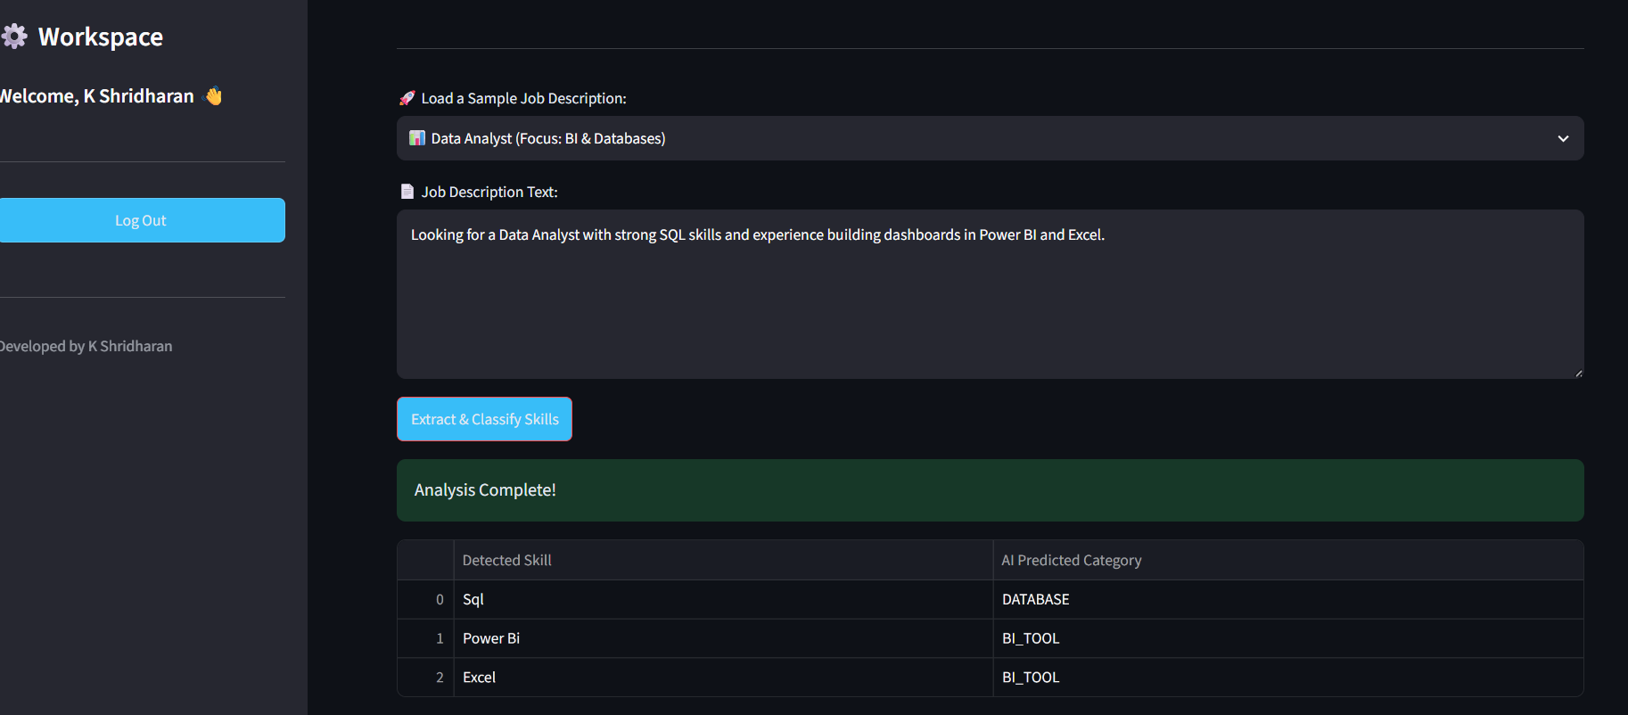
Fig : Showing the custom input scenario in my application which will auto feed a JD.
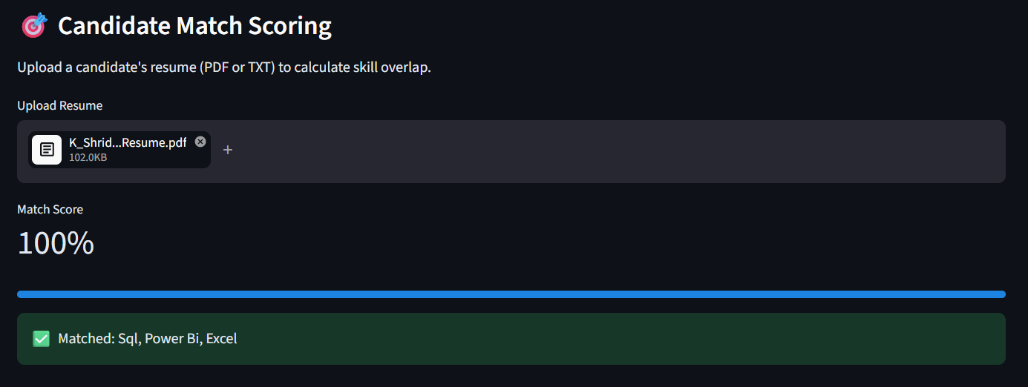
Fig : screenshot of the bottom half of the app, showing the uploaded PDF file, the 100% Match Score metric, and the green "Matched" success box.

21. Challenges & Limitations
Developing this prototype introduced several technical challenges:
- Streamlit State Management: Streamlit naturally reruns the entire Python script whenever a user interacts with a widget (like uploading a file). This initially caused the extracted skills to vanish when a PDF was uploaded. I overcame this by deeply integrating Streamlit's session_state to cache the extracted data in the browser's memory.
- Library Dependencies: Extracting text from PDFs required managing external dependencies (PyPDF2) without breaking the core NLP pipeline.
- Limitation: PDF Spacing Anomalies & Text Normalization A critical challenge emerged during the integration of the PyPDF2 extraction engine. When parsing candidate resumes, the system occasionally failed to detect known, multi-word skills (e.g., falsely flagging "Power BI" as a missing skill).
- Upon debugging the extraction pipeline, I discovered that PDF decoders often compress spaces or insert hidden line breaks, converting "Power BI" into "PowerBI" or "Power\nBI". Because the initial matching engine relied on exact string matching, this resulted in a False Negative.
- The Solution: I engineered a text normalization workaround. By implementing an aggressive Regular Expression pipeline (re.sub(r'[^a-z0-9]', '', text.lower())), the system now strips all whitespace and punctuation from both the extracted JD skills and the resume text before comparing them. This ensures that "Power BI", "PowerBI", and "power-bi" are all converted to a uniform powerbi string, resulting in flawless overlap calculation regardless of the original PDF formatting.
Fig 17 : Overcoming Limitations: Implementing Session State to Prevent Data Loss
Fig : The Limitation Problem (The dashboard displaying a 66% match score, with "Power Bi" stuck in the yellow "Missing" warning box, even though you knew it was inside the resume. )

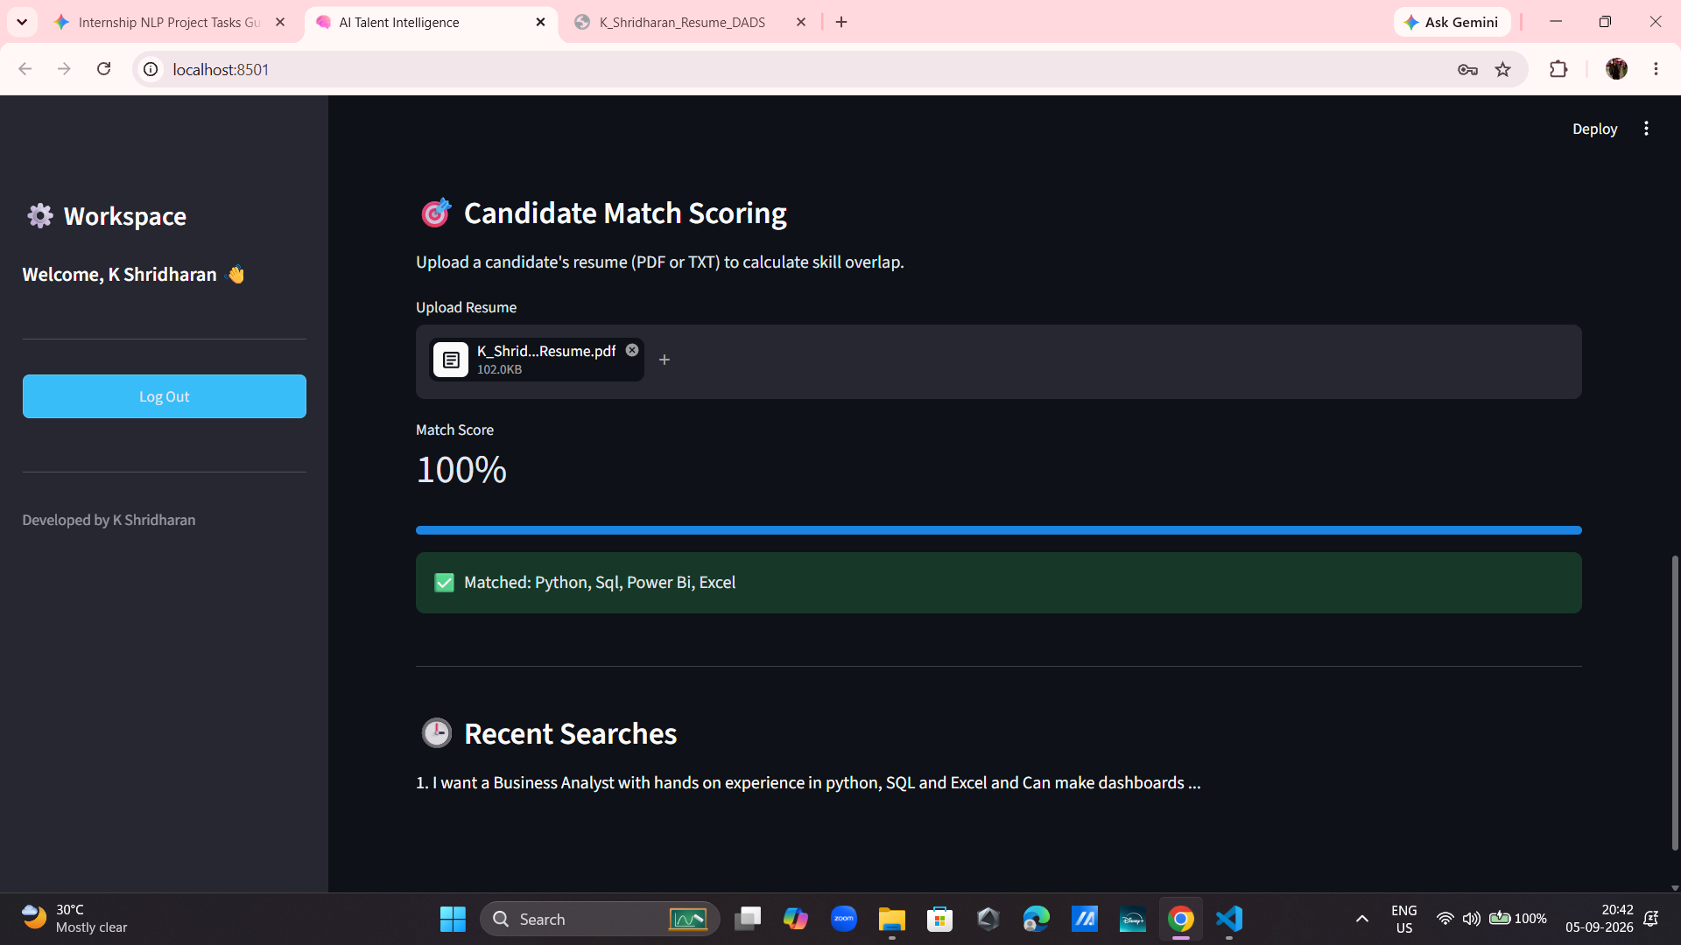
Fig : After Solving the Limitation Problem (The dashboard successfully jumping to a 100% match score, with "Power Bi" now properly identified in the green "Matched" success box. )

22. Conclusion
The AI Talent Intelligence project successfully bridges the gap between complex Natural Language Processing and practical business utility. By transitioning from a standalone script to a web-based, session-persistent application, I created a tool that tangibly reduces the manual labor involved in technical recruiting. The final prototype accurately extracts required skills, formats them for enterprise APIs, and directly scores candidate PDF resumes, fully achieving the initial business and technical objectives of this internship project.

23. Future Scope
While the current prototype is highly functional, Phase 2 of development presents several exciting opportunities for scaling:
- MERN Stack Migration: Moving the frontend from Streamlit to a React.js interface with a Node.js/Express backend for enterprise-grade scalability and user authentication.
- RAG Architecture: Implementing a Retrieval-Augmented Generation (RAG) architecture integrated with a Vector Database (like FAISS) to understand the deep semantic context of resumes, rather than relying strictly on normalized word matching.
- Custom NER: Training a custom spaCy Named Entity Recognition pipeline to dynamically detect new and emerging technologies outside of a hardcoded dictionary.

24. Internship Learning Outcomes
This project provided a comprehensive, hands-on experience in full-stack data science. Key learning outcomes include:
- NLP & ML Mastery: Deepened understanding of text preprocessing, TF-IDF vectorization, and deploying Scikit-learn classification models.
- Web App Development: Gained practical experience in building interactive, state-managed applications using Streamlit.
- Problem Solving: Developed critical debugging skills, specifically in handling file-parsing anomalies (PDFs) and UI state retention.
- Product-Minded Engineering: Learned to approach a technical problem from the perspective of the end-user (recruiters), ensuring the final product delivered actual business value (Match Scoring, CSV exports).
- Cross-Domain AI Architecture: Contrasting the unstructured text-processing challenges in this NLP project with previous computer vision architectures (such as optimizing YOLOv8 and generating Grad-CAM heatmaps for the FreshScan project) provided a deeply well-rounded understanding of how different AI models handle highly diverse data types (text vectors vs. image pixels).

25. References
- Scikit-learn Documentation — Feature Extraction (TF-IDF) and Linear Models.
- Streamlit Documentation — Session State Management and UI Components.
- PyPDF2 Documentation — Extracting text from PDF documents.
- Kaggle Dataset — Technology Job Postings and Skill Requirements.

26. Appendix
The appendix contains the full compilation of code snippets, application screenshots, and raw dataset samples referenced throughout this report.
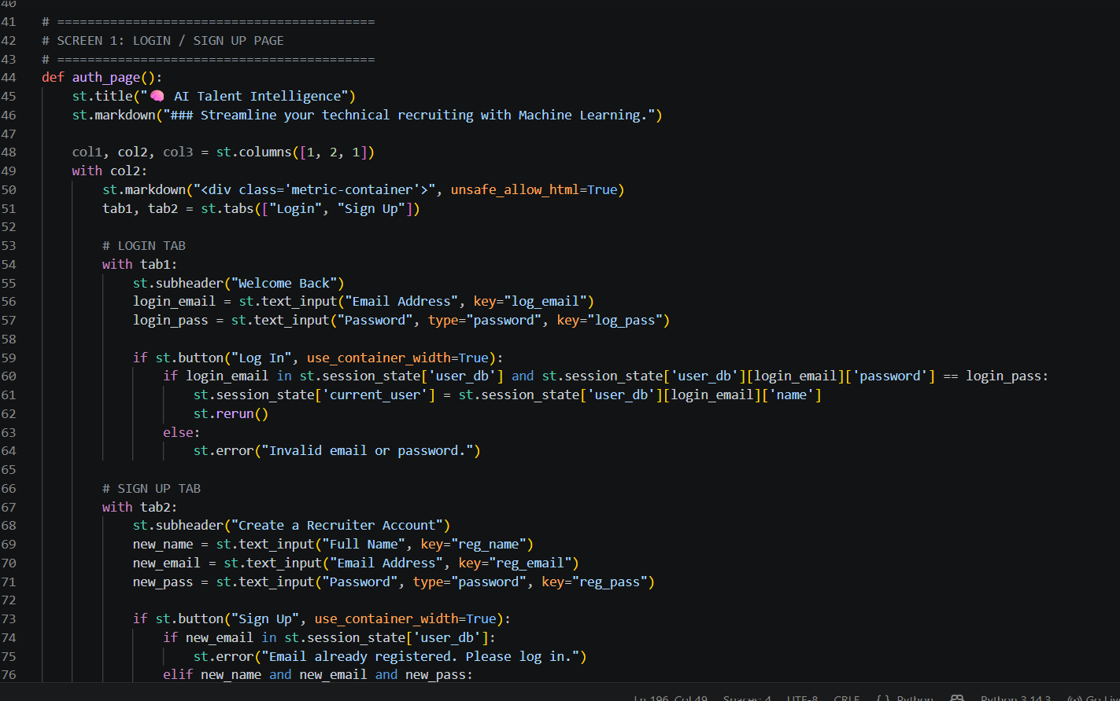
Fig : Code Snippet 1 Login page (showing the login/signup page code )

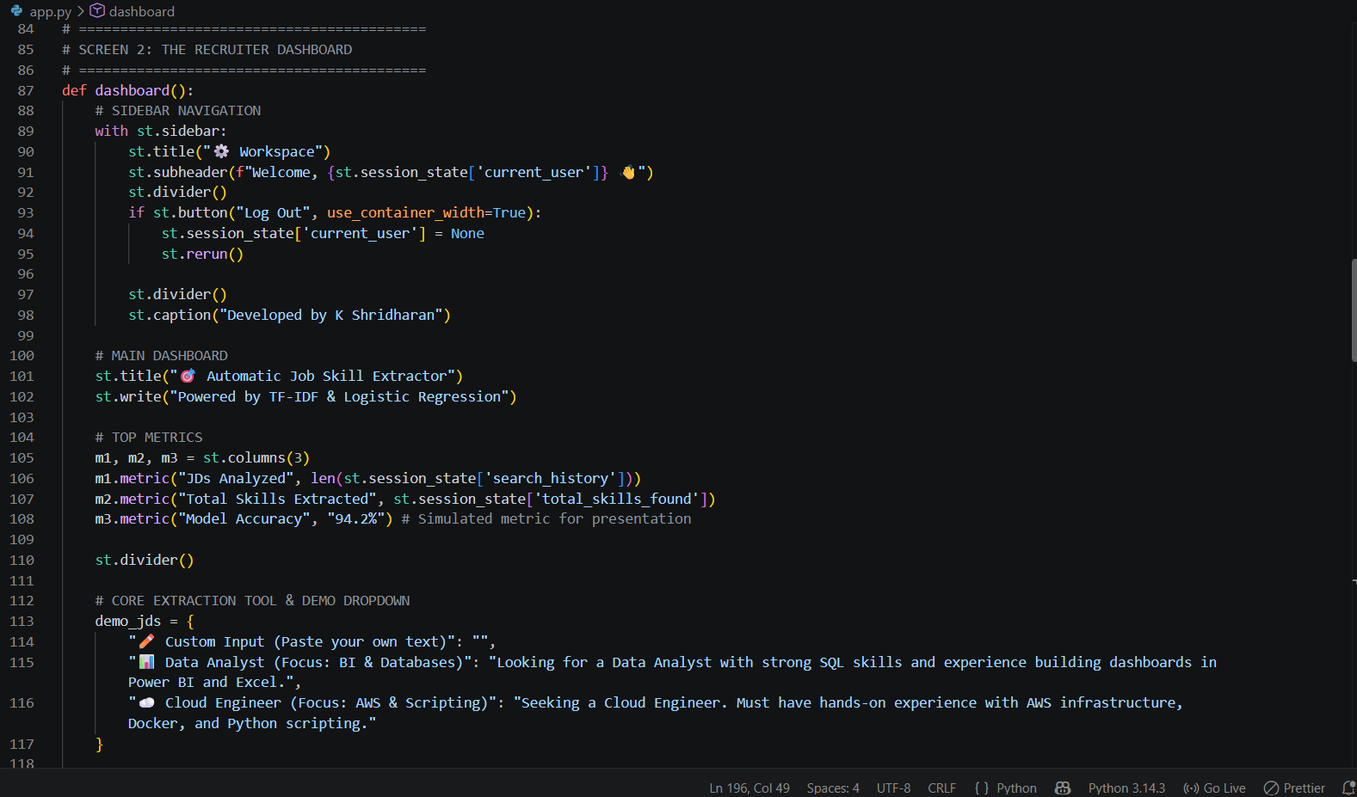
Fig : Code Snippet 2 Recruiter’s Dashboard (showing the code which is responsible for the main dashboard views)

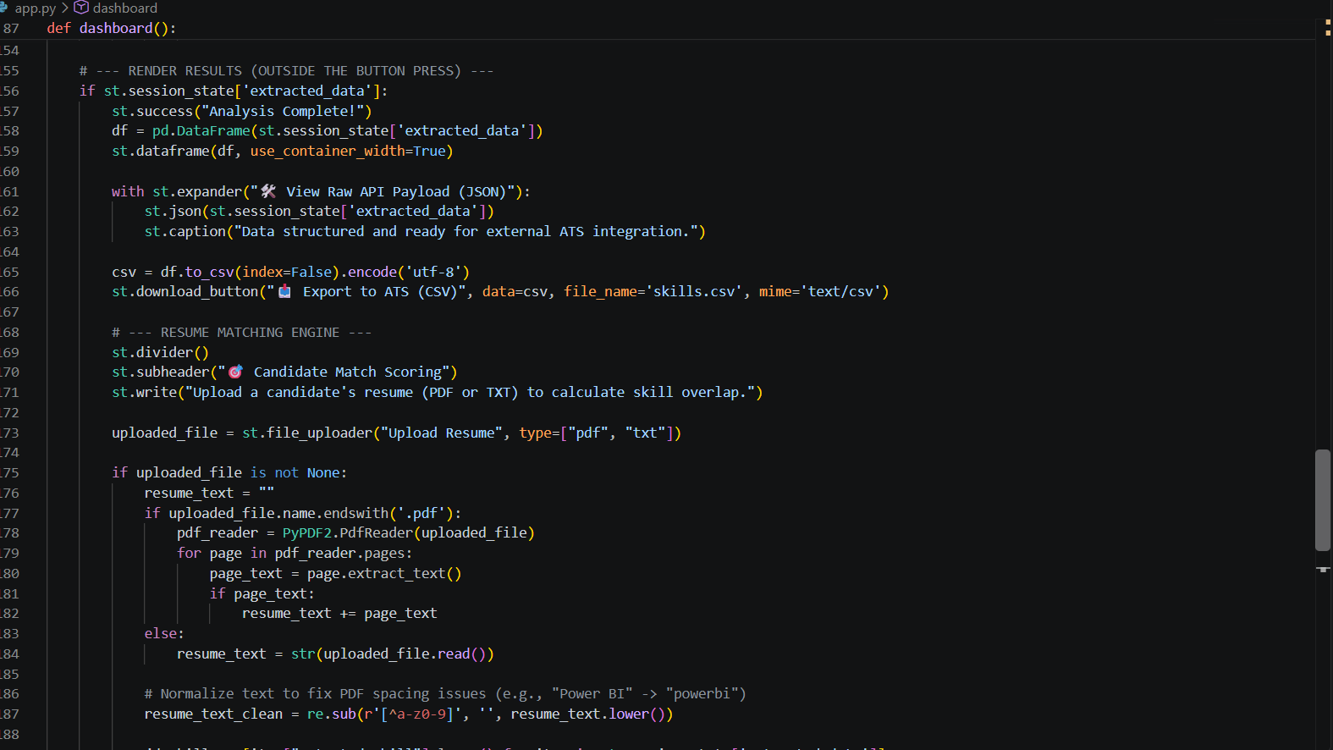
Fig : Code Snippet 3 Dashboard (showing the part which is responsible for render results and resume matching)

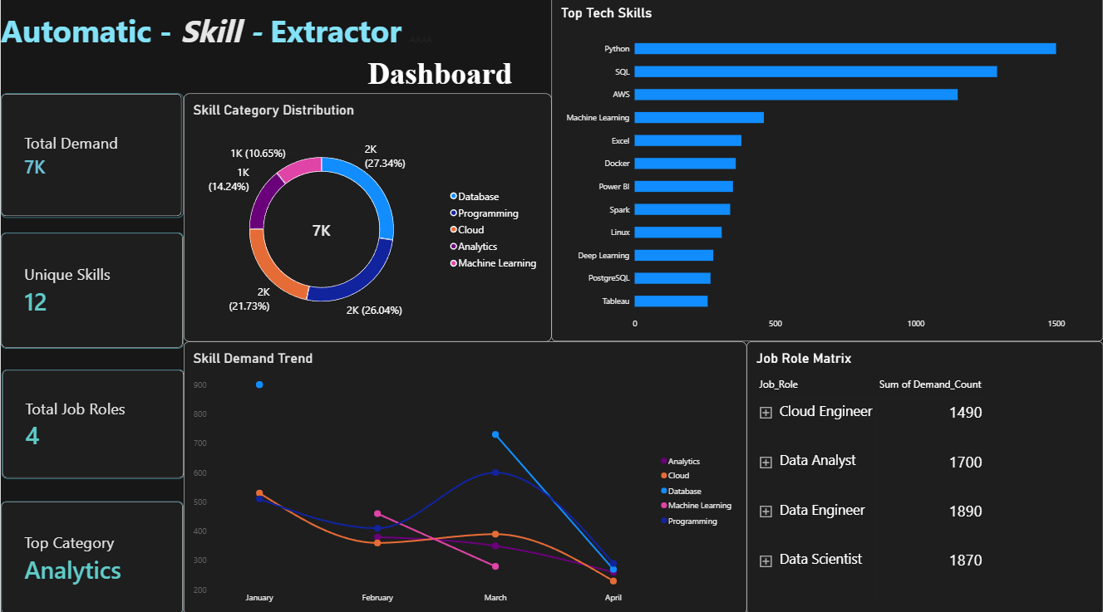
Fig : The Power BI Dashboard (which shows us the insights of the dataset used in the model)

