Week 3
Spring REST using Spring Boot 3
Superset ID: 7992907

1.Spring-rest-handson
Hands on 1 Create a Spring Web Project using Maven

Output – Executing Main Method:
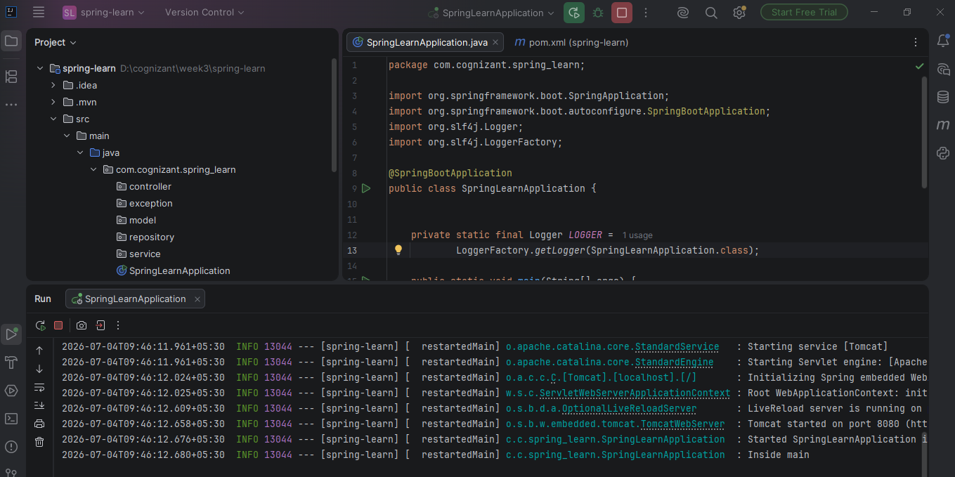
Output – Local Host
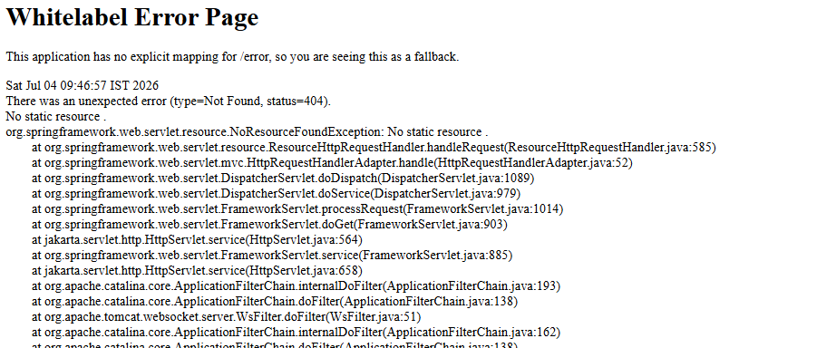
Pom.xml
<?xml version="1.0" encoding="UTF-8"?>
<project xmlns="http://maven.apache.org/POM/4.0.0" xmlns:xsi="http://www.w3.org/2001/XMLSchema-instance"
xsi:schemaLocation="http://maven.apache.org/POM/4.0.0 https://maven.apache.org/xsd/maven-4.0.0.xsd">
<modelVersion>4.0.0</modelVersion>
<parent>
<groupId>org.springframework.boot</groupId>
<artifactId>spring-boot-starter-parent</artifactId>
<version>3.5.16</version>
<relativePath/> <!-- lookup parent from repository -->
</parent>
<groupId>com.cognizant</groupId>
<artifactId>spring-learn</artifactId>
<version>0.0.1-SNAPSHOT</version>
<name/>
<description/>
<url/>
<licenses>
<license/>
</licenses>
<developers>
<developer/>
</developers>
<scm>
<connection/>
<developerConnection/>
<tag/>
<url/>
</scm>
<properties>
<java.version>21</java.version>
</properties>
<dependencies>
<dependency>
<groupId>org.springframework.boot</groupId>
<artifactId>spring-boot-starter-web</artifactId>
</dependency>
<dependency>
<groupId>org.springframework.boot</groupId>
<artifactId>spring-boot-devtools</artifactId>
<scope>runtime</scope>
<optional>true</optional>
</dependency>
<dependency>
<groupId>org.springframework.boot</groupId>
<artifactId>spring-boot-starter-test</artifactId>
<scope>test</scope>
</dependency>
</dependencies>
<build>
<plugins>
<plugin>
<groupId>org.springframework.boot</groupId>
<artifactId>spring-boot-maven-plugin</artifactId>
</plugin>
</plugins>
</build>
</project>

Hands on 4 Spring Core – Load Country from Spring Configuration XML

Output – Executing Main Method
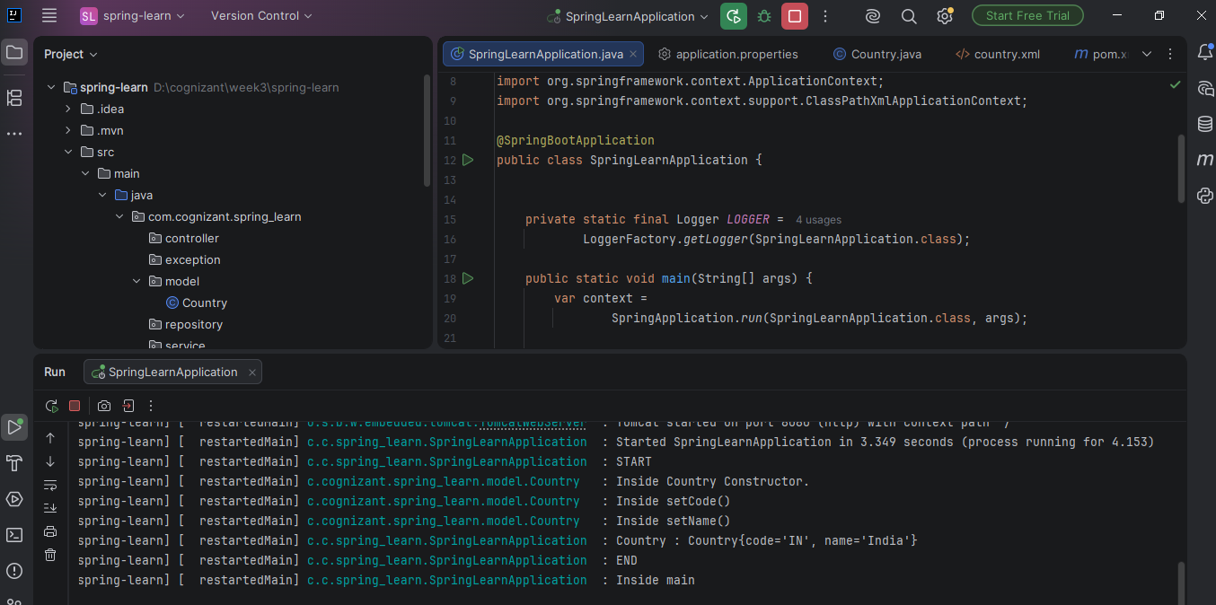
Country.java
package com.cognizant.spring_learn.model;
import org.slf4j.Logger;
import org.slf4j.LoggerFactory;
public class Country {
private static final Logger LOGGER =
LoggerFactory.getLogger(Country.class);
private String code;
private String name;
public Country() {
LOGGER.debug("Inside Country Constructor.");
}
public String getCode() {
LOGGER.debug("Inside getCode()");
return code;
}
public void setCode(String code) {
LOGGER.debug("Inside setCode()");
this.code = code;
}
public String getName() {
LOGGER.debug("Inside getName()");
return name;
}
public void setName(String name) {
LOGGER.debug("Inside setName()");
this.name = name;
}
@Override
public String toString() {
return "Country{" +
"code='" + code + '\'' +
", name='" + name + '\'' +
'}';
}
}

country.xml
<?xml version="1.0" encoding="UTF-8"?>
<beans xmlns="http://www.springframework.org/schema/beans"
xmlns:xsi="http://www.w3.org/2001/XMLSchema-instance"
xsi:schemaLocation="
http://www.springframework.org/schema/beans
https://www.springframework.org/schema/beans/spring-beans.xsd">
<bean id="country"
class="com.cognizant.spring_learn.model.Country">
<property name="code" value="IN"/>
<property name="name" value="India"/>
</bean>
</beans>

application.properties
spring.application.name=spring-learn
logging.level.com.cognizant.spring_learn=debug

SpringLearnApplication.java
package com.cognizant.spring_learn;
import org.springframework.boot.SpringApplication;
import org.springframework.boot.autoconfigure.SpringBootApplication;
import org.slf4j.Logger;
import org.slf4j.LoggerFactory;
import com.cognizant.spring_learn.model.Country;
import org.springframework.context.ApplicationContext;
import org.springframework.context.support.ClassPathXmlApplicationContext;
@SpringBootApplication
public class SpringLearnApplication {
private static final Logger LOGGER =
LoggerFactory.getLogger(SpringLearnApplication.class);
public static void main(String[] args) {
var context =
SpringApplication.run(SpringLearnApplication.class, args);
SpringLearnApplication app =
context.getBean(SpringLearnApplication.class);
app.displayCountry();
LOGGER.info("Inside main");
}
public void displayCountry() {
LOGGER.info("START");
ApplicationContext context =
new ClassPathXmlApplicationContext("country.xml");
Country country =
context.getBean("country", Country.class);
LOGGER.debug("Country : {}", country);
LOGGER.info("END");
}
}

2.Spring-rest-handson
Hello World RESTful Web Service

Output – Executing Main Method

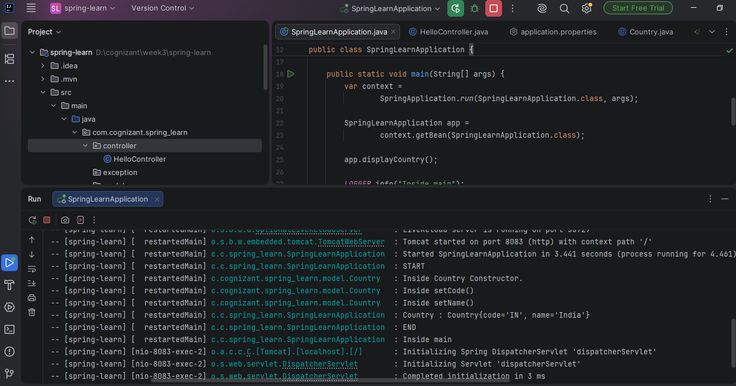

Output – Response in Postman
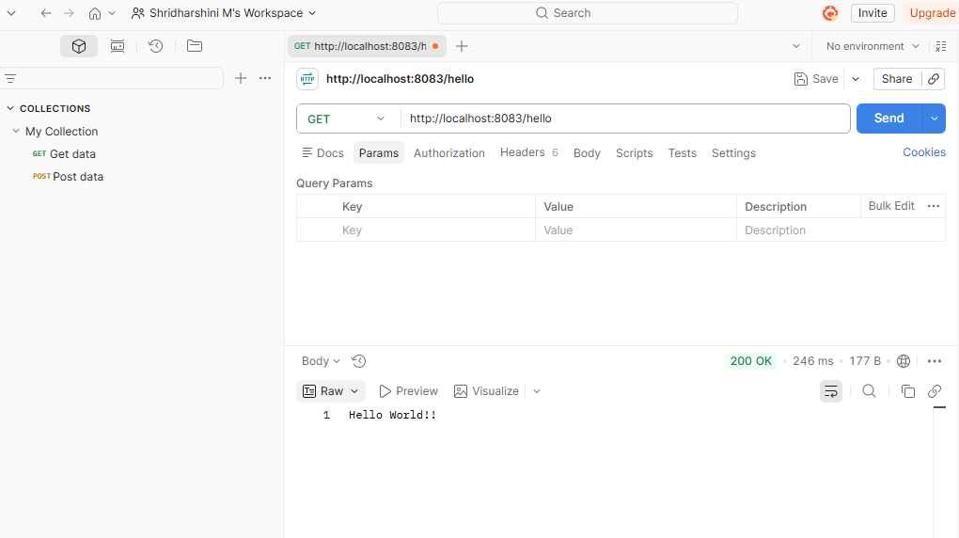
Output – Response in Chrome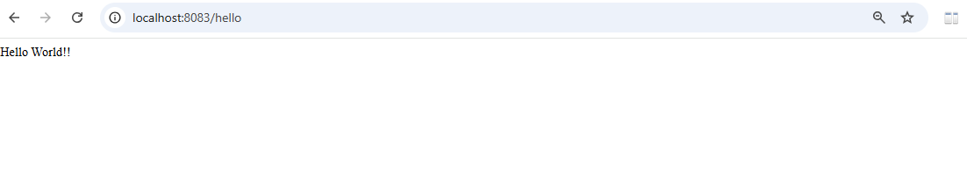
application.properties
spring.application.name=spring-learn
logging.level.com.cognizant.spring_learn=debug
server.port=8083

HelloController.java
package com.cognizant.spring_learn.controller;
import org.slf4j.Logger;
import org.slf4j.LoggerFactory;
import org.springframework.web.bind.annotation.GetMapping;
import org.springframework.web.bind.annotation.RestController;
@RestController
public class HelloController {
private static final Logger LOGGER =
LoggerFactory.getLogger(HelloController.class);
@GetMapping("/hello")
public String sayHello() {
LOGGER.info("START");
LOGGER.info("END");
return "Hello World!!";
}
}

REST - Country Web Service

Output – Executing Main Method:
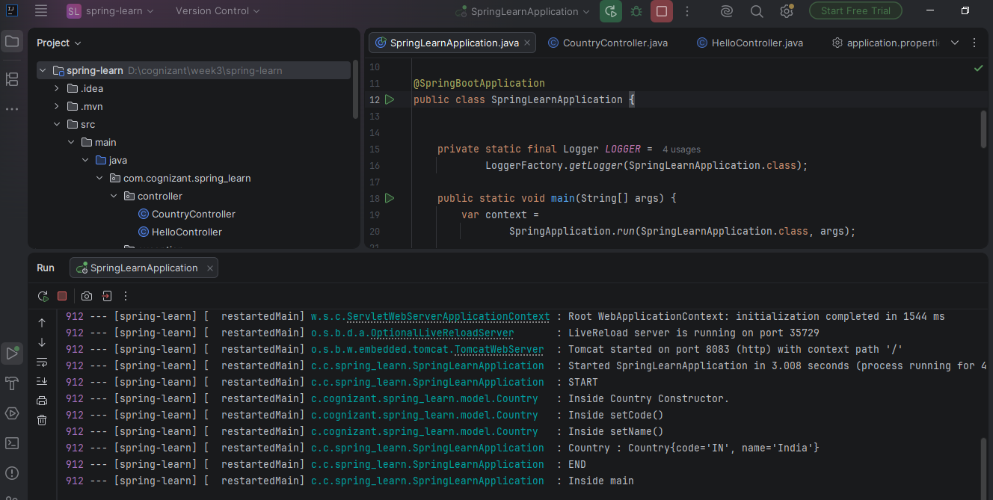
Output – Response in Chrome:
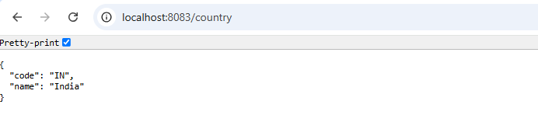
Output – Response in Postman:
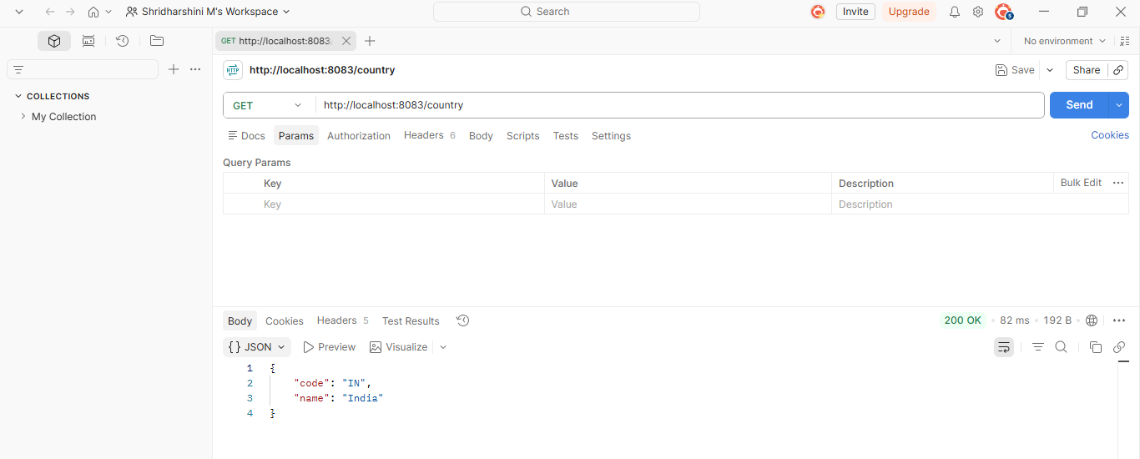
CountryController.java
package com.cognizant.spring_learn.controller;
import com.cognizant.spring_learn.model.Country;
import org.slf4j.Logger;
import org.slf4j.LoggerFactory;
import org.springframework.context.ApplicationContext;
import org.springframework.context.support.ClassPathXmlApplicationContext;
import org.springframework.web.bind.annotation.RequestMapping;
import org.springframework.web.bind.annotation.RestController;
@RestController
public class CountryController {
private static final Logger LOGGER =
LoggerFactory.getLogger(CountryController.class);
@RequestMapping("/country")
public Country getCountryIndia() {
LOGGER.info("START");
ApplicationContext context =
new ClassPathXmlApplicationContext("country.xml");
Country country =
context.getBean("country", Country.class);
LOGGER.info("END");
return country;
}
}

REST - Get country based on country code
Output – Executing Main Method:
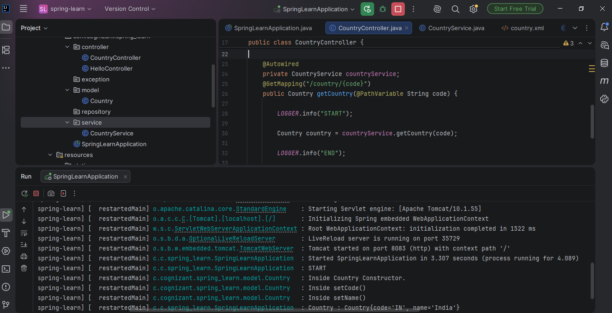
Output – Response in Chrome
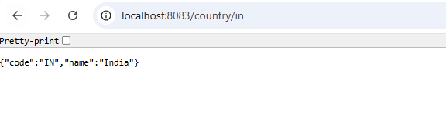
Output – Response in Postman
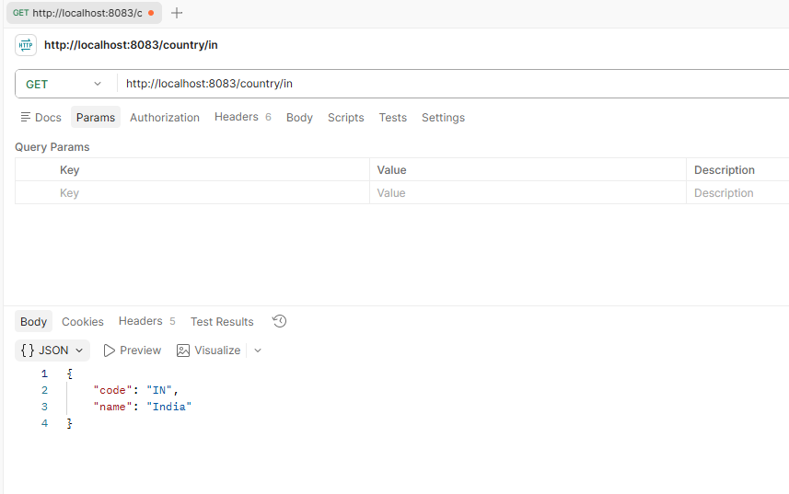

CountryService.java
package com.cognizant.spring_learn.service;
import com.cognizant.spring_learn.model.Country;
import org.springframework.context.ApplicationContext;
import org.springframework.context.support.ClassPathXmlApplicationContext;
import org.springframework.stereotype.Service;
import java.util.List;
@Service
public class CountryService {
public Country getCountry(String code) {
ApplicationContext context =
new ClassPathXmlApplicationContext("country.xml");
List<Country> countries =
(List<Country>) context.getBean("countryList");
for (Country country : countries) {
if (country.getCode().equalsIgnoreCase(code)) {
return country;
}
}
return null;
}
}
country.xml
<?xml version="1.0" encoding="UTF-8"?>
<beans xmlns="http://www.springframework.org/schema/beans"
xmlns:xsi="http://www.w3.org/2001/XMLSchema-instance"
xsi:schemaLocation="
http://www.springframework.org/schema/beans
https://www.springframework.org/schema/beans/spring-beans.xsd">
<bean id="country" class="com.cognizant.spring_learn.model.Country">
<property name="code" value="IN"/>
<property name="name" value="India"/>
</bean>
<bean id="countryList" class="java.util.ArrayList">
<constructor-arg>
<list>
<ref bean="country"/>
</list>
</constructor-arg>
</bean>
</beans>
CountryController.java
package com.cognizant.spring_learn.controller;
import com.cognizant.spring_learn.model.Country;
import com.cognizant.spring_learn.service.CountryService;
import org.slf4j.Logger;
import org.slf4j.LoggerFactory;
import org.springframework.web.bind.annotation.RestController;
import org.springframework.beans.factory.annotation.Autowired;
import org.springframework.web.bind.annotation.GetMapping;
import org.springframework.web.bind.annotation.PathVariable;
@RestController
public class CountryController {
private static final Logger LOGGER =
LoggerFactory.getLogger(CountryController.class);
@Autowired
private CountryService countryService;
@GetMapping("/country/{code}")
public Country getCountry(@PathVariable String code) {
LOGGER.info("START");
Country country = countryService.getCountry(code);
LOGGER.info("END");
return country;
}
}

5. JWT Handson
Create authentication service that returns JWT
Output – Executing Main Method:
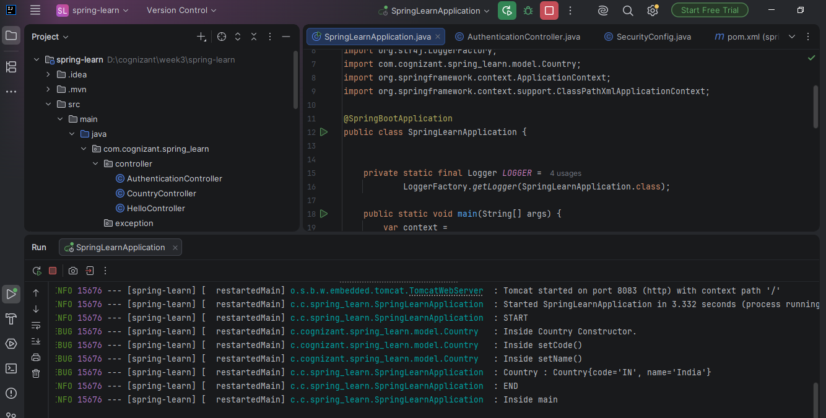
Output – Request using curl command
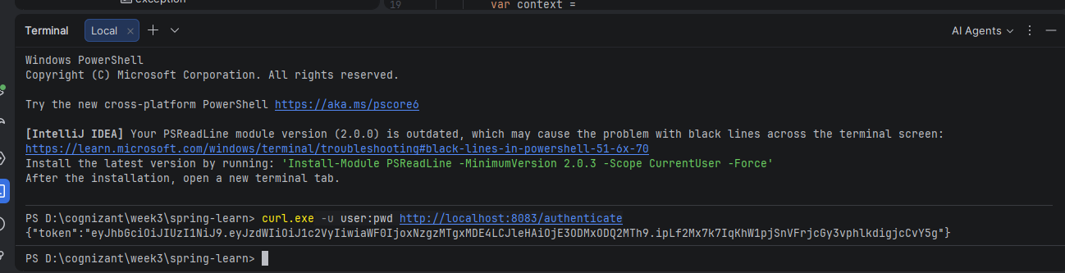
Output – Response in Postman
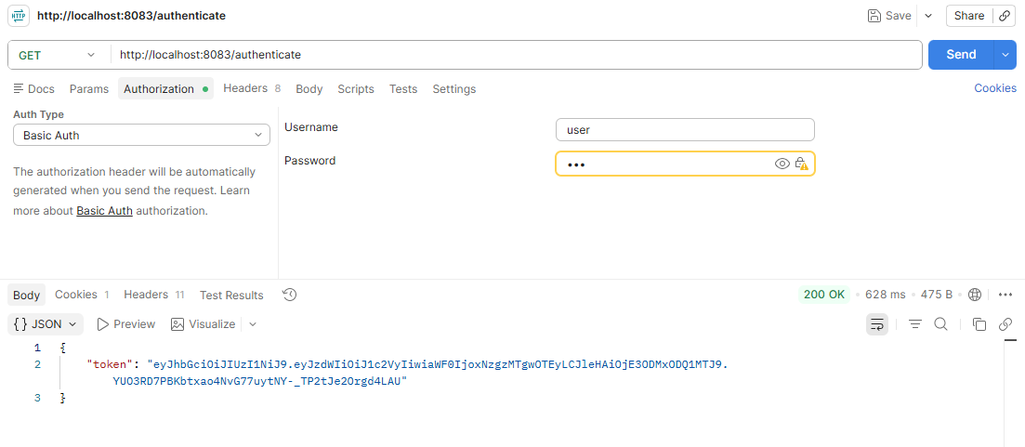
AuthenticationController.java
package com.cognizant.spring_learn.controller;
import org.slf4j.Logger;
import org.slf4j.LoggerFactory;
import org.springframework.web.bind.annotation.GetMapping;
import org.springframework.web.bind.annotation.RequestHeader;
import org.springframework.web.bind.annotation.RestController;
import com.cognizant.spring_learn.util.JwtUtil;
import java.util.Base64;
import java.util.HashMap;
import java.util.Map;
@RestController
public class AuthenticationController {
private static final Logger LOGGER =
LoggerFactory.getLogger(AuthenticationController.class);
@GetMapping("/authenticate")
public Map<String, String> authenticate(
@RequestHeader("Authorization") String authHeader) {
LOGGER.info("START");
String encodedCredentials = authHeader.substring("Basic ".length());
byte[] decodedBytes =
Base64.getDecoder().decode(encodedCredentials);
String credentials =
new String(decodedBytes);
LOGGER.debug("Credentials : {}", credentials);
String username = credentials.split(":")[0];
LOGGER.debug("Username : {}", username);
String token = JwtUtil.generateToken(username);
Map<String,String> map = new HashMap<>();
map.put("token", token);
LOGGER.info("END");
return map;
}
}
SecurityConfig.java
package com.cognizant.spring_learn.security;
import org.springframework.context.annotation.Bean;
import org.springframework.context.annotation.Configuration;
import org.springframework.security.config.Customizer;
import org.springframework.security.config.annotation.web.builders.HttpSecurity;
import org.springframework.security.core.userdetails.User;
import org.springframework.security.core.userdetails.UserDetails;
import org.springframework.security.crypto.bcrypt.BCryptPasswordEncoder;
import org.springframework.security.crypto.password.PasswordEncoder;
import org.springframework.security.provisioning.InMemoryUserDetailsManager;
import org.springframework.security.web.SecurityFilterChain;
@Configuration
public class SecurityConfig {
@Bean
public InMemoryUserDetailsManager userDetailsService() {
UserDetails admin = User.withUsername("admin")
.password(passwordEncoder().encode("pwd"))
.roles("ADMIN")
.build();
UserDetails user = User.withUsername("user")
.password(passwordEncoder().encode("pwd"))
.roles("USER")
.build();
return new InMemoryUserDetailsManager(admin, user);
}
@Bean
public PasswordEncoder passwordEncoder() {
return new BCryptPasswordEncoder();
}
@Bean
public SecurityFilterChain securityFilterChain(HttpSecurity http)
throws Exception {
http
.csrf(csrf -> csrf.disable())
.httpBasic(Customizer.withDefaults())
.authorizeHttpRequests(auth -> auth
.requestMatchers("/countries").hasRole("USER")
.requestMatchers("/authenticate").hasAnyRole("USER", "ADMIN")
.anyRequest().permitAll()
);
return http.build();
}
}

JwtUtil.java
package com.cognizant.spring_learn.util;
import io.jsonwebtoken.Jwts;
import io.jsonwebtoken.security.Keys;
import javax.crypto.SecretKey;
import java.nio.charset.StandardCharsets;
import java.util.Date;
public class JwtUtil {
private static final String SECRET =
"ThisIsASecretKeyForJwtGeneration123456";
private static final SecretKey KEY =
Keys.hmacShaKeyFor(SECRET.getBytes(StandardCharsets.UTF_8));
public static String generateToken(String username) {
return Jwts.builder()
.subject(username)
.issuedAt(new Date())
.expiration(new Date(System.currentTimeMillis() + 3600000))
.signWith(KEY)
.compact();
}
}

