Week 4
Microservices with Spring Boot 3 and Spring Cloud
Superset ID: 7992907

2. Microservices with API gateway
Creating Microservices for account and loan

Output – Executing Main Method (account):
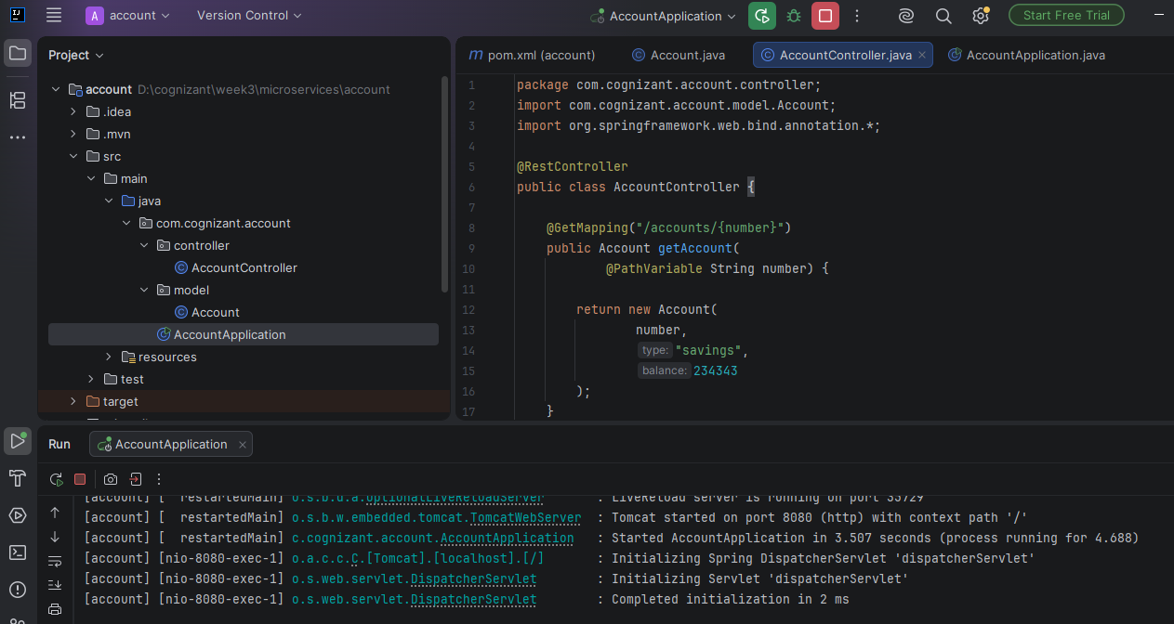

Output – Response in Chrome

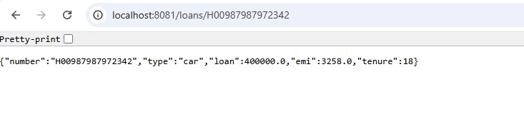
Output – Response in Postman
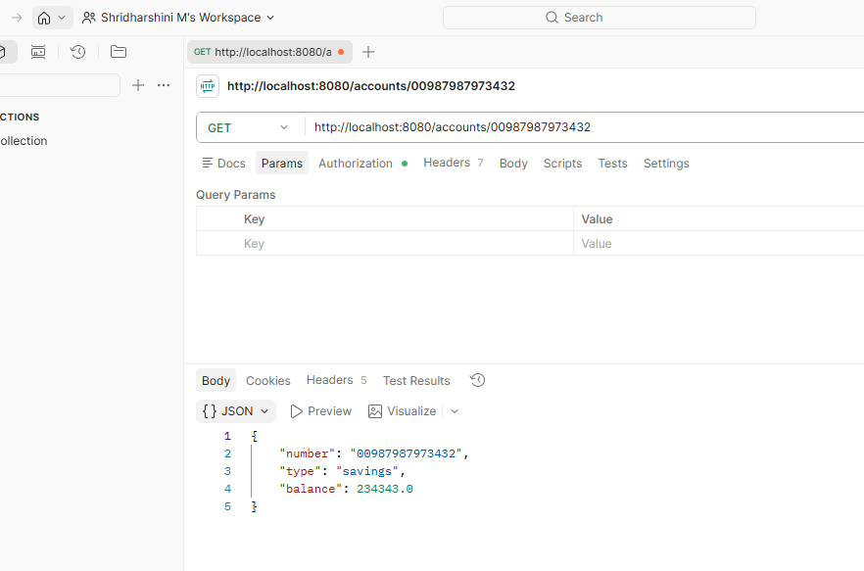

Account.java
package com.cognizant.account.model;
public class Account {
private String number;
private String type;
private double balance;
public Account() {
}
public Account(String number, String type, double balance) {
this.number = number;
this.type = type;
this.balance = balance;
}
public String getNumber() {
return number;
}
public void setNumber(String number) {
this.number = number;
}
public String getType() {
return type;
}
public void setType(String type) {
this.type = type;
}
public double getBalance() {
return balance;
}
public void setBalance(double balance) {
this.balance = balance;
}
}

AccountController.java
package com.cognizant.account.controller;
import com.cognizant.account.model.Account;
import org.springframework.web.bind.annotation.*;
@RestController
public class AccountController {
@GetMapping("/accounts/{number}")
public Account getAccount(
@PathVariable String number) {
return new Account(
number,
"savings",
234343
);
}
}

Output – Executing Main Method (loan):
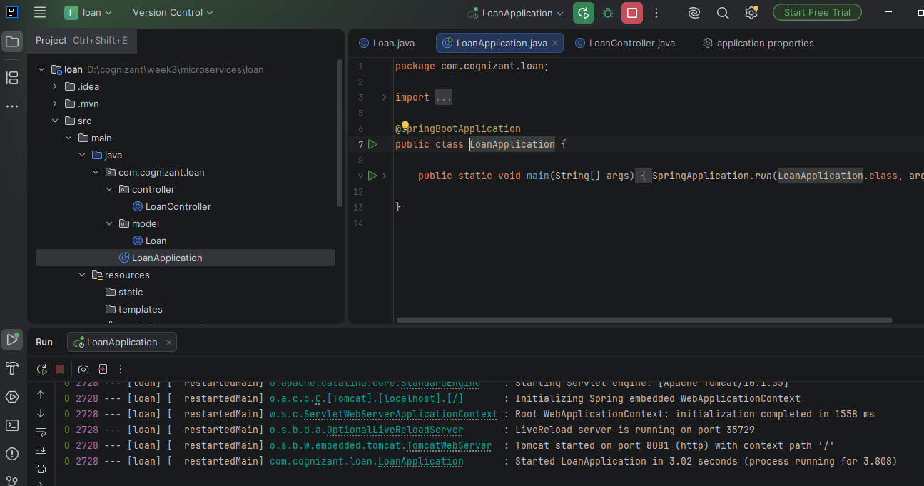
Output – Response in Chrome:

Output – Response in Postman:
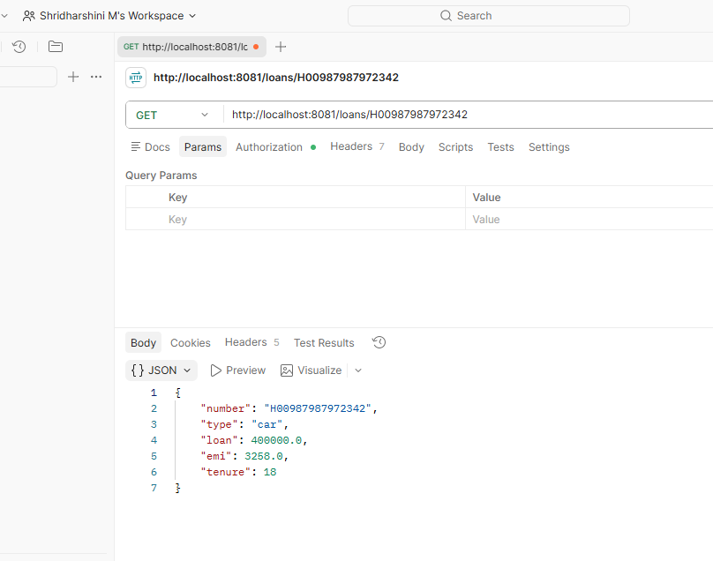

Loan.java
package com.cognizant.loan.model;
public class Loan {
private String number;
private String type;
private double loan;
private double emi;
private int tenure;
public Loan() {
}
public Loan(String number,
String type,
double loan,
double emi,
int tenure) {
this.number = number;
this.type = type;
this.loan = loan;
this.emi = emi;
this.tenure = tenure;
}
public String getNumber() {
return number;
}
public void setNumber(String number) {
this.number = number;
}
public String getType() {
return type;
}
public void setType(String type) {
this.type = type;
}
public double getLoan() {
return loan;
}
public void setLoan(double loan) {
this.loan = loan;
}
public double getEmi() {
return emi;
}
public void setEmi(double emi) {
this.emi = emi;
}
public int getTenure() {
return tenure;
}
public void setTenure(int tenure) {
this.tenure = tenure;
}
}
LoanController.java
package com.cognizant.loan.controller;
import com.cognizant.loan.model.Loan;
import org.springframework.web.bind.annotation.*;
@RestController
public class LoanController {
@GetMapping("/loans/{number}")
public Loan getLoan(
@PathVariable String number) {
return new Loan(
number,
"car",
400000,
3258,
18
);
}
}

