**COMPUTER ASSIGNMENT**

Name: **Shridipta Satpati**

Class: **11** Section: **A**

Roll No.: **48**

Session: **2023 -**

Write a menu driven program to perform conversion between different number systems using user’s choice:

Choice 1: Decimal to Binary

Choice 2: Decimal to Octal

Choice 3: Decimal to Hexadecimal

Choice 4: Binary to Decimal

Choice 5: Octal to Decimal

Choice 6: Hexadecimal to Decimal

import java.util.*;

class Number_System_Convert

{

Scanner sc = new Scanner(System.in);

public void main()

{

System.out.println("1. Dec to Bin");

System.out.println("2. Dec to Oct");

System.out.println("3. Dec to Hex");

System.out.println("4. Bin to Dec");

System.out.println("5. Oct to Dec");

System.out.println("6. Hex to Dec");

System.out.print("Enter your choice: ");

int ch = sc.nextInt();

switch (ch)

{

case 1:

DecToBin();

break;

case 2:

DecToOct();

break;

case 3:

DecToHex();

break;

case 4:

BinToDec();

break;

case 5:

OctToDec();

break;

case 6:

HexToDec();

break;

default:

System.out.println("Invalid input");

}

}

void DecToBin()

{

System.out.println("Enter a decimal number: ");

int dec = sc.nextInt();

int bin = 0;

int p = 0;

while (dec > 0)

{

int digit = dec % 2;

bin += digit * (int) Math.pow(10, p);

dec /= 2;

p++;

}

System.out.println("Binary representation: " + bin);

}

void DecToOct()

{

System.out.println("Enter a decimal number: ");

int dec = sc.nextInt();

int oct = 0;

int p = 0;

while (dec > 0)

{

int digit = dec % 8;

oct += digit * (int) Math.pow(10, p);

dec /= 8;

p++;

}

System.out.println("Octal representation: " + oct);

}

void DecToHex()

{

System.out.println("Enter a decimal number: ");

int dec = sc.nextInt();

String hex = "";

while (dec > 0) {

int digit = dec % 16;

if (digit < 10)

{

hex = (char) (digit + '0') + hex;

} else {

hex = (char) (digit - 10 + 'A') + hex;

}

dec /= 16;

}

System.out.println("Hexadecimal representation: " + hex);

}

void BinToDec()

{

System.out.println("Enter a binary number: ");

int bin = sc.nextInt();

int dec = 0;

int p = 0;

while (bin > 0)

{

int digit = bin % 10;

dec += digit * (int) Math.pow(2, p);

bin /= 10;

p++;

}

System.out.println("Decimal representation: " + dec);

}

void OctToDec()

{

System.out.println("Enter an octal number: ");

int oct = sc.nextInt();

int dec = 0;

int p = 0;

while (oct > 0)

{

int digit = oct % 10;

dec += digit * (int) Math.pow(8, p);

oct /= 10;

p++;

}

System.out.println("Decimal representation: " + dec);

}

void HexToDec()

{

System.out.println("Enter a hexadecimal number: ");

String hex = sc.next();

int dec = 0;

int p = 0;

for (int i = hex.length() - 1; i >= 0; i--)

{

char ch = hex.charAt(i);

int digit;

if (ch >= '0' && ch <= '9') {

digit = ch - '0';

} else {

digit = ch - 'A' + 10;

}

dec += digit * (int) Math.pow(16, p);

p++;

}

System.out.println("Decimal representation: " + dec);

}

}

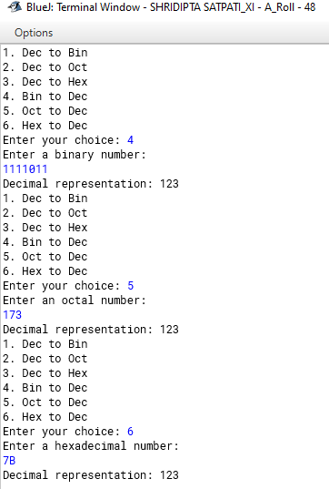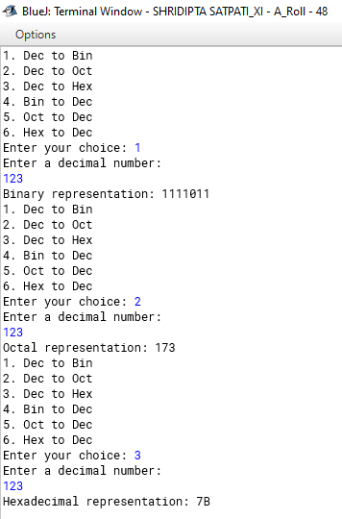

**Date and Time**

Write a program to check the validity of a date.

Write a program of calculate the number of days from 1 January to the given date of a particular year.

**Number Handling**

Write a program to check whether a number is a hamming number or not.

Write a program to check whether a given number is a circular number or not.

Program to enter any positive natural number 'N' where (1<= N<= 50) and generate lucky numbers less than the given natural number.

**Operator of an Array**

Write a program to display frequency of each element present in an array of 10 elements.

Write a program to check for symmetry matrix.

Write a program to calculate the saddle point in 2D array.

Write a program to perform 270 degrees right rotation in a 2D matrix.

Write a program to generate anagrams of a given word (3 letter word).

Write a program to display frequency of Vowels and consonants in each word in the specified format.

Write a program to convert each word of a sentence to Piglatin (Using String Tokenizer).