**FULL STACK .NET**

**DEPI– Round 2**

**(2025)**

**Learning Management System (LMS)**

**Project Documentation**

# **Project Teamwork**

|  |  |  |
| --- | --- | --- |
| **No** | **Name** | **Role** |
|  | **Mohamed Ahmed** | Team leader |
|  | **Mahitab Abdelwahed** | Member |
|  | **Sandra Nagy** | Member |
|  | **Shrief Hammed** | Member |

# 

# **Introduction**

# With the continuous evolution of educational technology, Learning Management Systems (LMS) have become essential tools for enhancing the learning experience, improving student engagement, and streamlining course management. The "LMS Project" aims to develop an intelligent web-based platform that facilitates seamless interaction between learners, teachers, and administrators by automating essential educational processes.

# The application features a user-friendly interface that allows teachers to create and manage courses, track student progress, and conduct assessments efficiently. Students can enroll in courses, complete quizzes, receive certifications, and provide feedback, ensuring a dynamic and interactive learning environment. The system also incorporates data-driven insights to help educators tailor their teaching strategies based on student performance and engagement.

# This project represents an innovative approach to modernizing education through technology, striving to create a collaborative and efficient learning environment that enhances knowledge acquisition and fosters continuous academic growth.

# **Project Idea**

The LMS project is designed to offer a comprehensive solution for managing educational content and student progress. The system will include the following core features:

User Roles: Different access levels for administrators, instructors, and students.

Course Management: Instructors can create, update, and organize courses with various multimedia resources.

Student Tracking: Students can monitor their progress, submit assignments, and receive feedback.

Assessments & Quizzes: Built-in tools for quizzes, exams, and grading.

Communication Tools: Discussion forums, messaging systems, and announcements.

Analytics & Reports: Insights into student performance and course effectiveness.

The system will be accessible via a web-based platform, ensuring flexibility and ease of use. By providing a structured and interactive learning experience, the LMS aims to enhance education delivery and engagement for both students and instructors.

# **1.1 Project Proposal**

**1. Project Title**

**Learning Management System (LMS):** A Smart Digital Platform for Education

**2. Project Overview**

With the increasing demand for digital learning platforms, educational institutions and training centers require an efficient Learning Management System (LMS) to manage courses, track student progress, and facilitate communication between instructors and learners. Our LMS project aims to provide a comprehensive, user-friendly, and scalable platform that enhances the online learning experience.

The system will enable teachers to create and manage courses, students to enroll and complete assessments, and administrators to oversee the platform’s operation. It will also incorporate automated grading, certification generation, and feedback collection, ensuring a streamlined and interactive learning process.

**3. Problem Statement**

In many educational institutions, managing learning resources, tracking student progress, and facilitating effective communication between instructors and students remain challenging tasks. Traditional learning management methods often lead to disorganization, inefficient access to learning materials, and a lack of personalized learning experiences. Additionally, limited monitoring of student performance can result in missed opportunities for timely intervention and support.

This project aims to develop an intelligent Learning Management System (LMS) that provides a centralized platform for course management, real-time student progress tracking, and interactive learning experiences. By incorporating automated progress analysis, personalized recommendations, and seamless communication tools, this system will enhance learning efficiency, support educators in delivering better instruction, and improve student engagement.

**4. Objectives**

**The primary objectives of this LMS project are:**

**1.** **Enhance Online Learning** – Provide a seamless and engaging platform for students and instructors.

**2.** **Simplify Course Management –** Enable teachers to create, edit, and manage courses efficiently.

**3.** **Automate Assessment & Certification** – Allow students to take quizzes, receive instant feedback, and obtain certifications.

**4.** **Improve Communication** – Facilitate interaction between students and instructors through discussion forums and feedback mechanisms.

**5. Monitor Student Performance** – Offer analytics and insights to help instructors assess and improve student learning outcomes.

**6. Ensure Security & Accessibility** – Provide a secure, user-friendly, and scalable system accessible from multiple devices.

**5. Scope of the Project**

The LMS will be designed to support a variety of users, including students, teachers, and administrators. The key functionalities included in the project scope are:

In-Scope Features:

User Management: Registration, authentication, and role-based access control (Students, Teachers, Admins).

Course Management: Course creation, content uploading, scheduling, and assignment management.

Assessment & Certification: Quizzes, automated grading, and certification issuance.

Student Progress Tracking: Performance analytics, progress reports, and feedback collection.

Communication Tools: Discussion forums, announcements, and direct messaging.

Security & Access Control: Data encryption, secure login, and user activity tracking.

Out-of-Scope Features (Future Enhancements):

Integration with AI-based recommendations for personalized learning paths.

Mobile application development for enhanced accessibility.

Support for third-party integrations (e.g., Zoom, Google Classroom, etc.).

This LMS project aims to revolutionize online education by providing a structured and interactive learning platform that caters to both educators and students.

**6. Key Features**

User Authentication & Role Management

Course Management (Create, Edit, Delete Courses)

Assignment & Quiz Management

Student Progress Tracking & Reports

Discussion Forums & Messaging System

Notifications & Alerts

Secure File Upload & Download System

Responsive Design for Web & Mobile Access

**7. Technology Stack**

Backend: .NET Core (C#), SQL Server

Frontend: HTML, CSS, JavaScript (React or Angular)

Database: Microsoft SQL Server

Hosting: Cloud-based (Azure or AWS)

**8. Expected Outcomes**

A fully functional LMS with essential educational features.

Improved engagement and learning experience for students and instructors.

Streamlined course management and performance tracking.

A scalable and secure system that can be expanded in the future.

**9. Timeline & Milestones**

Planning: Requirement Gathering, System Design – 2 Weeks

Development: Backend & Frontend Implementation – 8 Weeks

Testing: Functional & Security Testing – 3 Weeks

Deployment: System Launch & User Training – 2 Weeks

**10. Conclusion**

The LMS project aims to provide an innovative and efficient solution for managing online and blended learning. By offering an intuitive interface and advanced features, it will enhance the educational experience for both students and instructors while ensuring scalability and security.

**1.2 Project Plan**

|  |  |  |  |  |  |  |  |  |
| --- | --- | --- | --- | --- | --- | --- | --- | --- |
| Bhase | Task id | Task Name | **Assigned to** | Estimated | | Actual | | Status |
| start | finish | start | finish |
| **1.planning** | **1.1** | Project Proposal | Mahitab | 14/3/2025 | 15/3/2025 | 13/3/2025 | 14/3/2025 | Done |
| **1.2** | Project Plan &Gantt chart | Mahitab | 15/3/2025 | 15/3/2025 | 14/3/2025 | 14/3/2025 | Done |
| **1.3** | Literature Review | Mahitab | 17/3/2025 | 17/2025 | 16/3/2025 | 16/3/2025 | Done |
| **1.4** | Methodology | Mahitab | 18/3/2025 | 18/3/2025 | 17/3/2025 | 17/3/2025 | Done |
|  | **1.5** | Feasibility Study | Mahitab | 14/3/2025 | 14/3/2025 | 17/3/2025 | 18/3/2025 | Done |
| **2.** **Analysis** | **2.1** | **Stakeholder Analysis** | Mahitab | 14/3/2025 | 16/3/2025 | 16/3/2025 | 18/3/2025 | Done |
|  | **2.2** | Use Case | Mohamed Ahmed | 16/3/2025 | 17/3/2025 | 18/3/2025 | 18/3/2025 | Done |
|  | **2.3** | **Functional & Non-Functional Requirements** | Mohamed Ahmed | 17/3/2025 | 18/3/2025 | 18/3/2025 | 19/3/2025 | Done |
|  | **2.4** | Software Architecture | Mohamed Ahmed | 17/3/2025 | 18/3/2025 | 19/3/2025 | 20/3/2025 | Done |
|  | **2.5** | **ERD** | Shrief | 17/3/2025 | 19/3/2025 | 19/3/2025 | 20/3/2025 | Done |
|  | **2.6** | Schema | Mohamed Ahmed | 17/3/2025 | 19/3/2025 | 19/3/2025 | 20/3/2025 | Done |
|  | **2.7** | Sequence diagram | Mohamed Ahmed | 17/3/2025 | 19/3/2025 | 19/3/2025 | 20/3/2025 | Done |
|  | **2.8** | Activity Diagram | Mohamed Ahmed | 17/3/2025 | 19/3/2025 | 19/3/2025 | 20/3/2025 | Done |
|  | **2.9** | State Diagram | Mohamed Ahmed | 17/3/2025 | 19/3/2025 | 19/3/2025 | 20/3/2025 | Done |
|  | **2.10** | Class Diagram | Mohamed Ahmed | 17/3/2025 | 19/3/2025 | 19/3/2025 | 20/3/2025 | Done |
| **3.Design** | **3.1** | UI/UX Design | Sandra | 16/3/2025 | 18/3/2025 | 19/3/2025 | 20/3/2025 | Done |
| **4.Implementation** | **4.1** | Start coding front end |  | 14/3/2025 | 14/3/2025 |  |  |  |
|  | **4.2** | Start coding web |  | 14/3/2025 | 14/3/2025 |  |  |  |
|  | **4.3** | Start coding back end |  | 14/3/2025 | 14/3/2025 |  |  |  |

**1.2 Gantt chart & Time line**

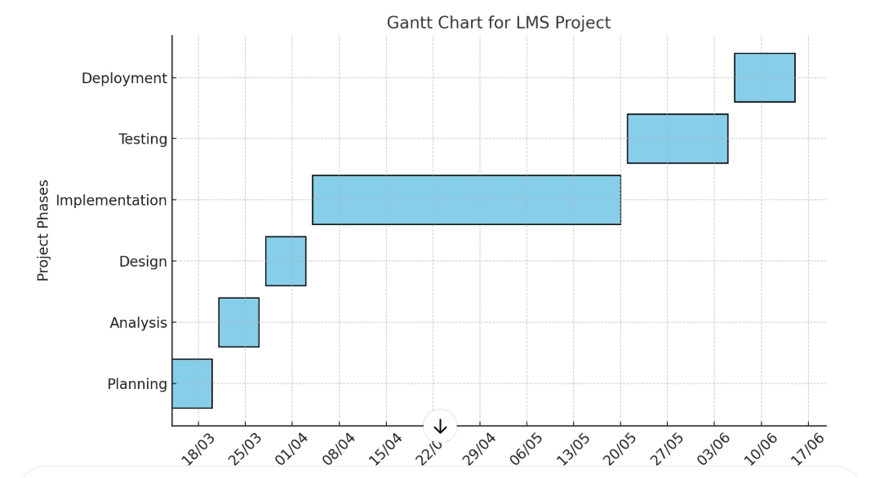

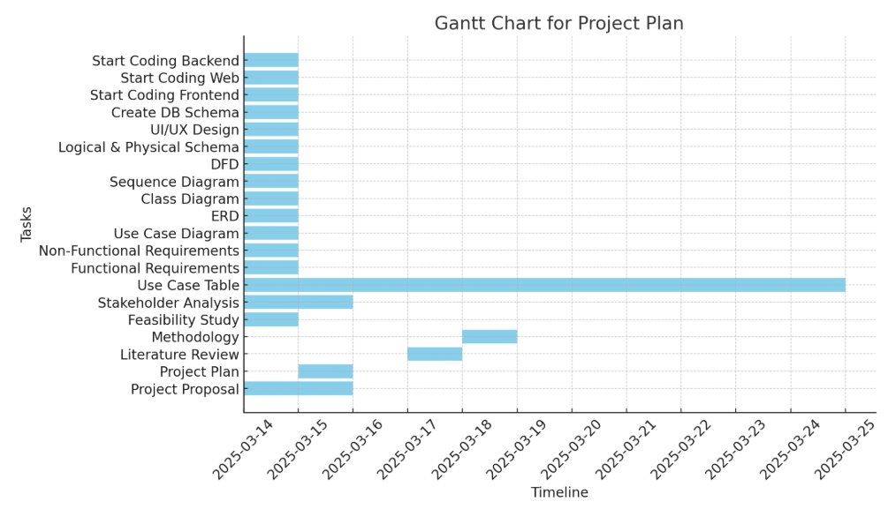

**1.3 Literature Review**

**Feedback & Evaluation**

**Throughout the project development, lecturers have provided valuable insights regarding the system’s design, functionality, and usability. The main points of evaluation include:**

**System Usability:** Feedback highlighted the importance of an intuitive user interface for both students and instructors.

**Performance & Scalability:** Suggestions were made to ensure that the LMS can handle multiple users simultaneously without performance degradation.

**Security Measures:** Lecturers emphasized the need for robust authentication and data protection strategies to secure student information.

**Digital Learning Tools:** Research suggests that incorporating interactive tools such as AI-based recommendations, real-time progress tracking, and adaptive learning models improves student engagement and learning outcomes.

**Instructor & Student Collaboration:** Studies highlight the importance of seamless communication between instructors and students. Features such as discussion forums, real-time chat, and automated feedback systems play a crucial role in fostering interactive learning.

**Cloud-Based LMS Solutions:** Cloud technology enables scalability, accessibility, and security. Institutions increasingly adopt cloud-based LMS platforms to ensure system reliability and data protection.

**Evaluation Metrics:** Academic studies assess LMS effectiveness based on parameters like student performance, retention rates, and system usability. Data-driven insights help institutions refine LMS functionalities for better adoption.

**Suggested Improvements**

**Based on the feedback received, several areas for enhancement have been identified:**

**Enhanced User Experience:** Implementing a more interactive and responsive design using modern front-end frameworks.

**Advanced Analytics & Reporting:** Introducing AI-driven analytics to provide better insights into student performance and engagement.

**Integration with External Tools:** Enabling third-party integrations (e.g., Zoom, Google Drive) to enhance the learning experience.

**Final Grading Criteria**

**The project will be evaluated based on the following criteria:**

**Documentation (20%):** Completeness and clarity of the project documentation, including system design, database schema, and use case diagrams.

**Implementation (40%):** Functionality, efficiency, and adherence to best coding practices in the development of the LMS.

**Testing & Security (20%):** Effectiveness of functional and security testing, ensuring the system meets quality standards.

**Presentation (20%):** Clarity and professionalism of the project demonstration, including responsiveness to questions and explanation of system features

**1.4 Methodology**

**Methodology (Agile)**

**Introduction**

In developing our **Learning Management System (LMS)**, we adopted the **Agile methodology** to ensure flexibility, continuous improvement, and rapid adaptation to user needs. Given the dynamic nature of e-learning environments and the necessity to meet both instructor and student expectations, Agile allows us to **incrementally develop features** while incorporating real-time feedback from educators, students, and administrators.

**Why Agile?**

* **Iterative Development**: The LMS is built in small, manageable cycles (**sprints**), allowing for **continuous enhancements**.
* **Continuous Feedback**: Gathering insights from teachers, students, and institutions to refine features and enhance user experience.
* **Adaptability to Change**: Quickly adjusting features or adding new ones based on user needs, technological advancements, or institutional requirements.

**Agile Process Flow**

*(Include a visual similar to the one in the reference image)*

The Agile development process for our LMS follows these key phases:

1. **Requirements Gathering** – Collecting insights from educational institutions and users.
2. **Planning** – Defining sprint goals and prioritizing features.
3. **Development** – Implementing core functionalities in an iterative manner.
4. **Testing** – Ensuring the system is functional, user-friendly, and bug-free.
5. **Review** – Analyzing feedback and improving the system based on evaluations.
6. **Deployment** – Delivering updates and maintaining system performance.

**Why Agile Works for LMS?**

**High Flexibility**: Easily adapts to changes in course structures, student needs, and institutional requirements.  
 **Continuous Improvement**: Ongoing enhancements based on real-time user feedback and system performance analysis.  
 **User-Centric Approach**: Regular involvement of educators and students ensures that the LMS truly

**1.5 Feasibility Study**

**Economic Feasibility?**

**Economically feasible**: The LMS utilizes **open-source frameworks** and **cloud-based solutions** to reduce infrastructure costs. It also aligns with academic budgets, making it a cost-effective solution for educational institutions.

**Technical Feasibility?**

**Technically feasible**: The system is built using **scalable technologies** such as **.NET, SQL databases, and cloud integration**, ensuring **compatibility** with existing e-learning platforms and **supporting future expansions**.

**Operational Feasibility?**

**Operationally feasible**: The demand for a **centralized LMS** has been validated through **educator and student feedback**. The system is designed to enhance learning experiences and streamline course management.

**Risks & Mitigation**

**Risk**: Potential scalability challenges when integrating with **large institutions**.  
**Mitigation**: Implementing **modular architecture** and **cloud scalability options** to support high traffic and large datasets.

**Risk**: Adoption resistance from **non-tech-savvy educators**.  
**Mitigation**: Providing **comprehensive training materials** and **user-friendly interfaces** to facilitate smooth onboarding.

**2.1 Stakeholder Analysis**

# 1. Primary Stakeholders

|  |  |  |  |
| --- | --- | --- | --- |
| Stakeholder |  |  | Needs & Expectations |

|  |  |
| --- | --- |
| **Students**  **Educators**  **Administrators** | - Easy access to educational content.   - Track academic progress.   - Interaction with teachers and peers.  - Upload and manage educational materials efficiently.   - Monitor student performance.   - Interactive tools for lessons and assessments.  - Control system and user management.   - Monitor data and generate analytical reports.   - Efficiently support academic operations. |

2. Secondary Stakeholders

|  |  |  |  |
| --- | --- | --- | --- |
| Stakeholder |  |  | Needs & Expectations |

|  |  |  |
| --- | --- | --- |
| **Parents**  **IT Support Team**  **Educational Institutions**  **Government & Accreditation Bodies** | - Ability to track students' progress.  - Regular notifications about their children’s performance.  - Communication channel with teachers.    - Ensure a stable and secure operating environment.  - Provide technical support when needed.  - Maintain data integration with other systems.   |  | | --- | | - A comprehensive system that aligns with institutional requirements.  - Reports and analytics on educational performance.  - Enhanced e-learning experience. |   - Ensure the system complies with educational standards.  - Maintain data privacy and security regulations.  - Support academic quality assurance. |

3. Potential Investors & Sponsors

* **Needs & Expectations:**
  + Return on investment by deploying the system across multiple institutions.
  + Assurance of long-term sustainability and scalability.
  + Access to performance reports and educational impact analysis.

**2.2 use case**

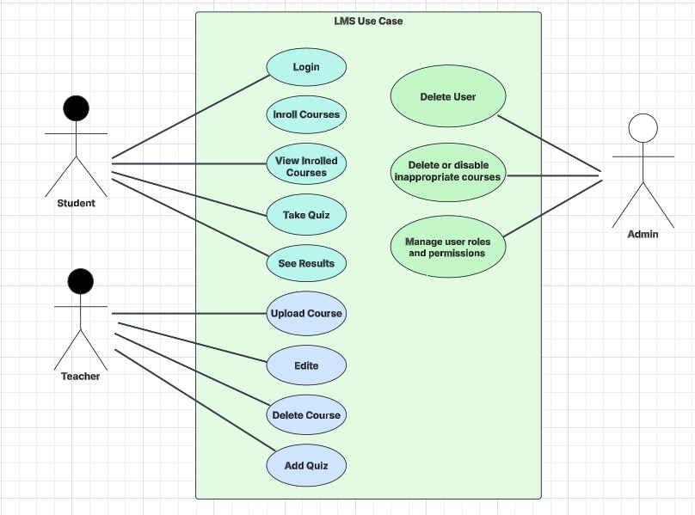

**2.3 Functional & Non-Functional Requirements**

Functional Requirements

1. Users must be able to register and log in to the system.
2. Users can browse and enroll in courses.
3. Students must be able to take quizzes and save their results.
4. Instructors should be able to create and update courses.
5. Each user must have a dashboard to view their details.

Non-Functional Requirements

1. System response time should be less than 2 seconds for 90% of requests.
2. It must support 500 concurrent users.
3. The platform should be compatible with modern browsers and mobile devices.
4. The database should be scalable to accommodate future growth.
5. Caching mechanisms should be implemented to improve performance.

# **2.4 Software Architecture**

# The system follows a layered architecture using ASP.NET Core MVC, ensuring separation of concerns :

# **Presentation Layer:** Handles user interactions via Controllers & Views.

# **Business Logic Layer (BLL):** Contains application logic and service implementations.

# **Data Access Layer (DAL):** Manages database operations using Entity Framework Core.

# **Tech Stack:** ASP.NET Core MVC, SQL Server, Entity Framework Core, Repository Pattern, Dependency Injection.

# **2.5 ERD**

# 

**2.6 Schema**

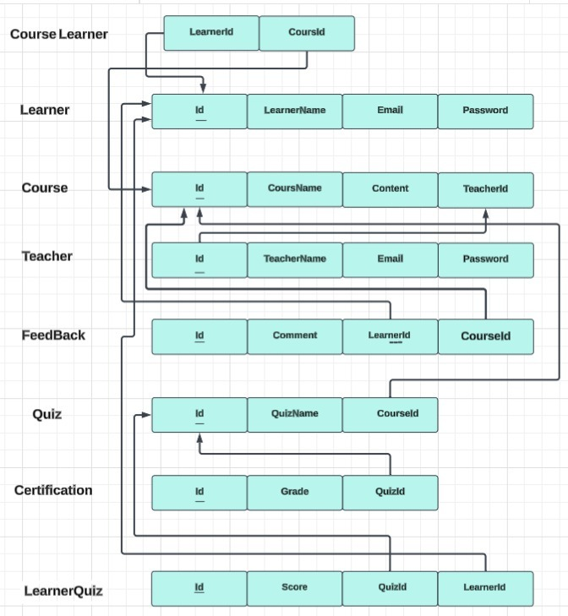

**2.7 Sequence diagram**

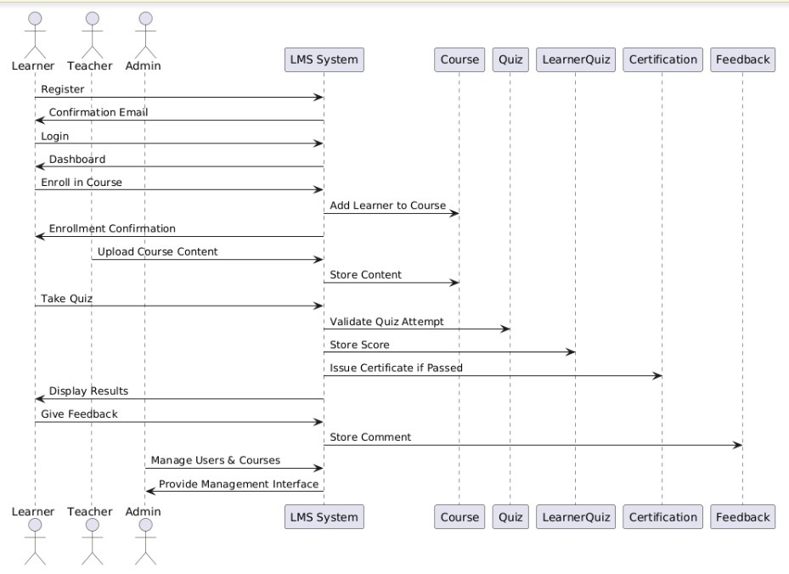

**2.8 Activity Diagram**

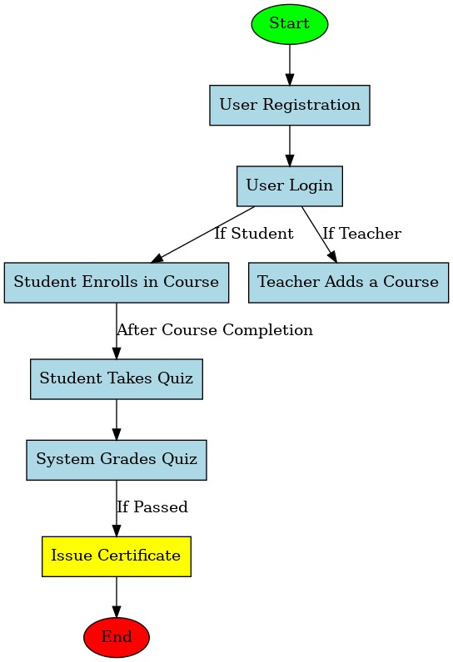

**2.9**  **State Diagram**

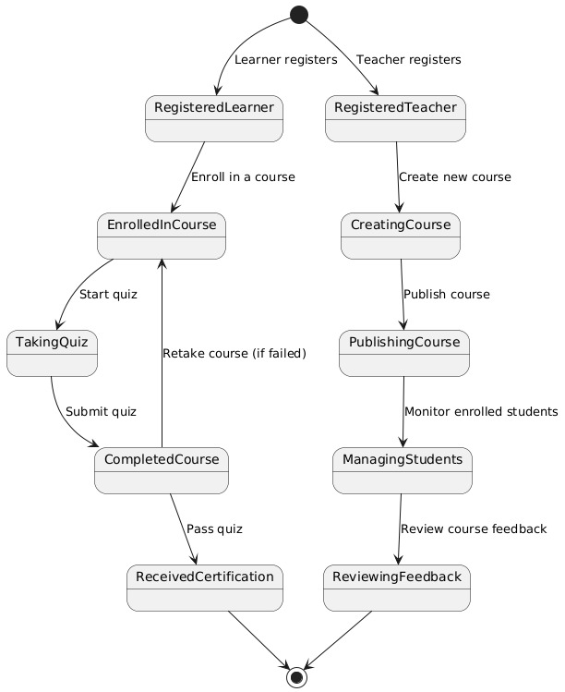

**2.10 Class Diagram**

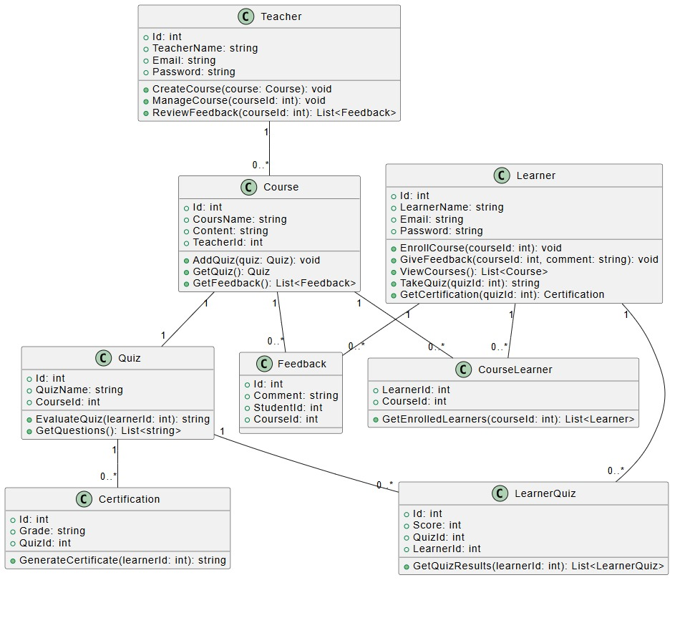

**3.1 UI/UX Design**

**3.1.1 Home Page**

**( Desktop View , Laptop View , Mobile View)**

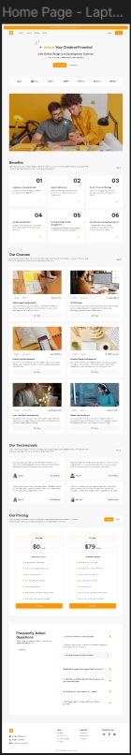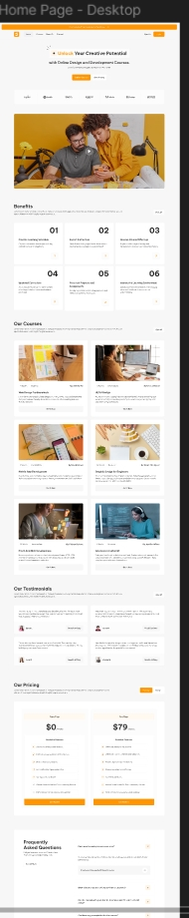

**3.1.2 Courses Page** **Mobile View**

** Desktop View**

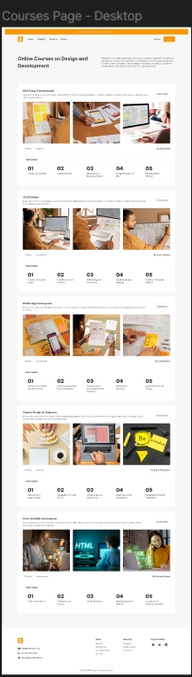 **Laptop View**

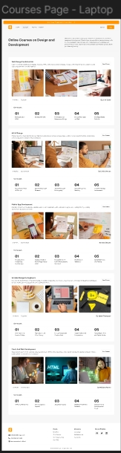

**3.1.3 Courses Open Page**

**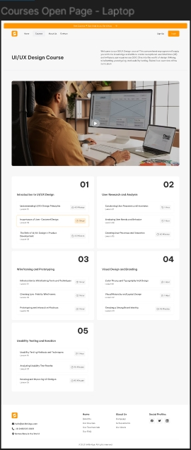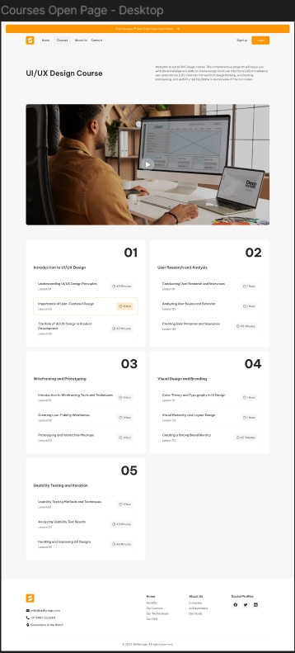****Desktop View Laptop view Mobile View**

**3.1.4 About Us Page**

**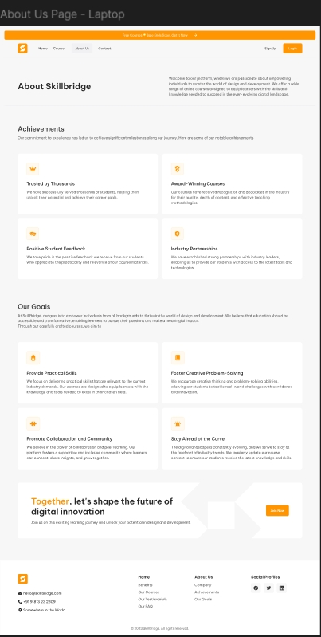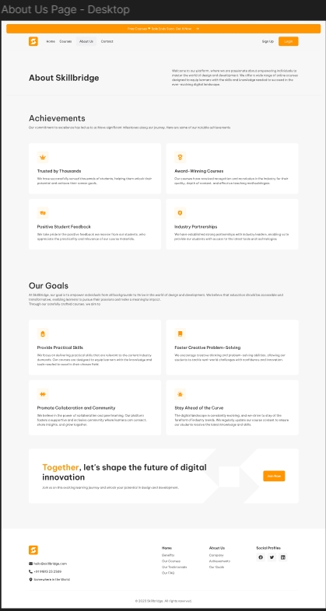****Desktop View** **Laptop View** **Mobile View**

**3.1.5 Login Page**

**Desktop**

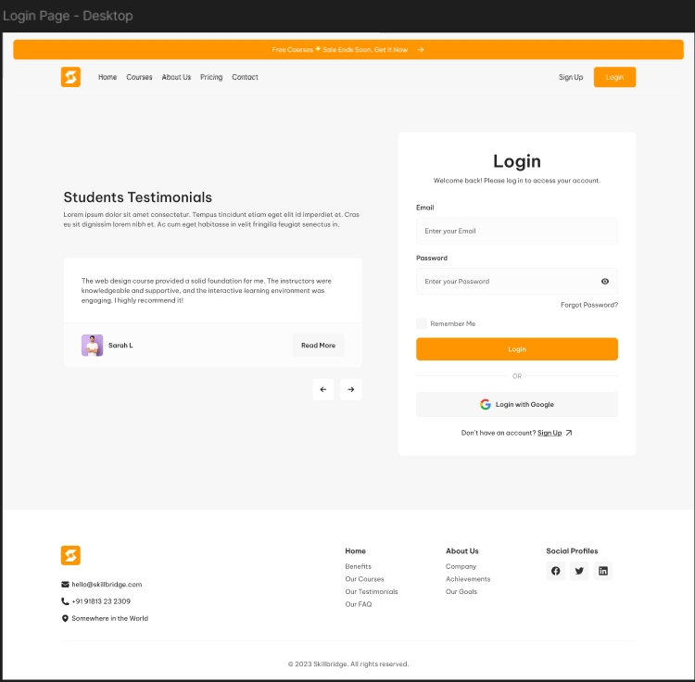

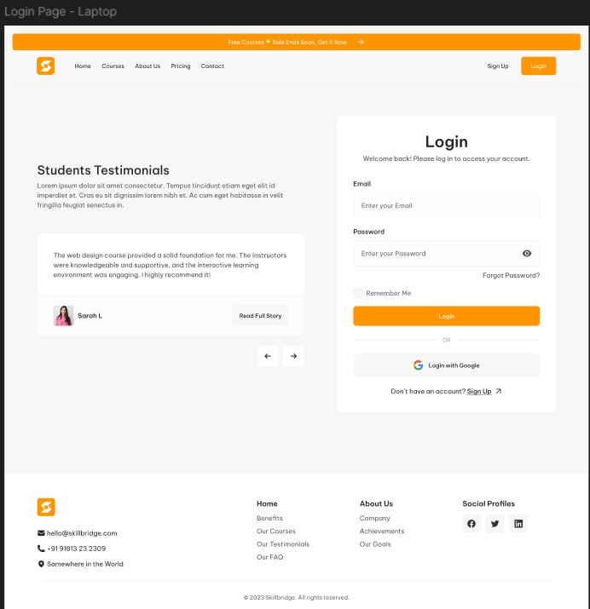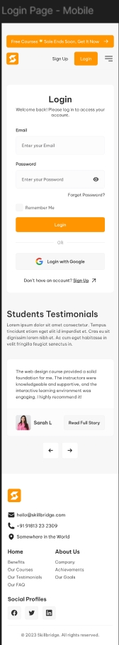**Laptop View Mobile View**

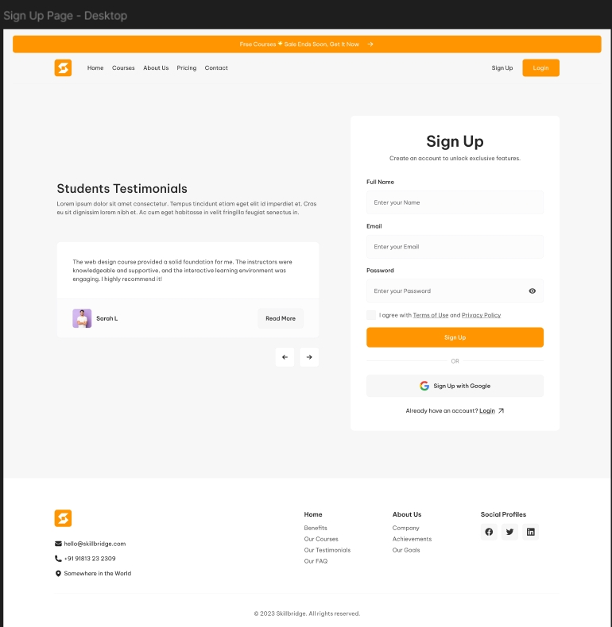**3.1.6 Sign Up Page**

**Desktop View**

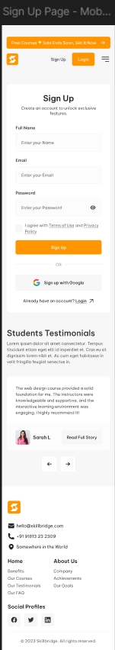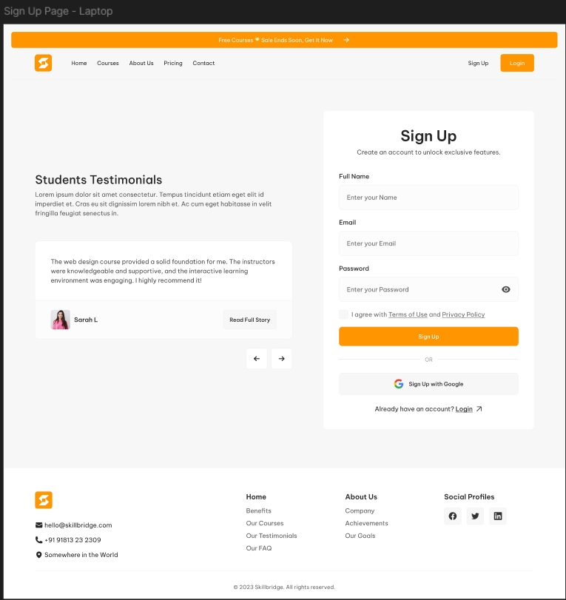

**3.1.7 Contact Page**

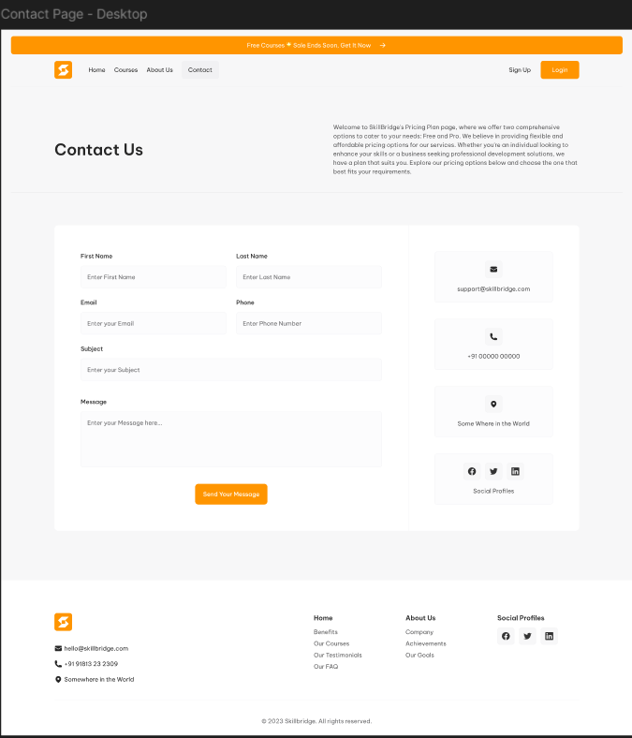

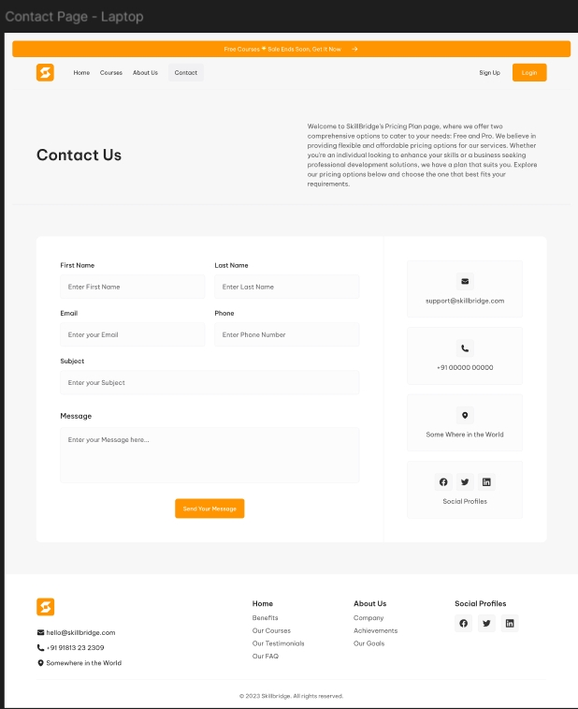**Laptop View Mobile View**