Al Based Synthetic Media Detection System
¹ Guide, Student ², Student ³, Student ⁴, Student ⁵
¹Professor, Department of AIDS Engineering, Matoshri College of Engineering and Research Centre, Nashik, Maharashtra, India
^{2,3,4,5} Students, Department of AIDS Engineering, Matoshri College of Engineering and Research Centre, Nashik, Maharashtra, India
ABSTRACT
The rapid advancement of artificial intelligence has made it possible to generate and manipulate realistic facial images, creating challenges for digital authenticity and online information reliability. Deepfake detection has therefore become an important research area in computer vision and digital forensics. This survey reviews major approaches used for deepfake image detection, including facial image preprocessing, handcrafted feature extraction, convolutional neural networks, manipulation artifact localization, and explainable artificial intelligence. Recent research on LAA-Net (2024), SIDA (2025), and hybrid Bag-of-Visual-Words and multi-CNN feature fusion (2026) is examined to understand their contributions, strengths, and relevance to image-based deepfake detection. The survey also discusses dataset selection, class imbalance, compression effects, demographic information, evaluation requirements, and the limitations of existing approaches. Finally, it identifies the need for practical detection systems that combine classification, confidence estimation, visual explanation, and accessible web-based interfaces. The findings provide a foundation for the proposed AI DeepGuard Detection system.
Keywords: Deepfake Detection, Computer Vision, Convolutional Neural Networks, Feature Extraction, Explainable AI, Digital Forensics.

1.INTRODUCTION
1.1 Background
Deepfake technology uses artificial intelligence and deep-learning techniques to create or manipulate images, videos, and other digital media. These technologies can produce realistic facial images that are difficult to distinguish from authentic content through visual inspection alone. Deepfakes have applications in entertainment and digital content creation, but they can also be misused for identity impersonation, misinformation, fraud, and privacy violations.
Deepfake detection has therefore become an important research area in computer vision and digital forensics. Existing approaches use convolutional neural networks (CNNs), handcrafted visual features, facial artifact analysis, and explainable artificial intelligence (XAI) to identify manipulated content. Recent research also investigates localization and explanation techniques to make detection results more interpretable.
1.2 Motivation
The increasing realism of AI-generated images creates a need for reliable and accessible methods to assess digital image authenticity. Manual inspection may not identify subtle manipulation artifacts, particularly in compressed or low-quality images. Furthermore, a classification result alone may not explain why an image has been identified as potentially manipulated.
The motivation behind AI DeepGuard Detection is to explore a practical system that combines deepfake image classification with confidence scores and visual explanations. A web-based interface can make these capabilities easier to access without requiring users to operate complex machine-learning tools directly.
1.3 Problem Statement
Existing deepfake detection techniques face challenges related to manipulation diversity, image compression, dataset imbalance, generalization to unseen manipulations, and interpretation of model predictions. Some approaches require substantial computational resources or provide limited explanations of their decisions.

Therefore, the problem addressed in this study is to examine existing deepfake image detection techniques and propose a web-based framework that integrates image preprocessing, Real/Fake classification, confidence estimation, visual explanation, and detection-result management.
1.4 Objectives
The main objectives of this survey and proposed project are:
- To review existing machine-learning and deep-learning techniques for deepfake image detection.
- To study facial image preprocessing and feature extraction methods.
- To examine datasets, class labels, compression effects, and class imbalance.
- To investigate visual explanation techniques such as Grad-CAM and heatmaps.
- To identify limitations in detection accuracy, robustness, and generalization.
- To propose a web-based detection framework using Python and Flask.
- To integrate prediction results, confidence information, detection history, and report generation into a unified interface.
1.5 Scope of the Study
This study focuses primarily on facial image deepfake detection rather than complete video or audio deepfake analysis. It reviews published research, examines the suitability of the FaceForensics dataset, and considers preprocessing, classification, explainability, and web application integration.
The proposed AI DeepGuard Detection system is intended to classify uploaded images using a trained model and display the associated prediction and visual analysis. Its reliability will need to be evaluated experimentally using appropriate training, validation, and independent test data.
2. Literature Survey
Researchers have developed several techniques to detect deepfake images using machine learning, deep learning, and digital image forensics. Early approaches focused on identifying visual inconsistencies, facial artifacts, and unusual image patterns. Later approaches introduced Convolutional Neural Networks (CNNs), transformer-based architectures, and frequency-domain analysis to improve detection. These methods learn patterns from real and manipulated images and classify them based on the features identified during training. However, detection performance may decrease when images come from unfamiliar datasets, use new manipulation techniques, or undergo compression.
FaceForensics++ is an important benchmark dataset used in research on facial manipulation detection. It provides manipulated facial videos and supports the evaluation of detection methods under different compression conditions. CNN-based models, such as XceptionNet and EfficientNet, are widely studied because they can learn visual features automatically. Vision Transformers and frequency-based methods have also been investigated to improve generalization across datasets. Comparative research indicates that performance on the training dataset alone is not sufficient to establish real-world reliability; models must also be evaluated on unseen datasets and images with different quality levels. Recent literature reviews highlight several remaining challenges, including detecting previously unseen manipulation methods, handling imbalanced datasets, improving robustness against compression, and explaining why a model predicts an image as fake. Explainable AI techniques, such as Grad-CAM, can generate heatmaps that highlight image regions influencing a model's prediction. These visual explanations can help users understand the prediction, although a heatmap does not independently prove that an image is manipulated. Researchers also emphasize the importance of consistent evaluation metrics and transparent reporting of experimental results.
Based on these findings, AI DeepGuard Detection aims to combine deepfake image classification with confidence scores, visual explanations, and a simple web-based interface. The proposed system will use image preprocessing and a trained detection model to classify an uploaded image as real or fake, while Grad-CAM-based visualization may help show the regions influencing the prediction. Detection history and report generation will support result management. The effectiveness of the proposed system will be assessed through experimental evaluation rather than assumed in advance. This approach focuses not only on classification but also on usability, interpretability, and the practical limitations of deepfake detection.
2. Proposed System Architecture
The proposed AI DeepGuard Detection system is a web-based application designed to identify whether an uploaded facial image is real or manipulated using artificial intelligence. The system uses Python and Flask for backend development, HTML, CSS, and JavaScript for the user interface, and a trained deep learning model for image classification. The architecture consists of image uploading, image validation, preprocessing, face detection, feature extraction, deepfake classification, explainable AI, and result presentation. Similar research systems combine image preprocessing, deep learning classification, and Grad-CAM visualizations to make detection results easier to interpret.
When a user uploads an image, the system first checks the file format and validates the input. The image is then resized and preprocessed to match the requirements of the trained model. If a face is detected, the relevant facial region is extracted and passed to the deepfake detection model. The model predicts whether the image is real or fake and generates a confidence score. Grad-CAM can then produce a heatmap highlighting the image regions that influenced the prediction. The result page displays the predicted class, confidence score, and heatmap to the user. The system can also save the prediction, timestamp, and related details in a database for future reference.
The architecture includes a user module for registration, login, image uploads, viewing results, accessing detection history, and downloading reports. An administrator module can provide user management and detection statistics. Flask connects the frontend with the image-processing and prediction modules, while the database stores user information and detection records. This modular architecture makes the system easier to maintain and extend. The reliability of its predictions will depend on the selected model, dataset quality, testing procedure, and evaluation results.
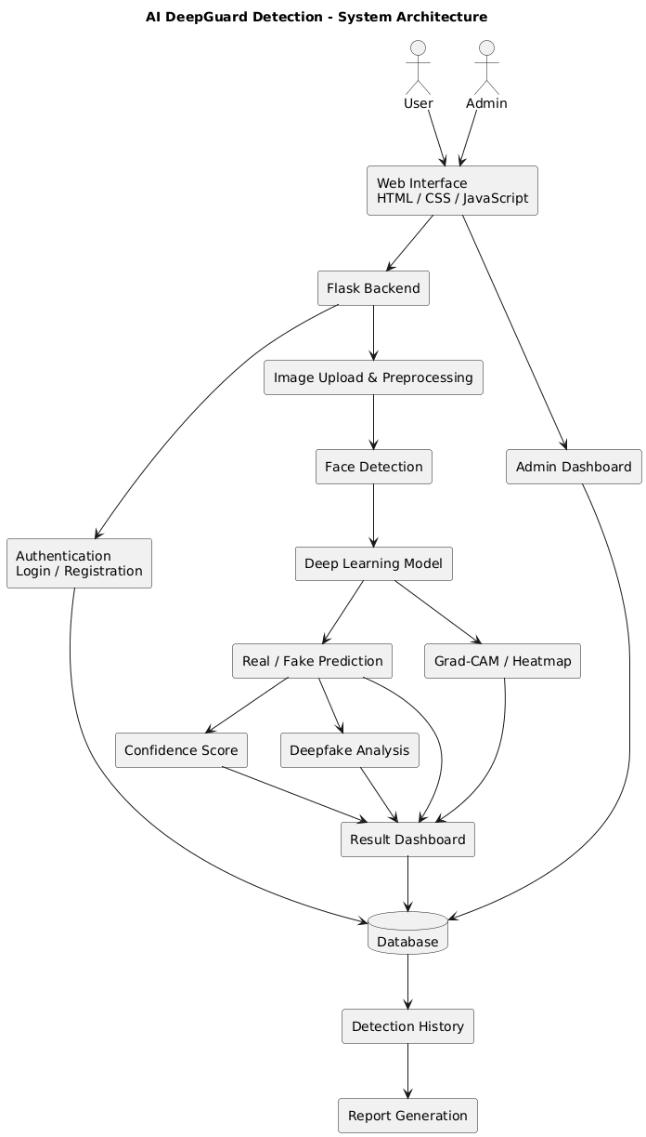
4. Details of Modules
The AI DeepGuard Detection system consists of several modules that work together to detect manipulated facial images. The User Authentication Module allows users to register and log in securely. The Image Upload Module enables users to upload facial images for analysis, while the Image Validation and Preprocessing Module checks the uploaded file and prepares the image by resizing, normalization, and other necessary operations. The Face Detection Module identifies the facial region in the image so that relevant facial features can be analyzed.
The Deepfake Detection Module uses a trained deep learning model to classify the input image as real or fake. The Confidence Score Module displays the model's confidence in its prediction. The Explainable AI Module uses Grad-CAM or a similar visualization technique to generate a heatmap showing regions that influenced the model's decision. These highlighted regions help users interpret the prediction but do not independently prove that an image is manipulated.
The Result Dashboard Module displays the predicted class, confidence score, and heatmap in a clear format. The Detection History Module stores previous detection records so that users can review their results. The Report Generation Module allows users to generate or download reports containing relevant detection information. The Database Module stores user details and detection records, while the Admin Dashboard Module enables administrators to manage users and view overall detection statistics. Together, these modules provide a structured and user-friendly platform for deepfake image analysis.
5. Algorithm
The AI DeepGuard Detection system follows a sequence of steps to identify whether an uploaded facial image is real or fake. First, the user uploads an image through the web application. The system validates the image format and checks whether the file can be processed. The valid image is then preprocessed by resizing and normalizing it according to the requirements of the trained deep learning model. Face detection is performed to identify the facial region, and the required features are extracted for classification.
Algorithm Steps:
- Start the system.
- Register or log in to the application.
- Upload a facial image.
- Validate the uploaded image.
- Preprocess the image.
- Detect and extract the facial region.
- Extract relevant features using the trained model.
- Classify the image as Real or Fake.
- Generate the confidence score.
- Generate the Grad-CAM heatmap, if available.
- Display the prediction and analysis results.
- Store the detection record in the database.
- Allow the user to view history or generate a report.
- Stop the process.

6.Conclusion
AI DeepGuard Detection is a proposed AI-based system designed to identify deepfake and manipulated facial images. The system combines image preprocessing, face detection, deep learning classification, confidence scoring, and explainable AI techniques to provide an organized image analysis process. It offers a web-based interface through which users can upload images and view the predicted results.
The system also includes detection history, report generation, and administrator functionalities to improve usability and result management. The use of Grad-CAM heatmaps can help users understand which image regions influenced the model's prediction. However, the reliability of the system depends on the quality of the dataset, the trained model, and its evaluation on different types of images. The proposed project aims to make deepfake image analysis more accessible and understandable while recognizing that AI predictions should not be treated as definitive proof of image manipulation.
9. References
- A. Rössler et al., “FaceForensics++: Learning to Detect Manipulated Facial Images,” Proceedings of the IEEE/CVF International Conference on Computer Vision (ICCV), 2019.
- Y. Li and S. Lyu, “Exposing DeepFake Videos By Detecting Face Warping Artifacts,” Proceedings of the IEEE Conference on Computer Vision and Pattern Recognition Workshops (CVPRW), 2019.
- F. Chollet, “Xception: Deep Learning with Depthwise Separable Convolutions,” Proceedings of the IEEE Conference on Computer Vision and Pattern Recognition (CVPR), 2017.
- R. R. Selvaraju et al., “Grad-CAM: Visual Explanations from Deep Networks via Gradient-Based Localization,” Proceedings of the IEEE International Conference on Computer Vision (ICCV), 2017.
- Kaggle, “FaceForensics Dataset.” Available at: https://www.kaggle.com/datasets/greatgamedota/faceforensics
- I. Goodfellow et al., “Generative Adversarial Nets,” Advances in Neural Information Processing Systems (NeurIPS), 2014.
- Python Software Foundation, “Python Documentation.” Available at: https://docs.python.org/3/
- Pallets Projects, “Flask Documentation.” Available at: https://flask.palletsprojects.com/
- OpenCV, “OpenCV Documentation.” Available at: https://docs.opencv.org/

