Contents

Introduction and Work-done 1

Short Descriptions Authored 1

Manually Authored: Short Description-1 (June/23/2025) 1

Felsch-Kincaid Score 2

AI Authored: Short Description-1 (June/23/2025) 3

InfoGraphics-1 (June/23/2025) 3

# Introduction and Work-done

Short Descriptions are key elements for a person who is visually-challenged and for search-engines. The google-crawler will first crawl over the **short descriptions** tag and try to understand the gist of contents present inside that topic. Hence, Short-Descriptions are very helpful in providing effective SEO results. Else, even with the content, it cannot be accessed effectively inside the vast collection of information called “The Internet”. More information on benefits of Short Descriptions can be accessed and viewed using LLMs like Chat-GPT.

In this file,

# Short Descriptions Authored

## Manually Authored: Short Description-1 (June/23/2025)

* The data which is collected by Active Health System and stored in the Active Health System log, is logged securely and kept isolated from other operating systems and customer data.
* The collection and logging of Active Health System data does not consume Host resources.
* The oldest data is replaced with the new data when the Active Health System Log is full.
* When downloading the Active Health System Log, you can also add your contact information and when you send the Active Health System data to HPE, you must agree to have the data used for analysis, technical resolution, and quality improvements.
* The data collected is managed by following the privacy statement, link here: <https://www.hpe.com/info/privacy>.

## Felsch-Kincaid Score

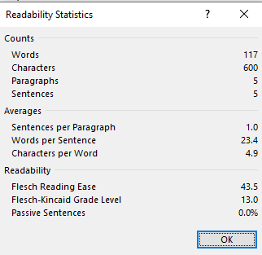

## AI Authored: Short Description-1 (June/23/2025)

* The Active Health System securely stores collected data in the Active Health System Log, separate from the operating system and customer data.
* Data collection and logging do not use host system resources.
* When the log is full, the oldest data is automatically overwritten by new data.
* The log can be downloaded in under five minutes and sent to a support professional for issue resolution.
* Users may include contact information when sending the log, and shared data is used by HPE for analysis, technical support, and quality improvements, in line with their [privacy policy](https://www.hpe.com/info/privacy).

## InfoGraphics-1 (June/23/2025)

