Contents

Introduction and Work-done 1

Short Descriptions Authored 1

Manually Authored: Short Description-2 (June/23/2025) 1

Felsch-Kincaid Score 2

AI Authored: Short Description-2 (June/23/2025) 2

InfoGraphics-2 (June/23/2025) 3

# Introduction and Work-done

Short Descriptions are key elements for a person who is visually-challenged and for search-engines. The google-crawler will first crawl over the **short descriptions** tag and try to understand the gist of contents present inside that topic. Hence, Short-Descriptions are very helpful in providing effective SEO results. Else, even with the content, it cannot be accessed effectively inside the vast collection of information called “The Internet”. More information on benefits of Short Descriptions can be accessed and viewed using LLMs like Chat-GPT.

In this file,

# Short Descriptions Authored

## Manually Authored: Short Description-2 (June/23/2025)

* The firmware Verification feature lets you to run scheduled scans. In response to the detected issues, configure iLO to:
  + Log the results
  + Log the results and initiate a repair action that uses a recovery install set.
* Based on scan results, the information gets logged in the Active Health System Log and the Integrated Management Log. The following firmware types are supported
  + iLO Firmware
  + System ROM (BIOS)
  + System Programmable Logic Device (CPLD)
* During a firmware verification scan, firmware updates cannot be installed and cannot upload firmware to the iLO Repository. The invalid iLO or System ROM (BIOS) firmware file detected is saved to a quarantine area in the iLO repository.
* To investigate the invalid file for its type and origin, you can download it. Quarantined images are not displayed on the iLO Repository page and cannot be selected when using the Flash Firmware feature.
* If a supported management tool is configured to listen for system recovery events, you can send a recovery event from this page.

## Felsch-Kincaid Score

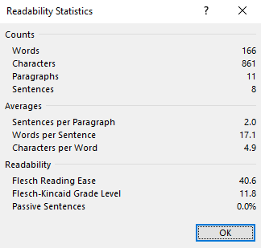

## AI Authored: Short Description-2 (June/23/2025)

* Firmware Verification enables scheduled scans for iLO Firmware, System ROM (BIOS), and CPLD to ensure integrity.
* Based on scan results, iLO can log issues or initiate automated repairs using a recovery install set.
* Results are recorded in the Active Health System Log and the Integrated Management Log.
* Firmware updates and uploads to the iLO Repository are disabled during verification scans.
* Detected invalid firmware is quarantined (hidden from the repository), available for download, and can trigger recovery events if supported tools are configured.

## InfoGraphics-2 (June/23/2025)

