Snipping tool User Guide

Contents

1. Introduction to Snipping Tool 2

a. About this guide 2

2. Capture a Picture 3

3. Capture a Video 3

4. Select the Selection Area Type 4

5. Set the Timer to Capture a Picture or a Video 4

6. Open a File 4

7. Change Default Save Location of Screenshots or Videos 4

8. Adjust Other Settings in Snipping Tool 5

a. Copy Screenshot Changes Automatically 5

b. Save Original Screenshots Automatically 5

c. Ask to Save Edited Screenshots 5

d. Open New Screenshots in Multiple Windows 5

e. Add Border to Each Screenshot 5

f. Correct HDR Screenshot Colors 5

g. Copy Screen Recording Changes Automatically 6

h. Save Original Screen Recordings Automatically 6

i. Ask to Save Edited Screen Recordings 6

j. Include Microphone Input by Default 6

k. Include System Audio by Default 6

l. Use the Print Screen Key to Open Snipping Tool 6

m. Change the App Theme 6

# Introduction to Snipping Tool

You use Snipping Tool to capture pictures or videos of anything on your screen. It replaces the older Snip & Sketch and classic Snipping Tool. You can capture, annotate, and save or share screenshots and screen recordings directly.

## About this guide

Considering that even school children will use Snipping Tool, and it is user-friendly, I have adopted AI techniques to create this UD from scratch. Alongside modular topics, even the prompts used for generating content is captured in this UG.

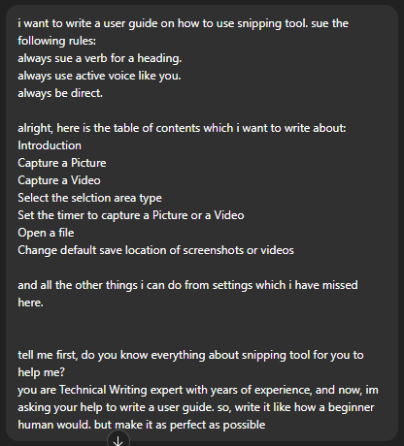

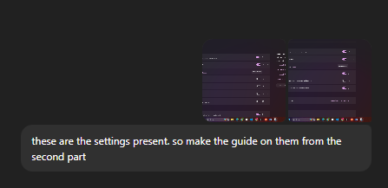

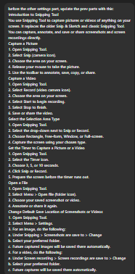

# Capture a Picture

1. Start Snipping Tool.
2. Select **Snip** (camera icon).
3. Choose the area on your screen. Then drag the mouse across that area by pressing and holding the left mouse-button.
4. Release the mouse-button to take the picture.
5. Use the toolbar to annotate, save, copy, or share.

# Capture a Video

1. Start Snipping Tool.
2. Select **Record** (video camera icon).
3. Choose the area on your screen. Then drag the mouse across that area by pressing and holding the left mouse-button.
4. Click **Start** to begin recording.
5. Click **Stop** to finish.
6. Save or share the video.

# Select the Selection Area Type

1. Start Snipping Tool.
2. Select the drop-down next to **Record** (video camera icon).
3. Choose **Rectangle**, **Free-form**, **Window**, or **Full-screen**.
4. Capture the screen using your chosen type.

# Set the Timer to Capture a Picture or a Video

1. Start Snipping Tool.
2. Select the **Timer** icon.
3. Choose 3, 5, or 10 seconds.
4. Click **Snip** or **Record**.
5. Prepare the screen before the timer runs out.

# Open a File

1. Start Snipping Tool.
2. Select **Menu** > **Open file** (folder icon).
3. Choose your saved screenshot or video.
4. Annotate or share it again.

# Change Default Save Location of Screenshots or Videos

1. Start Snipping Tool.
2. Select **Menu** > **Settings**.
3. For an image, do the following:
   1. Under **Snipping** > **Screenshots are save to** > **Change**.
   2. Select your preferred folder.
   3. Images captured in the future will be saved there automatically.
4. For a video, do the following:
   1. Under **Screen recording** > **Screen recordings are save to** > **Change**.
   2. Select your preferred folder.
   3. Videos captured in the future will be saved there automatically.

# Adjust Other Settings in Snipping Tool

## Copy Screenshot Changes Automatically

1. Start Snipping Tool.
2. lick on the ellipses and select **Settings**.
3. Toggle on the **Automatically copy changes** switch, under **Snipping**.

Edits to your screenshot copy to your clipboard immediately.

## Save Original Screenshots Automatically

1. Click on the ellipses and select **Settings**.
2. Toggle on the **Automatically save original screenshots** button under **Snipping**.
3. Select **Change** next to the save path to pick a folder.
4. Select Open folder to view saved snips.

## Ask to Save Edited Screenshots

1. Click on the ellipses and select **Settings**.
2. Toggle on the **Ask to save edited screenshots** switch under **Snipping**.

Snipping Tool will always prompt you to save changes before closing.

## Open New Screenshots in Multiple Windows

1. Click on the ellipses and select **Settings**.
2. Toggle on the **Multiple windows** switch under **Snipping**.

Each new screenshot opens in a separate window.

## Add Border to Each Screenshot

1. Click on the ellipses and select **Settings**.
2. Expand **Add border to each screenshot** drop-down.
3. Toggle on it on to automatically add a thin border around captures.
4. Choose the border color if offered.

## Correct HDR Screenshot Colors

1. Click on the ellipses and select **Settings**.
2. Toggle on the **HDR screenshot color corrector** switch.

Snipping Tool adjusts colors for screenshots from HDR monitors.

## Copy Screen Recording Changes Automatically

1. Click on the ellipses and select **Settings**.
2. Under Screen recording, Toggle on the **Automatically copy changes** switch.

Edits to your screen recording copy to your clipboard automatically.

## Save Original Screen Recordings Automatically

1. Click on the ellipses and select **Settings**.
2. Toggle on the **Automatically save original screen recordings** switch.
3. Select **Change** next to the save path to pick a folder.
4. Select Open folder to view saved recordings.

## Ask to Save Edited Screen Recordings

1. Click on the ellipses and select **Settings**.
2. Toggle on the **Ask to save edited screen recordings** switch.

Snipping Tool will prompt you to save before closing.

## Include Microphone Input by Default

1. Click on the ellipses and select **Settings**.
2. Toggle on the **Include microphone input by default** Switch.

Your mic audio records automatically with each new recording.

## Include System Audio by Default

1. Click on the ellipses and select **Settings**.
2. Toggle on the **Include system audio by default** switch.

Snipping Tool records system sounds automatically.

## Use the Print Screen Key to Open Snipping Tool

1. Click on the ellipses and select **Settings**.
2. Under Shortcuts, select **Change in Windows settings**.
3. Toggle on the **Use the Print Screen Key to open screen capture** switch to open Snipping Tool.

## Change the App Theme

1. Click on the ellipses and select **Settings**.
2. Under **Appearance**, expand **App theme**.
3. Choose **Light**, **Dark**, or **Use system setting**.