VISVESVARAYA TECHNOLOGICAL UNIVERSITY
“JnanaSangama”, Belgaum -590014, Karnataka.

LAB REPORT
On
OPERATING SYSTEM (23CS4PCOPS)
Submitted by
SHRIHARI VISWANATHAN (1BF24CS288)
in partial fulfillment for the award of the degree of
BACHELOR OF ENGINEERING
in
COMPUTER SCIENCE AND ENGINEERING

B.M.S. COLLEGE OF ENGINEERING
(Autonomous Institution under VTU)
BENGALURU-560019
February to June 2026
CERTIFICATE
B. M. S. College of Engineering,
Bull Temple Road, Bangalore 560019
(Affiliated To Visvesvaraya Technological University, Belgaum) Department of Computer Science and Engineering

This is to certify that the Lab work entitled “OPERATING SYSTEM” carried out by SHRIHARI VISWANATHAN (1BF24CS288), who is bonafide student of B. M. S. College of Engineering. It is in partial fulfillment for the award of Bachelor of Engineering in Computer Science and Engineering of the Visvesvaraya Technological University, Belgaum during the year 2025-26. The Lab report has been approved as it satisfies the academic requirements in respect of Analysis and Design of Algorithms Lab - (23CS4PCOPS) work prescribed for the said degree.
Ms. Ambuja K Dr. Kavitha Sooda
Assistant Professor Professor and Head
Department of CSE Department of CSE
BMSCE, Bengaluru BMSCE, Bengaluru

Index Sheet
Sl.  No. | Experiment Title | Page No.
1 | Lab Program 1 | 4
2 | Lab Program 2 | 14
3 | Lab Program 3 | 17
4 | Lab Program 4 | 26
5 | Lab Program 5 | 30
6 | Lab Program 6 | 36
7 | Lab Program 7 | 41

Course outcomes:
CO1 | Analyze time complexity of algorithms using asymptotic notations.
CO2 | Apply various algorithm design techniques for the given problem.
CO3 | Evaluate the appropriate algorithm/design technique for solving a given problem.
CO4 | Conduct practical experiments by applying appropriate algorithm design technique to solve problems.

Lab program 1:

Write a C program to simulate the following CPU scheduling algorithm to find turnaround time and waiting time.

a) FCFS

b) SJF

c) Priority

d) Round Robin

FCFS

Code:
#include <stdio.h>

int main() {
int n, bt[20], wt[20], tat[20], at[20], ct[20];
int i;
float twt = 0.0, ttat = 0.0, awt, att;

printf("Enter the number of processes: ");
scanf("%d", &n);

// Input arrival time and burst time
for(i = 0; i < n; i++) {
printf("Enter Arrival Time for Process %d: ", i + 1);
scanf("%d", &at[i]);

printf("Enter Burst Time for Process %d: ", i + 1);
scanf("%d", &bt[i]);
}

// First process
ct[0] = at[0] + bt[0];
wt[0] = 0;
tat[0] = bt[0];

// Remaining processes
for(i = 1; i < n; i++) {
if(ct[i - 1] < at[i]) {
ct[i] = at[i] + bt[i];
wt[i] = 0;
} else {
wt[i] = ct[i - 1] - at[i];
ct[i] = ct[i - 1] + bt[i];
}

tat[i] = wt[i] + bt[i];
}

// Calculate totals
for(i = 0; i < n; i++) {
twt += wt[i];
ttat += tat[i];
}

awt = twt / n;
att = ttat / n;

// Output table
printf("\nProcess\tAT\tBT\tCT\tWT\tTAT\n");

for(i = 0; i < n; i++) {
printf("P%d\t%d\t%d\t%d\t%d\t%d\n",
i + 1, at[i], bt[i], ct[i], wt[i], tat[i]);
}

printf("\nAverage Waiting Time = %.2f", awt);
printf("\nAverage Turnaround Time = %.2f\n", att);

return 0;
}

OUTPUT:

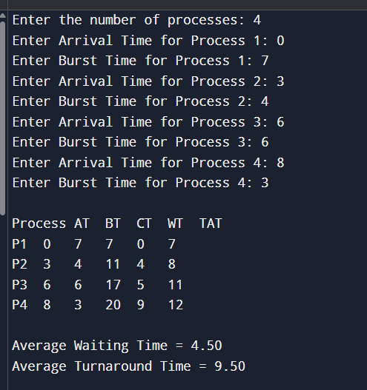

SJF

Code:
#include <stdio.h>

int main() {
int n, bt[20], wt[20], tat[20], at[20], ct[20];
int completed[20] = {0};
int i, time = 0, count = 0, min, index;
float twt = 0.0, ttat = 0.0, awt, att;

printf("Enter the number of process: ");
scanf("%d", &n);

for(i = 0; i < n; i++) {
printf("Enter AT for process %d: ", i + 1);
scanf("%d", &at[i]);

printf("Enter BT for process %d: ", i + 1);
scanf("%d", &bt[i]);
}

while(count < n) {
min = 9999;
index = -1;

for(i = 0; i < n; i++) {
if(at[i] <= time && completed[i] == 0) {
if(bt[i] < min) {
min = bt[i];
index = i;
}
}
}

if(index != -1) {
time += bt[index];
ct[index] = time;
tat[index] = ct[index] - at[index];
wt[index] = tat[index] - bt[index];
completed[index] = 1;
count++;
}
else {
time++;
}
}

for(i = 0; i < n; i++) {
twt += wt[i];
ttat += tat[i];
}

awt = twt / n;
att = ttat / n;

printf("\nP\tAT\tBT\tCT\tWT\tTAT\n");

for(i = 0; i < n; i++) {
printf("P%d\t%d\t%d\t%d\t%d\t%d\n",
i + 1, at[i], bt[i], ct[i], wt[i], tat[i]);
}

printf("\nAverage WT: %.2f", awt);
printf("\nAverage Turn Around: %.2f\n", att);

return 0;
}

Output:

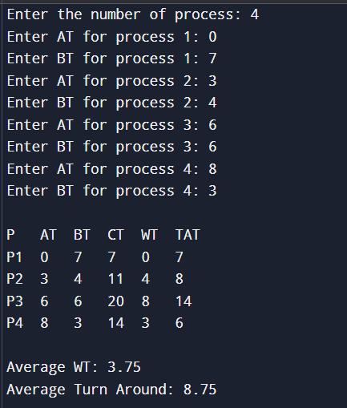

SRTF:

Code:
#include <stdio.h>

int main() {
int n, bt[20], wt[20], tat[20], at[20], ct[20], rt[20];
int i, time = 0, count = 0, min, index;
float twt = 0.0, ttat = 0.0, awt, att;

printf("Enter no of process: ");
scanf("%d", &n);

for(i = 0; i < n; i++) {
printf("Enter Arrival Time for Process %d: ", i + 1);
scanf("%d", &at[i]);

printf("Enter Burst Time for Process %d: ", i + 1);
scanf("%d", &bt[i]);

rt[i] = bt[i];
}

while(count < n) {
min = 9999;
index = -1;

for(i = 0; i < n; i++) {
if(at[i] <= time && rt[i] > 0) {
if(rt[i] < min) {
min = rt[i];
index = i;
}
}
}

if(index != -1) {
rt[index]--;
time++;

if(rt[index] == 0) {
ct[index] = time;
tat[index] = ct[index] - at[index];
wt[index] = tat[index] - bt[index];
count++;
}
} else {
time++;
}
}

for(i = 0; i < n; i++) {
twt += wt[i];
ttat += tat[i];
}

awt = twt / n;
att = ttat / n;

printf("\nP\tAT\tBT\tCT\tWT\tTAT\n");

for(i = 0; i < n; i++) {
printf("P%d\t%d\t%d\t%d\t%d\t%d\n",
i + 1, at[i], bt[i], ct[i], wt[i], tat[i]);
}

printf("\nAverage WT = %.2f", awt);
printf("\nAverage TAT = %.2f\n", att);

return 0;
}

Output:
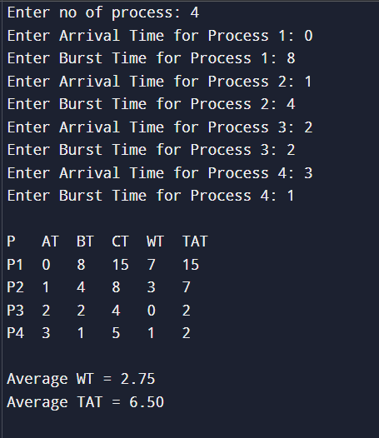

Priority
Code:
#include <stdio.h>

int main() {
int n, i, time = 0, highest;

printf("No of process: ");
scanf("%d", &n);

int at[n], bt[n], pr[n], ct[n], tat[n], wt[n], done[n];

for(i = 0; i < n; i++) {
printf("\nProcess P%d\n", i + 1);

printf("Arrival Time: ");
scanf("%d", &at[i]);

printf("Burst Time: ");
scanf("%d", &bt[i]);

printf("Priority: ");
scanf("%d", &pr[i]);

done[i] = 0;
}

int completed = 0;

printf("\nGantt Chart:\n");

while(completed < n) {
highest = -1;

for(i = 0; i < n; i++) {
if(at[i] <= time && done[i] == 0) {
if(highest == -1 || pr[i] < pr[highest]) {
highest = i;
}
}
}

if(highest == -1) {
time++;
}
else {
printf("P%d | ", highest + 1);

time += bt[highest];
ct[highest] = time;
tat[highest] = ct[highest] - at[highest];
wt[highest] = tat[highest] - bt[highest];

done[highest] = 1;
completed++;
}
}

printf("\n\nP\tAT\tBT\tPR\tCT\tTAT\tWT\n");

for(i = 0; i < n; i++) {
printf("P%d\t%d\t%d\t%d\t%d\t%d\t%d\n",
i + 1, at[i], bt[i], pr[i], ct[i], tat[i], wt[i]);
}

return 0;
}

Output:
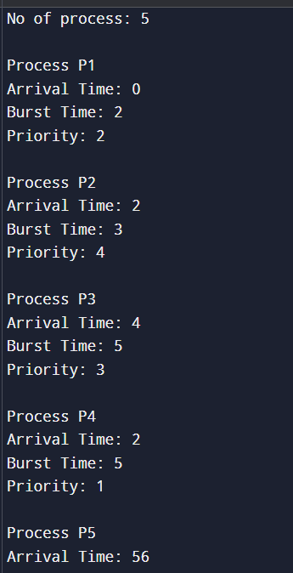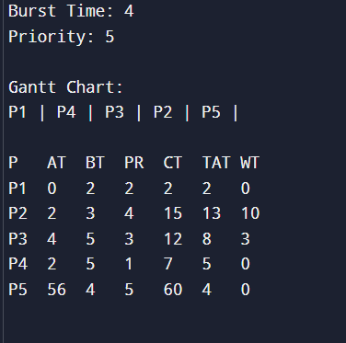

Round Robin

Code :
#include <stdio.h>

int main() {
int n, tq;
int at[10], bt[10], rt[10];
int ct[10], tat[10], wt[10];
int time = 0, remain, i;
float avg_tat = 0, avg_wt = 0;

printf("Enter the number of processes.\n");
scanf("%d", &n);
remain = n;

printf("Enter Arrival Time and Burst Time.\n");
for (i = 0; i < n; i++) {
printf("Process %d AT and BT: ", i + 1);
scanf("%d %d", &at[i], &bt[i]);
rt[i] = bt[i];
}

printf("Enter the quantum time: ");
scanf("%d", &tq);

while (remain != 0) {
int done_something = 0;

for (i = 0; i < n; i++) {
if (rt[i] > 0 && at[i] <= time) {
done_something = 1;

if (rt[i] > tq) {
time += tq;
rt[i] -= tq;
} else {
time += rt[i];
ct[i] = time;
rt[i] = 0;
remain--;
}
}
}

if (done_something == 0) {
time++;
}
}

printf("\nProcess\tAT\tBT\tCT\tTAT\tWT\n");

for (i = 0; i < n; i++) {
tat[i] = ct[i] - at[i];
wt[i] = tat[i] - bt[i];

printf("P%d\t%d\t%d\t%d\t%d\t%d\n",
i + 1, at[i], bt[i], ct[i], tat[i], wt[i]);

avg_tat += tat[i];
avg_wt += wt[i];
}

printf("\nAverage Turnaround Time = %.2f", avg_tat / n);
printf("\nAverage Waiting Time = %.2f\n", avg_wt / n);

return 0;
}

Output :
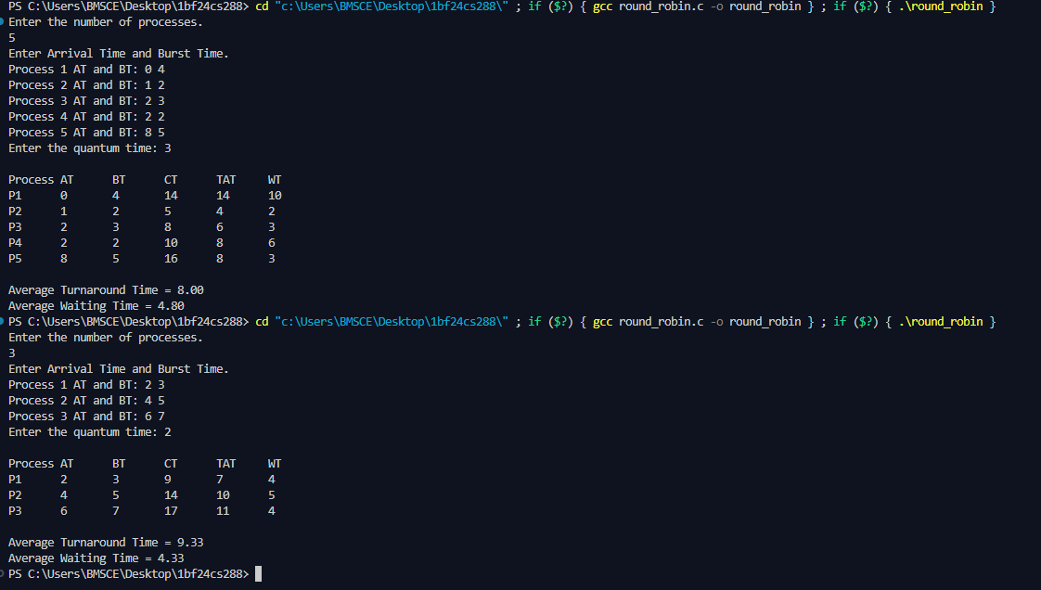

Lab Program 2:

Write a C program to simulate multi-level queue scheduling algorithm considering the following scenario. All the processes in the system are divided into two categories – system processes and user processes. System processes are to be given higher priority than user processes. Use FCFS scheduling for the processes in each queue.

Code:
#include <stdio.h>

struct Process {
int pid;
int at; // Arrival Time
int bt; // Burst Time
int ct; // Completion Time
int wt; // Waiting Time
int tat; // Turnaround Time
int type; // 0 = System, 1 = User
int done; // 0 = not done, 1 = completed
};

int main() {
int n, i, time = 0, completed = 0;

printf("Enter total number of processes: ");
scanf("%d", &n);

struct Process p[n];

// Input
for(i = 0; i < n; i++) {
printf("\nProcess %d\n", i+1);
p[i].pid = i + 1;

printf("Enter Arrival Time: ");
scanf("%d", &p[i].at);

printf("Enter Burst Time: ");
scanf("%d", &p[i].bt);

printf("Enter Type (0 = System, 1 = User): ");
scanf("%d", &p[i].type);

p[i].done = 0;
}

// Scheduling
while(completed < n) {
int idx = -1;

// Step 1: Check System processes first
for(i = 0; i < n; i++) {
if(p[i].at <= time && p[i].done == 0 && p[i].type == 0) {
idx = i;
break; // FCFS → first arrived
}
}

// Step 2: If no system process, check user
if(idx == -1) {
for(i = 0; i < n; i++) {
if(p[i].at <= time && p[i].done == 0 && p[i].type == 1) {
idx = i;
break;
}
}
}

// Step 3: If no process available → increment time
if(idx == -1) {
time++;
continue;
}

// Execute process
time += p[idx].bt;
p[idx].ct = time;
p[idx].tat = p[idx].ct - p[idx].at;
p[idx].wt = p[idx].tat - p[idx].bt;
p[idx].done = 1;
completed++;
}

// Output
float avg_wt = 0, avg_tat = 0;

printf("\nPID\tAT\tBT\tType\tCT\tTAT\tWT\n");

for(i = 0; i < n; i++) {
printf("%d\t%d\t%d\t%s\t%d\t%d\t%d\n",
p[i].pid, p[i].at, p[i].bt,
(p[i].type == 0) ? "SYS" : "USR",
p[i].ct, p[i].tat, p[i].wt);

avg_wt += p[i].wt;
avg_tat += p[i].tat;
}

printf("\nAverage WT = %.2f", avg_wt / n);
printf("\nAverage TAT = %.2f\n", avg_tat / n);

return 0;
}

Output:
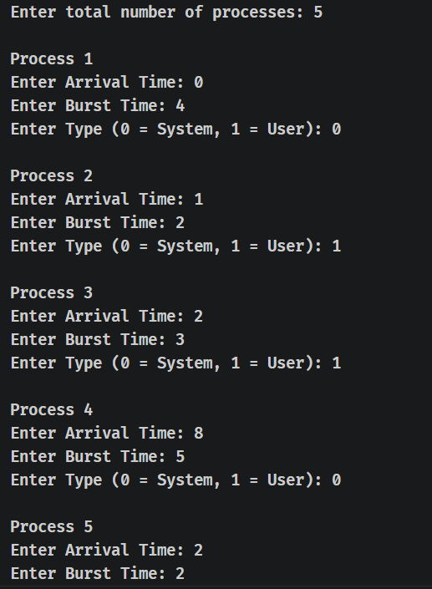
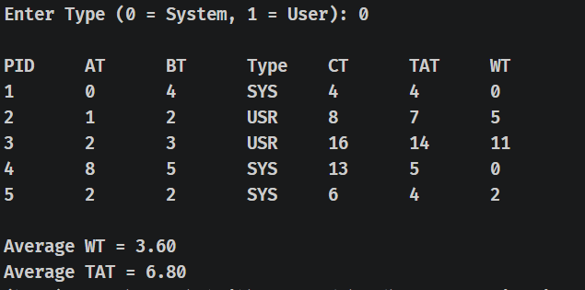

Lab Program 3:

Write a C program to simulate Real-Time CPU Scheduling algorithms:

a) Rate- Monotonic

b) Earliest-deadline First

c) Proportional scheduling

Rate Monotonic

Code:
// rate monotonic scheduling
#include<stdio.h>
#include<math.h>

struct tasks {
int pid;
int Ci;
int Ti;
int remaining;
int next_arrival;
};

//gcd function for getting lcm
int gcd(int a, int b) {
while(b != 0) {
int temp = b;
b = a % b;
a = temp;
}
return a;
}

//lcm function for 2 numbers
int lcm(int a,int b) {
return (a*b)/gcd(a,b);
}

//getting lcm of all tasks
int tasks_lcm(struct tasks t[],int n) {
int result=t[0].Ti;

for(int i=1;i<n;i++) {
result=lcm(result,t[i].Ti);
}
return result;
}

int main() {

int n;
printf("enter number of tasks: ");
scanf("%d",&n);

struct tasks t[n];

// input
for(int i=0;i<n;i++) {
printf("Task %d\n", i+1);

printf("enter Ci: ");
scanf("%d", &t[i].Ci);

printf("enter Ti: ");
scanf("%d", &t[i].Ti);

t[i].pid = i+1;

// init for step 5
t[i].remaining = 0;
t[i].next_arrival = 0;
}

// Step 1: CPU utilization
float u=0;
for(int i=0;i<n;i++) {
u += (float)t[i].Ci / t[i].Ti;
}
printf("CPU utilization: %f\n", u);

// Step 2: RMS bound
float bound = n * (pow(2, (float)1/n) - 1);
printf("Bound: %f\n", bound);

// Step 3
if(u <= bound) {
printf("Schedulable using RMS\n");
} else {
printf("Not guaranteed schedulable\n");
}

// Step 4: sort by Ti
for(int i=0;i<n;i++) {
for(int j=i+1;j<n;j++) {
if(t[i].Ti > t[j].Ti) {
struct tasks temp = t[i];
t[i] = t[j];
t[j] = temp;
}
}
}

// Step 5: Scheduling simulation

int LIMIT = tasks_lcm(t,n); // simulate till lcm time

printf("\n--- Scheduling ---\n");

for(int time = 0; time < LIMIT; time++) {

// check arrivals
for(int i=0;i<n;i++) {
if(time == t[i].next_arrival) {
t[i].remaining = t[i].Ci;
t[i].next_arrival += t[i].Ti;
}
}

// pick highest priority task (smallest Ti)
int idx = -1;
for(int i=0;i<n;i++) {
if(t[i].remaining > 0) {
idx = i;
break;
}
}

// execute
if(idx != -1) {
printf("Time %d: Task %d\n", time, t[idx].pid);
t[idx].remaining--;
} else {
printf("Time %d: Idle\n", time);
}
}

return 0;
}

Output:
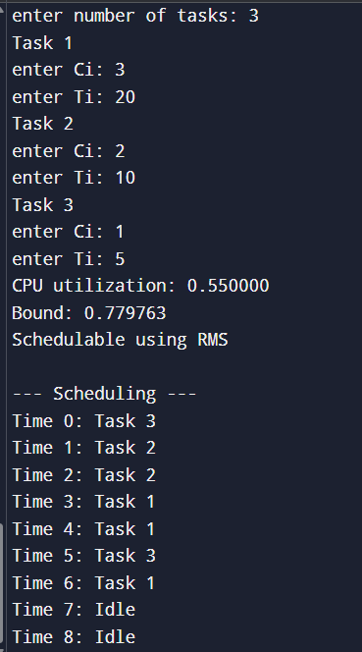

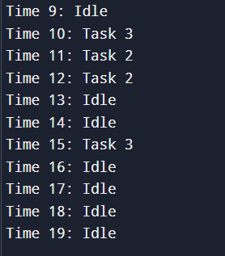

EDF

Code:
#include <stdio.h>

struct process {
int pid;
int Ci;
int Ti;
int Di; // deadline = Ti - 1

int remaining;
int next_arrival;
int absolute_deadline;
};

// GCD
int gcd(int a, int b) {
while(b != 0) {
int temp = b;
b = a % b;
a = temp;
}
return a;
}

// LCM
int lcm(int a, int b) {
return (a * b) / gcd(a, b);
}

// LCM of all Ti
int find_lcm(struct process p[], int n) {
int result = p[0].Ti;
for(int i = 1; i < n; i++) {
result = lcm(result, p[i].Ti);
}
return result;
}

int main() {
int n;
printf("Enter number of processes: ");
scanf("%d", &n);

struct process p[n];

// input
for(int i = 0; i < n; i++) {
printf("Process %d\n", i+1);

printf("Enter Ci: ");
scanf("%d", &p[i].Ci);

printf("Enter Ti: ");
scanf("%d", &p[i].Ti);

p[i].pid = i + 1;

// given condition
p[i].Di = p[i].Ti - 1;

// init
p[i].remaining = 0;
p[i].next_arrival = 0;
p[i].absolute_deadline = p[i].Di;
}

// utilization (EDF uses Di)
float U = 0;
for(int i = 0; i < n; i++) {
U += (float)p[i].Ci / p[i].Di;
}

printf("Utilization: %f\n", U);

if(U <= 1)
printf("Feasible\n");
else
printf("Not guaranteed feasible\n");

int LIMIT = find_lcm(p, n);

printf("\n--- EDF Scheduling (till %d) ---\n", LIMIT);

// scheduling loop
for(int time = 0; time < LIMIT; time++) {

// arrivals
for(int i = 0; i < n; i++) {
if(time == p[i].next_arrival) {
p[i].remaining = p[i].Ci;
p[i].absolute_deadline = time + p[i].Di;
p[i].next_arrival += p[i].Ti;
}
}

// select earliest deadline
int idx = -1;
int min_deadline = 999999;

for(int i = 0; i < n; i++) {
if(p[i].remaining > 0) {
if(p[i].absolute_deadline < min_deadline) {
min_deadline = p[i].absolute_deadline;
idx = i;
}
}
}

// execute
if(idx != -1) {
printf("Time %d: P%d\n", time, p[idx].pid);
p[idx].remaining--;
} else {
printf("Time %d: Idle\n", time);
}
}

return 0;
}

Output:
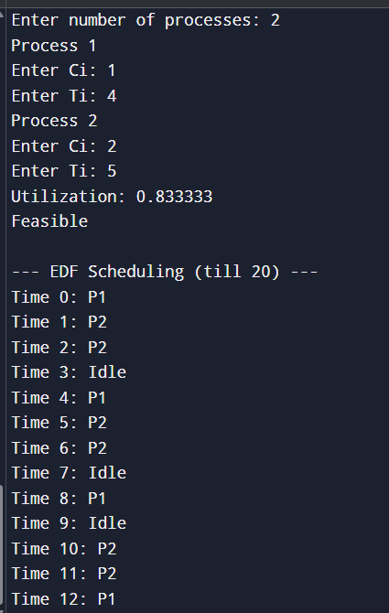
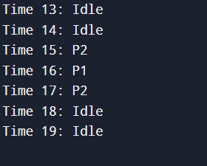

Proportional Scheduling:

Code:
#include <stdio.h>

#define TIME_QUANTUM 10 // you can change this

struct process {
int pid;
int Ci; // total execution time
int remaining;
int weight;
int completed;
};

int main() {
int n;
printf("Enter number of processes: ");
scanf("%d", &n);

struct process p[n];

int total_weight = 0;

// input
for(int i = 0; i < n; i++) {
printf("Process %d\n", i+1);

printf("Enter Ci: ");
scanf("%d", &p[i].Ci);

printf("Enter weight: ");
scanf("%d", &p[i].weight);

p[i].pid = i + 1;
p[i].remaining = p[i].Ci;
p[i].completed = 0;

total_weight += p[i].weight;
}

int time = 0;
int completed_count = 0;

printf("\n--- Proportional Share Scheduling ---\n");

// Step 4
while(completed_count < n) {

// Step 5: loop through all processes
for(int i = 0; i < n; i++) {
if(p[i].completed)
continue;

int time_slice = (p[i].weight * TIME_QUANTUM) / total_weight;
if(time_slice == 0) time_slice = 1; // avoid 0 slice

printf("Time %d: P%d runs for %d units\n", time, p[i].pid, time_slice);

p[i].remaining -= time_slice;
time += time_slice;

if(p[i].remaining <= 0) {
printf("P%d completed at time %d\n", p[i].pid, time);
p[i].completed = 1;
completed_count++;

total_weight -= p[i].weight;
}
}
}
return 0;
}

Output:
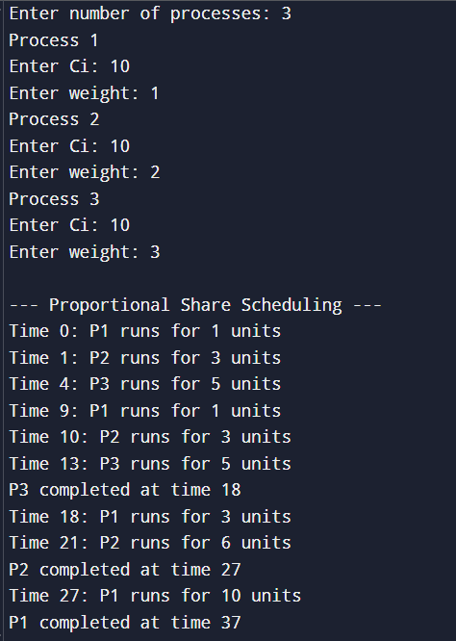

Lab Program 4:

Write a C program to simulate:

a) Producer-Consumer problem using semaphores.

b) Dining-Philosopher’s problem

Producer Consumer
#include <stdio.h>
#include <stdlib.h>
#include <pthread.h>
#include <semaphore.h>
#include <unistd.h>

#define BUFFER_SIZE 5
#define NUM_ITEMS 6

int buffer[BUFFER_SIZE];
int in = 0;
int out = 0;

pthread_mutex_t mutex;
sem_t empty;
sem_t full;

// Producer function
void* producer(void* arg) {
int item;
for (int i = 0; i < NUM_ITEMS; i++) {
item = rand() % 100;

sem_wait(&empty); // Wait if buffer is full
pthread_mutex_lock(&mutex); // Lock critical section

buffer[in] = item;
printf("Producer produced: %d at index %d\n", item, in);
in = (in + 1) % BUFFER_SIZE;

pthread_mutex_unlock(&mutex); // Unlock
sem_post(&full); // Signal item available

sleep(1);
}
return NULL;
}

// Consumer function
void* consumer(void* arg) {
int item;
for (int i = 0; i < NUM_ITEMS; i++) {
sem_wait(&full); // Wait if buffer is empty
pthread_mutex_lock(&mutex); // Lock critical section

item = buffer[out];
printf("Consumer consumed: %d from index %d\n", item, out);
out = (out + 1) % BUFFER_SIZE;

pthread_mutex_unlock(&mutex); // Unlock
sem_post(&empty); // Signal space available
sleep(2);
}
return NULL;
}
int main() {
pthread_t prod, cons;

pthread_mutex_init(&mutex, NULL);
sem_init(&empty, 0, BUFFER_SIZE); // Initially buffer is empty
sem_init(&full, 0, 0); // No items initially

pthread_create(&prod, NULL, producer, NULL);
pthread_create(&cons, NULL, consumer, NULL);

pthread_join(prod, NULL);
pthread_join(cons, NULL);

pthread_mutex_destroy(&mutex);
sem_destroy(&empty);
sem_destroy(&full);

return 0;
}

Output:
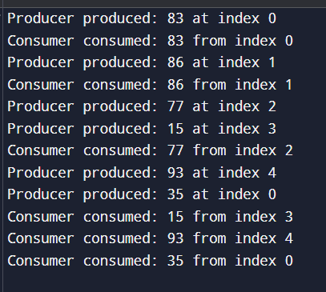

Dining Philosopher

Code:
#include <stdio.h>
#include <pthread.h>
#include <unistd.h>

#define NUM_PHILOSOPHERS 5

pthread_mutex_t chopsticks[NUM_PHILOSOPHERS];

void* philosopher(void* num) {
int id = *(int*)num;

while (1) {
printf("Philosopher %d is thinking...\n", id);
sleep(1);

// Pick up chopsticks
if (id == NUM_PHILOSOPHERS - 1) {
// The last philosopher picks up right then left to avoid deadlock
pthread_mutex_lock(&chopsticks[(id + 1) % NUM_PHILOSOPHERS]);
pthread_mutex_lock(&chopsticks[id]);
} else {
pthread_mutex_lock(&chopsticks[id]);
pthread_mutex_lock(&chopsticks[(id + 1) % NUM_PHILOSOPHERS]);
}

printf("Philosopher %d is eating!\n", id);
sleep(1);

// Put down chopsticks
pthread_mutex_unlock(&chopsticks[id]);
pthread_mutex_unlock(&chopsticks[(id + 1) % NUM_PHILOSOPHERS]);

printf("Philosopher %d finished eating and resumed thinking.\n", id);
}
}

int main() {
pthread_t threads[NUM_PHILOSOPHERS];
int ids[NUM_PHILOSOPHERS];

for (int i = 0; i < NUM_PHILOSOPHERS; i++) {
pthread_mutex_init(&chopsticks[i], NULL);
ids[i] = i;
}

for (int i = 0; i < NUM_PHILOSOPHERS; i++) {
pthread_create(&threads[i], NULL, philosopher, &ids[i]);
}

for (int i = 0; i < NUM_PHILOSOPHERS; i++) {
pthread_join(threads[i], NULL);
}

return 0;
}

Output:
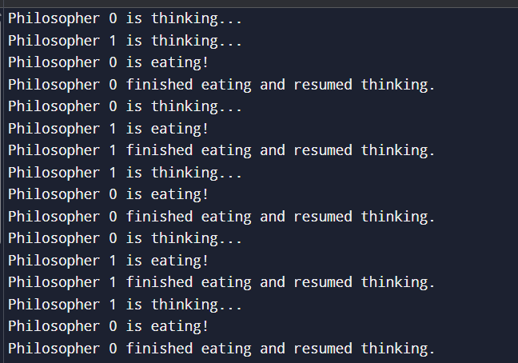

Lab Program 5:

Write a C program to simulate:

a) Bankers’ algorithm for the purpose of deadlock avoidance.

b) Deadlock Detection

Banker’s Algorithm

Code:
#include <stdio.h>
#include <stdbool.h>

int main() {
int n, m, i, j, k;
printf("Enter number of processes: ");
scanf("%d", &n);
printf("Enter number of resource types: ");
scanf("%d", &m);

int alloc[n][m], max[n][m], avail[m], need[n][m];
int finish[n], safeSeq[n], ind = 0;

printf("Enter Allocation Matrix:\n");
for (i = 0; i < n; i++)
for (j = 0; j < m; j++) scanf("%d", &alloc[i][j]);

printf("Enter Max Matrix:\n");
for (i = 0; i < n; i++)
for (j = 0; j < m; j++) scanf("%d", &max[i][j]);

printf("Enter Available Resources: ");
for (i = 0; i < m; i++) scanf("%d", &avail[i]);

// Calculate Need Matrix
for (i = 0; i < n; i++) {
for (j = 0; j < m; j++) {
need[i][j] = max[i][j] - alloc[i][j];
}
finish[i] = 0;
}

// Safety Algorithm
int work[m];
for (i = 0; i < m; i++) work[i] = avail[i];

for (k = 0; k < n; k++) {
for (i = 0; i < n; i++) {
if (finish[i] == 0) {
int flag = 0;
for (j = 0; j < m; j++) {
if (need[i][j] > work[j]) {
flag = 1;
break;
}
}
if (flag == 0) {
safeSeq[ind++] = i;
for (int y = 0; y < m; y++)
work[y] += alloc[i][y];
finish[i] = 1;
}
}
}
}

bool safe = true;
for(i=0; i<n; i++) if(finish[i] == 0) safe = false;

if (safe) {
printf("\nSystem is in SAFE State.\nSafe Sequence: ");
for (i = 0; i < n - 1; i++) printf("P%d -> ", safeSeq[i]);
printf("P%d\n", safeSeq[n - 1]);
} else {
printf("\nSystem is in DEADLOCK State (Unsafe).\n");
}

// --- NEW: Resource Request Section ---
int p_idx;
int request[m];
printf("\nEnter process index making a request (0 to %d): ", n-1);
scanf("%d", &p_idx);
printf("Enter request for resources: ");
for (i = 0; i < m; i++) scanf("%d", &request[i]);

// Step 1: Check if Request <= Need
for (i = 0; i < m; i++) {
if (request[i] > need[p_idx][i]) {
printf("Error: Process has exceeded its maximum claim.\n");
return 0;
}
}

// Step 2: Check if Request <= Available
for (i = 0; i < m; i++) {
if (request[i] > avail[i]) {
printf("Resources not available. Process P%d must wait.\n", p_idx);
return 0;
}
}

// Step 3: Speculative Allocation (Pretend to grant request)
for (i = 0; i < m; i++) {
avail[i] -= request[i];
alloc[p_idx][i] += request[i];
need[p_idx][i] -= request[i];
}

// --- Safety Algorithm (Check if pretend state is safe) ---
for (i = 0; i < m; i++) work[i] = avail[i];
for (i = 0; i < n; i++) finish[i] = 0;

ind = 0;
for (k = 0; k < n; k++) {
for (i = 0; i < n; i++) {
if (finish[i] == 0) {
int flag = 0;
for (j = 0; j < m; j++) {
if (need[i][j] > work[j]) {
flag = 1;
break;
}
}
if (flag == 0) {
safeSeq[ind++] = i;
for (int y = 0; y < m; y++)
work[y] += alloc[i][y];
finish[i] = 1;
}
}
}
}

safe = true;
for(i=0; i<n; i++) if(finish[i] == 0) safe = false;

if (safe) {
printf("\nRequest can be GRANTED safely.\nSafe Sequence: ");
for (i = 0; i < n - 1; i++) printf("P%d -> ", safeSeq[i]);
printf("P%d\n", safeSeq[n - 1]);
} else {
// Step 4: Rollback if unsafe
for (i = 0; i < m; i++) {
avail[i] += request[i];
alloc[p_idx][i] -= request[i];
need[p_idx][i] += request[i];
}
printf("\nRequest DENIED. Granting it would result in an unsafe state.\n");
}
return 0;
}

Output:
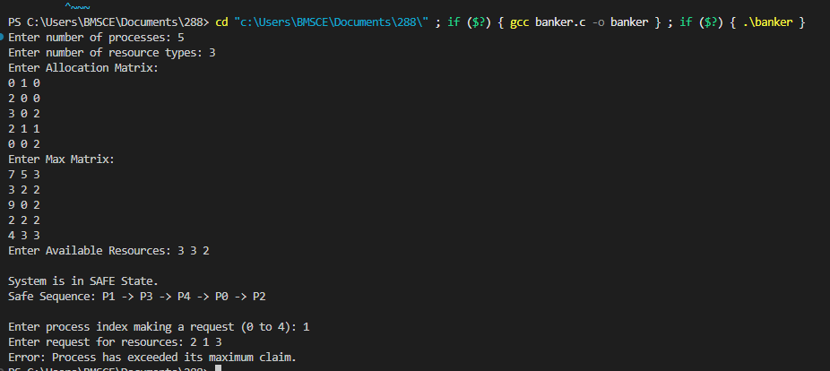

Deadlock detection:

Code:
#include <stdio.h>

int main() {
int n, m, i, j, k;
printf("Enter number of processes: ");
scanf("%d", &n);
printf("Enter number of resources: ");
scanf("%d", &m);

int alloc[n][m], request[n][m], avail[m], finish[n], work[m];

printf("Enter Allocation Matrix:\n");
for(i=0; i<n; i++)
for(j=0; j<m; j++) scanf("%d", &alloc[i][j]);

printf("Enter Request Matrix:\n");
for(i=0; i<n; i++)
for(j=0; j<m; j++) scanf("%d", &request[i][j]);

printf("Enter Available Resources: ");
for(i=0; i<m; i++) {
scanf("%d", &avail[i]);
work[i] = avail[i];
}

for(i=0; i<n; i++) finish[i] = 0;

// Detection Algorithm
for(k=0; k<n; k++) {
for(i=0; i<n; i++) {
if(finish[i] == 0) {
int canBeDone = 1;
for(j=0; j<m; j++) {
if(request[i][j] > work[j]) {
canBeDone = 0;
break;
}
}
if(canBeDone) {
for(j=0; j<m; j++) work[j] += alloc[i][j];
finish[i] = 1;
}
}
}
}

int deadlocked[n], count = 0;
for(i=0; i<n; i++) {
if(finish[i] == 0) {
deadlocked[count++] = i;
}
}

if(count > 0) {
printf("\nSystem is in DEADLOCK! Deadlocked processes: ");
for(i=0; i<count; i++) printf("P%d ", deadlocked[i]);
printf("\n");
} else {
printf("\nNo Deadlock Detected.\n");
}

return 0;
}

Output:
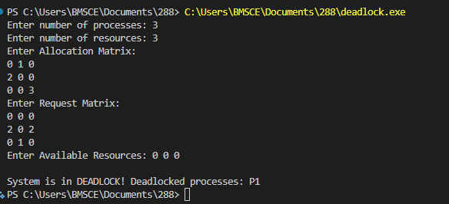

Lab Program 6:

Write a C program to simulate the following contiguous memory allocation techniques.

a) Worst-fit

b) Best-fit

c) First-fit

#include <stdio.h>

#define MAX 20

// ---------- FIRST FIT ----------
void firstFit(int blockSize[], int m, int processSize[], int n)
{
int allocation[MAX];
int used[MAX] = {0};

for(int i = 0; i < n; i++)
allocation[i] = -1;

for(int i = 0; i < n; i++)
{
for(int j = 0; j < m; j++)
{
// Allocate only if block is unused
if(!used[j] && blockSize[j] >= processSize[i])
{
allocation[i] = j;
used[j] = 1; // Mark block as used
break;
}
}
}

printf("\n========== FIRST FIT ==========\n");
printf("Process No.\tProcess Size\tBlock No.\n");

for(int i = 0; i < n; i++)
{
printf("P%d\t\t%d\t\t", i + 1, processSize[i]);

if(allocation[i] != -1)
printf("%d\n", allocation[i] + 1);
else
printf("Not Allocated\n");
}
}

// ---------- BEST FIT ----------
void bestFit(int blockSize[], int m, int processSize[], int n)
{
int allocation[MAX];
int used[MAX] = {0};

for(int i = 0; i < n; i++)
allocation[i] = -1;

for(int i = 0; i < n; i++)
{
int bestIdx = -1;

for(int j = 0; j < m; j++)
{
if(!used[j] && blockSize[j] >= processSize[i])
{
if(bestIdx == -1 || blockSize[j] < blockSize[bestIdx])
{
bestIdx = j;
}
}
}

if(bestIdx != -1)
{
allocation[i] = bestIdx;
used[bestIdx] = 1;
}
}

printf("\n========== BEST FIT ==========\n");
printf("Process No.\tProcess Size\tBlock No.\n");

for(int i = 0; i < n; i++)
{
printf("P%d\t\t%d\t\t", i + 1, processSize[i]);

if(allocation[i] != -1)
printf("%d\n", allocation[i] + 1);
else
printf("Not Allocated\n");
}
}

// ---------- WORST FIT ----------
void worstFit(int blockSize[], int m, int processSize[], int n)
{
int allocation[MAX];
int used[MAX] = {0};

for(int i = 0; i < n; i++)
allocation[i] = -1;

for(int i = 0; i < n; i++)
{
int worstIdx = -1;

for(int j = 0; j < m; j++)
{
if(!used[j] && blockSize[j] >= processSize[i])
{
if(worstIdx == -1 || blockSize[j] > blockSize[worstIdx])
{
worstIdx = j;
}
}
}

if(worstIdx != -1)
{
allocation[i] = worstIdx;
used[worstIdx] = 1;
}
}

printf("\n========== WORST FIT ==========\n");
printf("Process No.\tProcess Size\tBlock No.\n");

for(int i = 0; i < n; i++)
{
printf("P%d\t\t%d\t\t", i + 1, processSize[i]);

if(allocation[i] != -1)
printf("%d\n", allocation[i] + 1);
else
printf("Not Allocated\n");
}
}

// ---------- MAIN FUNCTION ----------
int main()
{
int m, n;

int blockSize[MAX];
int processSize[MAX];

// Input number of memory blocks
printf("Enter number of memory blocks: ");
scanf("%d", &m);

// Input memory block sizes
printf("Enter sizes of memory blocks:\n");
for(int i = 0; i < m; i++)
{
printf("Block %d: ", i + 1);
scanf("%d", &blockSize[i]);
}

// Input number of processes
printf("\nEnter number of processes: ");
scanf("%d", &n);

// Input process sizes
printf("Enter sizes of processes:\n");
for(int i = 0; i < n; i++)
{
printf("Process %d: ", i + 1);
scanf("%d", &processSize[i]);
}

// Separate copies for each technique
int firstBlocks[MAX], bestBlocks[MAX], worstBlocks[MAX];

for(int i = 0; i < m; i++)
{
firstBlocks[i] = blockSize[i];
bestBlocks[i] = blockSize[i];
worstBlocks[i] = blockSize[i];
}

// Function calls
firstFit(firstBlocks, m, processSize, n);

bestFit(bestBlocks, m, processSize, n);

worstFit(worstBlocks, m, processSize, n);

return 0;
}

Output:
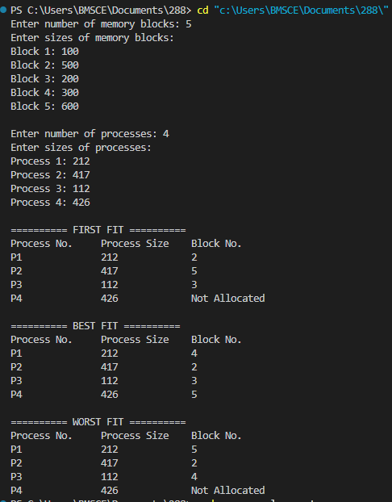

Lab Program 7:

Write a C program to simulate page replacement algorithms.

a) FIFO

b) LRU

c) Optimal

#include <stdio.h>

#define MAX 50

void printFrames(int f[], int n, int pf)
{
printf("PF No. %d: ", pf);

for(int i = 0; i < n; i++)
{
if(f[i] == -1)
printf("- ");
else
printf("%d ", f[i]);
}
printf("\n");
}

int search(int f[], int n, int key)
{
for(int i = 0; i < n; i++)
if(f[i] == key)
return i;

return -1;
}

// ---------------- FIFO ----------------
void FIFO(int p[], int n, int fn)
{
int f[MAX], i, j = 0, faults = 0;

for(i = 0; i < fn; i++)
f[i] = -1;

printf("\nFIFO Page Replacement Process:\n");

for(i = 0; i < n; i++)
{
if(search(f, fn, p[i]) == -1)
{
f[j] = p[i];
j = (j + 1) % fn;

faults++;
printFrames(f, fn, faults);
}
}

printf("FIFO Page Faults: %d\n", faults);
}

// ---------------- LRU ----------------
void LRU(int p[], int n, int fn)
{
int f[MAX], time[MAX], i, j, faults = 0, pos;

for(i = 0; i < fn; i++)
f[i] = -1;

printf("\nLRU Page Replacement Process:\n");

for(i = 0; i < n; i++)
{
pos = search(f, fn, p[i]);

if(pos != -1)
{
time[pos] = i;
}
else
{
int min = 9999;

for(j = 0; j < fn; j++)
{
if(f[j] == -1)
{
pos = j;
break;
}

if(time[j] < min)
{
min = time[j];
pos = j;
}
}

f[pos] = p[i];
time[pos] = i;

faults++;
printFrames(f, fn, faults);
}
}

printf("LRU Page Faults: %d\n", faults);
}

// ---------------- OPTIMAL ----------------
void Optimal(int p[], int n, int fn)
{
int f[MAX], i, j, k, faults = 0, pos;

for(i = 0; i < fn; i++)
f[i] = -1;

printf("\nOptimal Page Replacement Process:\n");

for(i = 0; i < n; i++)
{
if(search(f, fn, p[i]) == -1)
{
int far, index = -1;

for(j = 0; j < fn; j++)
{
if(f[j] == -1)
{
index = j;
break;
}
}

if(index == -1)
{
far = -1;

for(j = 0; j < fn; j++)
{
for(k = i + 1; k < n; k++)
{
if(f[j] == p[k])
break;
}

if(k > far)
{
far = k;
index = j;
}
}
}

f[index] = p[i];

faults++;
printFrames(f, fn, faults);
}
}

printf("Optimal Page Faults: %d\n", faults);
}

// ---------------- MAIN ----------------
int main()
{
int frames, n, pages[MAX];

printf("Enter the number of Frames: ");
scanf("%d", &frames);

printf("Enter the length of reference string: ");
scanf("%d", &n);

printf("Enter the reference string: ");

for(int i = 0; i < n; i++)
scanf("%d", &pages[i]);

FIFO(pages, n, frames);
LRU(pages, n, frames);
Optimal(pages, n, frames);

return 0;
}

Output:
