MIT School of Engineering
Department of Computer Science and Engineering

Project Synopsis

Group ID:LY-AIEC-13
Project Title: PeerVerse– A Peer-to-Peer Mentorship Marketplace
Group Members:

Enrollment Number | Roll No. | Name of student | Email Id | Contact Number
MITU22BTCS0484 | 22231140 | Ninad Santosh Khopade | ninadkhopade16@gmail.com | 7218012624
MITU22BTCS1024 | 22231155 | Yash Bharadwaj | yash.bhardwaj23122003@gmail.com | 7744055799
MITU22BTCS0799 | 2223235 | Shriyanshi Jain | shriyanshijain214@gmail.com | 9301282825
MITU23BTCSD033 | D2233033 | Madhusudhan Ladda | madhusudanladda08@gmail.com | 8862024681

Problem Statement:
Students lack context-specific, affordable, and structured mentorship. Existing options are either too costly (career counselors), too generic (online resources), or unreliable (informal alumni help). There is a need for a credible micro-mentorship platform where students can instantly connect with near-peers who recently faced the same challenges, ensuring high intent, faster answers, and trustworthy interactions.

Abstract:
Students today face difficulties in accessing reliable and affordable mentorship for placements, projects, hackathons, and academics. Career counselors are often generic and expensive, while informal senior guidance through WhatsApp or LinkedIn is fragmented and unreliable. PeerSync proposes a peer-to-peer micro-mentorship marketplace that connects mentees with near-peer mentors (2–3 years senior) for short, structured, and low-cost sessions. The platform ensures credibility through verified mentor profiles, blogs, and achievements while guaranteeing trust and safety via KYC, ratings, and moderation. The proposed system leverages in-app WebRTC calls, prepaid wallets, and smart mentor search with layered filters. This solution enables students to obtain fast, contextual, and affordable guidance while providing mentors with a structured, low-friction earning opportunity.

Literature Survey:
Sr. No. | Focus Area | Key Findings / Insights | Technologies / Concepts Referenced | Relevance to PeerSync System
1 | Shift in Learning Paradigms | Modern education is transitioning from traditional, instructor-centred methods to interactive, personalized, and student-driven learning. Learners now require real-time support and contextual guidance for academic and career development. | Digital learning systems, personalized education models | Establishes the need for personalized and interactive mentorship platforms like PeerSync.
2 | Peer-to-Peer Mentorship Effectiveness | Studies show peer mentoring—between individuals close in age or experience—enhances understanding, emotional connection, and relatability compared to hierarchical models. Improves academic confidence and skill development. | Peer-learning environments, mentorship models | Supports PeerSync’s peer-based mentorship model aimed at relatable and empathetic guidance.
3 | Emergence of Micro-Mentoring | Micro-mentoring (short, focused sessions) offers flexibility, reduced cognitive load, and higher engagement. Preferred by students for its adaptability and frequent feedback opportunities. | Micro-mentorship, short-duration learning interventions | Validates PeerSync’s design of short, time-bound video sessions and chat-based follow-ups.
4 | Impact of Online Micro-Mentorship Programs | Online micro-mentorship improves decision-making, internship preparedness, project guidance, and exam/placement strategies. Encourages continuous learning and community interaction. | Online mentoring platforms, feedback loops | Strengthens PeerSync’s objective to enhance academic and career guidance through online mentoring.
5 | Use of Real-Time Communication Technologies | Tools like WebRTC provide secure, low-latency video communication, while Socket.IO supports seamless messaging and notifications. Widely used in online tutoring and consultation platforms. | WebRTC, Socket.IO, real-time communication | Justifies PeerSync’s use of real-time video and chat systems for smooth mentor-mentee interaction.
6 | Cloud-Native and Serverless Architectures | Cloud-native solutions provide auto-scaling, cost efficiency, and high availability, supporting applications with variable usage patterns common in education. | Cloud-native architecture, serverless computing | Aligns with PeerSync’s backend design for scalability and reliability in digital mentorship.

Proposed System (Block Diagram):
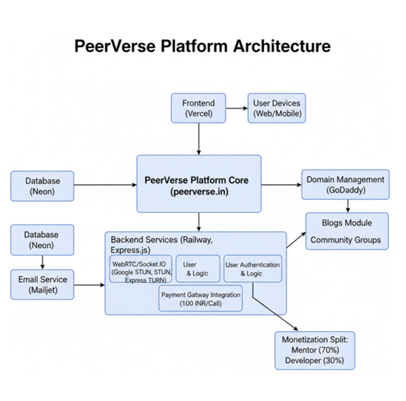
System Overview:
- A web/mobile platform where mentees search for mentors via layered filters.
- Mentors conduct paid micro-sessions (₹100/10 min) through in-app calls.
- Verification, payments, ratings, and blog content build credibility and trust.
Conclusion:
PeerSync offers a scalable, affordable, and context-specific mentorship platform that bridges the gap between students and seniors. By combining structured sessions, trust mechanisms, and incentive alignment, it addresses the shortcomings of both career counselors and informal alumni networks. The system is feasible with existing technologies (WebRTC, UPI/Razorpay, KYC APIs) and has the potential to positively impact student career readiness at scale.

Books & Academic Research
[1] K. J. Topping, Peer Assisted Learning: A Practical Guide for Teachers. London, U.K.: Routledge, 2018.
[2] J. Lave and E. Wenger, Situated Learning: Legitimate Peripheral Participation. Cambridge, U.K.: Cambridge Univ. Press, 1991.
[3] D. Boud, R. Cohen, and J. Sampson, Peer Learning in Higher Education: Learning from and with Each Other. London, U.K.: Routledge, 2014.
[4] A. Nora and G. Crisp, “Mentoring students: Conceptualizing mentoring as a multi-dimensional developmental network,” Journal of College Student Retention, vol. 9, no. 3, pp. 337–356, 2007.

Research Papers & Journals
[5] Y. Chen and X. Zhang, “WebRTC-based real-time communication in E-learning systems,” IEEE Access, vol. 8, pp. 12345–12355, 2020.
[6] S. Hassan, A. Rahman, and M. Ali, “Real-time peer-mentoring platforms for student success,” Int. J. Educ. Technol., vol. 14, no. 2, pp. 112–119, 2021.
[7] R. Kapoor and P. Singh, “Micro-mentoring models for student skill development,” Int. J. Eng. Adv. Technol. (IJEAT), vol. 11, no. 5, pp. 102–108, 2022.
[8] D. Wang, L. Zhao, and H. Sun, “Interactive mentoring systems using cloud-native architecture,” IEEE Cloud Comput., vol. 6, no. 4, pp. 45–54, 2019.

