CS2227 :: Database Management Systems

Name of the student: Shrinivas Hatyalikar Roll No. 24

Div: CS-B Batch: 1

Experiment No.2
Aim: Create a database with appropriate constraints using DDL and populate/modify it with the
help of DML.
.

Solution:

create database employee_tax_management;
use employee_tax_management;
create table employee(Id int not null primary key auto_increment,Name varchar(256),Email varchar(256), Dob date, Age int, Phone bigint);
create table salary(Basic_Salary bigint,LTA bigint,HRA bigint,Special_Allowances bigint,Standard_Deduction bigint,PF bigint);
create table registration(Id int not null primary key auto_increment,Password varchar(255) not null unique);
create table payslip(PaySlip_No int not null primary key auto_increment,Gross_Total_Income bigint,Gross_Taxable_Income bigint,Total_Tax bigint);
alter table employee modify phone char(10);
alter table employee modify phone char(10) not null unique;
alter table employee modify email varchar(256) not null unique;

alter table salary modify basic_salary bigint not null;
alter table salary modify LTA bigint not null;
alter table salary modify HRA bigint not null;
alter table salary modify special_allowances bigint not null;
alter table salary modify standard_deduction bigint not null;
alter table salary modify PF bigint not null;

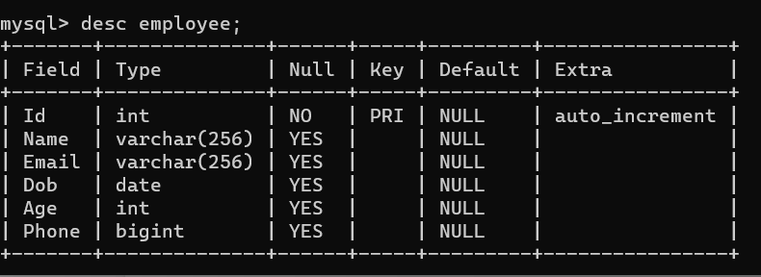
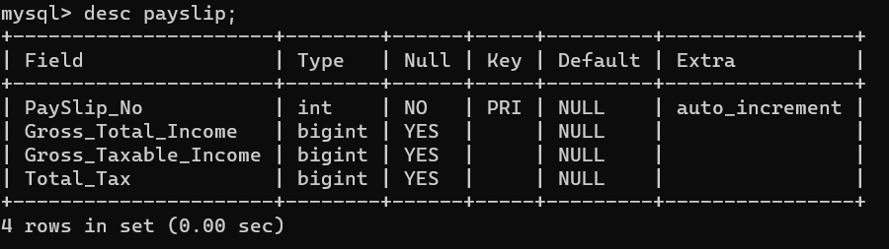
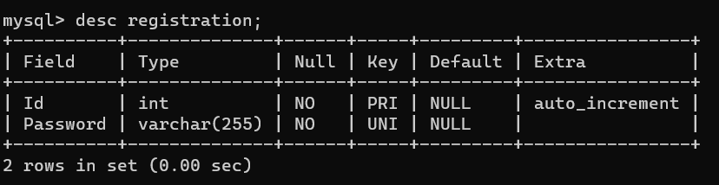
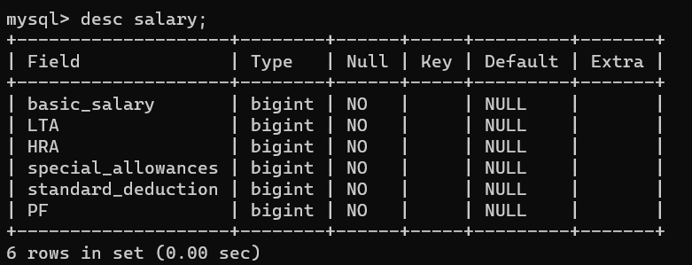

insert into employee(Id,Name,email,Dob,Phone)values(1,"Vikram Verma","vikram@gmailcom","1999-05-11",9850034871);
insert into employee(Name,email,Dob,Phone)values("Sartak Balla","Sartak.balla@gmailcom","1998-02-10",8880034871);
insert into employee(Name,email,Dob,Phone)values("Vikas Kumar","vikas123@gmailcom","1998-04-20",7890934871),("Kabir Singh","kabir09@gmail.com","1996-10-30",9822465670);
insert into salary(basic_salary,lta,hra,special_allowances,standard_deduction,pf)values(100000,7000,6000,10000,50000,9000);

select * from employee;
select * from salary;
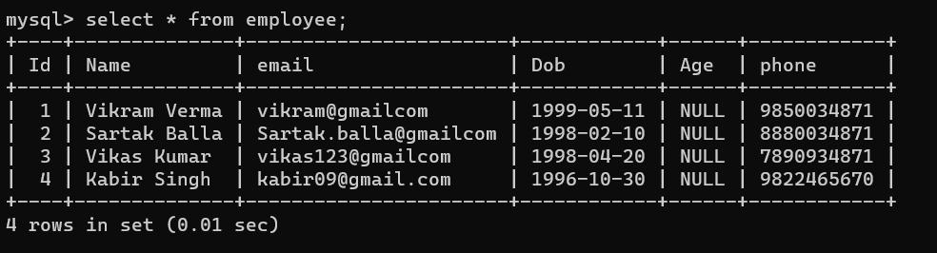
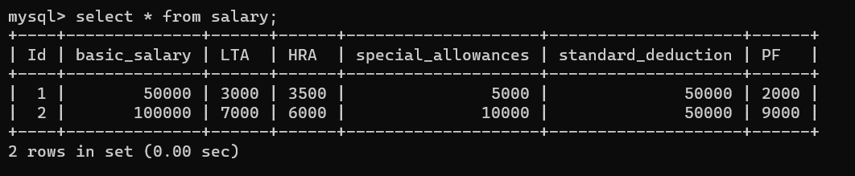

delete from employee where id=3;
delete from employee where id=4;
select * from employee;
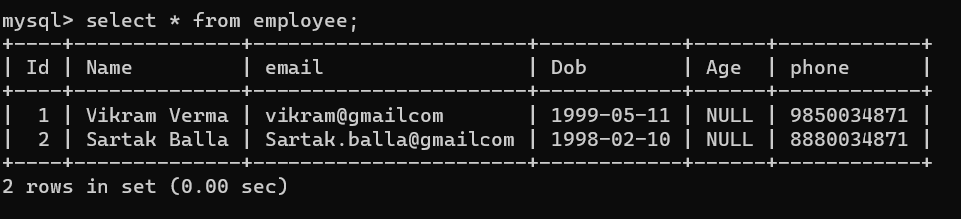

update employee set age=(curdate()-Dob)/10000;
