CS2227 :: Database Management Systems

Name of the student: Shrinivas Hatyalikar Roll No. 24

Div: CS-B Batch: 1

Experiment No.3
Aim: Design and Execute "SELECT" queries using conditional, logical, like/not like, in/not in,between...and, is null/is not null operators in where clause, order by, group by, aggregate
functions, having clause, and set operators. Use SQL single row functions for date, time, string
etc.
.

Solution:
use employee_tax_management;

select * from employee where id in(2); 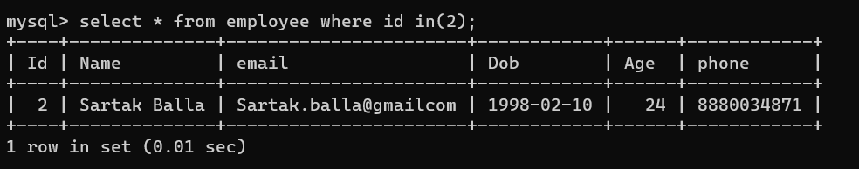 select * from employee where id not in(2); 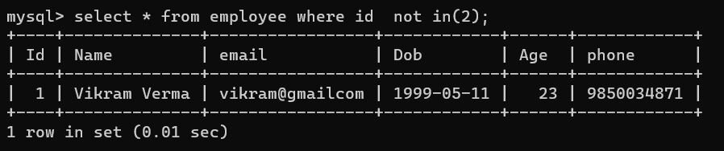
update employee set id=3 where id=5;
update employee set id=4 where id=6;
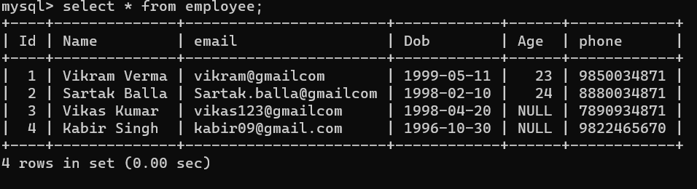

select * from employee where age is not null; 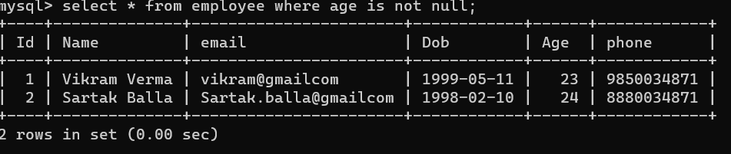select * from employee where age is null;
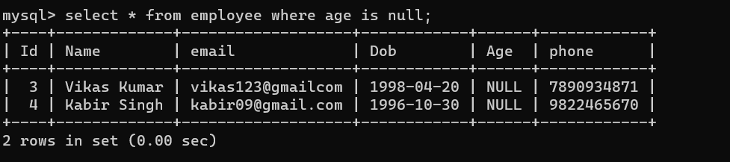select * from employee group by age;
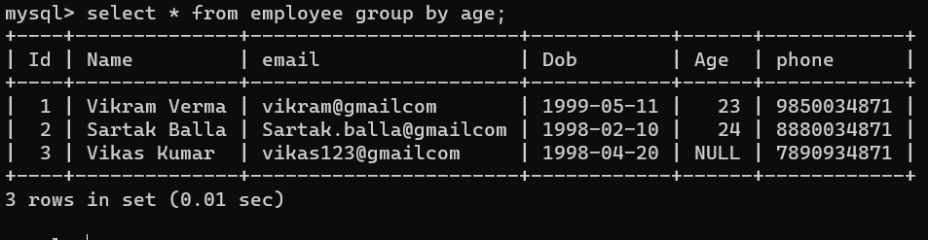

update employee set age=(curdate()-dob)/10000;
select count(id) from employee group by age;
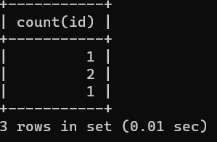

select count(id) from employee order by age;
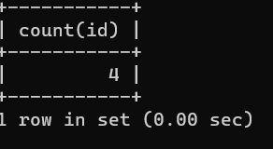

select (id) from employee order by age;
select (id) from employee order by age desc;
