CS2227 :: Database Management Systems

Name of the student: Shrinivas Hatyalikar Roll No. 24

Div: CS-B Batch: 1

Experiment No.4
Aim: Write equijoin, non equijoin, self join and outer join queries. Write queries containing
single row / multiple row / correlated sub queries using operators like =, in, any, all, exists etc.Write DML queries containing sub queries. Study a set of query processing strategies..

Solution:
use employee_tax_management;
select employee.name,salary.basic_salary from employee inner join salary where employee.id = salary.id;
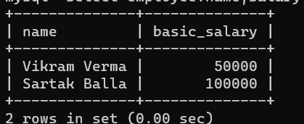
select employee.name,salary.basic_salary from employee left join salary on employee.id = salary.id;
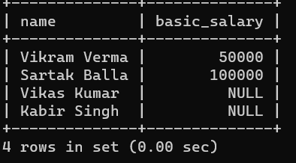

select employee.name,salary.basic_salary from employee right join salary on employee.id = salary.id;
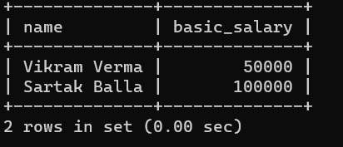
select employee.name,salary.basic_salary from employee left join salary on employee.id = salary.id union select employee.name,salary.basic_salary from employee right join salary on employee.id = salary.id;
