CS2227 :: Database Management Systems

Name of the student: Shrinivas Hatyalikar Roll No. 24

Div: CS-B Batch: 1

Experiment No.6
Aim: Write useful stored procedures and functions in PL/SQL to perform complex computation.

Solution:
use employee_tax_management;
delimiter $$
create procedure salary()
begin
select basic_salary,pf from salary;
end $$
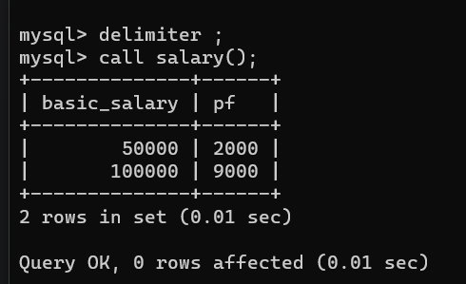

delimiter $$
create procedure AGE2()
begin
select * , Date_Format(From_Days(DateDiff(Now(),dob)),'%y')+0 as Age from employee;
end $$

