CS2227 :: Database Management Systems

Name of the student: Shrinivas Hatyalikar Roll No. 24

Div: CS-B Batch: 1

Experiment No.8
Aim: Execute DDL statements which demonstrate the use of views. Try to update the base table using its corresponding view. Perform view creation from multiple tables.

Solution:

Creating View from a single table:

create view v1 as select email,age,name from employee;

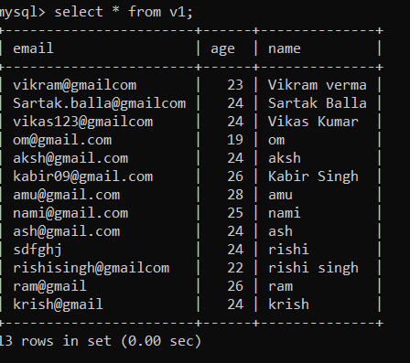

create view v2 as select name from employee order by name;

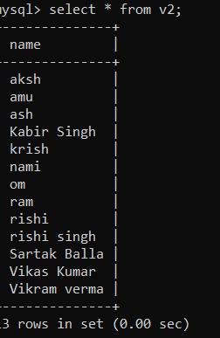

Creating View from multiple tables:

create view short_report as select salary.basic_salary,salary.standard_deduction,employee.name from salary,employee where salary.dob=employee.dob;

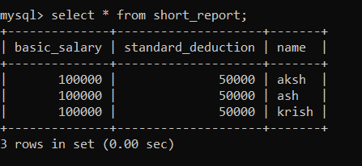

DELETING VIEWS

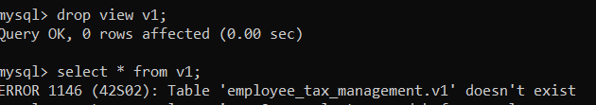

UPDATING VIEWS

create or replace view v2 as select name,dob from employee;

