**Name : Shrinivas Hatyalikar**

**Roll No. : 26**

**Div : CS-B**

**Assignment 6**

**Develop a client server using TCP Berkeley socket primitives to transfer a file in peer to peer and client server mode. Demonstrate the packets captured traces using Wireshark Packet Analyzer Tool for peer to peer mode.**

**Code**

**Server**

#include <stdio.h>

#include <stdlib.h>

#include <winsock2.h>

#define PORT 12345

#define MAX_BUFFER_SIZE 1024

void error(const char *msg) {

    perror(msg);

    exit(1);

}

int main() {

    WSADATA wsa;

    SOCKET server_socket, client_socket;

    struct sockaddr_in server_addr, client_addr;

    int addr_len = sizeof(client_addr);

    char buffer[MAX_BUFFER_SIZE];

    FILE *file;

    if (WSAStartup(MAKEWORD(2, 2), &wsa) != 0) {

        error("Failed to initialize Winsock");

    }

    server_socket = socket(AF_INET, SOCK_STREAM, 0);

    if (server_socket == INVALID_SOCKET) {

        error("Error creating socket");

    }

    memset(&server_addr, 0, sizeof(server_addr));

    server_addr.sin_family = AF_INET;

    server_addr.sin_addr.s_addr = INADDR_ANY;

    server_addr.sin_port = htons(PORT);

    // Bind socket to the server address

    if (bind(server_socket, (struct sockaddr *)&server_addr, sizeof(server_addr)) == SOCKET_ERROR) {

        error("Error on binding");

    }

    if (listen(server_socket, 5) == SOCKET_ERROR) {

        error("Error listening for connections");

    }

    printf("Server listening on port %d...\n", PORT);

    client_socket = accept(server_socket, (struct sockaddr *)&client_addr, &addr_len);

    if (client_socket == INVALID_SOCKET) {

        error("Error on accept");

    }

    // Open and send the file

    file = fopen("test.txt", "rb");

    if (file == NULL) {

        error("Error opening file");

    }

    int bytes_read;

    while ((bytes_read = fread(buffer, 1, MAX_BUFFER_SIZE, file)) > 0) {

        if (send(client_socket, buffer, bytes_read, 0) == SOCKET_ERROR) {

            error("Error sending data");

        }

    }

    printf("File sent successfully.\n");

    fclose(file);

    closesocket(client_socket);

    closesocket(server_socket);

    WSACleanup();

    return 0;

}

**Client**

#include <stdio.h>

#include <stdlib.h>

#include <winsock2.h>

#define PORT 12345

#define MAX_BUFFER_SIZE 1024

void error(const char *msg) {

    perror(msg);

    exit(1);

}

int main() {

    WSADATA wsa;

    SOCKET client_socket;

    struct sockaddr_in server_addr;

    char buffer[MAX_BUFFER_SIZE];

    FILE *file;

    if (WSAStartup(MAKEWORD(2, 2), &wsa) != 0) {

        error("Failed to initialize Winsock");

    }

    client_socket = socket(AF_INET, SOCK_STREAM, 0);

    if (client_socket == INVALID_SOCKET) {

        error("Error creating socket");

    }

    memset(&server_addr, 0, sizeof(server_addr));

    server_addr.sin_family = AF_INET;

    server_addr.sin_port = htons(PORT);

    server_addr.sin_addr.s_addr = inet_addr("127.0.0.1");

    if (connect(client_socket, (struct sockaddr *)&server_addr, sizeof(server_addr)) == SOCKET_ERROR) {

        error("Error connecting to the server");

    }

    file = fopen("received.txt", "wb");

    if (file == NULL) {

        error("Error opening file");

    }

    int bytes_received;

    while ((bytes_received = recv(client_socket, buffer, MAX_BUFFER_SIZE, 0)) > 0) {

        fwrite(buffer, 1, bytes_received, file);

    }

    printf("File received successfully.\n");

    fclose(file);

    closesocket(client_socket);

    WSACleanup();

    return 0;

}

**Output**

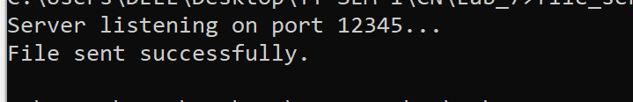



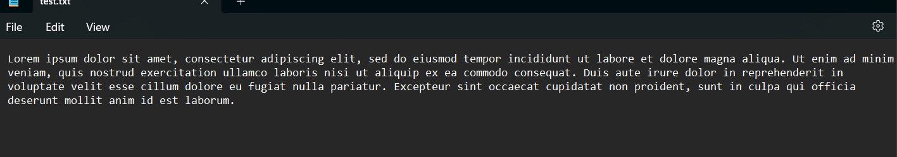



**Wireshark packet tracing**

