CYBERSECURITY AND ETHICAL HACKING INTERNSHIP

TASK 1: CYBERSECURITY LAB SETUP AND FUNDAMENTALS
Internship Organization: ApexPlanet Software Pvt. Ltd.
Submitted by: Shrija Sujit Chalke
Internship Task: Task 1
Domain: Cybersecurity
Tools Used:
- Kali Linux
- Oracle VirtualBox
- Metasploitable 2
- Nmap
- Wireshark
- Netcat
Submission Date: 04th Nov 2026

1. INTRODUCTION
Cybersecurity is the practice of protecting computer systems, networks, and data from unauthorized access, cyberattacks, and damage.
This internship task focuses on understanding cybersecurity fundamentals and establishing a virtual penetration-testing laboratory using Kali Linux and Metasploitable 2.
The lab provides a controlled environment to explore networking, vulnerability assessment, packet analysis, and communication between systems.
All practical activities were performed within the virtual lab environment.

2. OBJECTIVES
The objectives of this task are:
- To understand basic cybersecurity concepts and the CIA Triad.
- To configure a virtual cybersecurity laboratory using Oracle VirtualBox.
- To establish communication between Kali Linux and Metasploitable 2.
- To understand basic Linux networking commands.
- To perform network scanning using Nmap.
- To capture and analyze network packets using Wireshark.
- To demonstrate communication using Netcat.
- To develop foundational networking and cybersecurity skills.

3. LAB ENVIRONMENT SETUP
3.1 Tools and Technologies
The following tools were used to establish the cybersecurity laboratory:
Tool | Purpose
Oracle VirtualBox | Virtualization platform
Kali Linux | Attacker and testing machine
Metasploitable 2 | Intentionally vulnerable target machine
Nmap | Network scanning and service detection
Wireshark | Network packet analysis
Netcat | Network communication and debugging
3.2 Virtual Machine Configuration
Two virtual machines were used:
1. Kali Linux: Used for executing network scanning, packet analysis, and communication tests.
2. Metasploitable 2: Used as the vulnerable target machine for controlled security testing.
Both virtual machines were configured to communicate within a private virtual network.
3.3 Network Configuration
The lab used a VirtualBox Host-Only network to facilitate communication between the virtual machines.
The assigned IP addresses were:
- Kali Linux: 192.168.56.101
- Metasploitable 2: 192.168.56.103
The network configuration enabled communication between the attacker and target machines without requiring an external network connection for the lab activities.

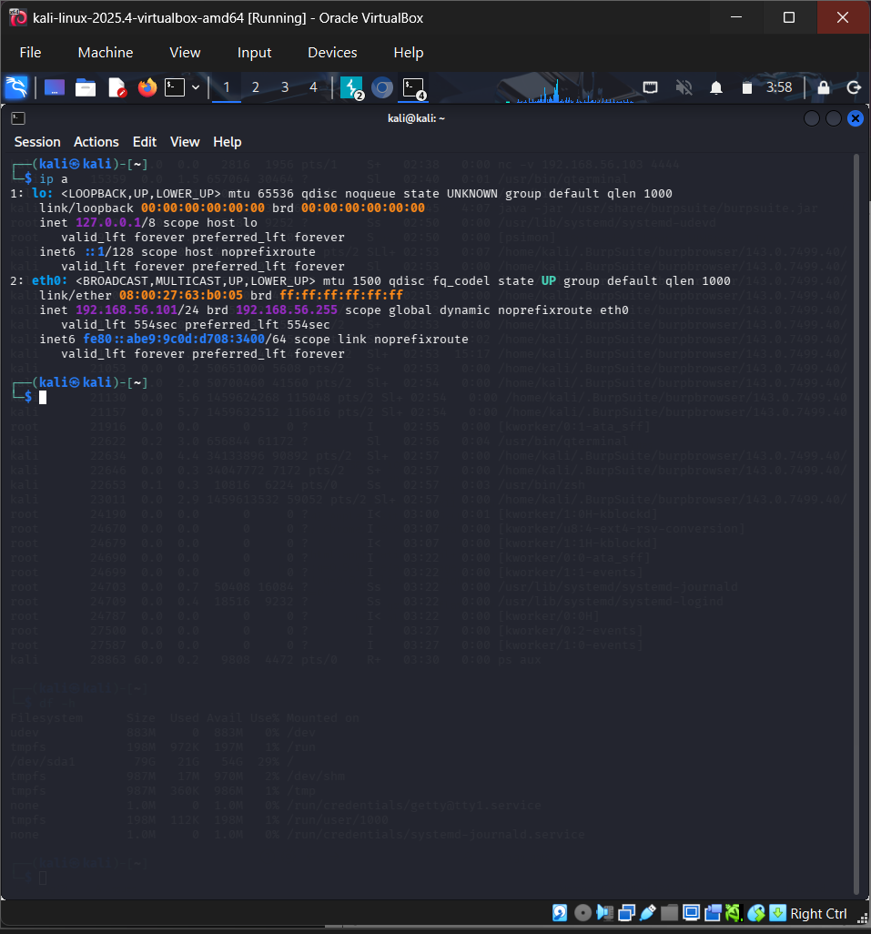

Fig 1: Kali IP address configuration

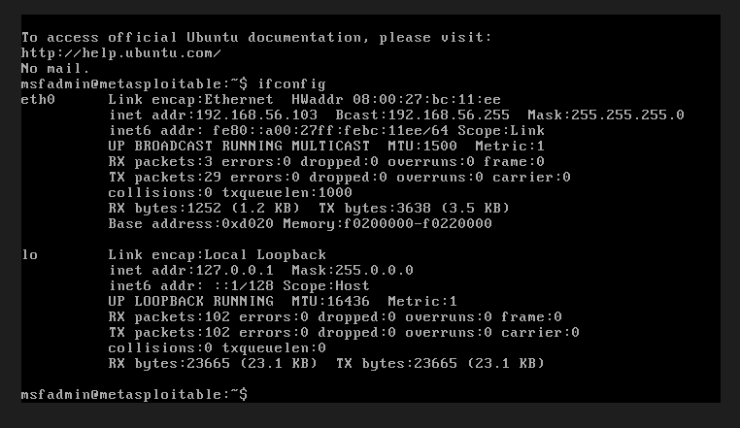

Fig 2. Metasploitable IP address configuration

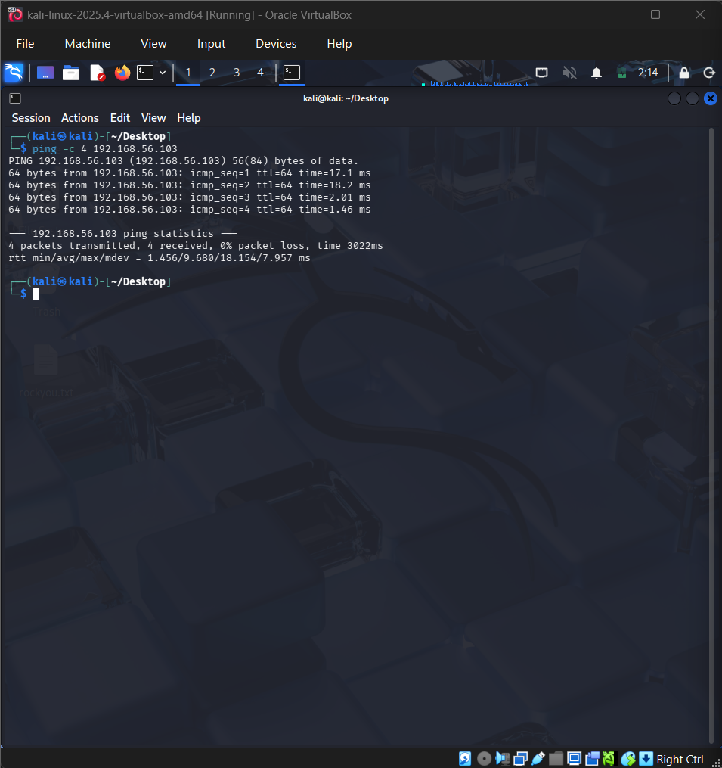

Fig 3: Successful network connectivity

4. NETWORK SCANNING USING NMAP

4.1 Introduction
Nmap (Network Mapper) is an open-source tool used for network discovery, port scanning, and service identification.
It helps cybersecurity professionals identify open ports and services running on a target system.
4.2 Practical Implementation
Nmap was executed from Kali Linux to scan the Metasploitable 2 target machine.
The following command was used:
nmap -sV 192.168.56.103
Command explanation:
- nmap: Launches the Nmap scanning tool.
- -sV: Detects versions of services running on open ports.
- 192.168.56.103: IP address of the target machine.
4.3 Results
The scan identified multiple open ports and services on the Metasploitable 2 machine.
This demonstrated how network scanning can be used to discover exposed services and identify potential security risks.
The results emphasize the importance of securing unnecessary open ports and maintaining network services properly.
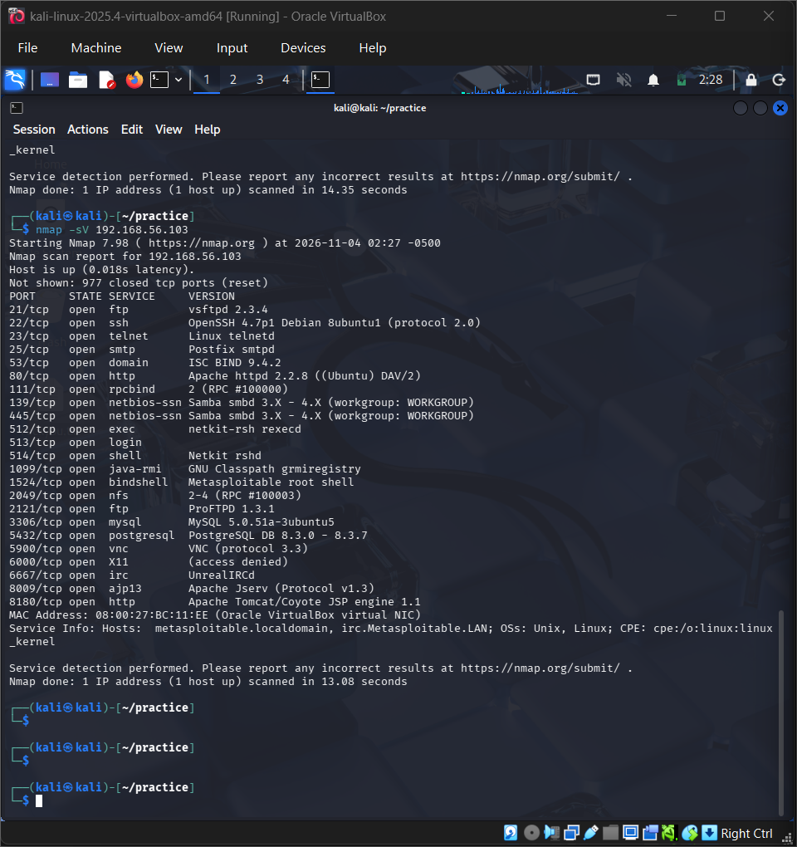
Fig 4: Nmap service version scan of metasploitable 2

5. NETWORK PACKET ANALYSIS USING WIRESHARK
5.1 Introduction
Wireshark is a network protocol analyzer used to capture and inspect network traffic in real time.
It helps identify communication between devices and understand protocols such as TCP, UDP, and ICMP.
5.2 Practical Implementation
Wireshark was launched on Kali Linux to capture network traffic between Kali Linux and Metasploitable 2.
The ICMP display filter was applied:
icmp
Ping requests and replies were generated to observe ICMP packets exchanged between the two virtual machines.
5.3 Results
The packet capture displayed ICMP Echo Requests sent from Kali Linux to Metasploitable 2 and ICMP Echo Replies returned by the target.
This confirmed successful communication and demonstrated how Wireshark can be used to monitor and analyze network traffic.
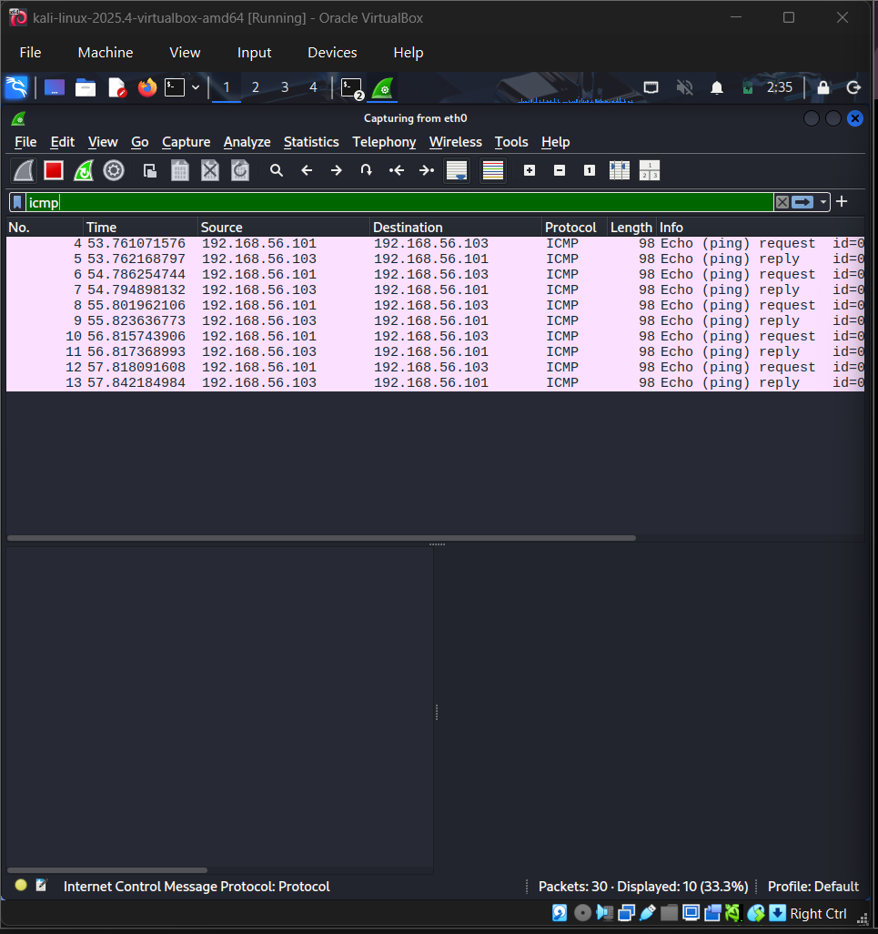
Fig 5: ICMP Packet capture and analysis using Wireshark

6. NETWORK COMMUNICATION USING NETCAT

6.1 Introduction
Netcat is a command-line networking utility used for establishing TCP or UDP connections, transferring data, and troubleshooting network services.
6.2 Practical Implementation
Netcat was used to establish communication between Kali Linux and Metasploitable 2 over TCP port 4444.
On Metasploitable 2, the following command was executed to listen for incoming connections:
nc -l -p 4444
On Kali Linux, the following command was used to connect to the target:
nc -v 192.168.56.103 4444
A test message, "Hello from kali!", was sent from Kali Linux to the target machine.
6.3 Results
The message was successfully received by Metasploitable 2, demonstrating successful TCP communication between the virtual machines.
This practical exercise demonstrated the use of Netcat for basic network communication and troubleshooting.
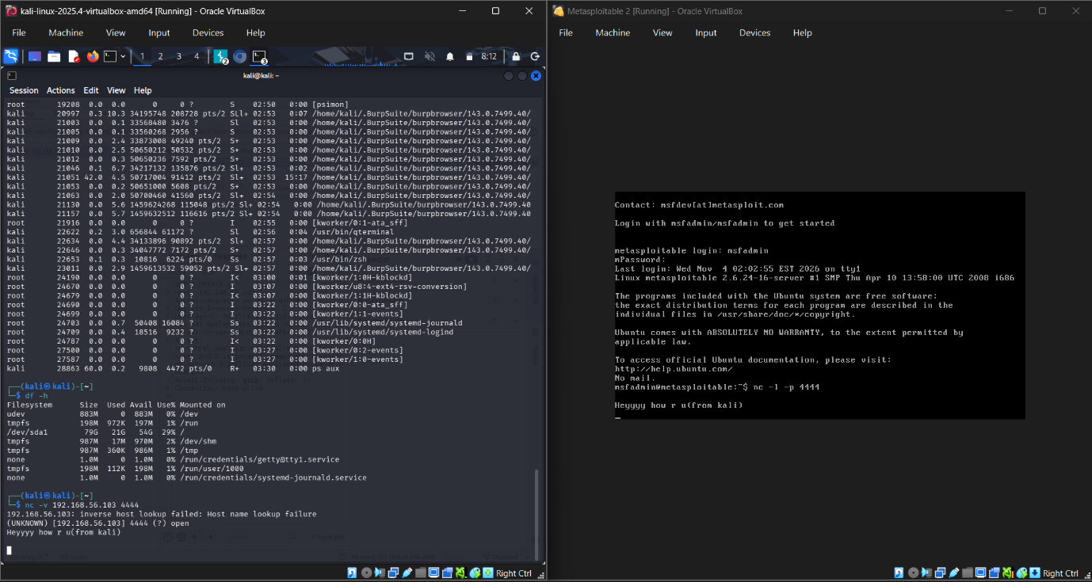
Fig 6: Successful netcat communication between Kali Linux and Metasploitable 2
7. CONCLUSION
This task provided practical exposure to cybersecurity fundamentals and network testing within a controlled virtual environment.
The lab was successfully established using Kali Linux and Metasploitable 2 in Oracle VirtualBox.
The successful ping test verified network connectivity. Nmap was used to identify open ports and services, Wireshark was used to analyze ICMP traffic, and Netcat demonstrated communication between the two virtual machines.
Overall, this task strengthened my understanding of networking, Linux commands, network scanning, packet analysis, and basic cybersecurity tools.

