Course code : INT22

CODE:

const express = require('express')
const app = express()
const fs = require('fs')
const zlib = require('zlib')

app.get('/', (req, res) => {
res.send(`
<form action='/view' method='get'>
Enter file (like server.js):
<input type="text" name="filename" placeholder="Enter filename" required />
<button type="submit">Compress</button>
</form>`)
})

app.get('/view', (req, res) => {
const file = req.query.filename
const readStream = fs.createReadStream(file, 'utf-8')
const writeStream = fs.createWriteStream(`server.js.gz`)
const gzip = zlib.createGzip()

readStream.pipe(gzip).pipe(writeStream)
res.send(`File compressed successfully! "server.js" to "server.js.gz"`)
})

app.listen(3000, () => {
console.log('server is running')
})

OUTPUT: 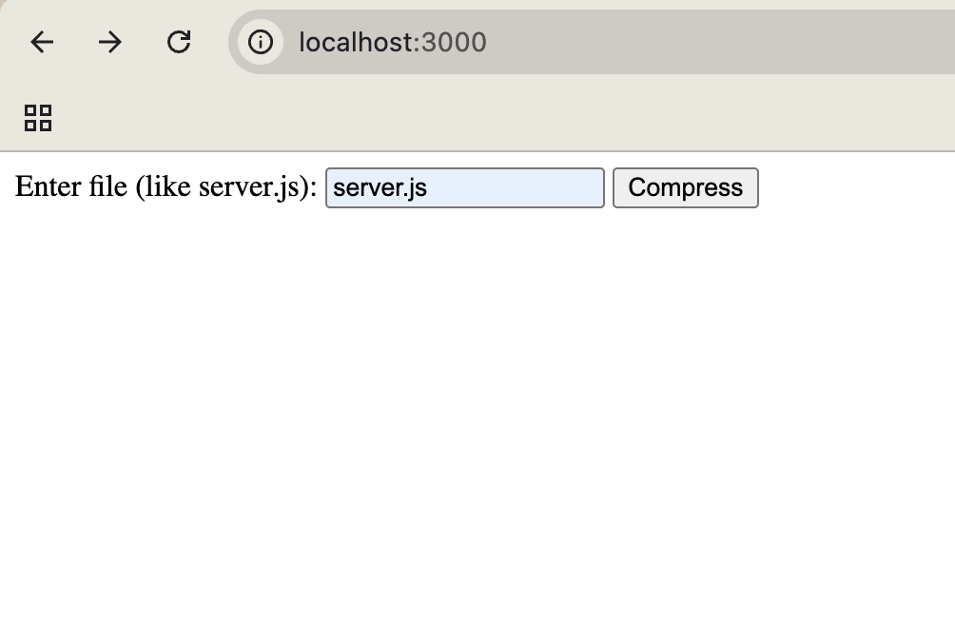
When compress button is clicked :

