> mydata <- read.csv("C:/data/occupancyrates.csv")

> attach(mydata)

> x<-Time

> Y<-Occupancy.rate

> d.y<-diff(Y)

> plot(x,Y)

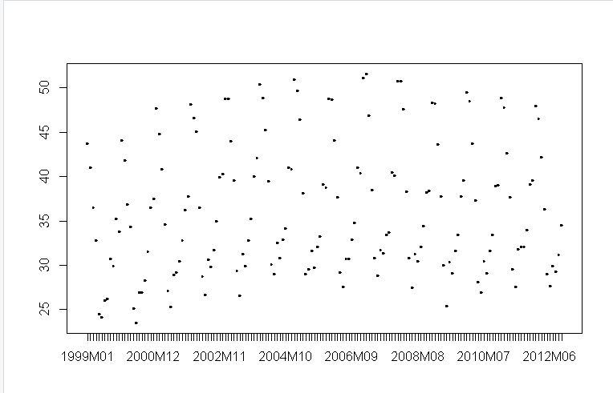

> acf(Y)

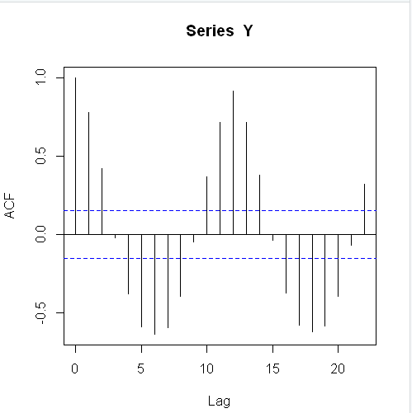

> pacf(Y)

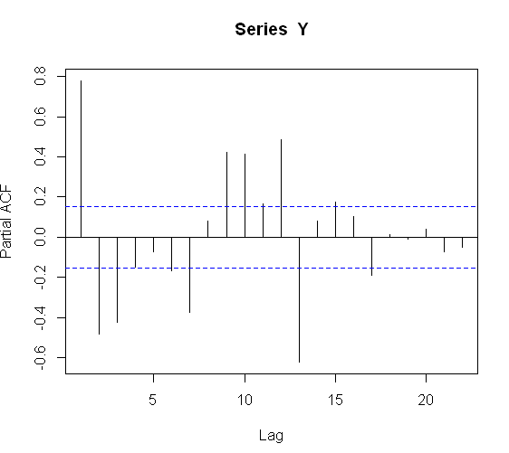

> acf(d.y)

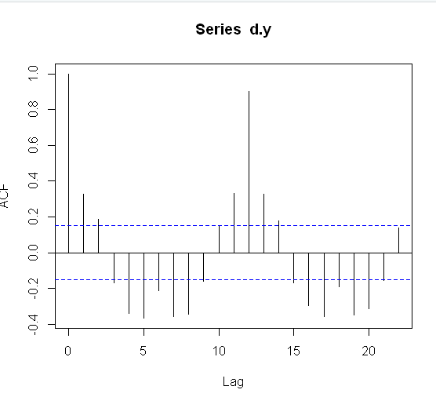

> arima(Y,order=c(1,0,1))

Call:

arima(x = Y, order = c(1, 0, 1))

Coefficients:

ar1 ma1 intercept

0.6868 0.3153 36.3027

s.e. 0.0625 0.0649 1.3809

sigma^2 estimated as 18.46: log likelihood = -478.13, aic = 964.26

> arima(Y,order=c(0,0,1))

Call:

arima(x = Y, order = c(0, 0, 1))

Coefficients:

ma1 intercept

0.6601 36.2179

s.e. 0.0388 0.6733

sigma^2 estimated as 27.44: log likelihood = -510.72, aic = 1027.45

> mydata.arima001<-arima(Y,order =c(0,0,1) )

> mydata.pred1<-predict(mydata.arima001,n.head=001)

> plot(Y)

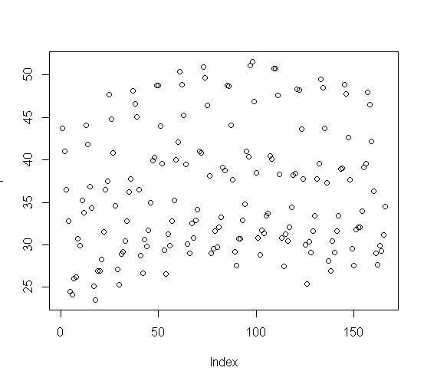

> lines(mydata.pred1$pred,col="blue")

> attach(mydata.pred1)

> head(mydata.pred1)

$`pred`

Time Series:

Start = 167

End = 167

Frequency = 1

[1] 35.86919

$se

Time Series:

Start = 167

End = 167

Frequency = 1

[1] 5.238236

> tail(mydata.pred1$pred)

[1] 35.86919

> head(mydata.pred1$pred)

[1] 35.86919