ORCHPILOT
The governed orchestration layer
for people, systems and AI
Investor strategy, product analysis, competitive positioning and 18-month roadmap

Product at a glance
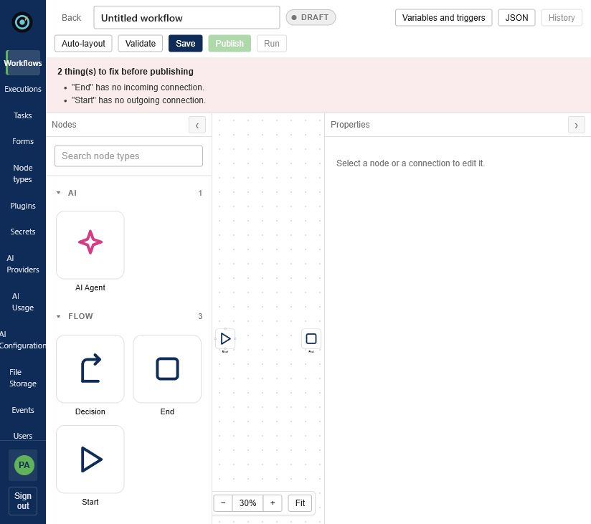
The working OrchPilot workflow designer: AI, deterministic flow and human steps in one canvas.
Status: working product foundation with deep engineering evidence; commercial traction, founder story, raise amount and customer ROI remain to be supplied before external circulation.

Executive summary
OrchPilot is an extensible workflow execution platform designed to coordinate long-running work across software systems, people and AI agents. Its strongest investment thesis is not generic no-code automation. The credible wedge is governed orchestration for organizations where approvals, exceptions, audit evidence, deployment control and recovery are materially valuable.
Investor thesis: OrchPilot can occupy the governed middle between easy-to-use automation tools and code-first durable execution platforms.

What is already credible
- A real execution engine with immutable workflow versions, checkpointed state, retries, compensation, synchronous/asynchronous/scheduled/event-driven modes and cluster-aware claiming.
- Human tasks as first-class workflow participants, including forms, assignment, claiming, drafts, expiration, reassignment and auditable history.
- Runtime plugin loading: validated JARs stored in GridFS, loaded with isolated classloaders and registered as new node types without rebuilding the engine.
- Enterprise control primitives: RBAC, JWT authentication, Argon2id password hashing, encrypted secrets, security audit logs and server-side validation.
- AI agent nodes and provider management that keep adaptive reasoning inside deterministic workflow boundaries.

What investors will still need
- A narrow beachhead and five design partners with quantified process baselines.
- Enterprise readiness proof: SSO/SCIM, high-availability benchmarks, deployment automation, observability, security review and support model.
- A pricing hypothesis validated by willingness-to-pay—not just a feature comparison.
- Founder-market-fit narrative, current traction, financing amount, runway plan and ownership/cap-table detail.

1. Product: what OrchPilot does
A workflow in OrchPilot is a graph. Built-in nodes control the process; plugin nodes connect external capabilities. Publishing snapshots an immutable version, and each execution pins that version so later edits cannot silently change a run already in flight. This is especially valuable for approvals and regulated processes that may remain open for hours or days.
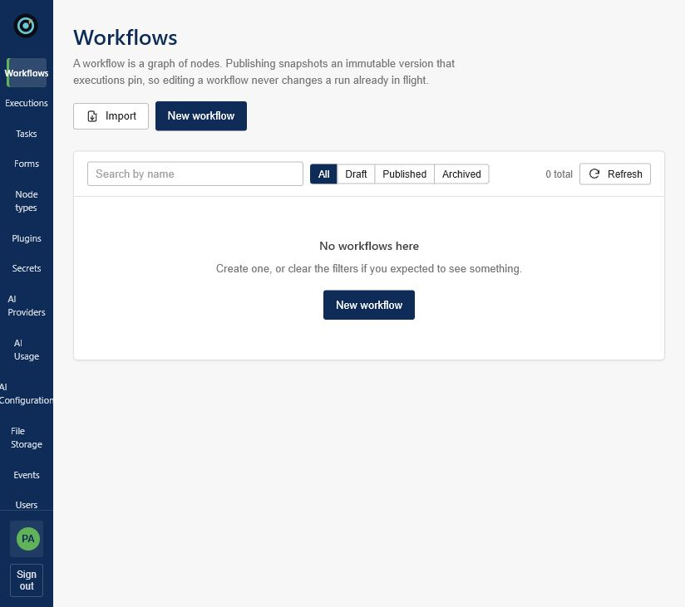
Workflow inventory and lifecycle management in the authenticated console.

Core user journeys
User | Job to be done | Product surface
Workflow owner | Design, validate, publish and operate a process | Designer, versions, validation, executions
Approver / operator | Claim, review and complete accountable human work | Task inbox, forms, drafts, history
Platform administrator | Control users, plugins, secrets, AI providers and storage | Admin, plugin manager, secrets, settings
Integration developer | Create reusable, governed capabilities | Plugin SDK, registry, schemas, permissions

2. Architecture and engineering assessment
The repository is a Maven multi-module system built with Java 17+, Spring Boot, MongoDB and Angular. The engine is deliberately integration-agnostic: plugin contracts live in a separate SDK, while the core resolves node types through a registry rather than integration-specific switch statements.
Evidence | Observed value | Investor meaning
Java production source | 650 files / 80,084 lines | Substantial platform implementation; requires maintainability discipline
Java tests | 141 files / 21,783 lines; 73 core test classes | Meaningful test investment, but scale/HA benchmarks still needed
REST surface | 160 handler annotations / 27 controllers | Broad operational and administrative API surface
Plugin modules | 13 | Demonstrates SDK breadth across SaaS, cloud, data and infrastructure
Angular source | 118 files / 28,595 lines | Full administration and workflow console, not API-only middleware

Source: Local source-only inventory, 26 August 2026. Generated targets and dependencies excluded.

Architectural strengths
- Plugin lifecycle is treated as an operational security boundary: validation, checksums, allowlisted hosts, scoped secrets, activation/deactivation and invocation history.
- Execution recovery persists state at node boundaries and uses ownership/heartbeat semantics to resume abandoned work.
- Idempotency keys include execution, node, plugin version and configuration fingerprint, reducing duplicate side effects after retry or crash.
- Workflow portability uses a signed/encrypted .orchpilot format and intentionally excludes secrets.
- Security design is explicit and documented, including password migration, token strategy, permission mapping and audit collections.

Technical gaps to address before enterprise claims
- Publish repeatable load, recovery, chaos and multi-node benchmarks with defined SLOs.
- Add SSO/SAML or OIDC federation, SCIM lifecycle management, external secret-manager integrations and tenant isolation if multi-tenant SaaS is planned.
- Harden the plugin sandbox beyond classloader isolation for untrusted third-party code; consider out-of-process execution for marketplace plugins.
- Formalize database migration/versioning, backup/restore drills, upgrade compatibility and disaster-recovery runbooks.
- Reduce source breadth risk through module ownership, architectural fitness tests and a published compatibility policy for the SDK.

3. Product experience and governance
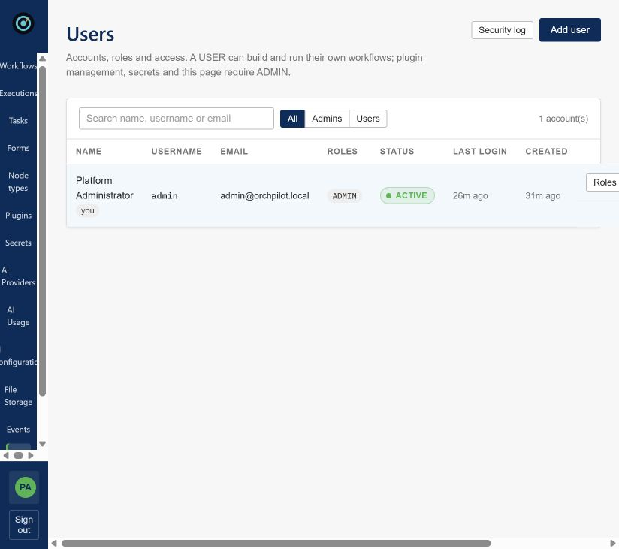
User governance with roles, account status and security-log access.
The console already exposes the operational surfaces enterprise buyers expect: workflows, executions, tasks, forms, node types, plugins, secrets, events, AI providers, storage, users and groups. This breadth is an advantage in diligence, but the pitch should focus on the few workflows that create budget urgency.
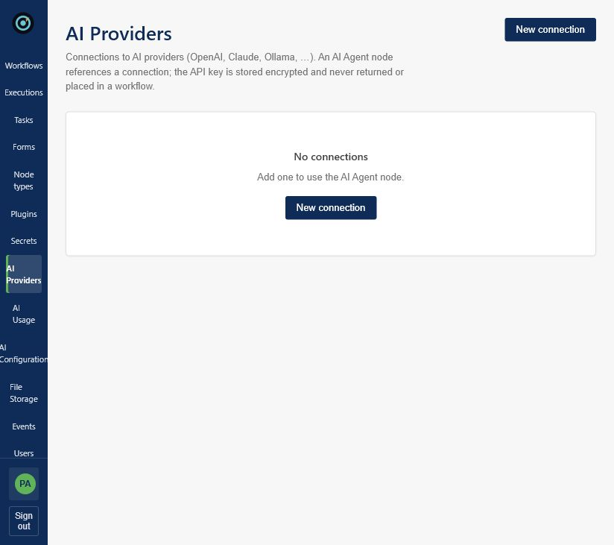
AI provider management: keys remain encrypted and are not returned to the browser or stored in workflows.
Product principle to preserve: AI should reason inside governed boundaries; deterministic workflow state, policy and human escalation should own the business outcome.

4. Market timing
Current market signals support an orchestration thesis. Gartner forecasts spending on consolidated business orchestration and automation technologies (BOAT) to grow 35% in 2025 to nearly $7 billion and cross $21 billion by 2029. A broader Gartner market map projects process-agnostic hyperautomation software at $119.2 billion by 2028, growing at 15.9% CAGR. These are category forecasts, not OrchPilot revenue projections.
Signal | Current evidence | Implication
Platform consolidation | BOAT spending projected above $21B by 2029 | Buyers want a control layer, not another isolated bot
AI enters core processes | Agentic systems increase nondeterminism and governance needs | Deterministic + adaptive orchestration becomes strategic
Self-hosting remains relevant | Leading vendors sell self-managed enterprise tiers | Deployment control can be a commercial feature
Human work persists | Major orchestration platforms treat tasks as first-class | Approvals and exceptions are a durable wedge

Source: Gartner BOAT forecast (May 2025); Gartner hyperautomation opportunity map (February 2025); Camunda, Temporal and n8n official product pages, accessed August 2026.

5. Competitive landscape
Product | Primary strength | Where OrchPilot should differentiate
Zapier / Make | Accessibility and very broad SaaS connector ecosystems | Do not compete on connector count; win governed, long-running operations
n8n | Flexible visual automation, self-hosting and technical-user adoption | Stronger plugin isolation, human accountability and execution governance
Camunda | Enterprise process orchestration, BPMN, governance and scale | Faster onboarding and a simpler plugin-native developer/operator experience
Temporal | Category-leading durable execution for developers | Business-visible workflow design, human tasks and schema-driven integrations
Workato / enterprise iPaaS | Enterprise integrations, governance and services ecosystem | Deployment control, developer extensibility and transparent execution economics

The defensible positioning is a governed orchestration control plane that is easier to adopt than BPMN-heavy suites, more operationally accountable than general automation tools, and more business-visible than code-only durable execution.

6. Beachhead, impact and go-to-market

Recommended beachhead
Target platform engineering, regulated operations and IT service-delivery teams in 500–5,000 employee organizations. These teams have hybrid systems, recurring approval-heavy processes, explicit compliance owners and enough failure cost to pay for orchestration reliability.
Beachhead workflow | Why it fits | Measure before / after
Cloud access & provisioning | Plugins + approvals + rollback + audit | Lead time, failed changes, manual touches
Customer onboarding / KYC exception | Forms + human judgment + immutable history | Cycle time, rework, SLA breaches
Incident remediation | Events + automation + escalation + evidence | MTTR, repeat incidents, operator time
Vendor / security review | Long-running tasks + documents + approvals | Days to decision, overdue tasks, audit prep

Why this can create market impact
- Turn fragile tribal processes into explicit, versioned operational assets.
- Let organizations adopt AI for exceptions without surrendering auditability or deterministic control.
- Give internal platform teams a reusable self-service layer instead of bespoke portals and scripts for every request.
- Create a plugin supply chain where partners package domain operations once and customers govern their use centrally.

Go-to-market motion
- Founder-led discovery: interview 25 process owners and platform leaders; score pain, frequency, compliance and budget ownership.
- Five design partners: implement one workflow each under a fixed success plan with baseline metrics.
- Convert three paid pilots: annual platform commitment plus scoped launch package; price before building custom breadth.
- Publish proof: architecture/security brief, reliability benchmark and two quantified case studies.
- Build channel leverage: certify specialist integrators and plugin authors around one vertical pack.

7. Business model recommendation
Revenue stream | Recommended structure | Validation question
Platform subscription | Annual contract by environment / deployment tier | Will governance and support unlock budget?
Execution bands | Committed annual executions with transparent overage | Does usage track customer value predictably?
Plugin marketplace | Certified paid plugins and private enterprise catalogues | Will partners build and customers pay for governed supply?
Launch services | Fixed-scope implementation and enablement | Can services produce repeatable templates rather than custom debt?

Treat pricing as a testable hypothesis. Do not publish tiers until five design-partner conversations reveal procurement anchors and usage patterns.

8. Eighteen-month product roadmap
Phase | Outcome | Product priorities | Evidence gate
0–3 months | Prove the wedge | Install path, first-use UX, vertical workflow pack, discovery instrumentation | 5 design partners; one process baseline each
4–9 months | Earn enterprise trust | SSO/SCIM, HA topology, observability, external secrets, backup/restore, policy controls | 3 paid pilots; documented SLO and recovery test
10–18 months | Scale distribution | Plugin certification, partner portal, SDK compatibility, cloud option, usage metering | Expansion to second process; partner-sourced pipeline

North-star metrics
- Time from install to first production workflow.
- Successful workflow completion rate and recovery rate after induced failure.
- Human wait time, overdue-task rate and exception resolution time.
- Number of production workflows per customer and expansion to a second department/process.
- Certified plugins used in production and partner-sourced annual recurring revenue.

9. Risks and mitigation
Risk | Why it matters | Mitigation
Crowded positioning | Automation language collapses into larger incumbent categories | Own governed orchestration for high-accountability workflows
Enterprise readiness gap | Feature breadth does not equal procurement readiness | Security roadmap, benchmarks, SLOs, support and deployment proof
Plugin security | In-process third-party code can exceed classloader boundaries | Certification, signing, policy and optional out-of-process runtime
Connector cold start | Customers expect their systems on day one | Vertical packs, REST fallback and partner-led plugin supply
Breadth before PMF | Large codebase can absorb effort without customer learning | Freeze non-wedge features until design-partner evidence

10. Investor pitch guidance

Thirty-second version
OrchPilot is the governed orchestration layer for critical workflows that span people, systems and AI. Unlike task automation tools, it owns long-running state, human accountability and recovery. Unlike code-only engines, it gives operators a visual, extensible control plane. The product foundation is built; the seed round converts it into repeatable enterprise adoption.

Questions to answer before pitching externally
- Who are the founders, and what unique access or insight makes this team credible in platform engineering or regulated operations?
- What is the raise amount, target runway, hiring plan and milestone-based allocation?
- Which design partners or conversations exist today, and what process pain has been quantified?
- What is the deployment model and license? Open core, commercial source, hosted SaaS or dual model?
- What is the first vertical plugin pack, and why can OrchPilot win distribution there?
- What scale has been tested: concurrent executions, workflow duration, recovery time and plugin isolation under failure?

Appendix A. Product capability map
Domain | Implemented evidence | Pitch status
Workflow lifecycle | Draft, validate, publish, immutable versions, archive, import/export | Built
Execution | Sync/async/manual/event/schedule, retry, compensation, pause/resume/cancel | Built
Human work | Forms, tasks, assignment, claim, draft, completion, history, expiry | Built
Plugins | SDK, registry client/server, upload, validation, activation, isolation, history | Built; marketplace is roadmap
Security | RBAC, JWT, Argon2id, audit, encrypted secrets, CSP/security headers | Built; enterprise identity is roadmap
AI | Agent node, provider configuration, usage and CLI controls | Built foundation; production proof needed
Operations | Health, metrics, logs, schedulers, recovery, cluster claims | Built foundation; benchmarks needed

Appendix B. Sources
• Workflow-OrchPilot/workflow-engine local repository: README.md, ARCHITECTURE.md, SECURITY.md, AI_AGENT_NODE.md, AI_CLI_CONFIGURATION.md, WORKFLOW_INSTANCE_LIFECYCLE.md, WORKFLOW_PORTABILITY.md and PLUGIN_OPERATION_FRAMEWORK.md (reviewed 26 August 2026).
• Gartner, Forecast Analysis: Business Orchestration and Automation Technologies, Worldwide (28 May 2025): https://www.gartner.com/en/documents/6530402
• Gartner, Market Opportunity Map: Hyperautomation via Process-Agnostic Software, Worldwide (11 February 2025): https://www.gartner.com/en/documents/6165623
• Gartner newsroom, enterprise network automation forecast (18 September 2024): https://www.gartner.com/en/newsroom/press-releases/2024-09-18-gartner-says-30-percent-of-enterprises-will-automate-more-than-half-of-their-network-activities-by-2026
• Camunda platform and use cases: https://camunda.com/platform/ and https://camunda.com/platform/use-cases/
• Temporal platform and platform-engineering solution: https://temporal.io/ and https://temporal.io/solutions/platform-engineering
• n8n pricing and Business plan: https://n8n.io/pricing/ and https://support.n8n.io/article/what-is-the-n-8-n-business-plan-that-launched-in-august-2025

