**Chapter 1**

**INTRODUCTION OF COMMERCIAL BANKING**

The word commercial bank leads to a financial institution that takes deposits, makes various loans, offers to check account services, and offers basic financial outcomes like certificates of deposit (CDs) and savings accounts to individuals and small businesses. A commercial bank is where most people do their banking. Commercial banks make money by producing and receiving interest from loans such as mortgages, business loans, auto loans, and personal loans. Customer deposits present banks with the capital to make these loans.

Commercial banks give basic banking services to the general public—to both individual consumers and small to mid-sized businesses.

Commercial banks have traditionally been located in buildings where customers come to use teller window services and automated teller machines (ATMs) to do their routine banking. With the rise in technology, most banks now allow their customers to do most of the same services online that they could do in person including transfers, deposits, and bill payments.

Commercial banks provide different types for loans for the development of the industrial sector. Some special industrial development commercial banks IDBP, PICIC etc are provide their remarkable service for the development the industrial sector. A commercial banks is something with which everyone of us is well known however different bankers and economists have defined it in a different way. According to banking ordinance 1962 banking means the accepting for the purpose of leading or investing the deposit money from the public repayable in demand or otherwise and Withdraw able by cheque draft order or otherwise. From the above definitions we conclude that the bank is an Institute which is established for the depositing withdrawing and borrowing money. Role of commercial bank in economy development. Various economic development it is the banking system which service as key agent along with the Entreneur in the process of economy development. According to prof Cameron in his “banking and economic development “a positive contribution to economic growth and development. Commercial banks help in the just and optimum allocation of resources some megaproject cannot be started due to a lack capital commercial bank provide loans and remove the problem of deficiency of capital. Due to the use of resources in a economy there is an increase in production income and employment etc. Commercial banks provide an incentives for the entrepreneur to take risks and to use idle resources for more and better production the general role of commercial bank is to provide financial bank is to provide financial services to the general public and business, ensuring economy and social stability growth of the economy.

**1.1 HISTORY OF COMMERCIAL BANK**

The commercial banking industry in India started in 1786 with the establishment of the Bank of Bengal in Calcutta. The Indian Government at the time established three Presidency banks, viz., the Bank of Bengal (established in 1809), the Bank of Bombay (established in 1840) and the Bank of Madras (established in 1843). In 1921, the three Presidency banks were amalgamated to form the Imperial Bank of India, which took up the role of a commercial bank, a bankers’ bank and a banker to the Government. The Imperial Bank of India was established with mainly European shareholders. It was only with the establishment of Reserve Bank of India (RBI) as the central bank of the country in 1935, that the quasi-central banking role of the Imperial Bank of India came to an end. In 1860, the concept of limited liability was introduced in Indian banking, resulting in the establishment of joint-stock banks. In 1865, the Allahabad Bank was established with purely Indian shareholders. Punjab National Bank came into being in 1895.

Between 1906 and 1913, other banks like Bank of India, Central Bank of India, Bank of Baroda, Canara Bank, Indian Bank, and Bank of Mysore were set up. After independence, the Government of India started taking steps to encourage the spread of banking in India. In order to serve the economy in general and the rural sector in particular, the All India Rural Credit Survey Committee recommended the creation of a state-partnered and state-sponsored bank taking over the Imperial Bank of India and integrating with it, the former state-owned and state-associate banks. Accordingly, State Bank of India (SBI) was constituted in 1955. Subsequently in 1959, the State Bank of India (subsidiary bank) Act was passed, enabling the SBI to take over eight former state-associate banks as its subsidiaries.

The commercial banking industry in India started in 1786 with the establishment of the Bank of Bengal in Calcutta. The Indian Government at the time established three Presidency banks, viz., the Bank of Bengal (established in 1809), the Bank of Bombay (established in 1840) and the Bank of Madras (established in 1843). In 1921, the three Presidency banks were amalgamated to form the Imperial Bank of India, which took up the role of a commercial bank, a bankers’ bank and a banker to the Government. The Imperial Bank of India was established with mainly European shareholders. It was only with the establishment of Reserve Bank of India (RBI) as the central bank of the country in 1935, that the quasi-central banking role of the Imperial Bank of India came to an end. In 1860, the concept of limited liability was introduced in Indian banking, resulting in the establishment of joint-stock banks. In 1865, the Allahabad Bank was established with purely Indian shareholders. Punjab National Bank came into being in 1895.

Between 1906 and 1913, other banks like Bank of India, Central Bank of India, Bank of Baroda, Canara Bank, Indian Bank, and Bank of Mysore were set up. After independence, the Government of India started taking steps to encourage the spread of banking in India. In order to serve the economy in general and the rural sector in particular, the All India Rural Credit Survey Committee recommended the creation of a state-partnered and state-sponsored bank taking over the Imperial Bank of India and integrating with it, the former state-owned and state-associate banks. Accordingly, State Bank of India (SBI) was constituted in 1955. Subsequently in 1959, the State Bank of India (subsidiary bank) Act was passed, enabling the SBI to take over eight former state-associate banks as its subsidiaries.

**1.2 SCOPE OF THE STUDY:**

Kishore (2011) in Strategic Financial Planning defines strategic planning as a systematic analytical approach which reviews the business as a whole in relation to its environment with the object of the following: I. Developing an integrated, coordinated and consistent view of the route the company wishes to follow II. Facilitating the adaptation of the organization to environmental change. He goes on to say that within Strategic Financial Management; strategic planning is longrange in scope and has its focus on the organization as a whole. The concept is based on an objective and comprehensive assessment of the present situation of the organization and the setting up of targets to be achieved in the context of an intelligent and knowledge anticipation of changes in the environment. The strategic financial planning involves financial planning, financial forecasting, provision of finance and formulation of finance policies which should lead the firm’s survival and success. The strategic financial planning show enable the firm to judiciously allocate funds, capitalization of relative strengths, mitigation of weaknesses, early identification of shifts in environment, counter possible actions of competitor, reduction in financing costs, effective use of funds deployed, timely estimation of funds requirement, identification of business and financial risks etc. To add to this, Kishore also elaborates that financial sector reforms aim at promoting a diversified, efficient and competitive financial sector with ultimate objective of improving the allocative efficiency of available resources, increasing the return on investments and promoting an accelerated growth of real sectors of economy. Brealey and Myers (2012) in Principles of Corporate Finance give an answer to a very pertinent question – Do Firms Rely Too Much on Internal Funds? According to Brealey et al., internal funds (retained earnings plus depreciation) cover most of the cash needed for investment. It seems that internal financing is more convenient than external financing by stock and debt issues. Singh and Saha (2011) in their research paper Centralization of Microfinance stated that according to Consultative Group to Assist the Poor (CGAP) (2006), microfinance means the supply of loans, savings, and other basic services to the poor people. It is based on the principle of helping people so that they are able to help themselves. In the development of entire region, the increased income earned by micro-entrepreneurs is the most important precondition. Thus, microfinance enables poor but economically active people to increase their income, and thus helps in generating some additional savings which may be used for further development. Majumdar and Sen (2010) in their research paper Debt in the Indian Corporate Sector: Its effects on firm strategy and performance stated that the relationship between a firm’s capital structure and its strategic behavior has been a question that has dominated much of the literature on corporate governance and corporate finance. The role of different types of debt has been completely downplayed. This is a particular omission in the emerging economy context, given that most firms in such economies tend to be highly leveraged. Also, there are several varieties of debt to be raised in emerging economies. The theoretical literature suggests that, similar to its application in the case of equity ownership, some types of debt holders such as banks may be able to exert a stronger monitoring role on managers of firms than other types of debt holders such as arm’s-length lenders.

**1.3 RESEARCH OBJECTIVES:**

The following are the objectives of the research. a. To study the profile of E-banking services by Commercial Banks in Madurai District. b. To study an overview of E-Banking services. c. To discuss the banker’s view and opinion of the networking of E-Banking service. d. To analyze the promotion of Banking Services through E-Banking from the view of customer. e. To analyze the comparison E-Banking products and services of selected Commercial Banks. 4 f. To offer suitable suggestion to increasing the E-Banking services Based on findings of the Study.

**1.4 RESEARCH METHODOLOGY**

For this research paper, the data collection was done via two ways: 1. RBI External Commercial Borrowings Monthly Data – May 2014 to July 2016. 2. RBI – Handbook of Statistics on Indian Economy 2015-16. For the first point of RBI External Commercial Borrowings Monthly Data – May 2014 to July 2016; please note the following: There is no specific methodology applicable. Hence, we have done the following:

♣ A consolidated table of the monthly numbers of ECB/FCCB from the RBI website from May 2014 to July 2016. (Source Link: <https://rbi.org.in/Scripts/ECBView.aspx>)

♣ A sum of the amounts sourced through automatic and approval route.

♣ A pivot table with the unique reasons for the requirement of funds.

♣ A corresponding pie diagram using the Pivot functionality within Microsoft Excel.

♣ For the data from the RBI – Handbook of Statistics on Indian Economy 2015-16; below are the tables which were analyzed for this paper:

♣ Table 64: Consolidated Balance Sheet of Scheduled Commercial Banks (Excluding Regional Rural Banks).

♣ Table 39: Sector-wise Cost Overrun of Delayed Central Sector projects (End-March).

♣ Table 61: Scheduled Commercial Banks' Direct Finance to Farmers according to size of land holdings (outstanding) - Short-term and long-term loans.

♣ Table 60: Scheduled Commercial Banks' Direct Finance to Farmers according to size of land holdings (disbursements) - Short-term and long-term loans.

♣ Table 65: Gross and Net NPAs of scheduled commercial banks - Bank group-wise.

♣ Table 178: Industry-wise Deployment of Bank Credit.

♣ Table 177: Deployment of Bank Credit by Major Sectors.

♣ Table 63: Scheduled Commercial Banks’ advances to Agriculture – Outstanding.

♣ Table 62: Scheduled Commercial Banks’ advances to Small-Scale Industries and Allied Services – Outstanding.

♣ Table 181: Commercial Bank Survey. The Median and Mean were calculated in an Excel file and hence, we have applied the Microsoft Excel formulae – MEDIAN (for calculating Median) and AVERAGE (for calculating Mean).

**Chapter 2**

**PROFILE**

**Comerical bank definition, Function Of Commercial Bank**

**Commercial bank**

**Definition :-**

An institution which accepts deposits, makes business loans, and offers relatedservices. Commercial banks also allow for a variety of depositaccounts, such as checking, savings, and time deposit. These institutions are run to make a profitand owned by a group of individuals. While commercial banks offer services to individuals, they are primarily concerned with receiving deposits and lending to businesses.

**Functions of Commercial Banks The functions of a commercial banks are divided into two categories:**

1)Primary functions, and

2)Secondary functions including agency functions.

**1)Primary functions**:

The primary functions of a commercial bank include:

a) accepting deposits; and

b) granting loans and advances;

**a) Accepting deposits**

The most important activity of a commercial bank is to mobilize deposits from the public. People who have surplus income and savings find it convenient to deposit the amounts with banks. Depending upon the nature of deposits, funds deposited with bank also earn interest. Thus, deposits with the bank grow along with the interest earned. If the rate of interest is higher, public are motivated to deposit more funds with the bank. There is also safety of funds deposited with the bank.

**b) Grant of loans and advances**

The second important function of a commercial bank is to grant loans and advances. Such loans and advances are given to members of the public and to the business community at a higher rate of interest than allowed by banks on various deposit accounts.The rate of interest charged on loans and advances varies depending upon the purpose, period and the mode of repayment. The difference between the rate of interest allowed on deposits and the rate charged on the Loans is the main source of a bank’s income.

1. **Loans**

A loan is granted for a specific time period. Generally, commercial banks grant short-term loans. But term loans, that is, loan for more than a year, may also be granted. The borrower may withdraw the entire amount in lumpsum or in instalments. However, interest is charged on the full amount of loan. Loans are generally granted against the security of certain assets. A loan may be repaid either in lumpsum or in instalments

.

1. **Advances**

An advance is a credit facility provided by the bank to its customers. It differs from loan in the sense that loans may be granted for longer period, but advances are normally granted for a short period of time. Further the purpose of granting advances is to meet the day to day requirements of business. The rate of interest charged on advances varies from bank to bank. Interest is charged only on the amountwithdrawn and not on the sanctioned amount.

**Modes of short-term financial assistanceBanks**

Banks grant short-term financial assistance by way of cash credit, overdraft and bill discounting.

1. **Cash Credit**

Cash credit is an arrangement whereby the bank allows the borrower to draw amounts upto a specified limit. The amount is credited to the account of the customer. The customer can withdraw this amount as and when he requires. Interest is chargedon the amount actually withdrawn. Cash Credit is granted as per agreed terms and conditions with the customers.

1. **Overdraft**

Overdraft is also a credit facility granted by bank. A customer who has a current account with the bank is allowed to withdraw more than the amount of credit balance in his account. It is a temporary arrangement. Overdraft facility with a specified limitis allowed either on the security of assets, or on personal security, or both**.**

1. **Discounting**

of Bills Banks provide short-term finance by discounting bills, that is, making payment of the amount before the due date of the bills after deducting a certain rate of discount. The party gets the funds without waiting for the date of maturity of the bills. In case any bill is dishonoured on the due date, the bank can recoverthe amount from the customer.

1. **Secondary functions**

Besides the primary functions of accepting deposits and lending money, banks perform a number of other functions which are called secondary functions. These are as follows –

a) Issuing letters of credit, travellers cheques, circular notes etc.

b) Undertaking safe custody of valuables, important documents, and securities by providing safe deposit vaults or lockers;

c) Providing customers with facilities of foreign exchange.

d) Transferring money from one place to another; and from one branch to another branch of the bank.

e) Standing guarantee on behalf of its customers, for making payments for purchase of goods, machinery, vehicles etc.

f) Collecting and supplying business information;

g) Issuing demand drafts and pay orders; and,

h) Providing reports on the credit worthiness of

**Role Of Commercial Bank in Industri and Economy Development**

**ABSTRACT**

The ability of any nation to sustain growth and development to a large extent depends on a number of factors, of which banking is once.  Hence, it becomes imperative to note that banking started not as a chance phenomenon rather, for the basic social and economic needs of the Society.

            The purpose of this study is to carry out a research on the role of commercial Banks in Industrial development of Onitsha.  For this purpose data were obtained from the bank, questionnaires were distributed, finance and analyzed from the data analysed and hypothesis tested, it was found that through some of the industrialists were of the opinion that commercial bank have not contributed to the development of their industries should not be traced in isolation of commercial bank.  This was evidenced when the hypothesis was tested.

            Though commercial banks and industrialists are sometime faced with some problems, attempts were made by the researcher to expose those problems.

Moreso, recommendations on how some of those problems should be solved were also brought into focus.

**PROPOSAL**

The role of Commercial banks in industrial development of Onitsha.

            A research proposal is an abridge account of what the researcher intends to do and the procedure he intends to adopt in doing it (Orjih 1996).

            Hence, the project work will heat and handle properly the role of commercial banks in industrial development of Onitsha.

            Therefore, in doing so, the work will be sub- divided into fine parts that will that cutting the task.

**Types of Commerical bank in India.**

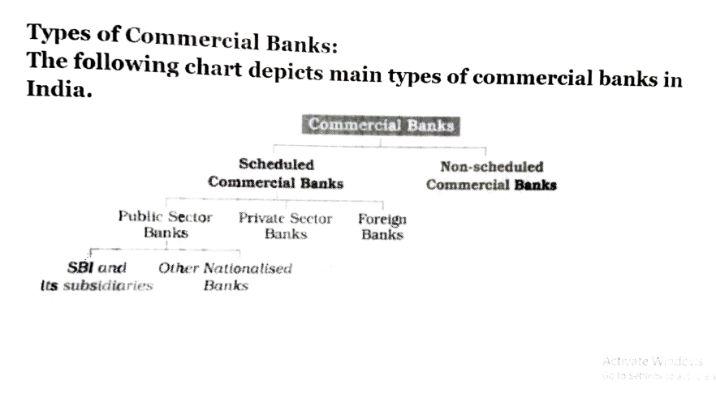

**Commercial Bank structure of Indian Commerical Banks**

**Structure of the Indian Banking System**

Reserve Bank of India is the central bank of the country and regulates the banking system of India. The structure of the banking system of India can be broadly divided into scheduled banks, non-scheduled banks and development banks.

Banks that are included in the second schedule of the Reserve Bank of India Act, 1934 are considered to be scheduled banks.

All scheduled banks enjoy the following facilities:

* Such a bank becomes eligible for debts/loans on bank rate from the RBI
* Such a bank automatically acquires the membership of a clearing house.

All banks which are not included in the second section of the Reserve Bank of India Act, 1934 are **Non-scheduled Banks**. They are not eligible to borrow from the RBI for normal banking purposes except for emergencies.

Scheduled banks are further divided into commercial and cooperative banks.

**Scheduled, Non-Scheduled Banks and Development Banks**

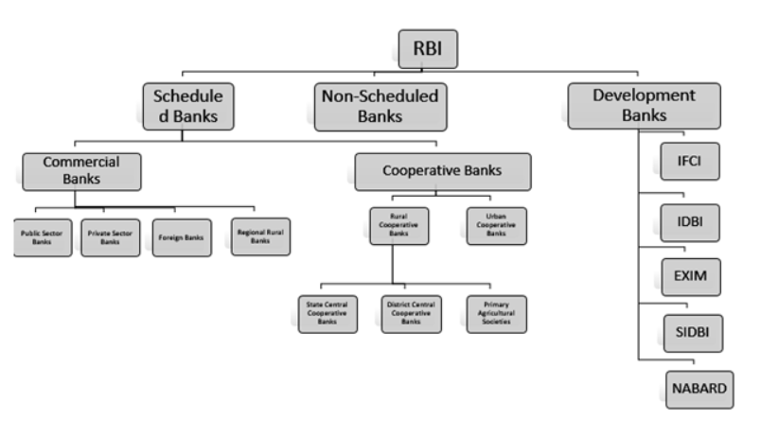

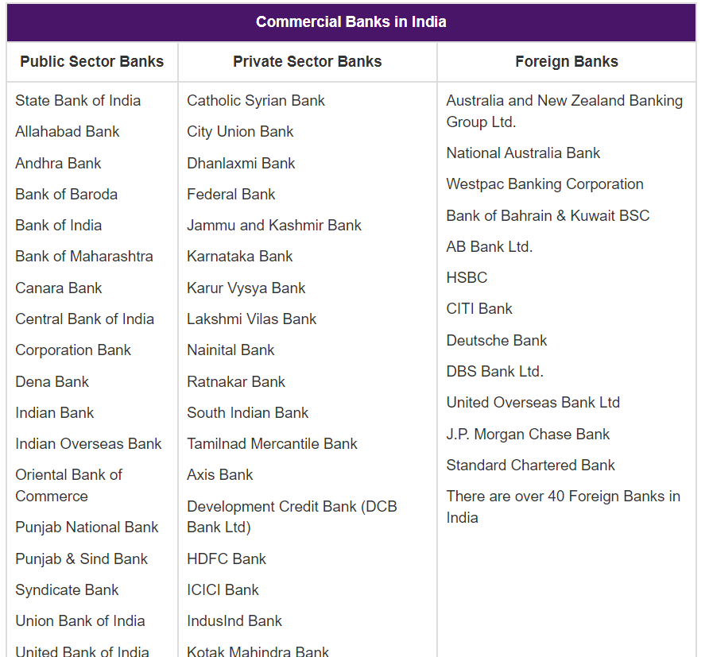

### Chapter 4

### DATA ANALYSIS AND INTERPRETATION

### 

### 

### Reasons for ECB/FCCB Reasons Counts Capital Expenditure for Ports 1 Financial Lease 2 General Corporate Purpose 296 Import of Capital Goods 344 Micro Finance 15 Mining, Exploration & Refining 3 Modernization 231 New Project 272 On-lending/Sub-lending. 32 Other 12 Others 4 Overseas Acquisition 20 Port 5 Ports 1 Power 25 Redemption of FCCBs 2 Refinancing of Earlier ECB 123 Refinancing of Rupee loans 16 Road 4 Rupee Expenditure Loc.CG 213 Telecommunication 3 Urban Infrastructure 1 Working Capital 98 Working Capital Purpose 1 Grand Total 1724 Table 1.2 – Below tabulated are the reasons for which funds were sourced Figure 1 Figure 1.1 - The pie chart is a representation of the various reasons listed above From the ECB and FCCB numbers, we can clearly observe that businesses were sourcing more money from external resources in dollar amounts for new business projects, modernization of existing projects, importing of capital goods and general corporate purposes indicating that businesses were raising funds for expansion. This is important from the perspective that probably India is not just sustaining on its service sector, but also rapidly expanding its manufacturing sector. While India already has its manufacturing sector well footed, the economies of scale are currently missing to make India a world-class manufacturing destination. The concern from the ECB/FCCB numbers would be the funds sourced for general corporate purposes, working capital and rupee expenditure LOC which suggest that the short-term financing of companies is not optimum. At the same time, it also reflects the inaccurate expense and credit management. However, it can also reflect the benefit some companies are availing from the rupee-dollar exchange rate by sourcing funds in dollars as they would get more rupees as against the same dollar amounts. Hence, this can also be viewed subjectively based on company-to-company. These investments under consolidated balance sheets of the commercial banks reflect the strength the economy has displayed in the midst of global economic turmoil registering an annual GDP growth of more than 9% from 2004 onwards. The loans and advances have a Median of Rs. 17,490.23 billion and a Mean of Rs. 26,060.51 billion which reflects that not just the investments were good enough, banks have also doled out equal amounts of loans and advances for commercial purposes which also reflects the economic growth as mentioned earlier. In a nutshell, the consolidated assets and liabilities reflect a strong performance by the commercial banks supported by the authorities and a growing economy. Cost overruns in projects are a recurring scenario in the Indian economy. It is surely not something which would a proud moment, but sometimes they delays also happen due to many reasons which could be unforeseen or compulsorily required , such as inflation, force majeure, local administrative issues, change in objectives, etc. More so, focus needs to be put in individual sectors wherein the overruns are significant. The highest cost overruns have happened in sectors which are particularly important from an infrastructure standpoint - surface transport, railways, power, coal, petroleum etc. These sectors are the focal points for the government for their investment purposes, a factor which supports their policies. From the scheduled commercial banks’ advances to agriculture – outstanding we can see that the indirect finance stopped for inputs - both fertilizers and power from 2007-08 onwards while it has stopped for Loan through various intermediaries and other institutions from 2012-13 onwards. This clearly reflects two things. 1) Commercial banks started to reach out to the farmers directly probably via various business models. 32) The government/RBI supported the removal of intermediaries in the lending process. This could to be to make the process of credit lending easy from the farmer's perspective. W33hile there is no concrete evidence provided in this project, we can assume that the reach of the buyer (farmer) and the seller (bank) was made quite simple in the last few years due to technological and infrastructural advancements. The scheduled commercial banks’ advances to small-scale industries and allied services – outstanding reflect the lack of initiative from entrepreneurs, government and banks to facilitate the expansion of businesses and industries. The Median for Small Enterprises was Rs. 342.46 billion and the Mean was Rs. 1,373.26 billion which shows that there has been initiative, support and facilitation for the growth of small scale industries in India. Even the numbers from the table suggest so where the growth was exponential from 2004 onwards. What needs to be seen is how the trend continues from 2015 onwards. The results clearly reflected that while banks continue to face risks both from NPA perspective, credit worthiness of borrowers and repayment discipline; they (the banks) have upped their lending businesses with a bullish view on Indian economy. The credit businesses have grown manifold to support multiple industries – both in priority and nonpriority sectors. The banks have their work cut out in terms of focusing lending businesses towards, Agro, MSME and SSI sector which requires financial support since many of them work on sound business fundamentals and a sustainable business model. It needs to be seen how the banking sector accommodates the growing expectations of businesses and government while RBI works on easing of rules/procedures to aim at an increased financial inclusion and supporting the growth of industries at a micro/rural level. Banks in India face many inherent risks in their operations such as political risk, country risk, economic risk, social risk, resource risk, completion risk, market risk, operational risk, force majeure, technological risk, environmental risk. Banks do operate based on guidelines prescribed by the RB; however, they do not take additional measures by itself. It would be important to understand how the banks incorporate these risks while aiming to grow and expand since growth and risks share a direct relationship. To conclude, in a global economy which is facing a slowdown, India has emerged as a favorable destination for investors to come and invest in. While the mainstream focus remains on that, the Indian financial sector faces challenges in terms of reformative practices, technology and inclusion. The government of the day introduced radical financial reforms from November 8 onwards, the results of which should soon be visible, the focus for the banks should be on expanding reach, connecting people & businesses to the mainstream & regulated banking and providing funds for expansion of worthy businesses in India.

### Regional Bank of India(RRB)

* These are special types of commercial Banks that provide concessional credit to agriculture and rural sector.
* RRBs were established in 1975 and are registered under a Regional Rural Bank Act, 1976.
* RRBs are joint ventures between the Central government (50%), State government (15%), and a Commercial Bank (35%).
* 196 RRBs have been established from 1987 to 2005.
* From 2005 onwards government started merger of RRBs thus reducing the number of RRBs to 82
* One RRB cannot open its branches in more than 3 geographically connected districts.

Aspirants can check the list of Regional Rural banks in India at the linked article.

### Local Area Banks (LAB)

* Introduced in India in the year 1996
* These are organized by the private sector
* Earning profit is the main objective of Local Area Banks
* Local Area Banks are registered under Companies Act, 1956
* At present, there are only 4 Local Area Banks all which are located in South India

### Specialized Banks

Certain banks are introduced for specific purposes only. Such banks are called specialized banks. These include:

* Small Industries Development Bank of India (SIDBI) – Loan for a small scale industry or business can be taken from SIDBI. Financing small industries with modern technology and equipments is done with the help of this bank
* [EXIM Bank](https://byjus.com/free-ias-prep/exim-bank/) – EXIM Bank stands for Export and Import Bank. To get loans or other financial assistance with  exporting or importing goods by foreign countries can be done through this type of bank
* National Bank for Agricultural & Rural Development ([NABARD](https://byjus.com/free-ias-prep/nabard/)) – To get any kind of financial assistance for rural, handicraft, village, and agricultural development, people can turn to NABARD.

There are various other specialized banks and each possesses a different role in helping develop the country financially.

### Small Finance Banks

As the name suggests, this type of bank looks after the micro industries, small farmers, and the unorganized sector of the society by providing them loans and financial assistance. These banks are governed by the central bank of the country.

Given below is the list of the Small Finance Banks in our country:

|  |
| --- |
|  |
| AU Small Finance Bank | Equitas Small Finance Bank | Jana Small Finance Bank | Northeast Small Finance Bank |
| Capital Small Finance Bank | Fincare Small Finance Bank | Suryoday Small Finance Bank | Ujjivan Small Finance Bank |
| Esaf Small Finance Bank | Utkarsh Small Finance Bank |  |  |

### Payments Banks

A newly introduced form of banking, the payments bank have been conceptualized by the Reserve Bank of India. People with an account in the payments bank can only deposit an amount of up to Rs.1,00,000/- and cannot apply for loans or credit cards under this account.

Options for online banking, mobile banking, the issue of ATM, and debit card can be done through payments banks. Given below is a list of the few payments bank in our country:

* Airtel Payments Bank
* India Post Payments Bank
* Fino Payments Bank
* Jio Payments Bank
* Paytm Payments Bank
* NSDL Payments Bank

**Commercial Banks**

The institutions that accept deposits from the general public and advance loans with the purpose of earning profits are known as **Commercial Banks**.

Commercial banks can be broadly divided into public sector, private sector, foreign banks and RRBs.

* In **Public Sector Banks**the majority stake is held by the government. After the recent amalgamation of smaller banks with larger banks, there are 12 public sector banks in India as of now. An example of Public Sector Bank is State Bank of India.
* **Private Sector Banks** are banks where the major stakes in the equity are owned by private stakeholders or business houses. A few major private sector banks in India are HDFC Bank, Kotak Mahindra Bank, ICICI Bank etc.
* A **Foreign Bank** is a bank that has its headquarters outside the country but runs its offices as a private entity at any other location outside the country. Such banks are under an obligation to operate under the regulations provided by the central bank of the country as well as the rule prescribed by the parent organization located outside India. An example of Foreign Bank in India is Citi Bank.
* **Regional Rural Banks** were established under the Regional Rural Banks Ordinance, 1975 with the aim of ensuring sufficient institutional credit for agriculture and other rural sectors. The area of operation of RRBs is limited to the area notified by the Government. RRBs are owned jointly by the Government of India, the State Government and Sponsor Banks. An example of RRB in India is Arunachal Pradesh Rural Bank.

**Cooperative Banks**

A **Cooperative Bank** is a financial entity that belongs to its members, who are also the owners as well as the customers of their bank. They provide their members with numerous banking and financial services. Cooperative banks are the primary supporters of agricultural activities, some small-scale industries and self-employed workers. An example of a Cooperative Bank in India is Mehsana Urban Co-operative Bank.

At the ground level, individuals come together to form a Credit Co-operative Society. The individuals in the society include an association of borrowers and non-borrowers residing in a particular locality and taking interest in the business affairs of one another. As membership is practically open to all inhabitants of a locality, people of different status are brought together into the common organization. All the societies in an area come together to form a Central Co-operative Banks.

Cooperative banks are further divided into two categories - urban and rural.

* Rural cooperative Banks are either short-term or long-term.
* Short-term cooperative banks can be subdivided into State Co-operative Banks, District Central Co-operative Banks, Primary Agricultural Credit Societies.
* Long-term banks are either State Cooperative Agriculture and Rural Development Banks (SCARDBs) or Primary Cooperative Agriculture and Rural Development Banks (PCARDBs).
* Urban Co-operative Banks (UCBs) refer to primary cooperative banks located in urban and semi-urban areas

.

**Development Banks**

Financial institutions that provide long-term credit in order to support capital-intensive investments spread over a long period and yielding low rates of return with considerable social benefits are known as **Development Banks**. The major development banks in India are; Industrial Finance Corporation of India (IFCI Ltd), 1948, Industrial Development Bank of India' (IDBI) 1964, Export-Import Banks of India (EXIM) 1982, Small Industries Development Bank Of India (SIDBI) 1989, National Bank for Agriculture and Rural Development (NABARD) 1982.

The banking system of a country has the capability to heavily influence the development of a country’s economy. It is also instrumental in the development of rural and suburban regions of a country as it provides capital for small businesses and helps them to grow their business. The organized financial system comprises Commercial Banks, Regional Rural Banks (RRBs), Urban Co-operative Banks (UCBs), Primary Agricultural Credit Societies (PACS) etc. caters to the financial service requirement of the people. The initiatives taken by the Reserve Bank and the Government of India in order to promote financial inclusion have considerably improved the access to the formal financial institutions. Thus, the banking system of a country is very significant not only for economic growth but also for promoting economic equality.

**RECOMMENDATIONS**

Although the numbers suggest that since the sourcing of funds via ECBs and FCCBs has been increasing over time, it may or may not mean that businesses are growing. While the numbers suggest the possible reasons of sourcing funds for new business projects, modernization of existing projects and importing of capital goods indicating a growing and expanding manufacturing base; banks need to delve deeper into companies, before lending more, who take this route for general corporate purposes, working capital and rupee expenditure LOC which suggest that the short-term financing of companies is not optimum. At the same time, it also reflects inaccurate expense and credit management. From the RBI Handbook of Statistics on Indian Economy 2015-16, following would be the recommendations;

♣ Before lending hook, line and sinker into upcoming infrastructure projects, there has always been a trend of cost overruns in core infrastructural sector, due to many issues, mainly operational and legal reasons.

♣ A keen eye needs to be maintained for mapping future growth of the company and the projects which they have initiated on this aspect.

♣ The numbers for outstanding amounts in farm credit deployment are worrisome with its own reasons such as – natural limitations and limited progress made in the last few decades.

♣ Although the credit deployment is being supported by the RBI and the government, the banks need to up their lending business into the farm and farm-related business sectors.

♣ To tackle the NPA problem plaguing the Indian banking sector, RBI wrote off bad debts worth more than Rs. 1 lakh crore. Currently, there are even talks of setting up of a bad bank. However, these cannot solve the larger issue which is detailed due diligence and credit worthiness checks of borrowers which should be the prime focus of banks.

♣ In this regard, Indian banks could emulate other international banks such as JP Morgan Chase or alike. Banks should also be prompt in taking strict action towards delinquent accounts.

♣ The industry-wide deployment of credit shows that commercial banks are deploying credit in areas which are on the focus of the government since the last three years, viz., infrastructure, oil, metals, power, etc. With the economy in its revival phase as suggested by many, this sector would surely be on the watch-out list of banks, investors, administrators, et al.

♣ To add to these, the renewable energy is fast gaining momentum in India with a recent study suggesting that India is the fourth largest producer of renewable energy in the world. This sector should be on the top priority of banks and financial institutions from a lending perspective.

♣ The sectoral deployment of credit reflects the export sector needing reforms in its process of revival. The current numbers are not really encouraging; however, any investment made currently could not provide the expected returns without the impetus from the RBI and/or the government.

♣ The manufacturing businesses are expected to grow more in the next few years by way of various projects and that would be a factor to consider from a lending perspective in the coming times which would ultimately benefit the export sector.

♣ Credit societies and scores of middlemen had their roles reduced with the rapid expansion mainstream and regulated banking reaching the rural and interior regions of India. The challenge for banks would be to compete against the likes of microfinance institutions such as Bandhan Microfinance which enjoy a premium position and stronghold in these markets.

♣ To compete against these institutions, banks need to develop a separate model altogether on the lines of a microfinance institution to first set up their businesses and then reaching the market with a wide array of offerings.

♣ Banks, (even if they have a predefined model) need to set up a risk management framework which can be at par with multinational banks. The specific focus would be on technological risk since that is the norm of the day and gaining more popularity with the passage of time. India does not have enough cyber security measures and it needs more of these. The RBI and the banks could play a pivotal role by themselves in this area and become torch-bearers for other countries

**CONCLUSION**

Brealey et al in their book Principles of Corporate Finance talk in depth of decision making under risk and uncertainty. The risks could be broadly classified into business risk and financial risk. A company’s business risk is determined by how it finances its investments. Financial risk is primarily influenced by the level of financial gearing, interest cover, operating leverage and cash flow adequacy. According to Brealey et al., uncertainty arises from a lack of previous experience and knowledge. Uncertainty could be attached to following factors:

♣ Level of capital outlay required

♣ Level of selling prices

♣ Level of sales volume

♣ Level of revenue

♣ Level of operating costs

♣ Taxationrules Based on these two broad parameters; we can say that businesses in India and elsewhere inherently have to face these while aiming to grow, both organically and inorganically. One of the approaches would be through the ECB/FCCB route depending on respective company’s reasons, domestic options available, costs associated with raising funds, etc. Consequentially, we saw that the performance of the commercial banks on various parameters via two simple methods – median and mean. These parameters have been set on the various numbers tabulated by the Reserve Bank of India in their annual publication, the Handbook of Statistics on Indian Economy 2015-16. While the numbers say a particular story – that of the growth of the economy on all major fronts, there would be a few factors which might require a deep-delving for making a real change. Finally to conclude, while we have a long way to go, our story has just begun where some of the world’s most formidable businesses are taking a serious note of. Investors are making a beeline for investments and with GST almost on track, India is set to project itself as a country to invest in, make in and serve in. While the focus remains on making India at topnotch investment destination, the financial sector needs to also focus on the MSME, SSI, Agriculture and related industries’ sectors which is aptly supported by a robust financial structure, a focused RBI and a huge market of supportive banks which are usually correct in their business practices, the economy just doesn’t seem to be a bubble but a force to reckon with.

**REFERENCES**

Anthony M. Santomero (1997), “Commercial Bank Risk Management: An Analysis of the Process”, Wharton Financial Institutions Center Conference on Risk Management in Banking, October 13-15, 1996. Anwarul Hoda and Prerna Terway (2015), “Credit Policy for Agriculture in India – An Evaluation”, Working Paper 302, Indian Council for Research On International Economic Relations. Ashima Goyal (2012), “Banks, Policy and Risks”, Indian Council for Research on International Economic Relations, ICRIER Policy Series, No. 12, January 2012. Ashish Kumar Rastogi, P.K. Jain and Surendra S. Yadav (2006), “Debt Financing in India in Public, Private and Foreign Companies”, Vision – The Journal of Business Perspective, Vol. 10 l, No. 3l July-Sept 2006. David H. Pyle (1997), “Bank Risk Management: Theory”, Working Paper RPF-272, UC Berkeley Research Progam in Finance, Conference on Risk Management and Regulation in Banking, Jerusalem, May 1997. Dr. Bhargav Pandya (2015), “Impact of Priority Sector Advances on Bank Profitability: Evidence from Scheduled Commercial Banks of India”, BVIMSR’s Journal of Management Research, Vol. 7 Issue – 2: October 2015. Dr. G. Parimalarani (2011), “Performance of Commercial Banks in Priority Sector Lending”, Asia Pacific Journal of Research in Business Management, Volume 2, Issue 7, July 2011. Dr. K. Ratna Manikyam (2014), “Indian Banking Sector – Challenges and Opportunities”, IOSR Journal of Business and Management, Volume 16, Issue 2. Ver. I (Feb. 2014). Jayan Jose Thomas (2013), “Explaining the ‘jobless’ growth in Indian manufacturing”, Journal of the Asia Pacific Economy, Vol. 18, No. 4, 673–692. Jaynal Ud-din Ahmed (2009), “Priority Sector Lending by Commercial Banks in India: A Case of Barak Valley”, Asian Journal of Finance & Accounting, Vol. 2, No. 1: E5, 2010. Nayan J. and Dr. M. Kumaraswamy (2014), “Retail Credit Risk Management in Indian Public Sector Banks”, Global Journal for Research Analysis, Volume-3, Issue-8, August2014. Peter Lindner and Sung Eun Jung (2014), “Corporate Vulnerabilities in India and Banks' Loan Performance”, IMF Working Paper, Asia and Pacific Department - International Monetary Fund, December 2014. Rajlakshmi Mallik (2015), “Being Credit Rationed: Delay and Transaction Cost”, International Game Theory Review, Vol. 17, No. 2, 1540020 (28 pages). Raju, M.T., Bhutani, U. and Anubhuti Sahay, “Corporate Debt Market in India: Key Issues and Policy Recommendations”, Securities and Exchange Board of India, Working Paper No. 9. Richard H. Gamble (2003), “Passage to India”, National Association of Credit Management. Saibal Ghosh (2016), “Small business, lending relationships and crisis: evidence from Indian micro data”, Decision - Official Journal of Indian Institute of Management Calcutta, Volume 43, Number 1. Sonia Singh and Hiranmay Saha (2011), “Centralization of Microfinance”, The IUP Journal of Entrepreneurship Development, Vol. VIII, No. 2. Stephanie Caputo, Ammar Askari and Barry Wides (2016), “Commercial Lending in Indian Country: Potential Opportunities in a Growing Market”, Office of the Comptroller of the Currency, February 2016. Sumit K. Majumdar and Kunal Sen (2010), “Debt in the Indian Corporate Sector: Its effects on firm strategy and performance”, Decision, Vol. 3, No.3, December 2010. Swaranajeet Arora (2013), “Credit Risk Analysis in Indian Commercial Banks - An Empirical Investigation”, Asia-Pacific Finance and Accounting Review, ISSN 2278-1838: Volume 1, No. 2, Jan - Mar 2013. Thirupathi Kanchu and M. Manoj Kumar (2013), “Risk Management In Banking Sector – An Empirical Study”, International Journal of Marketing, Financial Services & Management Research, Vol.2, No. 2, February (2013). Jyoti Gupta and Suman Jain (2012), “A study on Cooperative Banks in India with special reference to Lending Practices”, International Journal of Scientific and Research Publications, ISSN 2250-3153, Volume 2, Issue 10, October 2012. Karen Gordon Mills and Brayden McCarthy (2014), “The State of Small Business Lending: Credit Access during the Recovery and How Technology May Change the Game”, Working Paper 15-004, Harvard Business School Manuela Kristin Günther (2017), “The Progress of Financial Inclusion in India: Insights from Multiple Waves of Survey Data”, Overseas Development Institute, CAFRAL Ravi M. Kishore (2011), “Strategic Financial Management”, Taxmann Publications, 2nd Edition. Richard A Brealey, Stewart C Myers, Franklin Allen and Pitabas Mohanty (2012), “Principles of Corporate Finance”, Tata McGraw Hill, 10th Edition. Reserve Bank of India: External Commercial Borrowings Monthly Data – May 2014 to July 2016. Link - https://rbi.org.in/Scripts/ECBView.aspx Reserve Bank of India: Handbook of Statistics on Indian Economy 2015-16. Link - https://www.rbi.org.in/SCRIPTs/AnnualPublications.