**Project Title**

**Vehicle Insurance Management Site**

Submitted

By

Mr. Shrikant Sonawane

Mr. Siddharth Bhagat

Miss. Sarika Gholap

**(Team-9)**

Guide

Miss. Vineeta Singh

Client

Mr. Rohan More



**Centre for Development of Advanced Computing.**

**Kharghar**

**May-2021**

**INTRODUCTION:**

Vehicle Insurance Management System has been developed to override the problem prevailing in the practice manual system. This software is supported to eliminate in some cases reduce the hardship faced by this existing system. This system design for the particular need of the company to carry out the operation smoothly and effectively. The application is decreased as much as possible to avoid failures while entering the data. It’s also provided error message while entering invalid data.

**DESCRIPTION:**

Online Insurance management system is a web application which is developed for tracking the details of the insurance policy, customer details and company details. This web site is an online insurance Analysis and information management system that provides easy access of information regarding the people and resources of insurance. User can view their own personal details when login into the Policy Holder module. This project is useful for any kind of insurance company to manage the insurance details, to sanctioned the insurance for customer, process the insurance policy details and all kind of insurance process through online. The Insurance management system is a complete solution for organizations, which need to manage insurance for their vehicles.

This insurance management system can efficiently manage the company, records, provides instant access and one that improves the productivity. In this online process the user enter into the website it will show details about insurance and its types, also it will show the details about different duration schemes to the corresponding insurance type or insurance policy. The main objective of the developed system is to allow admin users to register insured persons with their name, date of birth, residence address and also policy details. In this process contains the user registration form which is used to apply for insurance policy through online. It also helps the customer to view their own insurance status information. After giving registering all the insured persons, website should provide management facilities like delete unwanted persons’ data.

If the user registered insurance policy to this website, it will process that registration form by verification and immediately give the temporary policy holder ID to the user. The web site provides easy links for easy navigation in the site. After submission of registration form, the admin will process to verify that particular details registered by the customer and sanctioned the insurance policy. A visitor with minimum knowledge of web browsing/surfing can access the site very easily. The developed system should allow admin users to register insured persons with their name, date of birth, residence address, medical history and also policy details. Then the admin send the permanent policy holder ID and password to the customer and also send status information about insurance policy to the corresponding policy holder. Due to dynamic nature of features, the members, Admin members should be able to understand the provided facilities. After registering all the insured persons, website should provide management facilities like delete unwanted persons’ data.

]If the policy holder wants to view the information about their own policy details, he/she login to policy status page by using the policy holder ID and password had already given by insurance company and view their own details and also they give feedback to the insurance company. An online help documentation will be provided to help the users and visitors in using the facilities.

**Use Case Diagram:**

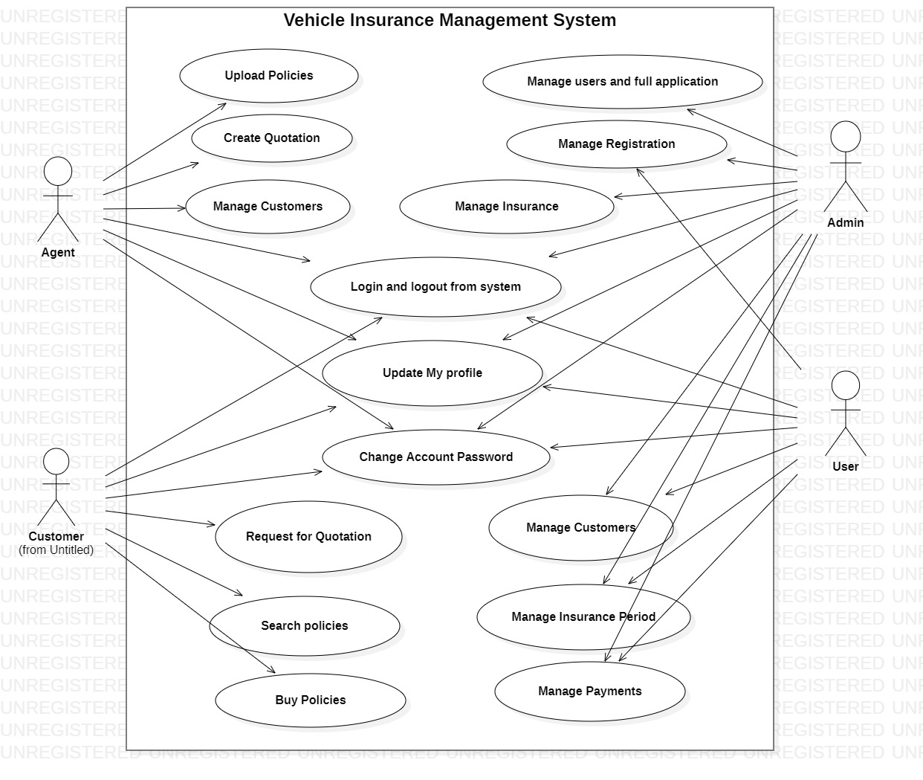

**Activity Diagram:**

**Admin Level:**

Invalid Login

/ Password

Admin is Registered

Set user level and permissions

Login to System successfully

Access the internal functionality according to permission

Check loginID

Password

Admin LoginID and password

END

START

**User Level:**

START

Login to Vehicle Insurance Management System Site

Check User and permission

Check Permissions

Check Permissions

Check Permissions

Check Permissions

Check Permissions

Manage

Insurance

Manage

Vehicle

Manage

Payment

Manage

Registration

Manage

Customer

Logout from System

END

**Class Diagram:**

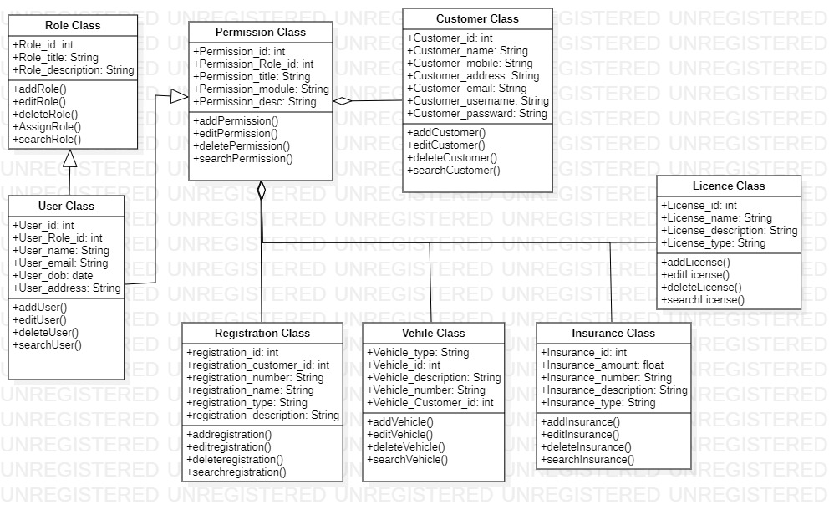

**Sequence Diagram:**

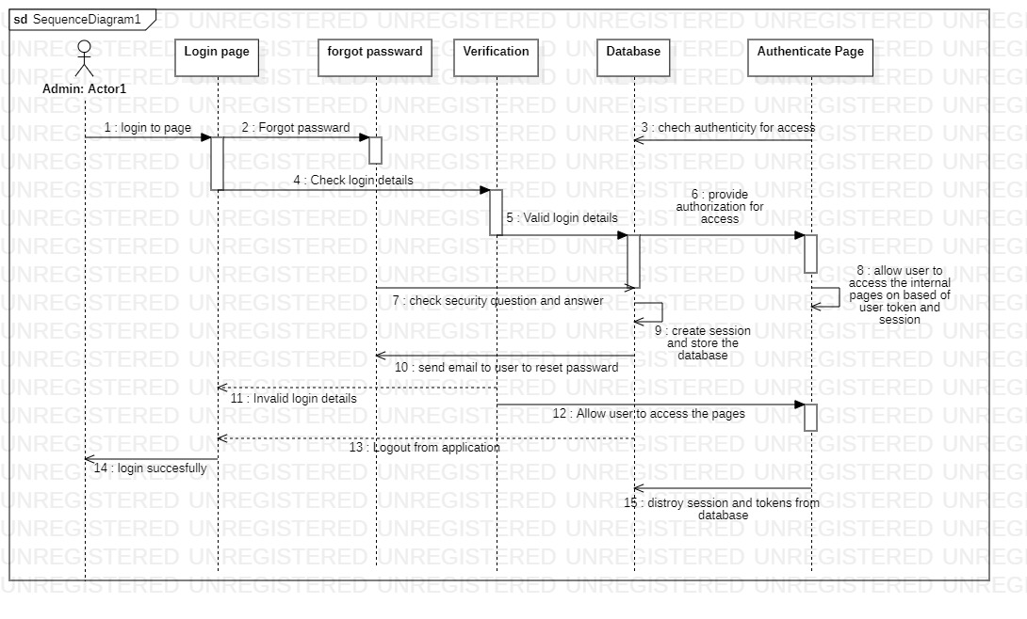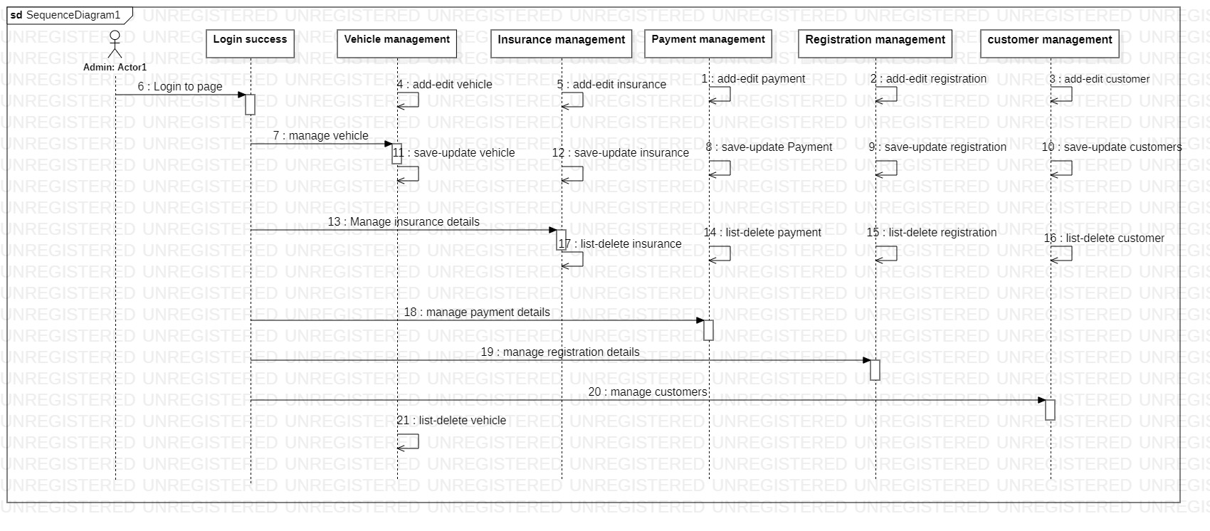

**ER Diagram:**

Registration

Login

User

Roles

HAS

Permissions

Vehicle

Insurance

MANAGE

HAS

Customer