Kubernetes Commands

minikube start

minikube dashboard

Kubectl get nodes

Kubectl get pods

kubectl get services

kubectl get replicaset

kubectl get namespaces

kubectl create deployment nginx-depl --image=nginx

kubectl get deployment

kubectl edit deployment nginx-depl
->> kubectl get deployment
->> Kubectl get pods (New Pod will be created after deployment edit)
->> kubectl get replicaset (Old replicaset will be deleted and new one will be created)
->> kubectl logs nginx-depl-7d459cf5c8-ljkj9 ( Pod logs)

kubectl create deployment mongo-depl --image=mongo
-->> kubectl get pods
-->> kubectl describe pod mongo-depl-85ddc6d66-6qq6j
Events:
Type Reason Age From Message
---- ------ ---- ---- -------
Normal Scheduled 70s default-scheduler Successfully assigned default/mongo-depl-85ddc6d66-6qq6j to minikube
Normal Pulling 69s kubelet Pulling image "mongo"
-->kubectl logs mongo-depl-85ddc6d66-6qq6j

kubectl exec -it mongo-depl-85ddc6d66-6qq6j –bin/bash
* exec --> Executation of the container
* -it --> Interactive mode

Delete Deployment:

kubectl delete deployment nginx-depl
kubectl delete deployment mongo-depl

Deployment Configuration file:

touch nginx-deployment.yaml
vim nginx-deployment.yaml
cat nginx-deployment.yaml

nginx-deployment.yaml
apiVersion: apps/v1
kind: Deployment
metadata:
name: nginx-deployment
labels:
app: nginx
spec: =============> (Specification for Deployment)
replicas: 2
selector:
matchLabels:
app: nginx
template:
metadata:
labels:
app: nginx
spec: =============> (Specification for Pod)
containers:
- name: nginx
image: nginx:1.16
ports:
- containerPort: 8080
kubectl apply -f nginx-deployment.yaml

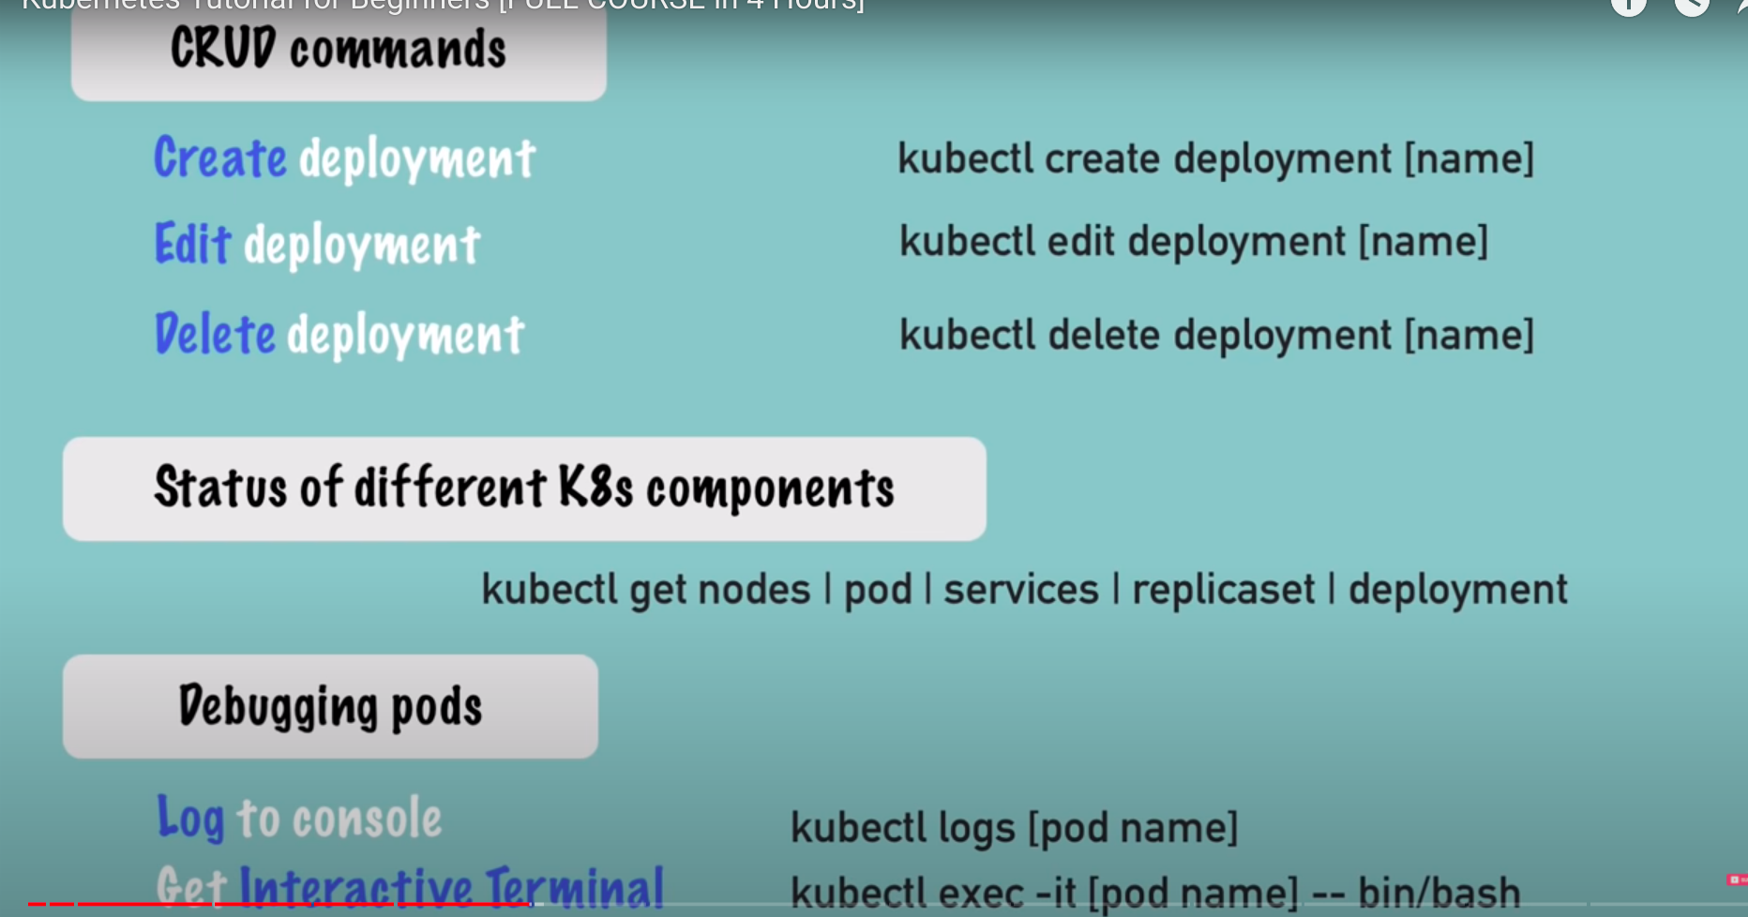

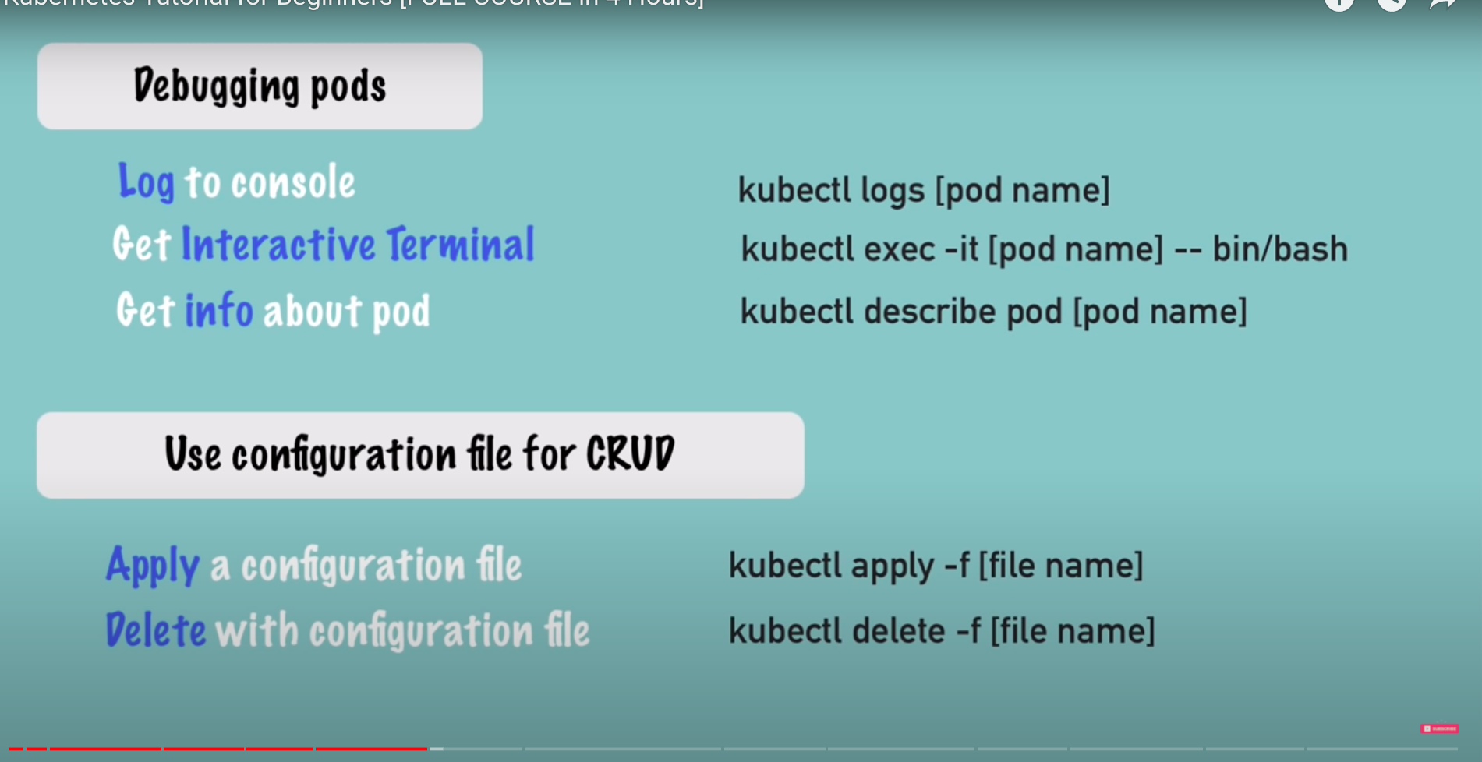

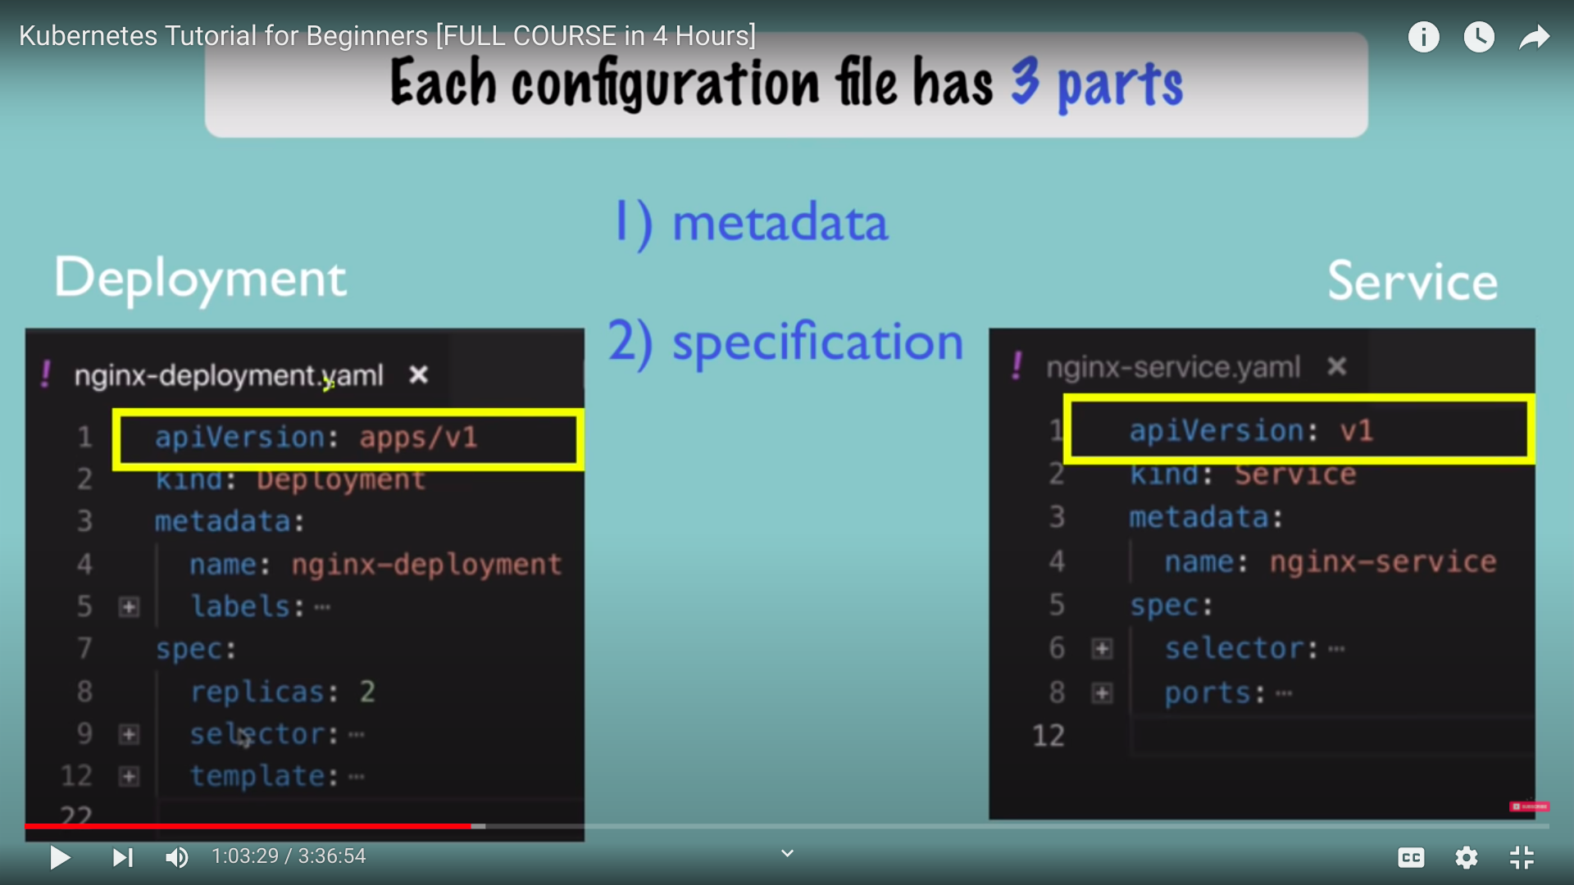

kubectl apply -f nginx-deployment.yaml
kubectl apply -f nginx-service.yaml

kubectl get deployment nginx-deployment -o yaml (To get the nginx-deployment deployment details which is stored in yaml)

kubectl get deployment nginx-deployment -o yaml > nginx-deployment-result.yaml

Complete MongoDB Example
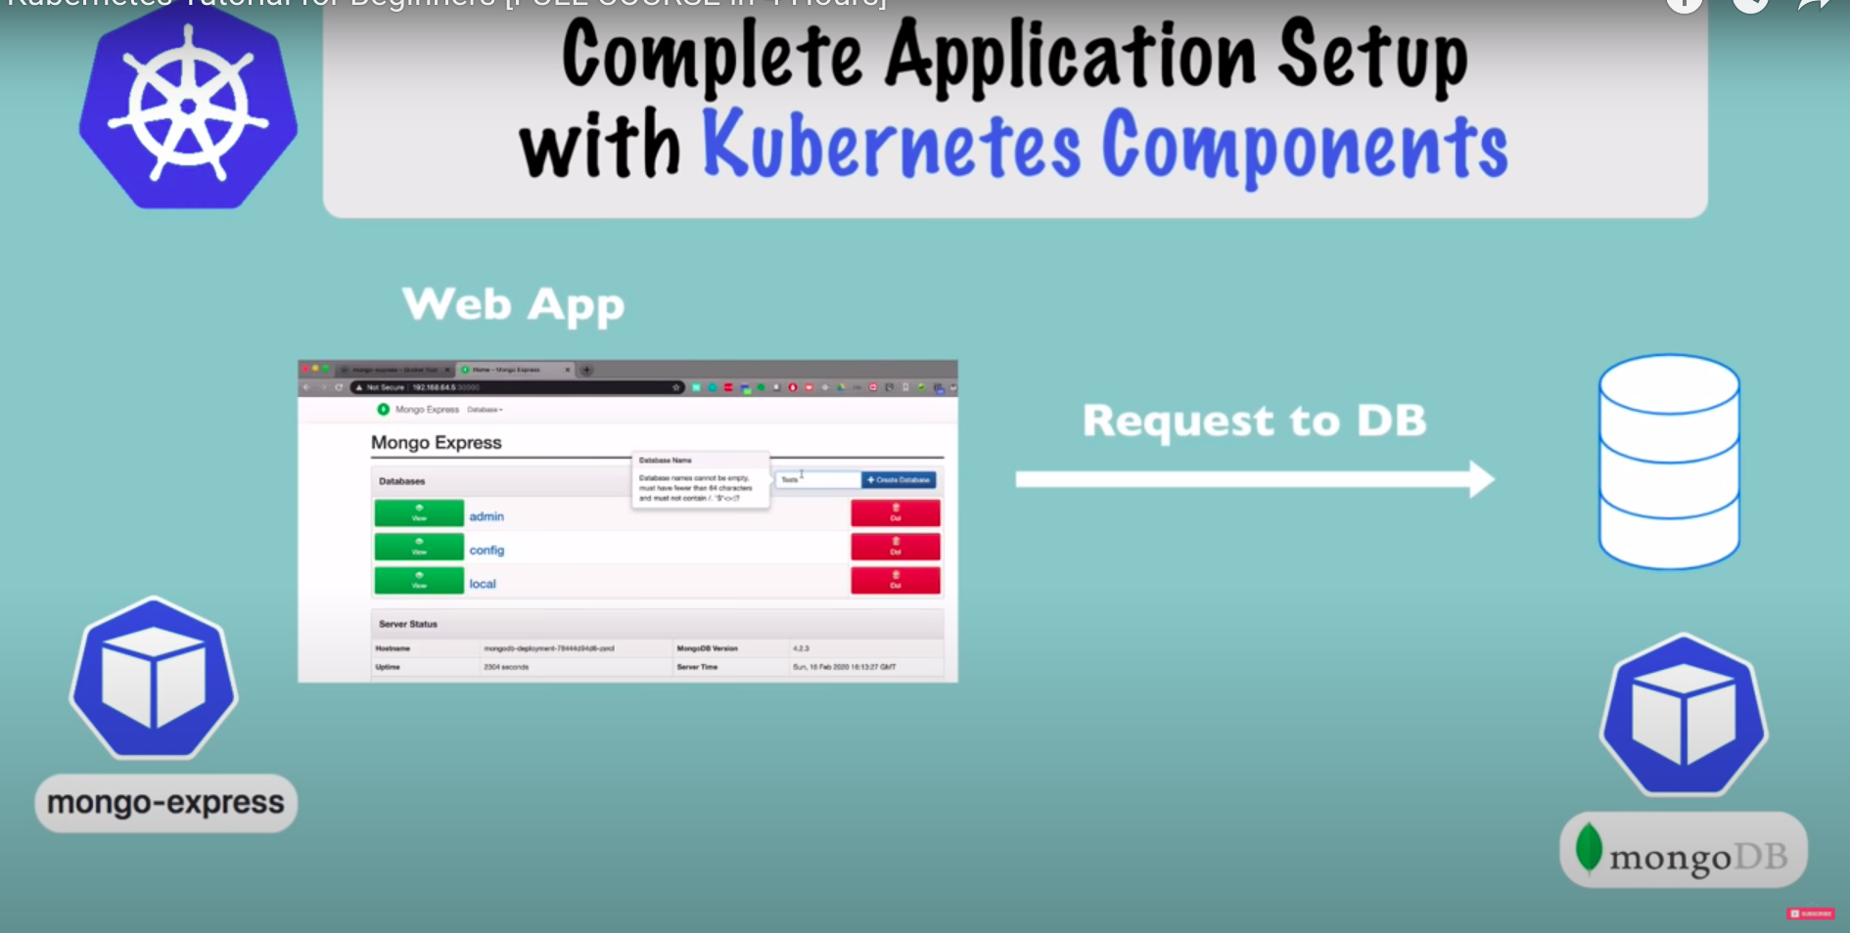

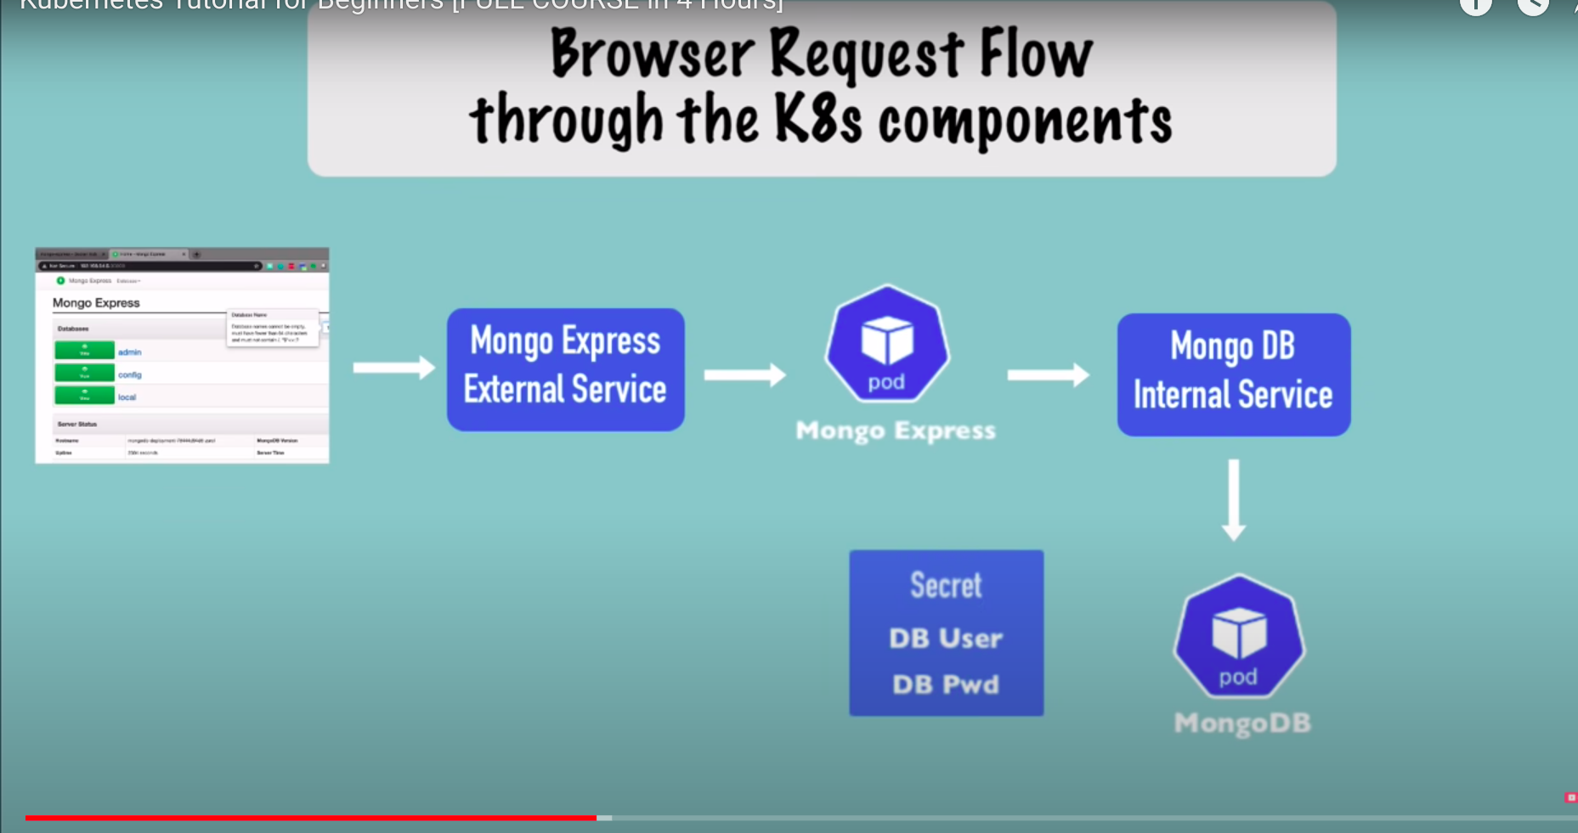

kubectl apply -f mongo-secret.yaml
kubectl apply -f mongo.yaml
kubectl apply -f mongo-configmap.yaml
kubectl apply -f mongo-express.yaml
https://gitlab.com/nanuchi/youtube-tutorial-series/-/blob/master/demo-kubernetes-components/k8s-commands.md

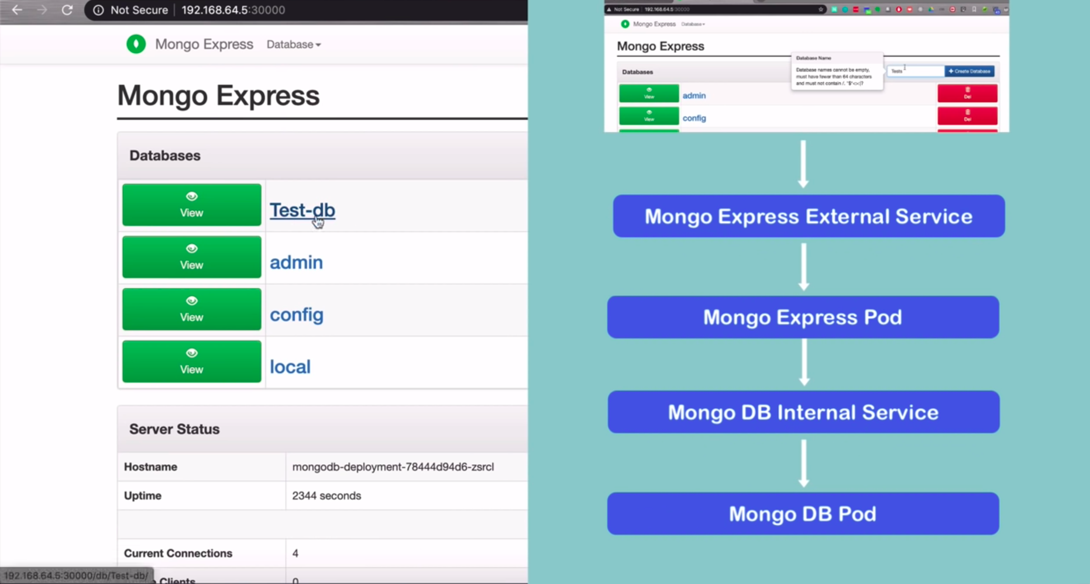
GitLab Reference for Commands
https://gitlab.com/nanuchi/youtube-tutorial-series/-/blob/master/basic-kubectl-commands/cli-commands.md

