Assembly Programming using RISC-V ISA
Lab Manual
PES University, Department of ECE, Electronic City Campus, Bangalore

RISC-V Lab Course plan
RIPES Simulator
RIPES is a RISC-V simulator with visuals.
- We will write assembly programs and C programs and run it through RIPES and check the results.
- Basic assembly showing loads, stores and the base instructions.
- Simple arithmetic RV32I programs like adding two numbers and storing. Assuming data
- We will cover all the different types of instruction operations like R-type, I-type and so on.
- We will also show the M and C extensions in RIPES (enabled and disabled).
- C programs like sort algorithms, search algorithms and swap algorithms we will demonstrate. Concepts like loops, functions and data types will be covered in these sessions.
Spike - RISC-V ISA Simulator
- Spike, we can demo the same experiments as above but we get to use F extension and other extensions.

RISCulator
- Visual representation of computation so it can be used to demonstrate the processing of a C program’s binary.
- We will use the same set of programs used for RIPES.

Codasip
  - Demonstration of instruction profiler and it’s uses.
  - SDK support if Codasip provides?
Shakti
  - Demonstration of Shakti E-class and/or C-class on FPGA with on-chip debugging and flashing with code.
  - Using SDK to write code for Shakti.
  - (Extra) Exploring adding AXI IPs to Shakti.

Vexriscv
  - Easier than Shakti to use. We will test both and decide which will be good to demonstrate.
  - We will use the same programs again.
LiteX/chipyard
• System-on-chip showcasing RISC-V cores with other peripherals

Index
Sl.No | Title of the Experiment/Program | Page No
1 | Assembler Directives
2 | Instructions and Instruction Formats
3 | Power Abstraction using a C programming and assembly code
4 | Use Single cycle and 5 stage Pipelined w/o forwarding (Data dependency)
5 | Addition of two numbers using (RV32I) – Data types Unsigned and Signed 8/16/32/64)
6 | Looping Example: Assembly equivalent of for loop written in C  main()  {  unsigned int a[11]={0x12345678,,,…..}, h;  h=0  for (i=0, i<10 ; i++)  {  h = h + a[i];  }  a[10]= h;  }  Write an ALP to add ‘N’ a) 32 bit numbers b) 16 bit numbers c) 8 bit numbers
7 | - Little Endian to Big Endian  - 2 out of 5 Code  - Hamming code Encoding
8 | - Write an ALP to a) check whether given string is a palindrome (Using stack operations)  - Write an ALP to search a given number in an array.  - To check register a0 is divisible by a given number.  - RISC-V program to perform the following  for (i = 0; i < 10; i = i+1)  c[i] = a[i] x b[i] + c[i-1];

Chapter1: Introduction to Directives
Assembler Directives
.text
A read-only section containing the actual instructions of the program.
Syntax
.text
Description
This portion of the object file or virtual address space is also known as the code segment or simply the text segment of the program. It contains executable instructions which cannot be modified at run-time. Any attempt to store into the .TEXT section will produce a “Segmentation” error and the program is terminated immediately. The code segment can contain constants in addition to instructions.

Example:
.text
addi x5, 100
addi x5, x0, 100

.data
A read-write portion of the object file, which contains data for the variables of the program.
Syntax
.data
Variables
Description
The .data section contains initialized static variables that are global and static local variables.

Example:
.data
.word 1
helloworld: .ascii "Hello World!"

.HALF
The .HALF directive for naturally aligned 2byte or 16-bit comma-separated words.
Syntax
.half value
where, value to be initialized
Description
The .HALF directive initializes the specified value to 2 bytes or 16-bit aligned integers. It can also store multiple comma-separated values. The operands specified can be decimal, hex, binary, or character constants, but not labels.
Eample:
.half 0x1000
.WORD

The .WORD directive for naturally aligned 4-bytes or 32-bit comma-separated.
Syntax
.word value
where, value to be initialized
Description
The .WORD directive initializes the specified value to 4 bytes or 32-bit aligned integers. It can also store multiple comma-separated values and the operands specified can be decimal, hex,binary, or character constants, but not labels.
Example
.word 0x1000000

.DWORD

The Double Word (.DWORD) directive for naturally aligned 8-bytes or 64-bit comma separated words.
Syntax
.dword value
where, value to be initialized
107
Description
The .DWORD directive creates a double word constant. They can also store multiple comma separated values. The operands specified can be decimal, hex, binary, or character constants, but not labels.
Example
.dword 0x7000000000000000

.BYTE
The .BYTE directive for unaligned 8-bit comma -separated words.
Syntax
.byte value
where value to be initialized
Description
The .BYTE directive initializes the specified value to 1 bytes or 8-bit unaligned integers. It can also store multiple comma-separated values. The operands specified can be decimal, hex, binary, or character constants, but not labels.
Example:
.byte 0x10

.STRING

String (.STRING) instruction emits the specified string.
Syntax
.string "String"
where, “String” User specified string

Description
For the .STRING directive, the assembler increments the location counter by the length of the
string, including the null character at the end.
Example:
.string "Hello World"

.ZERO
Zero Bytes (.ZERO) instruction reserves a block of memory.
Syntax
.zero integer
where, integer Number of bytes to reserve

Description
.ZERO instruction reserves a block of memory as an input buffer, it reserves and initializes a block of memory to zero.
Example
.zero 100 # mem[100-bytes] − 0
This instruction reserves 100 bytes of memory and stores zeros in them.

Chapter2: Instruction Sets and Instruction Formats
2.1 Instructions Sets
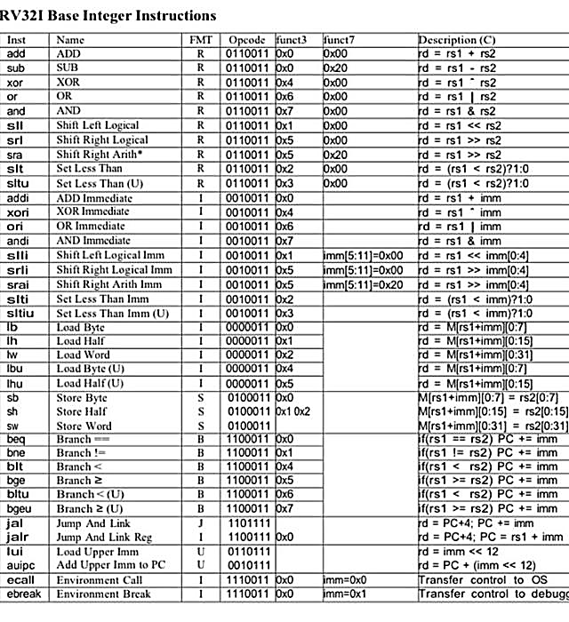

2.2 Instruction Formats and Encoding Assembly Code
RISC V Instruction Set Format
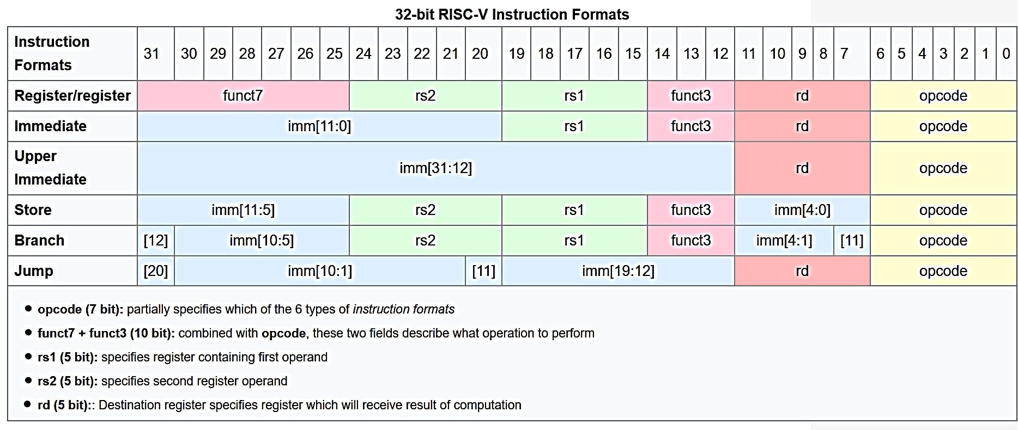

Experiment 1
Objective
This lab introduces RIPES Simulator and Understanding
- Datapath of Single Cycle Processor architecture and role of each stage in the data path
- 5 stage architecture using RIPES tool chain.
- Understanding effect of pipeline on Tclk.
Example: Execute the following set of Instructions and
- Analyze the Datapath at each stage and indicate the result obtained at each stage of execution using a) Single cycle Processor
- 5- stage pipelined Processor

.data
num: .word 0x12345678,0x126351265,0
.text
la x10,num
lw x20, 0(x10)
lw x21,4(x10)
add x22,x21,x20
sw x22,8(x10)

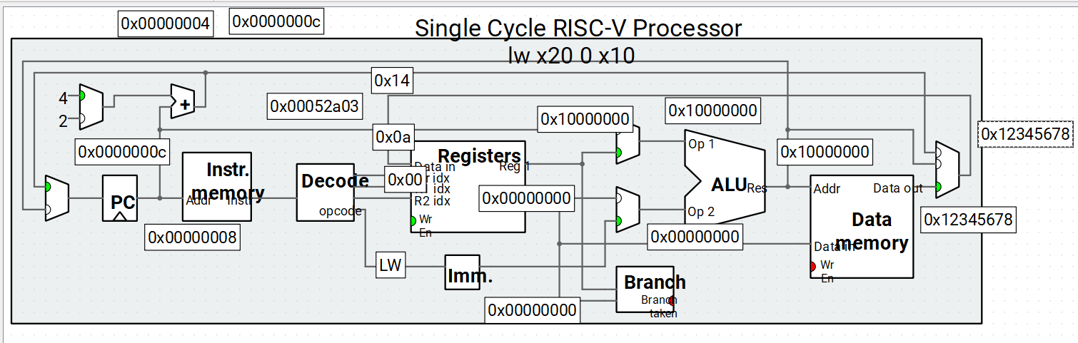

Experiment 2
Objective
This lab introduces you to the RISC-V simulator (RIPES) and basic assembly/C programming. By the end of this lab, you should be able to:
- Use RISC-V Simulator to compile and run assembly and C programs.
- Memory and Registers Manipulation.
- Observing the number of cycles, Number of Instructions retired, CPI, and IPC, and From the observation made Understand the
a) Difference between CPI and IPC
b) Why there is a difference in Cycle count when a program is written in C and Assembly
- Why clock rate changes for every Instruction execution

Experiment 3
Objective
This lab introduces one of the Great Ideas – By the end of this lab, you should be able to:
- Understand the level of abstraction in each case.
- Observing the number of cycles, Number of Instructions retired, CPI, and IPC, and From the observation made Understand the
a) Difference between CPI and IPC
b) Why there is a difference in Cycle count when a program is written in C and Assembly
- Understand the different stages involved in Instruction Execution and
- Also, decode the machine code generated using the Instruction format???
Program 1:
#include<stdio.h>
unsigned int a=0x05,b=0x05,c;
int main()
{
c=a+b;
printf("Number = %d", c);
}

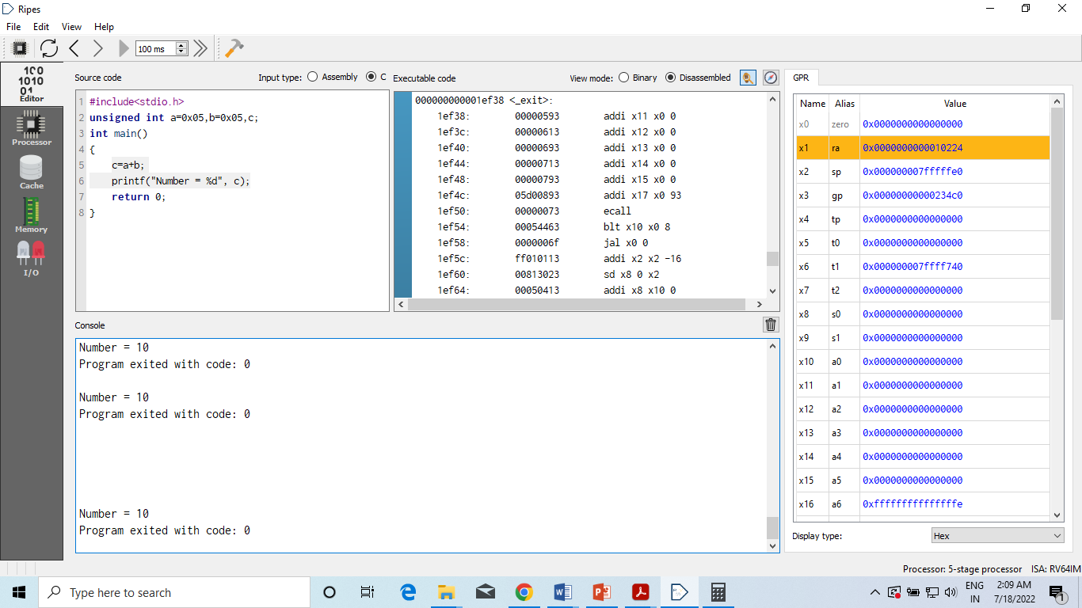

Observation:
- Disassembled code
- Result Displayed
- Number of cycles, Number of Instructions retired, CPI, IPC
- Why clock rate changes for every Instruction execution

Assembly Equivalent of C
 | Instructions | Comments
.data
NumElements: | .word | 15, 6, 0x00
.text
 | la x1, NumElements | # loads the location address of the specified SYMBOL
 | lwu x4,0(x1)
 | lwu x5,4(x1)
 | add x6,x4,x5
 | sw x6,8(x1)

Editor Window
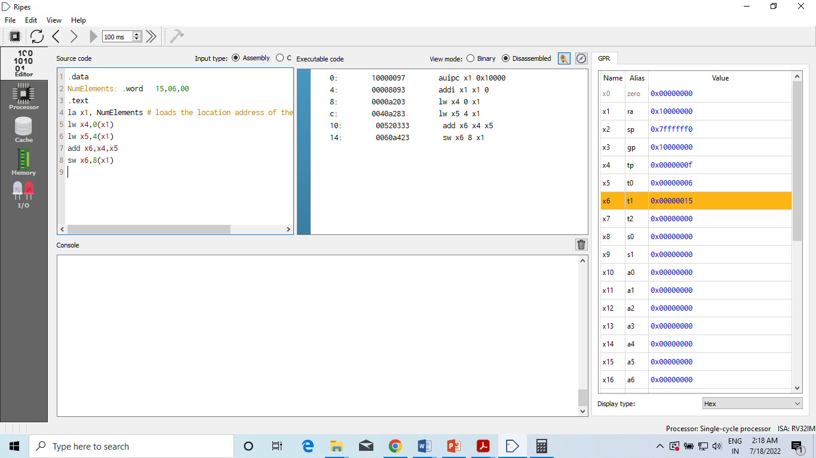
Memory Window

Processor Window

Analyzing Different stages in Single Cycle Processor

FETCH | DECODE | Register Select | EXECUTE | WRITE BACK

Experiment 4
Pre-Requirement
Students should be knowing the Single Cycle Processor data path and 5 stage Pipeline

Objective
This lab introduces you to the RISC-V 5-stage pipeline using RIPES Simulator and by the end of this lab, you should be able to:
- Performance via Pipelining: 5 Stage Pipeline processor w/o forwarding and data hazard detection in comparison with the non-Pipelined Single cycle processor and understanding the significance of pipelining.
- Performance via Parallelism in comparison with the Single Pipelined processor and non-Pipelined Single cycle processor and Understanding the significance of Parallelism
- Analyze the concept of data dependency using the examples given.

Example 1: No data dependency
addi x4,x0,1
addi x5,x0,2
addi x6,x0,3
addi x7,x0,5
addi x8,x0,6

Execute the above example using
- Single Cycle Processor and Verify the number of cycles, Number of Instructions retired, CPI, IPC
- 5-stage pipeline processor w/o forwarding and data hazard detection and Verify the number of cycles, Number of Instructions retired, CPI, and IPC
- Comment on which one is Faster based on CPI and IPC

Example 2: Data dependency
addi x3,x4,5
addi x3,x3,2

Execute the above example using
- Single Cycle Processor and Verify the number of cycles, Number of Instructions retired, CPI, IPC
- 5-stage pipeline processor w/o forwarding and data hazard detection and Verify the number of cycles, Number of Instructions retired, CPI, and IPC.
- Check the final result stored in x3 and verify the correctness of the result. If the result is wrong then Identify the reason for the incorrect result
- If the result is wrong then modify the code to get the correct result and Check the number of cycles used

Note: Expected Sum of 5+5=0x0A=10d but the result obtained is 0x05 (Wrong)

Modified Code to get the expected result
addi x3,x4,5
nop
nop
nop
addi x3,x3,5

Experiment 5
Objective
This lab introduces to assembly level programming using load and store architecture. By the end of this lab, you should be able to:
- Understand the what is load and store architecture.
- Hardware constraints – ALU size and registers size
- How handle Carry/ borrow without having flag registers logically.
- Observing the number of cycles, Number of Instructions retired, CPI, and IPC,
- Understand the how Instruction execution flows through Datapath (IF, ID, EX, MA, WB).
- Use of ISA: Load/ store, Arithmetic, conditional branch and sltu

Program 1: Addition of two unsigned words present in the data memory and store result in memory. Use RV32I Single cycle processor and Five stage Processor (This has forwarding, hazard detection)

Assembly Code
ISA : R-type: add, sltu , I-type : lw S-type: sw
.data
a: .word 0x92345678, 0x80000000,0xFFFFFFFF,0x81234567
.text
la x10,a // Loads base address of variable a into x10
lw x20,0(x10) // x20 ← value at Effective address [x10+0]
lw x21,4(x10) // x21 ← value at Effective address [x10+4]
add x22,x21,x20 // x22 = x21+x20
sltu x23,x22,x21 // Set x23 as 0x01 if x22 < x21 i.e., x23=0x01 if carry generated
sw x23,8(x10) // Effective address [x10+8] = Content of x23
sw x22,12(x10) // Effective address [x10+12] = Content of x22

Result Summary
- Memory Mapping

Result in data Memory

Address Word byte0 byte1 byte2 byte3

Case 1: Single Cycle RISC-V Processor

Results in Registers Execution Information

Case 2: Five stage RISC-V Processor

Program 2: Addition of two unsigned double words present in the data memory and store result in memory. Use RV32I Single cycle processor and Five stage Processor (This has forwarding, hazard detection

Assembly Code
ISA : R-type: add, sltu , I-type : lw S-type: sw

Constraints: Target is RV32I and data to be processed is double word.

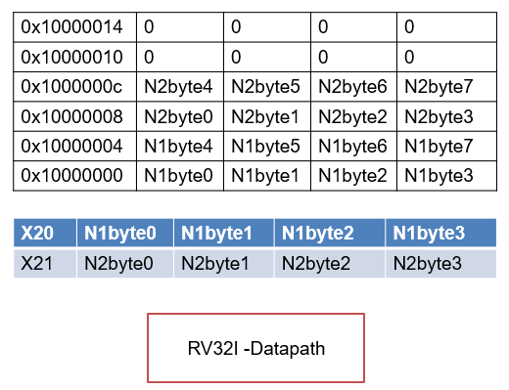

Logic: Perform addition of lower words of N1 and N2 followed by higher words of N1 and N2, which are carried out by lower word addition.

.data
a: .dword 0x1234567880000000,0xFFFFFFFF81234567,0,0
.text
la x10,a # Loads base address of variable a into x10
lw x20,0(x10) # x20 ← value at Effective address [x10+0] i.e., Lower word of N1
lw x21,8(x10) # x21 ← value at Effective address [x10+4] i.e., Lower word of N2
add x22,x21,x20 # x22 = x21+x20
sltu x23,x22,x21 # Set x23 as 0x01 if x22 < x21 i.e., x23=0x01 if carry generated
sw x22,16(x10) # Store Lower word added result
lw x20,4(x10) # x20 ← value at Effective address [x10+0] i.e., Lower word of N1
lw x21,12(x10) # x21 ← value at Effective address [x10+4] i.e., Lower word of N2
add x22,x21,x20 # x22 = x21+x20
sltu x24,x22,x21 # Set x23 as 0x01 if x22 < x21 i.e., x23=0x01 if carry generated
add x22,x22,x23 # Result of Higher word addiction with Carry of Lower word addition
sw x22,20(x10) # Store Higher word addition result with the carry of Lower word addition
sb x23,24(x10) # Store final carry

Result Summary
- Memory Mapping

Result in data Memory

Address Word byte0 byte1 byte2 byte3
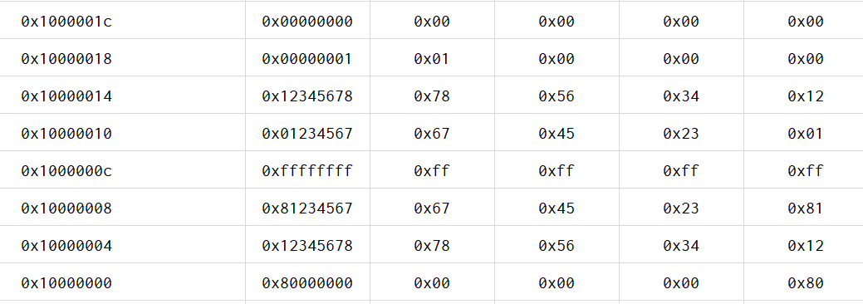

Case 1: Single Cycle RISC-V Processor

Results in Registers Execution Information

First half Result Second half Result

Case 2: Five stage RISC-V Processor

Results in Registers Execution Information

Experiment 6
Objective
This lab introduces to assembly equivalent of for loop written in C. By the end of this lab, you should be able to:
- Looping in assembly code.
- Observing the number of cycles, Number of Instructions retired, CPI, and IPC,
- Understand how Instruction execution flows through Datapath (IF, ID, EX, MA, WB).

Use of ISA: Load/ store, Arithmetic, conditional branch, and Shift left Logical.

Program 1: Write an assembly code to implement the following C statement.

main()
{
unsigned int a[11]={0x12345678,,,…..}, h;
h=0
for (i=0, i<10 ; i++)
{
h = h + a[i];
}
a[10]= h;
}
Assume array a[] base address mapped to x10 and length of array a[] mapped x11, variable h to x12. Use RV32I Single cycle processor and Five stage Processor (This has forwarding, hazard detection

Assembly code

.data
a: .half 0x1234,0x0001,0x2001,0x2111,0x3115,0,0

.text
la x10,a
addi x11,x0,10
back: lhu x20,0(x10)
add x12,x12,x20
addi x10, x10,2 / slli x10,x10,1
addi x13,x13,1
bltu x13,x11,back
sw x12,0(x10)

Result Summary
Memory Mapping

Result in data Memory

Address Word byte0 byte1 byte2 byte3

Case 1: Single Cycle RISC-V Processor

Results in Registers Execution Information

Case 2: Five stage RISC-V Processor
Results in Registers Execution Information

Experiment 6
Objective
This lab introduces to use of shift and logical operation, looping. By the end of this lab, you should be able to:
- Looping in assembly code.
- Use of Logical and shift operators.
- Observing the number of cycles, Number of Instructions retired, CPI, and IPC,
- Understand the how Instruction execution flows through Datapath (IF, ID, EX, MA, WB).

Use of ISA: Load/ store, logical, conditional branch and Shift Right Logical.

Program 1
Write an assembly code to check whether the byte in the memory is 2 out of 5 code or not? Is yes store 0x01 in x22 else store 0x02 in x22.

What is 2 out of 5 code
A 8 bit number is said to be 2 out of 5 code iff Condition1 and 2 both are TRUE
Condition1 : Most Significant 3 bit [7:5] =000 and
Condition2 :In the Least Significant 5 bits [4:0] there are 2 1’s out of 5.
D7 | D6 | D5 | D4 | D3 | D2 | D1 | D0 | Comment
0 | 0 | 1 | 1 | 0 | 0 | 0 | 1 | Condition1 FAILS – Not 2 out 5
0 | 0 | 0 | 1 | 1 | 0 | 0 | 1 | Condition1 is TRUE but Condition 2 FAILS, It is Not 2 out of 5.
0 | 0 | 0 | 0 | 1 | 1 | 0 | 0 | Condition1 is TRUE and Condition 2 TRUE, It is a 2 out of 5

Steps
- Read 8 bit unsigned number from Memory into a register
- Mask [4:0] of Number and retain [7:5]
- Check Is the result produced in step2 produces result as ZERO. If NO, Condition1 fails and It is Not 2 out of 5. Therefore skip step 4,5,6 and declare it is Not 2 out of 5 code else continue (As condition1 is TRUE)
- Take a counter as 5
- Count how many 1’s in [4:0] of the number ( Use logic for counting 1’s in a given number)
- Check the Count obtained in step5 is 2(Two) means 2 1’s in [4:0] i.e., Condition2 is TRUE. If TRUE declare it is 2 out of 5 code and Skip step 7 and go to step8 else step7

Assembly Code

.data
num: .byte 0X14
.text

la x10,num
lbu x11,0(x10) # Read unsigned 8 bit number into x11
andi x12,x11,0x0E0 # Mask [4:0] and retain [7:5]
bne x12,x0,exit # Check Are [7:5] Not equal to 0. If Not equal branch to exit
----------------------------------------------------------------------------
addi x13,x0,5 # Count=5 to check Number of 1’s in [4:0]
back: andi x12,x11,0x01 # Mask[7:1] and retain [0] bit
addi x14,x14,x12 # Counterx14 to keep track of 1’s ( Number of 1’s in [4:0]
srli x11,x11,1 # x11=x11>>1 to bring Next bit to be checked to lsb
addi,x13,x13,-1 # Counter x13 = Counter-1
bne x13,x0,back # If Counter != 0, Go back
---------------------------------------------------------------------------
addi x13,x0,2 # x13 = 2
bne x14,x13,exit # Is Count in (x14 != 2), Go to exit as Not 2 out of 5
addi x20,x0,0x01 # Is 2 out of 5 , x20=0x01
beq x0,x0,skip # Skip Next Instruction
exit: addi x20,x0,0x02 # Is Not 2 out of 5, x20=0x02
skip: nop

Note: This code stores 0x01 in x20 if it is 2 out of 5 code else stores 0x02 in x20.

Memory Mapping

Results in Registers

Case 1: Single Cycle RISC-V Processor
Execution Information (Not 2 out of 5 ) Execution Information ( 2 out of 5 )
num=0x34 num=0x14

Case 1: 5 stage RISC-V Processor
Execution Information (Not 2 out of 5 ) Execution Information ( 2 out of 5 )
num=0x34 num=0x14

