1. c) Circuit theory assumes electrical size is much smaller than the wavelength.
2. c) The uniform cross-sectional dimensions of the transmission line
3. c) Parallel plate capacitor
4. a) Self-inductance of the two conductors
5. b) Power losses
6. b) Time domain
7. b) A transmission line with a uniform cross-section
8. b) To minimize reflections and maximize power transfer
9. a) R=0 and G=0
10. b) Γ=0
11. c) Resistance (R) and Conductance (G)
12. a) Less than λ/4
13. d) All of the above
14. b) Prevent reflections
15. b) Voltage and current remain constant throughout the line
16. a) Zero
17. b) Ratio of reflected voltage wave to incident voltage wave
18. b) There is a reflected wave interfering with the incident wave
19. b) 1 ≤ VSWR ≤ ∞
20. b) λ/2
21. c) 3/5
22. b) 1.33
23. a)
24. b)
25. a)
26. a)
27. c)
28. d)
29. c)

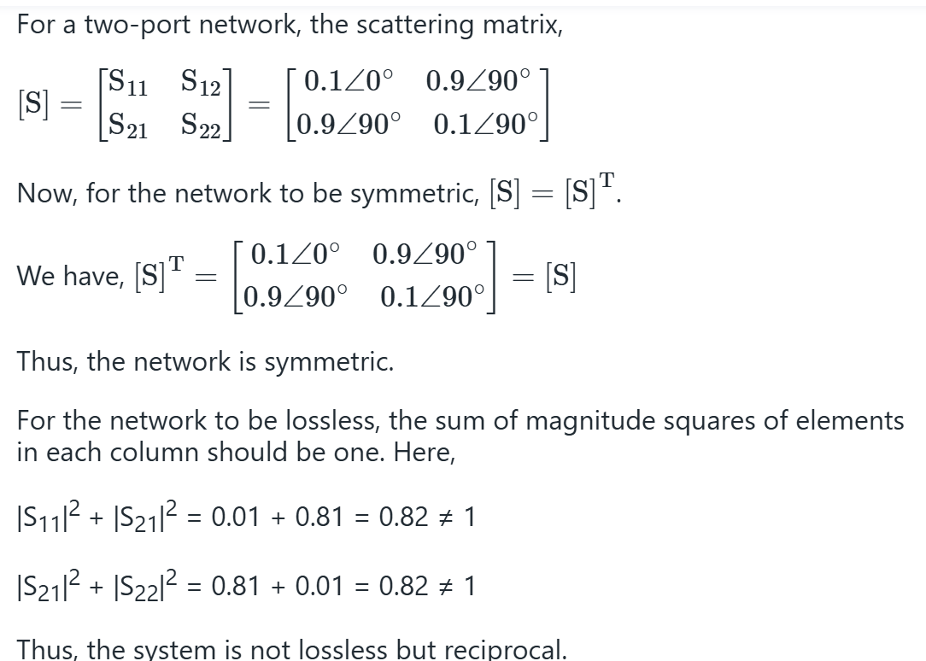

1. b)

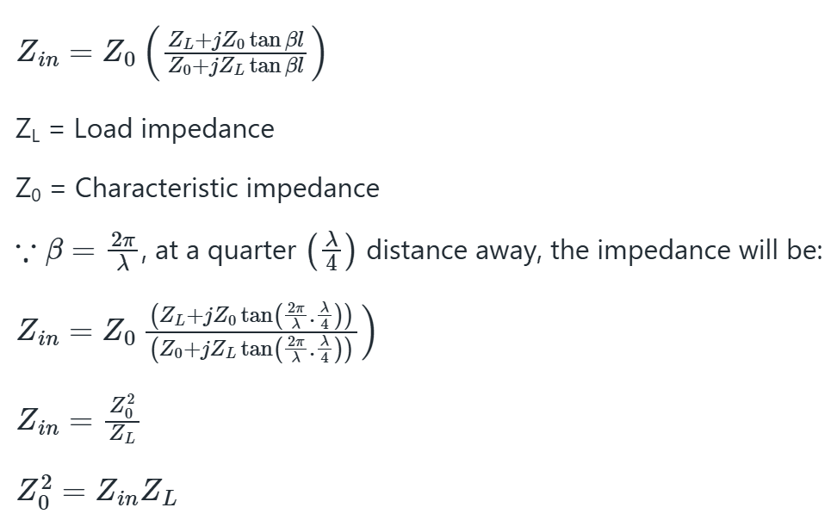

1. c) Both stub length and position
2. b)
3. b) It corresponds to an open circuit
4. For a **λ/2 line**, Zin=ZL​
5. d)
6. c)
7. b)
8. c)
9. a)
10. a)