REACT

Manager Login: (Rohit)

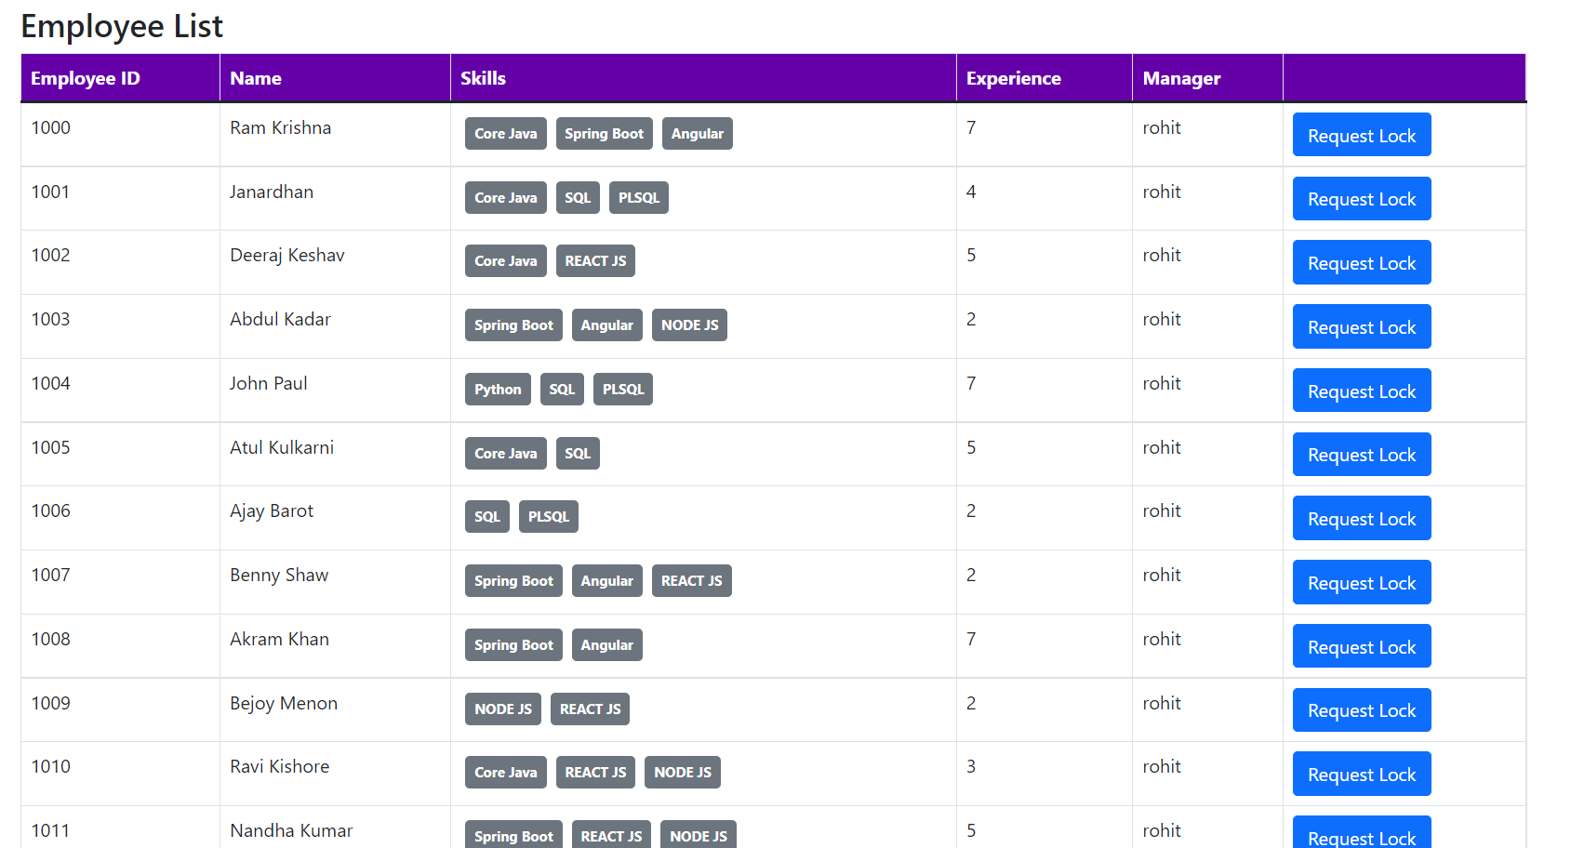

Manager Login: (Karan)

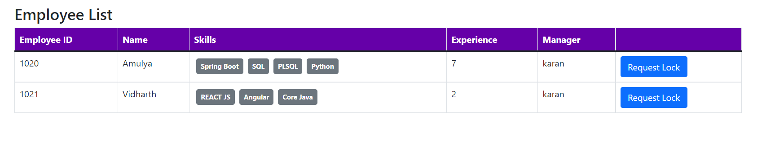

Manager Login: (Faizal)

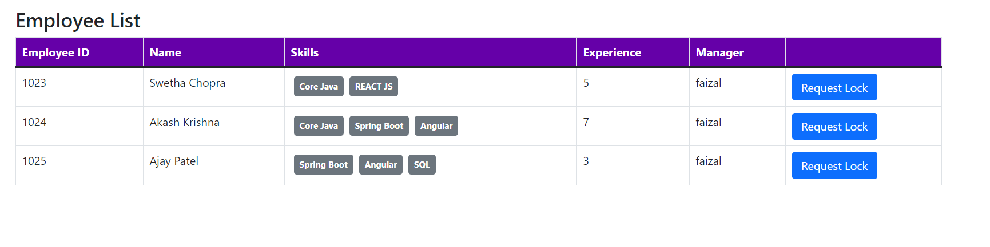

WFM Manager: (Lokesh)

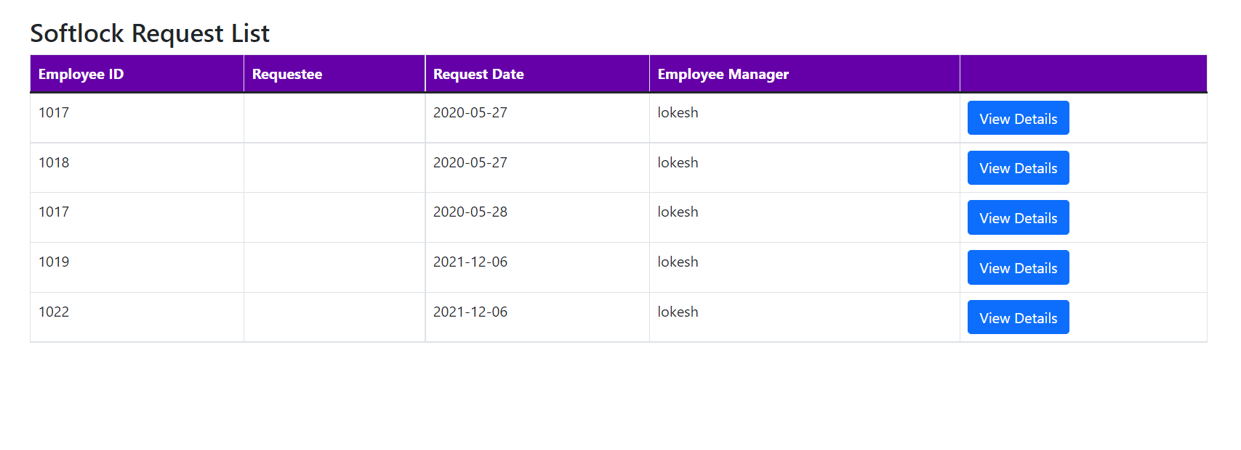

Manager Login : Soft Lock Request Screen:

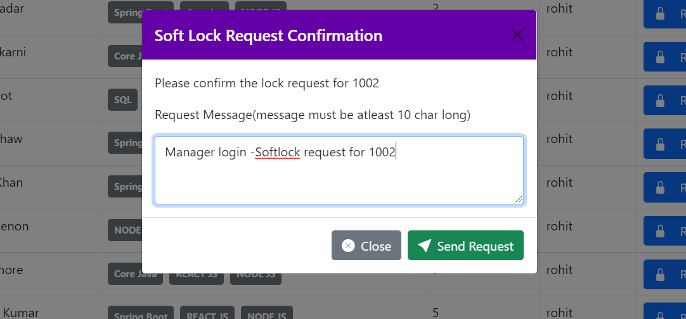

WFM Manager Login : Soft Lock Request Update Screen

