Requiremets for Resource Management Applications

Resource managemnet for bench-In service provider companies resources are hired for future projects. So till these resources get tagged to particular projects we can utilise their skills for internal project developement.
http://respro-developer-edition.ap16.force.com/resources
- Track the resources who are on bench with their experience.
- Any employee can post project ideas and submit it for approval.
- Project will get automatically created from project idea once it is approved.
- Task will be assigned to Manager to add project lead and due date,No of vacancy .
- Project lead can create tasks and assign tasks to employees with due date.
- Notify employee when the task is assigned to him/her.
- Notify the project lead when employee completed his/her task.
- Notify the employees when there is vacancy in project.(If any existing employee of project quit from project or take leave)
- Notify Manager when the project is completed.
- Provide security for project data so its not mistakenly viewed,edited,or deleted by employees who should not have access.
- Chatter is used for discussion and resolving queries.
- All the documents related to project will be documented in one folder. (documents like Requirements, Architecture and gantt chart).
- Reports will give overview of project status, number of project ideas,number of resources available.
----------------------------------------------------------------------------------------------------------------
Additional requirements:
- Knowledge evaluation-
Training faculty can add different tests in application
These tests can be activated and deactivated for particular time.
Maintain the scores of test
- File System to store Study material

---------------------------------------------------------------------------------------------------------
Improvement:
//Develop this app using Community- you cannot allocate each employee salesforce license . It will cost a company a lot. Solution-Design salesforce site
//Configure no reply email
//deployment of angular java war and jar rest API
//explore data table
//So in report and dashboard you can show for each skills how much of your budget you have invested
//Project idea life cycle-
create project idea
Evaluate, check feasibility
Approve idea
Allocate Budget
Assign Team lead , Assign Team
Assign Task
Complete and close the project
//revenue and quarter
//vacancy custom object so you can align employee
//chatter is not available for guest users= https://developer.salesforce.com/forums/?id=906F00000009AifIAE
// https://www.youtube.com/watch?v=fvCa7pRoIg4
//we need to post vacancy on site as all the employees wont be active users of salesforce org
// PPT size=249 MB
//automatic employee who submitted idea will get added in project : difficulty I process builder.I am not able to find right field
// remove search icon in site= use variable
//object level action
//mobile compact layout
//add text box to show who is logged in
//deploy angular and spring boot on tomcat server
Ng build –prod command will create aritifact which can be deployed

Problem faced & learnings

1)Approval process- reevaluate criteria if you are using the process builder to automatically approve the process
2)Problem with saving the record from salesforce site. Crated constructor and created object inside it. problem with calling sequence
3)Debugger-debug log from quick find and classic is fast and better to debug the errors.
4)returning page sequence
5)public setting of site need to be used for providing access to users
6)Apps created in lightning does not support in classic.
Lightning apps are created and managed in Lightning Experience.
But you can upgrade app created in classic to lightning
App launcher-> select app->upgrade
7)if you want to add existing record in related list . You need to create custom button in visual force page
8)Look u relationship -----if you are creating employee lookup in projectaides.
You will see all the project ideas in related list of employees
9) Master detail relationship---when you create master detail relationship on object that object will be detail object.
10)Permission set can not override page layout access
11) when assigning value to lookup field assign a salesforce id/record id

------------------------------------------------------------------------------------------------------------------------------

Architecture:

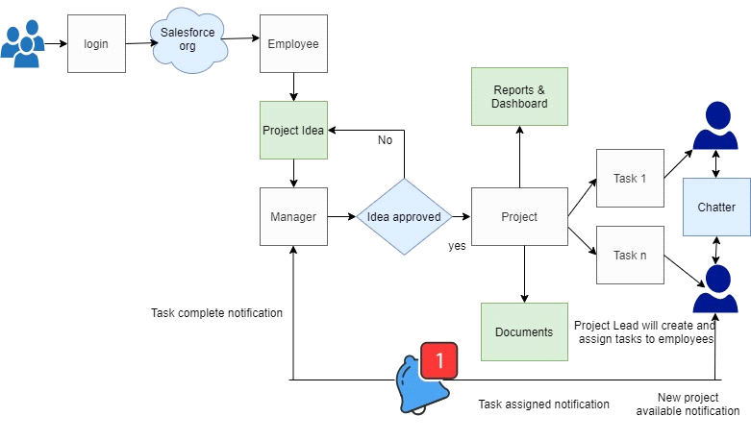

----------------------------------------------------------------------------------------------------------
Data Model

1)Employee-profile, (Custom Object)
- employee ID/Number-Text
- name
- qualification-text
- experience-Number
- location/Address- Standard field
- phone- Standard field
- email- Standard field
- Assigned to project/Project Name-Bench , Client project name

2)Project Idea (Custom Object)
- Name
- Idea-description
- Supporting document
- status-new,pending for approval,approve,reject,need improvemnet

3) Project (Custom object)
- Project name:
- project lead
- features
- technology
- due date
- tasks: Master detail. One to many relationship
- employees working for project
- Budget
- No of vacancy

4)Tasks(Standard object)
- task name
- status
- start date
- due date
- Assigned to:
- Priority

5)Primary Skill
1.Name

6)Junction Object(Employee Primary kill)
One Employee can have many primary skills
One skill can be aquired by many employees
1.Rating-validation rule-( Rating__c <1) || ( Rating__c > 5)
2.Experience in months

7)Secondary Skill
1.Name

8)Junction Object(Employee Secondary kill)
One Employee can have many Secondary skills
One skill can be aquired by many employees
1.Rating-validation rule-( Rating__c <1) || ( Rating__c > 5)
2.Experience in months

9) Vacancy( Custom Object)

Name(Software Developer ,Trainee Programmer)
Project: master detail relationship
Technology
Skills:
Location
Experience:
No of Positions:
Contact Person:
Status open/closed

-------------------------------------------------------------------------------------------------------------------
Security

1)Employee Profile
- can create read edit own Project idea
- read project
- read task
- Employee tab is hidden
- Can not read No of Vacancy
- Can not edit budget

Swati more: Swati997@gmail.com/ shreya997@gmail.com
password:abc@1234

2)Resource Manager- permission Set-role
- create edit delete project
- create edit delete project idea
- approve idea
- Assign project lead
- Employee tab is visible

Pooja Desai: Pooja997@gmail.com
password:abc@1234

3)Project Lead - Permission Set-role
- create ,delete,edit ,assign task
- create edit delete project idea
- read,edit project
- Employee tab is visible
Amrita Tiwari : Amrita997@gmail.com
password:abc@1234

---------------------------------------------------------------------------------

Created Approval process for new Project idea.

----------------------------------------------------------------------

Created Employees
1)himanshu997@gmail.com
Bench
Java
2)Amrita Tiwari- amrita997@gmail.com
Bench
Java
3)Shreya Jain-Shreya997@gmail.com
Evertz
C++

4)Swati More-Bench
5)Akshay PAwar-Bench
6)Neha Patil

-------------------------------------------------------------------------------------------------------------------

Community based approach

Employee can self register on portal.No need to assign liscence.

------------------------------------------------------------------------

Code migration stategy
Code coverage
Change set
Inbouns ans outbound
Admin package the application
Dependency
Permission missing
Supported migration tool
1)change set
2)Salesforce cli
3)SFDX
4)Ant migration tool
5) Xml files -maintained by ide like force.com(not preffered )

Conteneous interation
Contineous deployment

Scratch code 30 days valid

Objects , way in which it is deployed dependency

